Emmanuel obo
18/ENG02/065
COMPUTER ENGINEERING

BUSINESS PLAN ON POULTERY FARMING
One of the problems hindering the growth and development of agriculture in Nigeria is funding. Lots of farmers need money to expand their current operations and many people thinking of starting an agricultural business need money to kick start their operations.
There is a lot of money out there from public and private institutions available to back agriculture businesses but many people aren’t able to access these funds. The major reason why people can’t access these funds is because they aren’t able to convince lenders (public and private lenders) that their money will be put to good use.
This inability to convince lenders is because farmers and entrepreneurs aren’t able to properly articulate why they need the money and how they intend to use the money once they get it. You can only convince lenders that you will put their money to good use via a well-written business plan. With a well-written business plan, your chances of accessing the billions in the coffers of private and public institutions is greatly improved.
This post will help you access the money you need for your agriculture business by showing you how to write an agribusiness plan. We will use a poultry farming business has the template for writing our business plan and you’ll be walked through the key components of a business plan that receives funding.
My 12 key parts of a good poultry farming business plan are:
- Company name and logo (optional)
My company name will appear at the top of your business plan pitch or proposal. Also, get a good graphic designer to design a nice logo for your company. Doing this will give your business plan a professional look and it will immediately make it stand out from the crowd.
For my poultry farming business plan, the company name is GREEN HOUSE FARMING LTD

2. Headling
The next step is to describe my company and the business opportunity it will be taking advantage of. Make sure you use strong, compelling and graphic words to describe your company and its business opportunity. Include in your headline the things that will make your company successful (e.g. innovative products, industry experience etc.)
For my poultry farming business plan, the headline will be: GREEN HOUSE FARMING LTD is a full service poultry farming business setup to provide quality and affordable poultry products to the millions of Nigerians earning less than the minimum wage. This will be achieved through our unique and proprietary methods of raising poultry gained from over 20 years of experience in the poultry farming industry.

3. Problem(s) my company will solve
Here I will state the problem(s) that my company intends to solve for my target customers. These problems can be unmet needs or wants in the market or a unique and different method of solving the present needs and wants in your target market.
For my poultry farming business plan, the problems we intend to solve will be expressed as follows:
GRREN HOUSE FARMING LTD intends to address the following problems/pain points in the market:
- Making poultry products affordable to low-earning workers who only eat poultry on special occasions (Christmas, birthdays etc.)
- Ensuring that poultry products are well packed and prepared hygienically

4. My company’s solution
In this section I will explain how my company company intends to solve the problems the target customers face. The lenders must see clearly what my company offers and how my solution provides a different and unique alternative to what is presently in the market place.
For my poultry farming business plan, the solutions we will bring will be expressed as follows:
GRREN HOUSE FARMING LTD will make poultry affordable to the masses by
- Drastically reducing the cost of raising poultry by using new feeding methods, practices and feed materials
- Eliminate the middle men in product distribution by supplying directly to the consumers through use of e-commerce and community peer sales outlets

5. Explain my target market
I will be crystal clear about the type of people agriculture business intends to serve. My business plan must be clear on the customers i want to concentrate on, the segment of the populace who will represent my primary market, the segment of the populace your business will actively ignore etc. As i identify the potential customers for my agriculture business, i ensure to get figure and statistics about them. I need to know the number of people who make up my target market and how much they averagely spend each year to address the problem I intend to solve. Some market research will be needed for this aspect and I can get market data from sources like the United Nations, World Bank, and National Bureau of Statistics.
For my poultry farming business plan, the target market are the low-income earners in Nigeria. Some facts and figures about this segment of the population can be seen below:
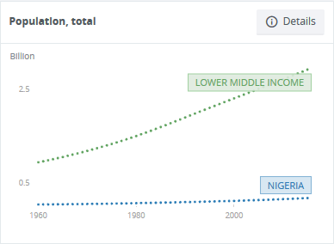
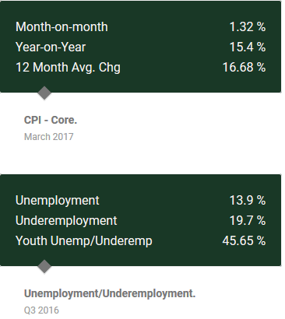

6. My competitive landscape
A key feature or component that defeats most business plan in real life is not taking competition into consideration. To prevent this from happening to my business, I need to have a good grasp of my competitive landscape. In this section, I will make a short list of my competitors. My competitors are divided into two categories: direct and indirect. Direct competitors are those businesses that already exist in my intended market or industry space and who are producing similar products and services. my indirect competitors are those businesses who aren’t producing similar or the same products and services like I intend to but who are still competing for money, my target customers could have spent with you.
The competitive landscape for my poultry farming business plan is listed below:
Direct Competitors
1 | Better packaging, More variety
2 | Cheaper price, More variety
3 | Cheaper price, Better packaging
4 | Cheaper price, Better packaging

Indirect Competitors
Pork meat | Mass appeal
Meat sellers | Better hygiene
Fish sellers | Tastier, Better hygiene, Better packaging
Canned Products | Healthier, Fresher

- Funding needs
I will state the amount of money I want to raise and how I intend to spend the money on my agriculture business.
For my sample poultry farming business plan, the funding needs can be stated as follows:
GRREN HOUSE FARMING LTD intends to raise N160,200,000 which would be spent as shown below:
- Processing Equipment and Machinery— N105,000,000
- Staff & Personnel— N4,800,000
- Birds— N5,400,000
- Feeding Material— N45,000,000
8. Your sales channels
In this section I will explain and describe how I plan to get my products or services to market. I will be selling and delivering to my target customers directly through a retail store, website, or even a catalogue. I will have a sales team. I will plan to sell through intermediaries — distributors, dealers, resellers, or others. Identifying my sales channels is important to understanding the economics of your business model.
For my sample poultry farming business plan, the sales channels will be outlined as follows:
GRREN HOUSE FARMING LTD intends to get her poultry products directly to her customers through the following sales channels:
- Online store: where customers can order directly to their homes
- Community peer channels: we will setup clusters of peer sales outlets in densely populated areas where customers can buy poultry products from
- Farm sale shops
9. Marketing activities
In this section, I explain how I plan to attract attention, build interest in my offerings, and convert prospects into customers.
For my sample poultry farming business plan, the marketing activities will be listed as follows:
- Facebook marketing campaign
- Product flyers and banners
- Radio advert
- Twitter promotion
- Google adword campaign

Financial Forecast

when I am confident that I have identified a market with a problem worth solving, it's time to put together a quick financial forecast for your solution. Then I ask my self questions,
- What does it cost to make what sell?
I need to know my direct costs. The idea behind direct costs is that every time I make a sale, I incur more costs. Common examples of direct costs (also known as costs of sales, costs of goods sold, or just COGS) are the raw materials I need to manufacture my products, wholesale purchases of products I am reselling, and sales commissions. Where regular expenses like rent, marketing, and insurance may remain steady as your sales fluctuate, making more sales always means incurring more direct costs.
11. Team and key roles
In this section of my sample poultry farming business plan, I identify the key members of my organization, and explain why their involvement is important to our future success. I plan to ensure I include company owners and members of the management team. I may also want to add key employees with strategically valuable skills or connections.
12. Partners and resources
In this last section of the poultry farming business plan, I identify any relationships, equipment, facilities, patents, or other resources that are strategically important to our business model.

