Electron Microscopic Technique & Ultrastructure
Fadairo Adegbenga Samuel
16/mhs03/012
Human Anatomy

Question
1) Write an essay on the history of microscopy

2) Differentiate between the light microscope and electron microscope

3) Differentiate between the SEM and TEM

History of Microscopy
During the 1st century AD (year 100), glass had been invented and the Romans were looking through the glass and testing it. They experimented with different shapes of clear glass and one of their samples was thick in the middle and thin on the edges. They discovered that if you held one of these “lenses” over an object, the object would look larger. They discovered that you can focus the rays of the sun with one of these special “glasses” and start a fire. These early lenses were called magnifiers or burning glasses. The word lens by the way, is derived from the latin word lentil, as they were named because they resembled the shape of a lentil bean. These lenses were not used much until the end of the 13th century when spectacle makers were producing lenses to be worn as glasses.
The early simple “microscopes” which were really only magnifying glasses had one power, usually about 6X - 10X . One thing that was very common and interesting to look at was fleas and other tiny insects. These early magnifiers were hence called “flea glasses”. Sometime about the year 1590, two Dutch spectacle makers, Zaccharias Janssen and his father Hans started experimenting with these lenses. They put several lenses in a tube and made a very important discovery. The object near the end of the tube appeared to be greatly enlarged, much larger than any simple magnifying glass could achieve by itself! They had just invented the compound microscope (which is a microscope that uses two or more lenses).
Galileo heard of their experiments and started experimenting on his own. He described the principles of lenses and light rays and improved both the microscope and telescope. He added a focusing device to his microscope and of course went on to explore the heavens with his telescopes. Anthony Leeuwenhoek of Holland became very interested in lenses while working with magnifying glasses in a dry goods store. He used the magnifying glass to count threads in woven cloth. He became so interested that he learned how to make lenses. By grinding and polishing, he was able to make small lenses with great curvatures. These rounder lenses produced greater magnification, and his microscopes were able to magnify up to 270X!
Anthony Leeuwenhoek became more involved in science and with his new improved microscope was able to see things that no man had ever seen before. He saw bacteria, yeast, blood cells and many tiny animals swimming about in a drop of water. From his great contributions, many discoveries and research papers, Anthony Leeuwenhoek (1632-1723) has since been called the "Father of Microscopy". Robert Hooke, an Englishman (who is sometimes called the “English Father of Microscopy”), also spent much of his life working with microscopes and improved their design and capabilities. Little was done to improve the microscope until the middle of the 19th century when great strides were made and quality instruments like today’s microscope emerged. Companies in Germany like Zeiss and an American company founded by Charles Spencer began producing fine optical instruments.
Today, there are little or no microscope manufacturers in the US and most of the microscopes come from Germany, Japan and China. Toy plastic microscopes should be avoided as they do not achieved the level of quality of the basic instruments with metal frames and glass lenses. Because of foreign production, quality microscopes have become affordable for all. Zaccharias Janssen, the inventor of the microscope would marvel at the quality of even the most basic microscopes found in schools today.

Timeline of the Microscope
14th century: spectacles first made in Italy
1590: Two Dutch spectacle-makers and father-and-son team, Hans and Zacharias Janssen, create the first microscope.
1667: Robert Hooke's famous "Micrographia" is published, which outlines Hooke's various studies using the microscope.
1675: Enter Anton van Leeuwenhoek, who used a microscope with one lens to observe insects and other specimens. Leeuwenhoek was the first to observe bacteria. 18th century: As technology improved, microscopy became more popular among scientists. Part of this was due to the discovery that combining two types of glass reduced the chromatic effect.
1830: Joseph Jackson Lister discovers that using weak lenses together at various distances provided clear magnification.
1878: A mathematical theory linking resolution to light wavelength is invented by Ernst Abbe.
1903: Richard Zsigmondy invents the ultra-microscope, which allows for observation of specimens below the wavelength of light.
1932: Transparent biological materials are studied for the first-time using Frits Xernike's invention of the phase-contrast microscope.
1938: Just six years after the invention of the phase contrast microscope comes the electron microscope, developed by Ernst Ruska, who realized that using electrons in microscopy enhanced resolution.
1981: 3-D specimen images possible with the invention of the scanning tunneling microscope by Gerd Binnig and Heinrich Rohrer.

Differentiate between the light microscope and electron microscope
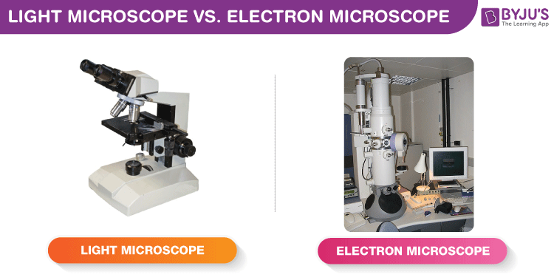

Differences between Light Microscope and Electron Microscope
Light Microscope | Electron Microscope
Illuminating source is the Light. | Illuminating source is the beam of electrons.
Specimen preparation takes usually few minutes to hours. | Specimen preparation takes usually takes few days.
Live or Dead specimen may be seen. | Only Dead or Dried specimens are seen.
Condenser, Objective and eye piece lenses are made up of glasses. | All lenses are electromagnetic.
It has low resolving power (0.25µm to 0.3µm). | It has high resolving power (0.001µm), about 250 times higher than light microscope.
It has a magnification of of 500X to 1500X. | It has a magnification of 100,000X to 300,000X.
The object is 5µm or thicker. | The object is 0.1µm or thinner.
Image is Colored. | Image is Black and White.
Vacuum is not required. | Vacuum is essential for its operation.
There is no need of high voltage electricity. | High voltage electric current is required (50,000 Volts and above).
There is no cooling system. | It has a cooling system to take out heat generated by high electric current.
Filament is not used. | Tungsten filament is used to produce electrons.
Radiation risk is absent. | There is risk of radiation leakage.
Specimen is stained by colored dyes. | Specimen is coated with heavy metals in order to reflect electrons.
Image is seen by eyes through ocular lens. | Image is received in Zinc Sulphate Fluorescent Screen or Photographic Plate.
It is used for the study of detailed gross internal structure. | It is used in the study of external surface, ultra structure of cell and very small organisms.

Differentiate between the SEM and TEM
Properties | Scanning Electron Microscopy (SEM) | Transmission Electron Microscopy (TEM)
Light Source | SEM is based on scattered electrons, i.e. electrons emitted from the surface of a specimen. It is the EM analog of a stereo light microscope. | Electrons are used as “light source”. TEM is based on transmitted electrons and operates on the same basic principles as the light microscope.
Purpose | SEM provides detailed images of the surfaces of cells. SEM focuses on the sample’s surface and its composition, so SEM shows only the morphology of samples. | Transmission electron microscope is used to view thin specimens (tissue sections, molecules, etc). TEM can show many characteristics of the sample, such as internal composition, morphology, crystallization, etc.
Sample Preparation | Sample is coated with a thin layer of heavy metal such as gold or palladium. | The sample in TEM has to be cut thinner (70-90 nm) because electrons cannot penetrate very far into materials.
Resolution | SEM can resolve objects as close as 20 nm. | TEM has a much higher resolution than SEM. It can resolve objects as close as 1 nm i.e. down to near-atomic levels.
Magnification | The magnifying power of SEM is up to 50,000X. | The magnifying power of TEM is up to 2 million times.
Processing of sample (s) | SEM allows for a large amount of sample to be analyzed at a time | With TEM only a small amount of samples can be analyzed at a time.
Image formation | Secondary or backscattered electrons arising from the interaction of electron beam and metal-coated specimen are collected and the resulting image is displayed on a computer screen. | Transmitted electrons hit a fluorescent screen giving rise to a “shadow image” of the specimen with its different parts displayed in varied darkness according to their density. The image can be studied directly by the operator or photographed with a camera.
3D picture | SEM provides a 3-dimensional image | TEM provides a 2-dimensional picture.
Current Applications | To study topography and atomic composition of specimens, process control and also, for example, the surface distribution of immuno-labels | To image the interior of cells (in thin sections), the structure of protein molecules (contrasted by metal shadowing), the organization of molecules in viruses and cytoskeletal filaments (prepared by the negative staining technique), and the arrangement of protein molecules in cell membranes (by freeze-fracture).

