NAME: EGBUNU KHADIJAT OCHONIYA
MATRIC NUMBER: 16/ MHS01/075
COURSE: ELECTRON MICROSCOPIC TECHNIQUE AND ULTRASTRUCTURE
COURSE CODE: ANA 402
LECTURER: DR. OGEDENGBE
QUESTIONS
- Write an essay on the history of microscopy
- Differentiate between light microscope and electron microscope
- Differentiate between SEM and TEM

QUESTION 1
HISTORY OF MICROSCOPY
~710 BC – Nimrud lens
The Nimrud lens – a piece of rock crystal – may have been used as a magnifying glass or as a burning-glass to start fires by concentrating sunlight. It is later unearthed by Austen Henry Layard at the Assyrian palace of Nimrud in modern-day Iraq.
~1000 AD – Reading stone
The first vision aid, called a reading stone, is invented. It is a glass sphere placed on top of text, which it magnifies to aid readability.
~1021 AD – Book of Optics
Muslim scholar Ibn al-Haytham writes his Book of Optics. It eventually transforms how light and vision are understood.
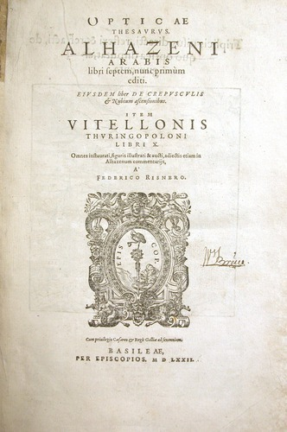
Cover page for Book of Optics
This is a seven-volume treatise on optics and other fields of study by the medieval Arab scholar Ibn al-Haytham, (965– c. 1040 AD).
1590 – Early microscope
Zacharias Janssen and his son Hans place multiple lenses in a tube. They observe that viewed objects in front of the tube appear greatly enlarged. This is a forerunner of the compound microscope and the telescope.
1609 – Compound microscope
Galileo Galilei develops a compound microscope with a convex and a concave lens.
1625 – First use of term ‘microscope’
Giovanni Faber coins the name ‘microscope’ for Galileo Galilei’s compound microscope.
1665 – First use of term ‘cells’
English physicist Robert Hooke publishes Micrographia, in which he coins the term ‘cells’ when describing tissue. The book includes drawings of hairs on a nettle and the honeycomb structure of cork. He uses a simple, single-lens microscope illuminated by a candle.
1676 – Living cells first seen
Antonie van Leeuwenhoek builds a simple microscope with one lens to examine blood, yeast and insects. He is the first to describe cells and bacteria. He invents new methods for making lenses that allow for magnifications of up to 270 times.
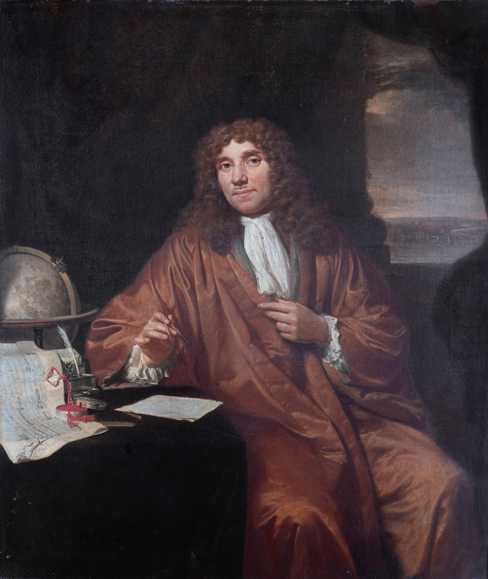
Portrait of Antonie van Leeuwenhoek (1632–1723) by Jan Verkolje.
1931 – Transmission electron microscope
Ernst Ruska and Max Knoll design and build the first transmission electron microscope (TEM), based on an idea of Leo Szilard. The electron microscope depends on electrons, not light, to view an object. Modern TEMs can visualise objects as small as the diameter of an atom.
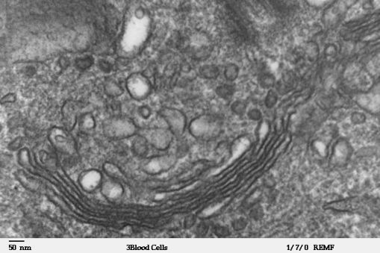
Cells viewed with the TEM Transmission electron microscope image of a human leukocyte (also known as a white blood cell), showing the Golgi apparatus, which is a structure involved in protein transport in the cytoplasm of the cell.
1932 – Phase contrast microscope
Frits Zernike develops phase contrast illumination, which allows the imaging of transparent samples. By using interference rather than absorption of light, transparent samples, such as cells, can be imaged without having to use staining techniques.
1942 – Scanning electron microscope
Ernst Ruska builds the first scanning electron microscope (SEM), which transmits a beam of electrons across the surface of a specimen.
1972 – First CAT scanner
Godfrey Hounsfield and Allan Cormack develop the computerised axial tomography (CAT) scanner. With the help of a computer, the device combines many X-ray images to generate cross-sectional views as well as three-dimensional images of internal organs and structures.
1973 – Electron backscatter patterns observed
John Venables and CJ Harland observe electron backscatter patterns (EBSP) in the scanning electron microscope. EBSP provide quantitative microstructural information about the crystallographic nature of metals, minerals, semiconductors and ceramics.

1981 - Scanning tunnelling microscope
Gerd Binnig and Heinrich Rohrer invent the scanning tunnelling microscope (STM). The STM ‘sees’ by measuring interactions between atoms, rather than by using light or electrons. It can visualise individual atoms within materials.
1986 – Nobel Prize for microscopy
The Nobel Prize in Physics is awarded jointly to Ernst Ruska (for his work on the electron microscope) and to Gerd Binnig and Heinrich Rohrer (for the scanning tunnelling microscope).
1993–1996 – Super-resolution microscopy
Stefan Hell pioneers a new optical microscope technology that allows the capture of images with a higher resolution than was previously thought possible. This results in a wide array of high-resolution optical methodologies, collectively termed super-resolution microscopy.
2010 – Atoms of a virus seen
Researchers at UCLA use a cryoelectron microscope to see the atoms of a virus.
2014 – Chemistry Nobel prize for super microscopes
Nobel Prize in Chemistry awarded to Eric Betzig, Stefan Hell and William Moerner for the development of super-resolved fluorescence microscopy which allows microscopes to now ‘see’ matter smaller than 0.2 micrometres.

QUESTION 2
DIFFERENCES BETWEEN ELECTRON MICROSCOPE AND LIGHT MICROSCOPE
Magnification and resolving power is the key difference between Light Microscope and Electron Microscope which is about 1000X of the magnification with resolving power of 0.2um in Light Microscope and that of Electron Microscope is 10,00,000X magnification with resolving power of 0.5nm or even less.
Comparison chart
Basis for Comparision | Light Microscope | Electron Microscope
Invented by | It is believed that Dutch spectacles makers Zacharius Jansen and his father Hans were the first to invent the compound microscope in the 16th century. | In 1931 physicist Ernst Ruska and German engineer Max Knoll.
Source to view the object | Visible light source . | Beam of charged particles i.e. electrons.
Lense used | Glass lenses. | Electromagnetic lenses.
Magnification | 1000X. | 10,00,000X.
Resolving power | 0.2um. | 0.5nm.
Screen | Projection screen. | Fluorescent screen.
Voltage | No need of high voltage electricity. | High voltage electric current is required (around 50,000 volts and above).
Cooling system | There is no requirement of cooling system. | It has high cooling system in order to move out the heat generated by high voltage electric current.
Preparation | Preparation of sample is quick and simple. | Complex preparation.
Filament | No filament used. | Tungsten filament is used.
Radiation leakage | No radiation risk. | There is the risk of radiation leakage.
Availability | Easily available and cheaper in rate. | Not easily available and expensive.
Visibility | Living, as well as the dead sample, can be viewed. | Only dead (fixed) organisms can be viewed.
 | Studying the detailed structure of an organism is difficult. | 3D structure is obtained due to which it is easy to study the structural and other details of organisms.
 | The natural colour of specimen is obtained. | Only black and white image is obtained.
 | The image can be seen directly. | Image is seen only on fluorescent screen

QUESTION 3
DIFFERENCES BETWEEN SEM AND TEM
Scanning electron microscope (SEM) | Transmission electron microscope (TEM)
Used to produce excellent images of the surfaces of cells and small organisms. Excellent for studying surface morphology of the organisms, cells or any suitable material under study | Used to study the ultra structure of cells and its components. It can see objects as small as a protein molecule or even at nano level. Provides details about internal composition of cells or any suitable material under study
Electron beam scans over the surface of the sample | Electron beam pass through the sample
Based on scattered electrons or produces images by detecting secondary electrons which are emitted from the surface due to excitation by the primary electron beam | Based on transmitted electrons or produces images by detecting primary electrons transmitted from the sample
Comparatively low resolution than TEM; resolution: 2nm(average), 0.2nm(special) | High resolution; resolution: 10nm(average), 0.5nm(special)
Depth of field: high | Depth of field: moderate
Magnifying power: 100,000X | Magnifying power: 5,000,000X
Specimen contrast: by electron adsorption | By electron scattering
Produces three-dimensional black and white images | Produces two dimensional black and white images
Preparation technique: easy | Skilled, very thin sample is required
Preparation thickness: variable | Very thin
Specimen mounting: aluminium stubs | Thin films on copper grids
Field of view: large | Limited

