Name: Evbarunegbe Adesuwa Mitchelle
Matric number : 17/mhs01/126
Gross anatomy of head and neck

Intrinsic Muscles
The intrinsic muscles only attach to other structures in the tongue. There are four paired intrinsic muscles of the tongue and they are named by the direction in which they travel: the superior longitudinal, inferior longitudinal, transverse and vertical muscles of the tongue. These muscles affect the shape and size of the tongue – for example, in tongue rolling – and have a role in facilitating speech, eating and swallowing.
Motor innervation for the intrinsic muscles of the tongue is via the hypoglossal nerve (CNXII).

Extrinsic Muscles
The extrinsic muscles are as follows:

Genioglossus
- Attachments: Arises from the mandibular symphsis. Inserts into the body of the hyoid bone and the entire length of the tongue.
- Function: Inferior fibres protrude the tongue, middle fibres depress the tongue, and superior fibres draw the tip back and down
- Innervation: Motor innervation via the hypoglossal nerve (CNXII).

Hyoglossus
- Attachments: Arises from the hyoid bone and inserts into the side of the tongue
- Function: Depresses and retracts the tongue
- Innervation: Motor innervation via the hypoglossal nerve (CNXII).

Styloglossus
- Attachments: Originates at the styloid process of the temporal bone and inserts into the side of the tongue
- Function: Retracts and elevates the tongue
- Innervation: Motor innervation via the hypoglossal nerve (CNXII).

Palatoglossus
- Attachments: Arises from the palatine aponeurosis and inserts broadly across the tongue
- Function: Elevates the posterior aspect of the tongue
- Innervation: Motor innervation via the vagus nerve (CNX).
All of the intrinsic and extrinsic muscles are innervated by the hypoglossal nerve (CN XII), except palatoglossus, which has vagal innervation (CN X).
By TeachMeSeries Ltd (2020)
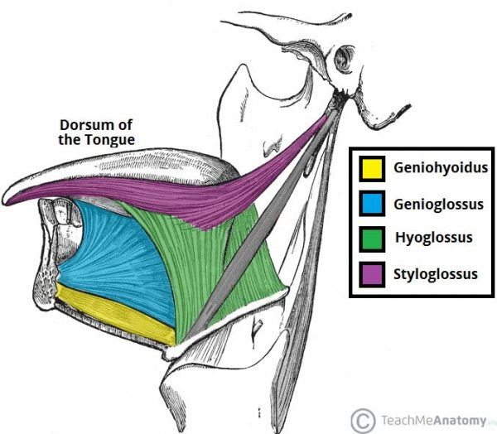
Fig 1 – The extrinsic muscles of the tongue. Note the palatoglossus muscle is not included in this illustration.

Innervation
Once we start examining the sensory supply of the tongue, we need to start looking at its division into an anterior 2/3, and a posterior 1/3. Later in this article, when we discuss the development of the tongue, the reason for this boundary becomes clear.
By TeachMeSeries Ltd (2020)
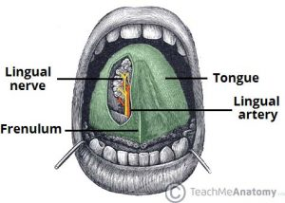
Fig 1.2 – The lingual nerve provides sensory innervation to the to the 2/3 of the tongue.
In the anterior 2/3, general sensation is supplied by the trigeminal nerve (CNV). Specifically the lingual nerve, a branch of the mandibular nerve (CN V3).
On the other hand, taste in the anterior 2/3 is supplied from the facial nerve (CNVII). In the petrous part of the temporal bone, the facial nerve gives off three branches, one of which is chorda tympani. This travels through the middle ear, and continues on to the tongue.
The posterior 1/3 of the tongue is slightly easier. Both touch and taste are supplied by the glossopharyngeal nerve (CNIX).

Vasculature
The lingual artery (branch of the external carotid) does most of the supply, but there is a branch from the facial artery, called the tonsillar artery, which can provide some collateral circulation. Drainage is by the lingual vein.

Lymphatic Drainage
The lymphatic drainage of the tongue is as follows:
- Anterior two thirds – initially into the submental and submandibular nodes, which empty into the deep cervical lymph nodes
- Posterior third – directly into the deep cervical lymph nodes

Embryological Development
A good understanding of the tongue’s embryological development greatly simplifies the complex innervation to the structure. One of the central points is that the first branchial arch is supplied by the trigeminal nerve, the second by the facial, the third by the glossopharyngeal, and the fourth and sixth by the vagus.
When the tongue is developing, it starts as a two longitudinal bulbous ridges, with contribution from the first four branchial arches. These ridges join, giving rise to the longitudinal line (median sulcus) down the centre of your tongue. The contribution from the second branchial arch is grown over by that of the third arch, but the nerve supply remains. Using this information, we can understand why the majority of the tongue’s innervation is by the trigeminal nerve (CN V) and the glossopharyngeal nerve CN IX.
Look further towards the back of your tongue – there is a transverse line near the root of the tongue. This is called sulcus terminalis, and in the centre, where it meets the median sulcus, there is a pit. This is the now-closed top of a deep pit, the foramen cecum (blind window), at the end of which lies the thyroid gland. During development, this descends from the tongue down into the neck, If, on the way down, the pit (thyroglossal duct) doesn’t close behind the gland, midline thyroglossal cysts or fistulae may remain.

Clinical Relevance - A Bit Tongue Tied?
Klaus D. Peter, Wiehl, Germany [CC BY 2.0], via Wikimedia Commons
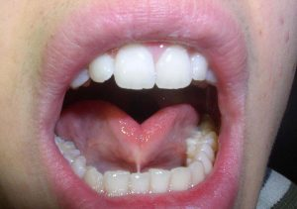
Fig 1,1 – Tongue tied
The tongue is attached anteroinferiorly by a piece of connective tissue called the frenulum, which lies in the midline. The process by which the frenulum is formed is the same by which your fingers are made, and is known as sculpting apoptosis. Just as some people may have webbed fingers if this process fails, it can result in excess frenulum. This is called being ‘tongue-tied’, and presents in children. There are varying degrees of severity of tongue-tie and in some cases it can restrict the movement of the tongue causing difficulties with breast feeding. This can be managed with simple surgery.

2] The paranasal sinuses are air-filled extensions of the respiratory part of the nasal cavity. There are four paired sinuses, named according to the bone in which they are located; maxillary, frontal, sphenoid and ethmoid.
The function of the sinuses is not clear. It is thought that they may contribute to the humidifying of the inspired air. They also reduce the weight of the skull.
Sinuses are formed in childhood by the nasal cavity eroding into surrounding bone. As they are outgrowths of the nasal cavity, they all drain back into it – openings to the paranasal sinuses are found on the roof and lateral walls of the nasal cavity. The inner surface is lined by a respiratory mucosa. Ethmoidal Sinuses: There are three ethmoidal sinuses; anterior, middle and posterior. They empty into the nasal cavity at different places:
- Anterior – Hiatus semilunaris
- Middle – Ethmoid bulla
- Posterior – Superior meatus
Maxillary Sinuses: The largest of the sinuses. It is located laterally and slightly inferiorly to the nasal cavities. It drains into the nasal cavity at the hiatus semilunaris, underneath the frontal sinus opening. This is a potential pathway for spread of infection – fluid draining from the frontal sinus can enter the maxillary sinus.By Patrick J. Lynch and Michał Komorniczak [Frontal Sinuses: These are the most superior in location, found under the forehead. The frontal sinuses are variable in size, but always triangular-shaped. They drain into the nasal cavity via the frontonasal duct, which opens out at the hiatus semilunaris on the lateral wall.
Sphenoid Sinuses: The sphenoid sinuses also lie relatively superiorly, at the level of the spheno-ethmodial recess. They are found more posteriorly, and are related superiorly and laterally to the cranial cavity. The sphenoid sinuses drain out onto the roof of the nasal cavity. The relationships of this sinus are of clinical importance – the pituitary gland can be surgically accessed via passing through the nasal roof, into the sphenoid sinus and through the sphenoid bone.
Ethmoidal Sinuses: There are three ethmoidal sinuses; anterior, middle and posterior. They empty into the nasal cavity at different places:
- Anterior – Hiatus semilunaris
- Middle – Ethmoid bulla
- Posterior – Superior meatus
Maxillary Sinuses: The largest of the sinuses. It is located laterally and slightly inferiorly to the nasal cavities. It drains into the nasal cavity at the hiatus semilunaris, underneath the frontal sinus opening. This is a potential pathway for spread of infection – fluid draining from the frontal sinus can enter the maxillary sinus.

Clinical Relevance: Sinusitis

As the paranasal sinuses are continuos with the nasal cavity, an upper respiratory tract infection can soread to the sinuses. Infection to the sinuses causes inflammation of the mucosa and is known as sinusitis. If more than one sinus is infected, it is called pansinusitis.

The maxillary nerve supplies both the maxillary sinus and maxillary teeth so as inflammation of that sinus can be present with toothache.
As the paranasal sinuses are continuous with the nasal cavity, an upper respiratory tract infection can spread to the sinuses. Infection of the sinuses causes inflammation (particularly pain and swelling) of the mucosa, and is known as sinusitis. If more than one sinus is affected, it is called pansinusitis.
The maxAs the paranasal sinuses are continuous with the nasal cavity, an upper respiratory tract infection can spread to the sinuses. Infection of the sinuses causes inflammation (particularly pain and swelling) of the mucosa, and is known as sinusitis. If more than one sinus is affected, it is called pansinusitis.
The maxillary nerve supplies both the maxillary sinus and maxillary teeth, and so inflammation of that sinus can present with toothache.

