AGBEDE OLUWANIFEMI JANET
17/MHS01/032
300L MBBS
ANA 301 ASSIGNMENT 2

QUESTION ONE: WRITE AN ESSAY ON THE CAVERNOUS SINUS.

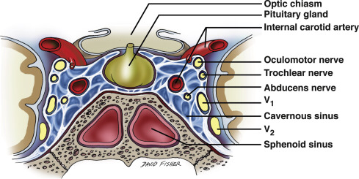

The cavernous sinus within the human head is one of the dural venous sinuses creating a cavity called the lateral sellar compartment bordered by the temporal bone of the skull and the sphenoid bone, lateral to the sella turcica. It is a network of veins that sit in a cavity, approximately 1 x 2 cm in size in an adult. The carotid siphon of the internal carotid artery, and cranial nerves III, IV, V (branches V1 and V2) and VI all pass through this blood filled space.

Relations.
- Superiorly: optic tract, optic chiasma, internal carotid artery.
- Inferiorly: Foramen lacerum and the junction of the body and greater wing of sphenoid bone.
- Medially: Hypophysis cerebri or (pituitary gland) and sphenoidal air sinus.
- Laterally: temporal lobe with uncus.
- Anteriorly: superior orbital fissure and the apex of the orbit.
- Posteriorly: apex of petrous temporal bone.
Venous Connections.
The cavernous sinus receives blood from:
- Superior and inferior ophthalmic veins.
- Sphenoparietal sinus.
- Superficial middle cerebral veins.
- Inferior cerebral veins.
Blood leaves the sinus via superior and inferior petrosal sinuses as well as via the emissary veins through the foramina of the skull (mostly through foramen ovale). There are also connections with the pterygoid plexus of veins via inferior ophthalmic vein, deep facial vein and emissary veins.

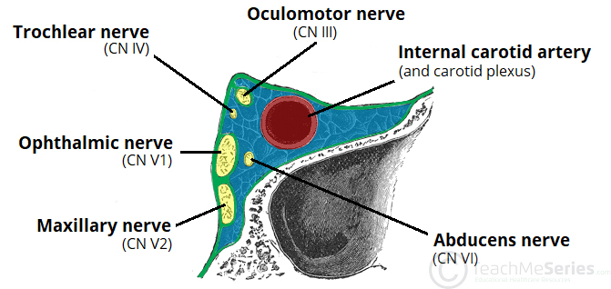
Contents.
Apart from the blood which passes through a venous sinus, several anatomical structures, including some cranial nerves and their branches, also pass through the sinus.
Structures within the outer (lateral) wall of the compartment from superior to inferior include;
- Oculomotor nerve.
- Trochlear nerve.
- Ophthalmic and maxillary branches of the trigeminal nerve.
Structures passing through the midline (medial) wall include;
- Abducens nerve.
- Internal carotid artery accompanied by the Internal carotid plexus.

These nerves, with the exception of CN V2(maxillary branch of the trigerminal nerve), pass through the cavernous sinus to enter the orbital apex through the superior orbital fissure. The maxillary nerve, division V2 of the trigeminal nerve travels through the lower portion of the sinus and exits via the foramen rotundum. The maxillary branch passes external to, but immediately adjacent to, the lateral wall of the sinus.
The optic nerve lies just above and outside the cavernous sinus, superior and lateral to the pituitary gland on each side, and enters the orbital apex via the optic canal.
Function of the cavernous sinus.
- Venous drainage;
As a venous sinus, the cavernous sinus receives blood from the superior and inferior ophthalmic veins and from superficial cortical veins, and is connected to the basilar plexus of veins posteriorly. The cavernous sinus drains by two larger channels, the superior and inferior petrosal sinuses, ultimately into the internal jugular vein via the sigmoid sinus, also draining with emissary vein to pterygoid plexus.
Clinical Correlates.
- It is the only anatomic location in the body in which an artery travels completely through a venous structure. If the internal carotid artery ruptures within the cavernous sinus, an arteriovenous fistula is created (more specifically, a carotid-cavernous fistula). Lesions affecting the cavernous sinus may affect isolated nerves or all the nerves traversing through it.
- The pituitary gland lies between the two paired cavernous sinuses. An abnormally growing pituitary adenoma, sitting on the bony sella turcica, will expand in the direction of least resistance and eventually compress the cavernous sinus. Cavernous sinus syndrome may result from mass effect of these tumors and cause ophthalmoplegia (from compression of the oculomotor nerve, trochlear nerve, and abducens nerve), ophthalmic sensory loss (from compression of the ophthalmic nerve), and maxillary sensory loss (from compression of the maxillary nerve). A complete lesion of the cavernous sinus disrupts CN III, IV, and VI, causing total ophthalmoplegia, usually accompanied by a fixed, dilated pupil. Involvement of CN V (V1 and variable involvement of V2) causes sensory loss in these divisions of the trigeminal nerve. Horner's syndrome can also occur due to involvement of the carotid ocular sympathetics, but may be difficult to appreciate in the setting of a complete third nerve injury.
- Because of its connections with the facial vein via the superior ophthalmic vein, it is possible to get infections in the cavernous sinus from an external facial injury within the danger area of the face. In patients with thrombophlebitis of the facial vein, pieces of the clot may break off and enter the cavernous sinus, forming a cavernous sinus thrombosis. From there the infection may spread to the dural venous sinuses. Infections may also be introduced by facial lacerations and by bursting pimples in the areas drained by the facial vein.
- Potential causes of cavernous sinus syndrome include metastatic tumors, direct extension of nasopharyngeal tumours, meningioma, pituitary tumors or pituitary apoplexy, aneurysms of the intracavernous carotid artery, carotid-cavernous fistula, bacterial infection causing cavernous sinus thrombosis, aseptic cavernous sinus thrombosis, idiopathic granulomatous disease (Tolosa–Hunt syndrome), and fungal infections. Cavernous sinus syndrome is a medical emergency, requiring prompt medical attention, diagnosis, and treatment.

QUESTION TWO: DISCUSS THE WALLS OF THE NOSE.

The nasal cavity is made up of a floor, a roof, a medial wall and a lateral wall.
- The floor.
This is composed of:
- The palatine process of the maxilla making up the anterior 3/4th.
- The horizontal process of the palatine bone making up the posterior 1/4th.

- The roof.
This is composed of:
- An anterior slope made up of the nasal bone.
- A posterior slope made up of the body of sphenoid.
- A middle horizontal bone made up of cribiform plate of the ethmoid bone through which the olfactory nerve pass through.

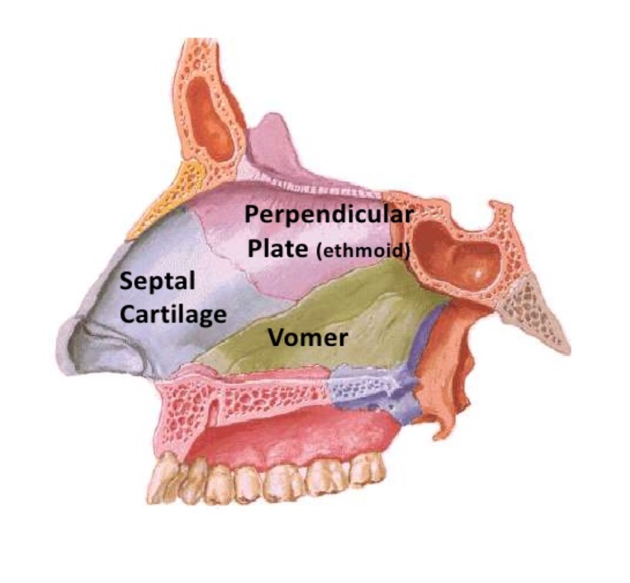

- The medial wall.
The medial wall is made up cartilage and the septum proper.
The septum proper is made up of:
- Septal cartilage
- The perpendicular plate of the ethmoid postero-superiorly
- The vomer posterior-inferiorly
These articulate with the following bones to complete the septum.
- Superiorly: the nasal bone, frontal bone and rostum of the sphenoid.
- Inferiorly: with the nasal crest of the maxilla, the anterior nasal spine of the maxilla and the palatine bone.
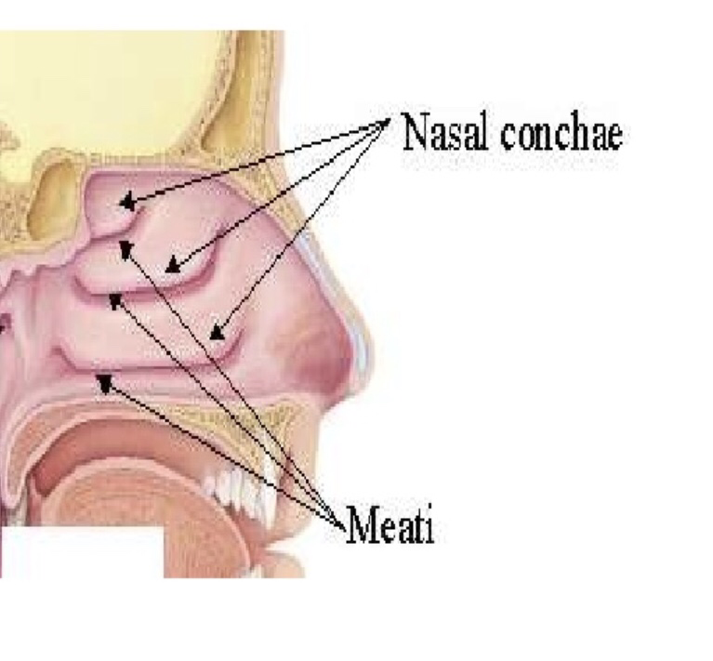
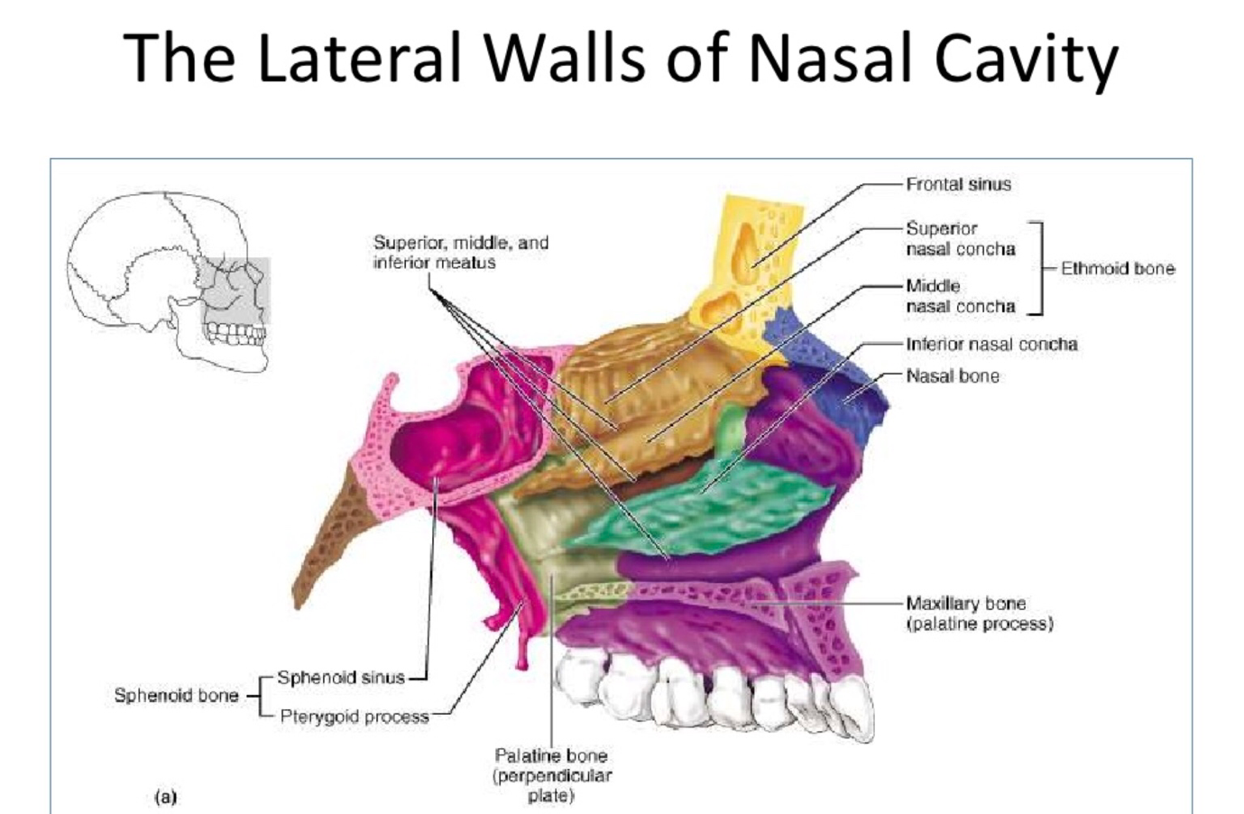

- The lateral wall.
It is made up of:
- Medial part of maxilla.
- Ethmoid bone.
- Nasal bone.
- Ascending part of the maxilla.
- Inferior nasal conchae.
- Medial pterygoid plate.
- Perpendicular plate of the palatine bone.
The lateral wall has projections called concha: they are long and narrow curled protections that protrudes into the breathing passage of the nose to interrupt air flow in order to increase its contact with the blood vessels that line the nasal cavity.

The conchae;
- The superior conchae: part of the ethmoid.
- The middle conchae: part of the ethmoid.
- The inferior conchae: a separate bone.
- And sometimes the presence of a fourth conchae called the concha suprema.

Below and lateral to each conchae Is a corresponding meatus;
- The inferior meatus: the nasolacrimal duct opens into its anterior part.
- The middle meatus: the frontal, maxillary and anterior ethmoidal sinus open into it. It makes up the bulla ethmoidalis, the hiatus semilunaris and the infundibulum.
- The superior meatus: the posterior ethmoidal sinus opens into it.
- The sphenoethmoidal recess: this is a triangular fossa that lies above the superior meatus. The Sphenoidal sinus opens into it.

