NAME: CHINENYE CHIDNMA MARY-JOSEPHINE
LEVEL: 300 MBBS
ASSIGNMENT TITLE: NOSE AND ORAL CAVITY
COURSE TITLE: GROSS ANATOMY OF HEAD AND NECK
COURSE CODE: ANA 301

QUESTION
1) Discuss the Gross anatomy of the tongue and comment on its applied anatomy
2) write an essay on the air sinuses
ANSWERS
- GROSS ANATOMY OF THE TONGUE:
Introduction:
The tongue is a muscular structure that forms part of the floor of the oral cavity and part of the anterior wall of the oropharynx. Its anterior part is in the oral cavity and is somewhat triangular in shape with a blunt apex of tongue. The apex is directed anteriorly and sits immediately behind the incisor teeth. The root of tongue is attached to the mandible and the hyoid bone. The superior surface of the oral or anterior two-thirds of the tongue is oriented in the horizontal plane.

The pharyngeal surface or posterior one-third of the tongue curves inferiorly and becomes oriented more in the vertical plane. The oral and pharyngeal surfaces are separated by a V-shaped terminal sulcus of tongue. This terminal sulcus forms the inferior margin of the oropharyngeal isthmus between the oral and pharyngeal cavities. At the apex of the V-shaped sulcus is a small depression (the foramen caecum of tongue), which marks the site in the embryo where the epithelium invaginated to form the thyroid gland. (In some people a thyroglossal duct persists and connects the foramen caecum on the tongue with the thyroid gland in the neck. )
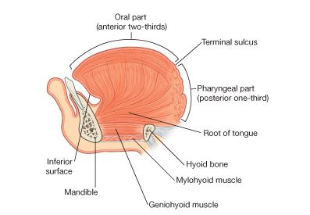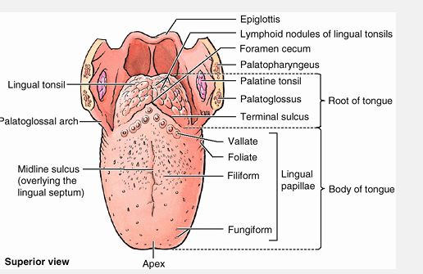Surfaces of the Tongue
There are three surfaces of the tongue: superior, inferior and pharyngeal surfaces.
- Superior surface: The superior surface of the oral part of the tongue is covered by hundreds of papillae, which are:
- filiform papillae are small cone-shaped projections of the mucosa that end in one or more points;
- fungiform papillae are rounder in shape and larger than the filiform papillae, and tend to be concentrated along the margins of the tongue;
- the largest of the papillae are the vallate papillae, which are blunt-ended cylindrical papillae in invaginations in the tongue's surface-there are only about 8 to 12 vallate papillae in a single V-shaped line immediately anterior to the terminal sulcus of tongue;
- foliate papillae are linear folds of mucosa on the sides of the tongue near the terminal sulcus of tongue. The papillae in general increase the area of contact between the surface of the tongue and the contents of the oral cavity. All except the filiform papillae have taste buds on their surfaces.
- Inferior surface of tongue

The undersurface of the oral part of the tongue lacks papillae, but does have a number of linear mucosal folds. A single median fold (the frenulum of tongue) is continuous with the mucosa covering the floor of the oral cavity, and overlies the lower margin of a midline sagittal septum, which internally separates the right and left sides of the tongue. On each side of the frenulum is a lingual vein, and lateral to each vein is a rough fimbriated fold.

- Pharyngeal surface

The mucosa covering the pharyngeal surface of the tongue is irregular in contour because of the many small nodules of lymphoid tissue in the submucosa. These nodules are collectively the lingual tonsil. There are no papillae on the pharyngeal surface.

Muscles of the Tongue
The bulk of the tongue is composed of muscle. The tongue is completely divided into a left and right half by a median sagittal septum composed of connective tissue. This means that all muscles of the tongue are paired. There are intrinsic and extrinsic lingual muscles. Except for the palatoglossus, which is innervated by the vagus nerve [X], all muscles of the tongue are innervated by the hypoglossal nerve [XII]. The muscles can be seen in the table below:

Muscle | Origin | Insertion |  | Innervations |  |  | Function
Intrinsic muscles : contribute to precision movements of the tongue required for speech, eating, and swallowing.
Superior longitudinal (just deep to surface of tongue) | Submucosal connective tissue at the back of the tongue and from the median septum of the tongue | Muscle fibers pass forward and obliquely to submucosal connective tissue and mucosa on margins of tongue |  | Hypoglossal nerve [XII] |  |  | Shortens tongue; curls apex and sides of tongue
Inferior longitudinal (between genioglossus and hyoglossus muscles) | Root of tongue (some fibers from hyoid) | Apex of tongue |  | Hypoglossal nerve [XII] |  |  | Shortens tongue; uncurls apex and turns
Transverse | Median septum of the tongue | Submucosal connective tissue on lateral margins of tongue |  | Hypoglossal nerve [XII] |  |  | Narrows and elongates tongue
Vertical | Submucosal connective tissue on dorsum of tongue | Connective tissue in more ventral regions of tongue |  | Hypoglossal nerve [XII] |  |  | Flattens and widens tongue
Extrinsic muscles: originate from structures outside the tongue and insert into the tongue, These muscles protrude, retract, depress, and elevate the tongue.
Genioglossus (thick fan-shaped, occuring on either side of the midline septum that separates left and right halves of the tongue.) | Superior mental tubercles | Body of hyoid; entire length of tongue |  | Hypoglossal nerve [XII] |  | Protrudes anterior part of the tongue out of the oral fissure (i.e. 'stick the tongue out').; depresses center of tongue
Hyoglossus (thin quadrangular muscles lateral to the genioglossus muscles) | Greater horn and adjacent part of body of hyoid bone | Lateral surface of tongue |  | Hypoglossal nerve [XII] |  | Depresses tongue
Styloglossus | Styloid process (anterolateral surface) | Lateral surface of tongue |  | Hypoglossal nerve [XII] |  | Elevates and retracts tongue
Palatoglossus (muscles of the soft palate and the tongue) | Inferior surface of palatine aponeurosis and passes anteroinferiorly to the lateral side of the tongue | Lateral surface of tongue | Vagus nerve [X] (via pharyngeal branch to pharyngeal plexus) |  | Depresses palate; moves palatoglossal fold toward midline; elevates back of the tongue (These movements facilitate closing of the oropharyngeal isthmus and as a result separate the oral cavity from the oropharynx)

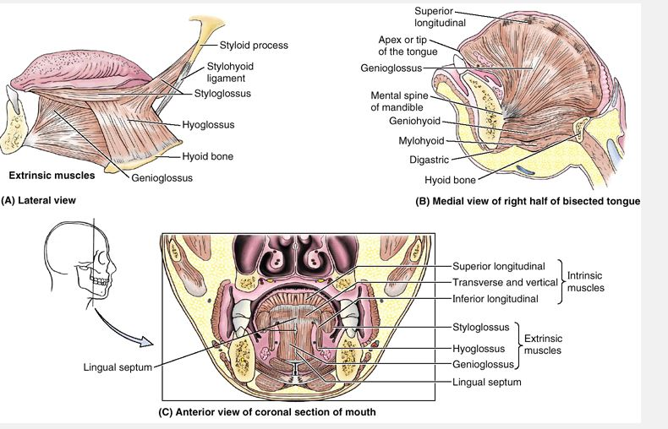
N/B:
- Asking a patient to 'stick your tongue out' can be used as a test for the hypoglossal nerves [XII]. If the nerves are functioning normally, the tongue should protrude evenly in the midline. If the nerve on one side is not fully functional, the tip of the tongue will point to that side.
- The hyoglossus muscle is an important landmark in the floor of the oral cavity: the lingual artery from the external carotid artery in the neck enters the tongue deep to the hyoglossus, between the hyoglossus and genioglossus; the hypoglossal nerve [XII] and lingual nerve (branch of the mandibular nerve [V₃]), from the neck and infratemporal fossa of the head, respectively, enter the tongue on the external surface of the hyoglossus.

Blood Supply to the Tongue
Arterial supply: The major artery of the tongue is the lingual artery. In addition to the tongue, the lingual artery supplies the sublingual gland, gingiva, and oral mucosa in the floor of the oral cavity.
Veinous Drainage: The tongue is drained by dorsal lingual and deep lingual veins.
Innervations : Innervation of the tongue is complex and involves a number of nerves; Glossopharyngeal nerve [IX],
Lingual nerve,
Facial nerve [VII],
Hypoglossal nerve [XII],
Lymphatic drainage: All lymphatic vessels from the tongue ultimately drain into the deep cervical chain of nodes along the internal jugular vein. 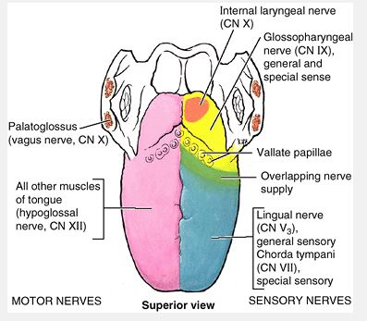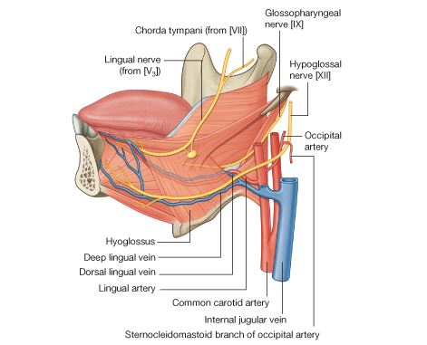

Clinical anatomy

- Gag Reflex
It is possible to touch the anterior part of the tongue without feeling discomfort; however, when the posterior part is touched, the individual gags. CN IX and CN X are responsible for the muscular contraction of each side of the pharynx. Glossopharyngeal branches provide the afferent limb of the gag reflex.
- Paralysis of the Genioglossus
When the genioglossus muscle is paralyzed, the tongue has a tendency to fall posteriorly, obstructing the airway and presenting the risk of suffocation. Total relaxation of the genioglossus muscles occurs during general anesthesia; therefore, an airway is inserted in an anesthetized person to prevent the tongue from relapsing.
- Injury to the Hypoglossal Nerve
Trauma, such as a fractured mandible, may injure the hypoglossal nerve (CN XII), resulting in paralysis and eventual atrophy of one side of the tongue. The tongue deviates to the paralyzed side during protrusion because of the action of the unaffected genioglossus muscle on the other side.
- Sublingual Absorption of Drugs
For quick absorption of a drug, for instance, when nitroglycerin is used as a vasodilator in angina pectoris, the pill or spray is put under the tongue where it dissolves and enters the deep lingual veins in <1 min .
- Lingual Carcinoma
- Frenectomy
- Thyroglossal Duct Cyst
- Aberrant Thyroid Gland
- AIR SINUSES
Paranasal Sinuses
The paranasal sinuses are air-filled extensions of the respiratory part of the nasal cavity into the following cranial bones: frontal, ethmoid, sphenoid, and maxilla. They are named according to the bones in which they are located. The sinuses continue to invade the surrounding bone, and marked extensions are common in the crania of older individuals.
- Frontal Sinuses
The frontal sinuses are between the outer and the inner tables of the frontal bone, posterior to the superciliary arches and the root of the nose). Frontal sinuses are usually detectable in children by 7 years of age. Each sinus drains through a frontonasal duct into the ethmoidal infundibulum, which opens into the semilunar hiatus of the middle nasal meatus. The frontal sinuses are innervated by branches of the supraorbital nerves (CN V₁).
- Ethmoidal Cells
The ethmoidal cells (sinuses) are small invaginations of the mucous membrane of the middle and superior nasal meatus into the ethmoid bone between the nasal cavity and the orbit. The ethmoidal cells usually are not visible in plain radiographs before 2 years of age but are recognizable in CT scans. The anterior ethmoidal cells drain directly or indirectly into the middle nasal meatus through the ethmoidal infundibulum. The middle ethmoidal cells open directly into the middle meatus and are sometimes called â€œbullar cellsâ€ because they form the ethmoidal bulla, a swelling on the superior border of the semilunar hiatus .The posterior ethmoidal cells open directly into the superior meatus. The ethmoidal cells are supplied by the anterior and posterior ethmoidal branches of the nasociliary nerves (CN V₁).
- Sphenoidal Sinuses
The sphenoidal sinuses are located in the body of the sphenoid and may extend into the wings of this bone. They are unevenly divided and separated by a bony septum. Because of this extensive pneumatization (formation of air cells or sinuses), the body of the sphenoid is fragile. Only thin plates of bone separate the sinuses from several important structures: the optic nerves and optic chiasm, the pituitary gland, the internal carotid arteries, and the cavernous sinuses. The sphenoidal sinuses are derived from a posterior ethmoidal cell that begins to invade the sphenoid at approximately 2 years of age. In some people, several posterior ethmoidal cells invade the sphenoid, giving rise to multiple sphenoidal sinuses that open separately into the sphenoethmoidal recess. The posterior ethmoidal arteries and posterior ethmoidal nerve supply the sphenoidal sinuses.
- Maxillary Sinuses
The maxillary sinuses are the largest of the paranasal sinuses. They occupy the bodies of the maxillae and communicate with the middle nasal meatus.
- The apex of the maxillary sinus extends toward and often into the zygomatic bone.
- The base of the maxillary sinus forms the inferior part of the lateral wall of the nasal cavity.
- The roof of the maxillary sinus is formed by the floor of the orbit.
- The floor of the maxillary sinus is formed by the alveolar part of the maxilla. The roots of the maxillary teeth, particularly the first two molars, often produce conical elevations in the floor of the sinus.
Each maxillary sinus drains by one or more openings, the maxillary ostium (ostia), into the middle nasal meatus of the nasal cavity by way of the semilunar hiatus.
The arterial supply of the maxillary sinus is mainly from superior alveolar branches of the maxillary artery; however, branches of the descending and greater palatine arteries supply the floor of the sinus. Innervation of the maxillary sinus is from the anterior, middle, and posterior superior alveolar nerves, which are branches of the maxillary nerve.
Transillumination of the Sinuses
Transillumination of the maxillary sinuses is performed in a darkened room. A bright light is placed in the patient's mouth on one side of the hard palate. The light passes through the maxillary sinus and appears as a crescent-shaped, dull glow inferior to the orbit. If a sinus contains excess fluid, a mass, or a thickened mucosa, the glow is decreased. The frontal sinuses can also be transilluminated by directing the light superiorly under the medial aspect of the eyebrow, normally producing a glow superior to the orbit. Because of the great variation in the development of the sinuses, the pattern and extent of sinus illumination differs from person to person (Swartz, 2002). The ethmoidal and sphenoidal sinuses cannot be examined by transillumination.

