NAME: Oshenye Michael Oghenegare

DEPARTMENT: Electrical and Electronics Engineering

MATRIC NO: 19/ENG04/065

COURSE TITLE: Structured Programming

COURSE CODE: ENG 224

C PROGRAMMING ASSIGNMENT

1. Write a C program to convert 1343 days into years, weeks and days (Note: Ignore leap year).

Program Code:

- #include<stdio.h>

- void main()

- {

- int nodays,years, weeks,days;

- printf("Enter the total days\n");

- scanf("%d",&nodays);

- years=nodays/365;

- weeks=(nodays%365)/7;

- days=(nodays%365)%7;

- printf("%d = %d years,%d weeks,%d days\n",nodays,years,weeks,days);

- }

Output:
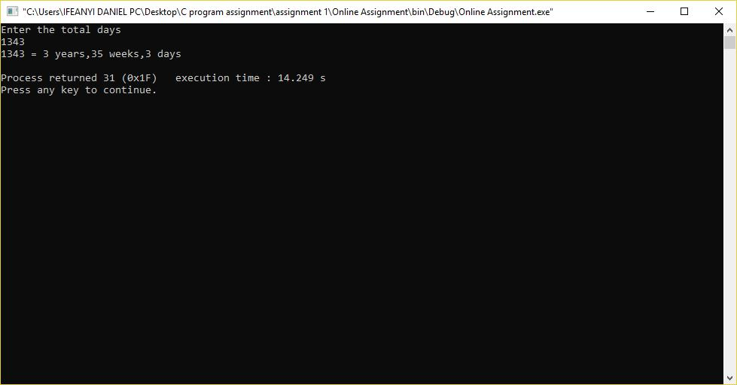

- Write a C program to calculate the distance between the two points. Note: x1, y1, x2, y2 are all double values.
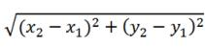

Program Code:

- #include <stdio.h>

- #include <math.h>

- int main() {

- float x1, y1, x2, y2, gdistance;

- printf("Input x1: ");

- scanf("%f", &x1);

- printf("Input y1: ");

- scanf("%f", &y1);

- printf("Input x2: ");

- scanf("%f", &x2);

- printf("Input y2: ");

- scanf("%f", &y2);

- gdistance = ((x2-x1)*(x2-x1))+((y2-y1)*(y2-y1));

- printf("Distance between the said points: %.4f", sqrt(gdistance));

- printf("\n");

- return 0;

- }

Output:
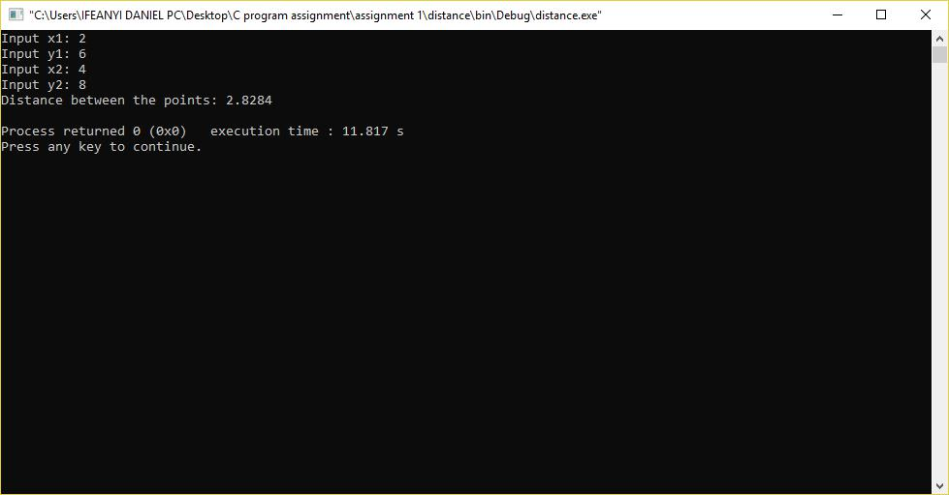

- Write a C program that reads three floating values and check if it is possible to make a triangle with them. Also, calculate the perimeter of the triangle if the said values are valid.

.

Program Code:

5

3 | .

- #include <stdio.h>

- int main() {

- float x, y, z, P, A;

- printf("\nInput the first number: ");

- scanf("%f", &x);

- printf("\nInput the second number: ");

- scanf("%f", &y);

- printf("\nInput the third number: ");

- scanf("%f", &z);

- if(x < (y+z) && y < (x+z) && z < (y+x))

- {

- P = x+y+z;

- printf("\nPerimeter = %.1f\n", P);

- }

- else

- {

- printf("Not possible to create a triangle..!");

- }

- }

Output:

- Write a C program to read age of 20 people and count total baby age, school age and adult age. Hint:

  - Still a baby- age 0 to 4

  - Attending school - age 5 to 17

  - Adult life-age 18 & over

[Using while loop]

Program Code:

- #include <stdio.h>

- int main()

- {

- int age;

- int cnt_baby=0,cnt_school=0,cnt_adult=0;

- int count=0;

- while(count<15)

- {

- printf("Enter age of person [%d]: ",count+1);

- scanf("%d",&age);

- if(age>=0 && age<=5)

- cnt_baby++;

- else if(age>=6 && age<=17)

- cnt_school++;

- else

- cnt_adult++;

- //increase counter

- count++;

- }

- printf("Baby age: %d\n",cnt_baby);

- printf("School age: %d\n",cnt_school);

- printf("Adult age: %d\n",cnt_adult);

- return 0;

- }

Output:

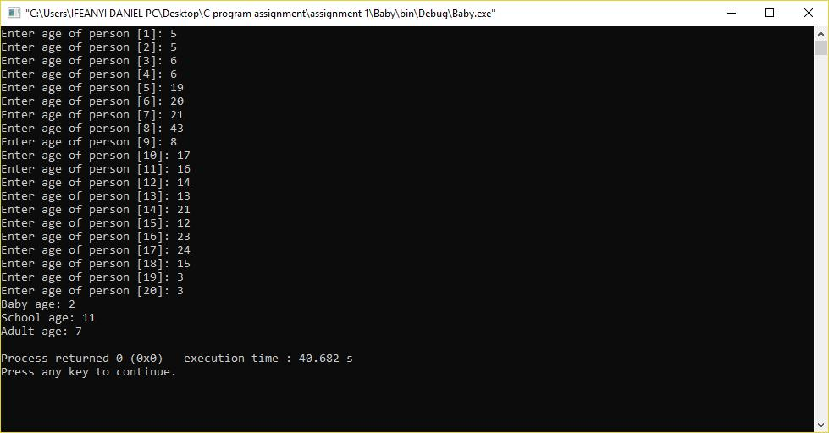

- Write a C-program to read a random number and then ask user to guess it (from 0 to 100). Hint:

User guess correct number, which is to be generated randomly. The program will give 7 attempts to the user. On each attempt, program will inform the user that entered number is less than or greater than the random generated number.

Program Code:

- #include <stdio.h>

- #include <stdlib.h>

- #include <time.h>

- int main()

- {

- int random_genNo=0,count=0,num;

- int stime;

- long ltime;

- //initialise srand with current time, to get random number on every run

- ltime = time(NULL);

- stime = (unsigned) ltime/2;

- srand(stime);

- //generate random number

- random_genNo=rand()%100;

- //run infinite loop

- while(1)

- {

- //increase counter

- count+=1;

- //read number from user

- printf("\n\nGuess a number from (0 to 100): ");

- scanf("%d",&num);

- //compare entered number with generated number

- if(random_genNo==num){

- printf("You have guessed a correct number.");

- break;

- }

- else if(random_genNo<num){

- printf("Generated number is less than entered number, try again...");

- }

- else if(random_genNo>num){

- printf("Generated number is greater than entered number, try again...");

- }

- if(count==7){

- printf("\n\n### Maximum limit of attempt reached\n");

- break;

- }

- }

- return 0;

- }

Output:

