- With the aid of a well labelled architectural diagram, provide detailed explain on the
working principle of 3G, 4G and 5G networks?
3G architecture
3G also called UMTS (Global Mobile Telecommunications System) UMTS, short for Global Mobile Telecommunications System, is a 3 G networking interface used as an enhancement of existing GSM platform in most of the world. UMTS uses WCDMA, a platform that shares a lot with the widely used CDMA networks, but it is not consistent with them. UMTS base level networks are typically capable of downlink speeds of as high as 384 kbps. The UMTS architecture takes advantage of existing GSM and GPRS networks that act as the central UMTS infrastructure network.
UMTS consists of three main components:
- User Equipment: it is assigned to a single user and contains all the functions needed to access UMTS services. It contains: – Mobile Equipment (ME): it is a wireless terminal used to link the UMTS subscriber via Uu network interface to the fixed part of the UMTS system UMTS Subscriber Identity Module (USIM): a smartcard with a subscriber ID authentication protocols, encryption keys, etc.
- UMTS Terrestrial Radio Access Network (UTRAN): it addresses mobility at the cellular level. It is a mobility related feature of base station and controller handling system. Which includes
- Radio Network Controllers (RNC)
- Nodes B (Base Stations)
- Core Network: GSM and GPRS share the core network. Core Network (CN) The CN includes intersystem transfer functions, gateways to other networks, and location management functions.
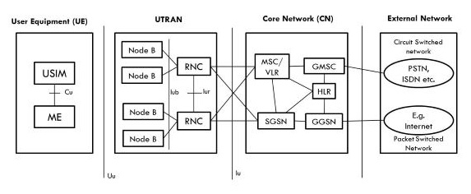

4G architecture
The following figure shows the architecture of Generic Mobile Communication. 4 G network is the convergence of the Ad Hoc, Mobile, Hotpot and satellite radio elements in all heterogeneous wireless networks. Smart input and multiple output (MIMO), IPv6, VoIP, OFDM and software defined radio (SDR) systems are the technologies used in 4G.
Smart antennas:
- Intelligent antennas are antennas transmitted and received.
- No increase in power and additional frequency is required.
Technology for IPV6:
- To accommodate a wide range of wireless enabling apps, 4 G is using IPV6 technology.
- This allows a variety of applications with improved multicast capabilities, protection and route optimization.
And so, on(Ikkelä et al., 2005)
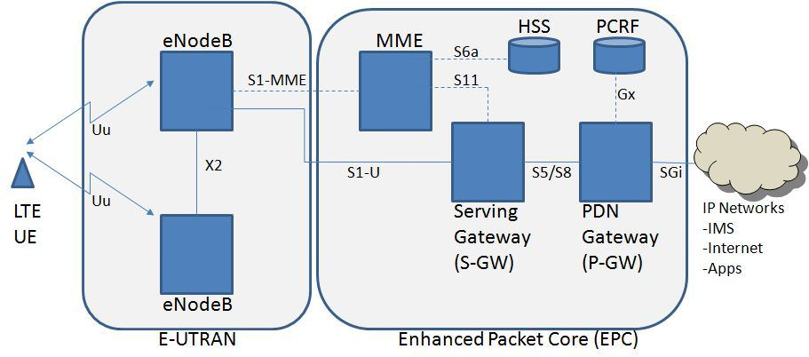
5G architecture
The service-driven 5G network architecture aims to flexibly and efficiently meet diversified mobile service requirements. With software-defined networking (SDN) and Network Functions Virtualization (NFV) supporting the underlying physical infrastructure, 5G comprehensively cloudifies access, transport, and core networks. Cloud adoption allows for better support for diversified 5G services, and enables the key technologies of E2E network slicing, on-demand deployment of service anchors, and component-based network functions.
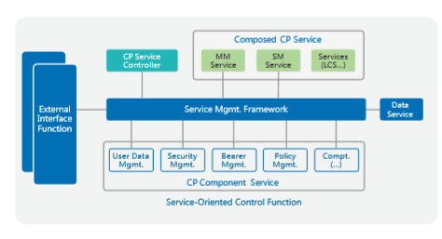
(Sutton, 2018)

Advantages of 3G
- Rates for faster results.
- Help multimedia applications, such as photography and video.
- Services such as mobile tv, GPS, video call and video conferencing added value.
- Fast high-speed internet connection.
- Increased Capacity
Disadvantages of 3G
- Includes Handsets compliant with 3G.
- Charges on upgrading to a 3G system are high.
- High power consumption.
- Closer base stations need 3 G which are costly.
Advantages of 4G
- Quickly download files over a wireless network
- Extremely high voice quality
- Easily access Internet, IM, social networks, streaming media, video calling
- Higher bandwidth
- 4G is 10 times faster than 3G

Disadvantages of 4G
- New frequencies mean new components in cell towers.
- Higher data prices for consumers
- Consumer is forced to buy a new device to support the 4G
- It is impossible to make your current equipment compatible with the 4G network
Advantages of 5G
- Technology to gather all networks on one platform.
- Technology to facilitate subscriber supervision tools for the quick action.
- High resolution and bi-directional large bandwidth shaping.
Disadvantages of 5G
- The risk of overcrowding the frequency range of the 5G wireless spectrum is greater as more devices are connected to one channel.
- 5G is more costly compared to other Mobile Network Technology because many technical/ official engineers are required to install and maintain it.
- High cost of infrastructure.

- DIFFERENCES BETWEEN 3G 4G AND 5G
S/N | 2G | 3G | 4G | 5G
1 | The max speed of 2G with General Packet Radio Service (GPRS) is 50 Kbps or 1 Mbps with Enhanced Data Rates for GSM Evolution (EDGE). | With 3G, smartphones generally see download speeds of up to around 2Mbps (megabits per second). | 4G download speeds is around 3 to 5Mbps | 5G peak download speed is up to 20,480 Mbps, a huge leap from any generation previously
2 | Its service is digital voice higher capacity, packetized data | Its service is integrated high quality audio, video and data | Its service is dynamic information access, wear-able devices, HD streaming, global roaming. | Its service is dynamic information access, wear-able devices, HD streaming: any demand of users; upcoming all technologies; global roaming smoothly,
3 | 2G works at a frequency of 1.8GHz | 3G works at frequency up to 1.6-2GHz | 4G works at frequency up to 2 – 8GHz | 5G works at frequency up to 3-30GHz
4 | 2G bandwidth is 14.4-64kbps | 3G bandwidth is 2Mbps | 4G bandwidth is 2000Mbps to 1Gbps | 5G bandwidth is 1Gbps and higher
5 | Its network technology name is GSM | Its network technology name is WCDMA | Its network technology name is LTE, WiMAX | Network technology name is MIMOO, mm Waves
(Swisscom, 2015)
- Recently in Nigerian there has been a widespread of opinion that the advent of 5G
evolution will aid the spread of the corona virus which has become a pandemic all over the
world
- Is there any correlation between 5G and Corona virus? NO
- Do you support the state, if yes or No, in not more than 500 words Justify your answer to?
    - and (ii)
There is no correlation between 5G and corona virus, Corona virus is a virus and 5G is a computer network, the two of them have nothing to do with each other and no overlap.
Your immune system can be dipped by all sorts of thing by being tired one day, or not having a good diet. Those fluctuations aren't huge but can make you more susceptible to catching viruses. While very strong radio waves can cause heating, 5G is nowhere near strong enough to heat people up enough to have any meaningful effect.

Radio waves can disrupt your physiology as they heat you up, meaning your immune system can't function. But the energy levels from 5G radio waves are tiny and they are nowhere near strong enough to affect the immune system. There have been lots of studies on this. The radio waves involved in 5G and other mobile phone technology sit on the low frequency end of the electromagnetic spectrum. Less powerful than visible light, they are not strong enough to damage cells, unlike radiation at the higher frequency end of the spectrum which includes the sun's rays and medical x-rays. It would also be impossible for 5G to transmit the virus.
Coronavirus started in Wuhan (china) where the first 5G networks were established, that’s incorrect, south Korea and part of the US had access to 5G in early 2019, that’s about 8 months long enough before the first case of corona virus in Wuhan(china).
There are plenty of nations e.g. Nigeria without 5G but has corona virus cases and it’s still spreading. There is no scientific evidence that 5G wavelength can harm the body or immune system not to talk of give virus. The world health organization, an arm of the united nations has found no evidence that 5G adversely affects health.
It is unfortunate that this conspiracy theories keeps spreading on the internet from people who do not know the knowledge about the 5G network and the causes of corona virus.

REFERENCES
Ikkelä, K., Myllynen, M., Heinanen, J., & Martikainen, O. (2005). 4G Mobile Network Architecture. Emerging Personal Wireless Communications, 183–195. https://doi.org/10.1007/0-306-47001-2_12
Sutton, A. (2018). 5G network architecture. Journal of the Institute of Telecommunications Professionals, 12, 8–15. https://doi.org/10.1016/b978-0-08-102267-2.00001-4
Swisscom. (2015). 2G 3G 4G 5G (p. 2020). http://www.elektronik-kompendium.de/sites/kom/0406221.htm
Online videos on YouTube
https://www.viavisolutions.com/en-us/5g-architecture

