NAME: SIMON OKUBOYE
COURSE: SOC 102.
MARIC NO: 19/SMS11/006
DEPARTMENT : INTELLIGENCE & SECURITY STUDIES.
COLLEGE: SOCIAL & MANAGEMENT SCIENCES.

1. Family can be defined as a group of individuals or people who are affiliated by a relationship, that influences each other. It is made upof partners, children, parents, aunts, uncles, cousins, grandparents etc. A family has values which are expected to be passed unto members, it should be kind, caring and also loving.
2. functions of family are:
A family should maintain moral and motivate its members to participate in society commitment e.g based on spiritual sense of duty or economic necessity. A family should be responsible for any addition of new members through reproduction.
A family should provide physical care for its members, including adults, children and the dependent relatives.
A family should teach its children skills, knowledge, values, attitudes and good morals in the society.
A family should control its member’s behavior to maintain and ensure orderliness.
3. African traditional family:
African traditional family practiced polygamy because of the idea that the larger the family or clan, the more workers there are to work on the family farms, so that more wealth could be possessed. African family maintains strong bond through traditional practices such as upbringing of children and maintaining strong family values. Its practice now depends on religion of the person e.g the muslims can take up to 3 to 4 wives while christains (most) practice monogamy.
4. My nuclear family:
My nucleear family basically consists of my parents, my two siblings and i. we all have strong bonds, mutual feelings towards each other, we are united by ties, simple, loving, caring and kind.
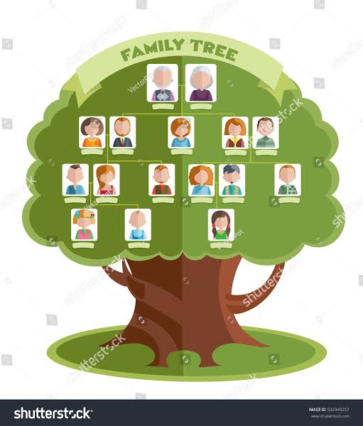
5. Family tree: A family tree, or pedigree chart, is a chart representing family relationships in a conventional tree structure.

