NAME: OMOYIBO EMUEJEVOKE PRECIOUS
MAT NO: 15/ENG04/045
DEPT: ELECT/ELECT ENG
COURSE: DIGITAL COMMUNICATION EEE512
ASSIGNMENT ANSWERS
1i THIRD GENERATION (3G)
The 3G standard utilizes Universal Mobile Telecommunications System (UMTS) as its core network architecture. 3G network combines aspects of the 2G network with new technologies and protocols to deliver a significantly faster data rate. By using packet switching, the original technology was improved to allow speeds up to 14 Mbps. It used Wide Band Wireless Network that increased clarity. It operates at a range of 2100MHz and has a bandwidth of 15-20MHz.
Some of the main features of 3G are:
- Speed of up to 2 Mbps
- Increased bandwidth and data transfer rates
- Send/receive large email messages
- Large capacities and broadband capabilities
International Mobile Telecommunications-2000 (IMT-2000) were the specifications by the International Telecommunication Union for the 3G network. Theoretically, 21.6 Mbps in the max speed of HSPA+.
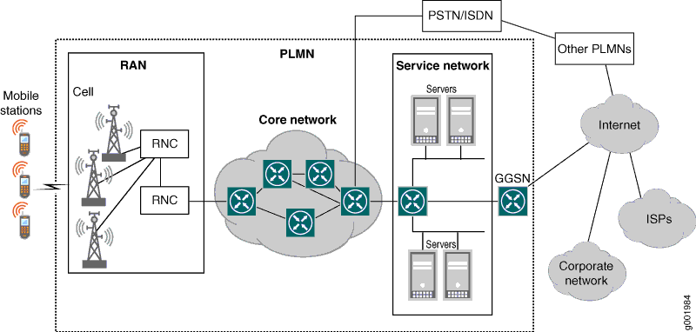
FOURTH GENERATION (4G)
The main difference between 3G and 4G is the data rate. There is also a huge difference between 3G and 4G technology. The key technologies that have made 4G possible are MIMO (Multiple Input Multiple Output) and OFDM (Orthogonal Frequency Division Multiplexing). The most important 4G standards are WiMAX and LTE. While 4G LTE is a major improvement over 3G speeds, it is technically not 4G. What is the difference between 4G and LTE? Even after it was widely available, many networks were not up to the required speed of 4G. 4G LTE is a “fourth generation long term evolution”, capable of delivering a very fast and secure internet connection. Basically, 4G is the predetermined standard for mobile network connections. 4G LTE is the term given to the path which has to be followed to achieve those predefined standards.

Some of the features of 4G LTE are:
- Support interactive multimedia, voice, video
- High speed, high capacity and low cost per bit (Speeds of up to 20 Mbps or more)
- Global and scalable mobile networks.
- Ad hoc and multi-hop networks.

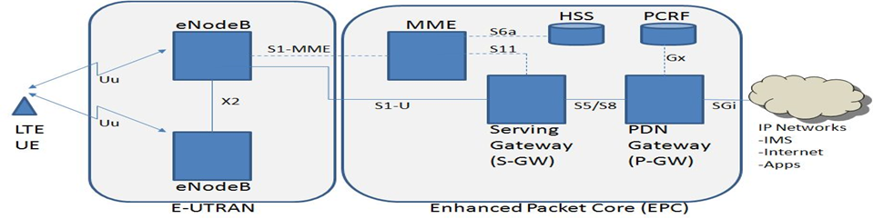
FIFTH GENERATION (4G)
5G uses the rarely used radio millimeter bands in the 30 GHz to 300 GHz range. Testing of 5G range in mmWave has produced results approximately 500 meters from the tower. Using small cells, carriers using millimetre wave for the deployment of 5G can improve overall coverage area. Combined with Beamforming, small cells can deliver extremely fast coverage with low latency. Low latency is one of 5G’s most important features. 5G uses a scalable orthogonal frequency-division multiplexing (OFDM) framework. 5G benefits greatly from this and can have latency as low as one millisecond with realistic estimates to be around 1 – 10 seconds. 5G is estimated to be 60 to 120 times faster than the average 4G latency.
With speeds of up to 10 Gbps, 5G is set to be as much as 10 times faster than 4G. Following is a brief comparison of 2G, 3G, 4G, and 5G.
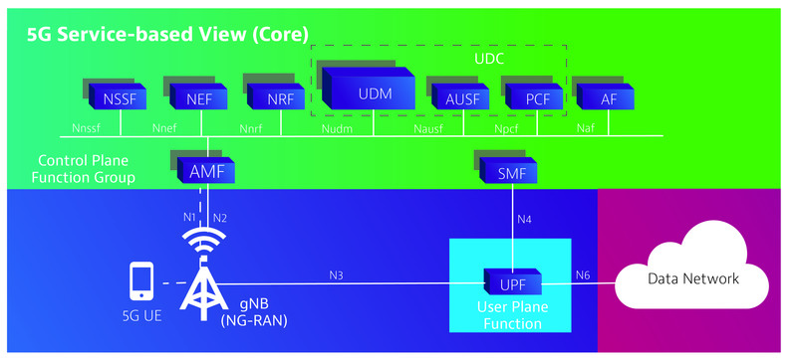
1ii. Advantages of 3G
- Faster data rates.
- Support multimedia applications such as video and photography.
- Value added services like mobile television, GPS, video call and video conference.
- High speed mobile internet access.
- Increased capacity.
Disadvantages of 3G:
- Requires 3G compatible handsets.
- The cost of upgrading to 3G device is expensive.
- Power consumption is high.
- 3G requires closer base stations which is expensive.
Advantages of 4G:
- Quickly download files over a wireless network
- Extremely high voice quality
- Easily access Internet, IM, social networks, streaming media, video calling
- Higher bandwidth
- 4G is 10 times faster than 3G
Disadvantages of 4G:
- New frequencies means new components in cell towers.
- Higher data prices for consumers
- Consumer is forced to buy a new device to support the 4G
- It is impossible to make your current equipment compatible with the 4G network.
Advantages of 5G
- High resolution and bi-directional large bandwidth shaping.
- Technology to gather all networks on one platform.
- More effective and efficient.
- Technology to facilitate subscriber supervision tools for the quick action.
Disadvantages of 5G
- 5G is cost more compared to other Mobile Network Technology because many technical/ official engineers are required to install and maintain it.
- The risk of overcrowding the frequency range of the 5G wireless spectrum is greater as more devices are connected to one channel.
- 5G network Technology will take more time for security and privacy issues.
- Coverage indoor distance up to 2 meters and 300 meters outdoors can be achieved due to greater losses at higher frequencies as 5Gmm wave influences from such losses (rain losses, attenuation due to rain, etc.).
- 5G infrastructure is very high.

2. 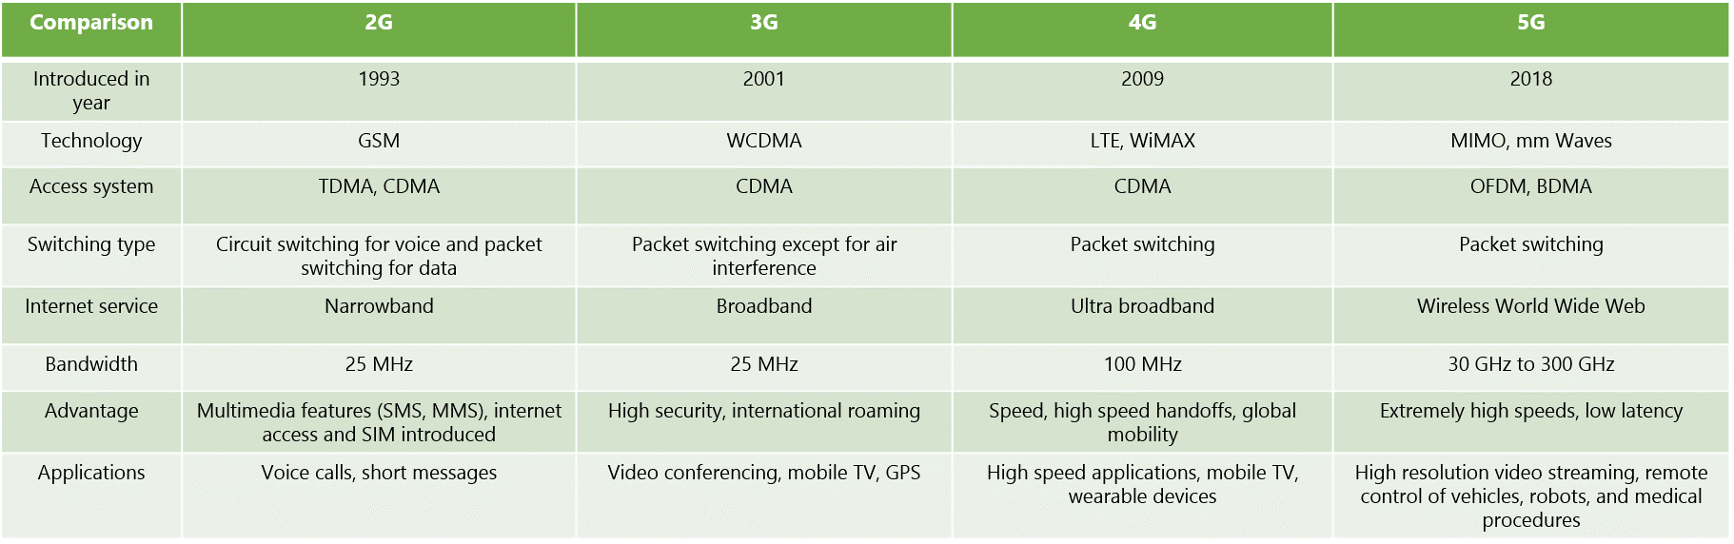
3i. NO there is no correlation between 5G and corona virus.
3ii. NO I do not support the state
There is no scientific/Logical evidence that 5G would any way cause the spread of CORONA virus around the globe. The coronavirus outbreak started in December 2019 in Wuhan, China. The Center for Disease Control says on its website the virus had links to a "seafood and live animal market" where a human might have contracted the virus from an animal. The virus then spread person-to-person. The symptoms of COVID-19 include fever, tiredness, cough, and shortness of breath that can appear two to 14 days after being exposed to the virus. The coronavirus is spread person-to-person.
Mobile phones use radio waves. They send and receive radiofrequency electromagnetic fields (RF EMFs). 5G uses "beam-forming technology", which allows radiofrequency electromagnetic fields to go directly where needed. The commission says the main effect that radiofrequency electromagnetic fields have on the human body is increased temperature of exposed tissue. The body can handle small increases to body temperature, such as through exercising, but radiofrequency exposure and increased temperature can be dangerous above a certain threshold. The only two recognized health effects are nerve stimulation in up to 10 MHz and heating from 100 kHz.
Coronavirus symptoms can be found in detail on official government and international health organization sites. They bear no similarity to possible health effects stemming from mobile phone or 5G use.

