OLUWAFUNKE AKINBUWA
17/MHS01/042
MBBS/MHS
GROSS ANATOMY OF HEAD AND NECK

GROSS ANATOMY OF THE TONGUE
The tongue is a unique organ located in the oral cavity that not only facilitates perception of gustatory stimuli but also plays important roles in mastication and deglutition. Additionally, the tongue is an integral component of the speech pathway, as it helps with articulation.
Key facts about the tongue
Embryology | Starting with day 23
Parts | Tip (apex), body, base
Surfaces | Dorsal (superior) and ventral (inferior)
Relations | Anterior and lateral - teeth  Superior - hard and soft palates  Inferior - mucosa of the floor of the oral cavity, sublingual salivary glands, posterior wall of oropharynx  Posterior - epiglottis, pharyngeal inlet  Lateral - palatoglossal and palatopharyngeal arches
Muscles | Intrinsic - superior longitudinal, vertical, transverse, inferior longitudinal muscles  Extrinsic - genioglossus, hypoglossus, styloglossus, palatoglossus muscles
Blood Supply | Lingual artery (dorsal lingual, sublingual, deep lingual arteries), ascending palatine, tonsillar, ascending pharyngeal arteries
Lymphatics | Marginal, central, dorsal, submandibular, jugulo-omohyoid, deep cervical lymph nodes
Innervation | Hypoglossal nerve, pharyngeal plexus, lingual nerve, glossopharyngeal nerve, facial nerve, vagus nerve, chorda tympani
Mucosa | Stratified squamous keratinized (dorsal surface) and non-keratinized (ventral surface) epithelia
Lingual Papillae | Filiform, fungiform, foliate, circumvallate
Taste Buds | Stratified squamous epithelium  Structure - gustatory cells, supportive cells, basal stem cells, taste pore

Part of the tongue
The tongue is embryologically divided into an anterior and a posterior part. The anterior part of the tongue is also called the oral or presulcal part of the tongue. Conversely, the posterior part of the tongue is referred to as the pharyngeal or postsulcal part of the tongue. It is important to note that the root and base of the tongue mean different things. The base of the tongue refers to the postsulcal part that forms the ventral wall of the oropharynx, while the root of the tongue refers to a part of the presulcal tongue that is attached to the floor of the oral cavity.
The tongue is subdivided into
1. Apex/tip: is the anterior end of the body which rest against the incisor teeth. It is mobile.
2. Body: is the anterior 2/3 of the tongue. It is related to the floor of the oral cavity.
3. Root: part that rests on the floor of the mouth. It is attached to the mandible and hyoid bone.
Function
1. It is used in detecting taste in food and other substances.
2. It is an important accessory organ in the digestive system as it is involved in mastication.
3. Its intrinsic muscles are involved in speech.
4. It plays a role in physical intimacy and sexuality

Embryology
Development of the tongue begins toward the end of the fourth gestational week. The anterior two-thirds of the organ are known as the presulcal (oral) part, and the posterior third is the postsulcal (pharyngeal) part. The presulcal tongue originates from the first pharyngeal arch, while the postsulcal part arises from the third and fourth pharyngeal arches. Neither the tuberculum impar (from 1st pharyngeal arch) nor the copula (2nd pharyngeal arch) contributes to structures of the adult tongue. The presulcal tongue has lingual papillae and taste buds, while the postsulcal part has lingual tonsils and taste buds. Innervation of the tongue is dependent on the pharyngeal arch that the area was derived from.
Taste buds and papillae
The coarse texture of the dorsal surface of the tongue can be attributed to the numerous lingual papillae that are found on its surface. As the 8th gestational week draws to a close, foliate and vallate papillae are the first of the four papillae to develop. These are followed by the appearance of fungiform papillae. By the 10th – 11th week of gestation, the thread-like filiform papillae can be observed on the dorsal surface of the tongue. Each type of papillae has a particular role in tongue physiology, and as such, has a unique innervation based on the nerve endings they developed closest to.
The development of taste buds begins as the last of the papillae are formed in the 11th week of gestation and is concluded around the 13th gestational week.
The papillae are of four types:
1. Filiform papillae: small cone-shaped with one or multi ends. They are present over the anterior 2/3 of the tongue. It acts as an abrasive coating for cleaning and grasping action. It does not contain taste buds.
2. Fungiform papillae: these are round shaped and larger than filiform papillae. They are present on the tip and margins of the tongue. It has taste buds embedded in its surfaces. They respond to both sweet and sour tastes.
3. Foliate papillae: red leaf-like mucosal ridges. They are present at the sides near the sulcus terminalis. It has numerous taste buds.
4. Circumvallate papillae: these are large cylindrical structures. They are 8-12 in number and form a 'V' shaped row in front of sulcus terminalis.
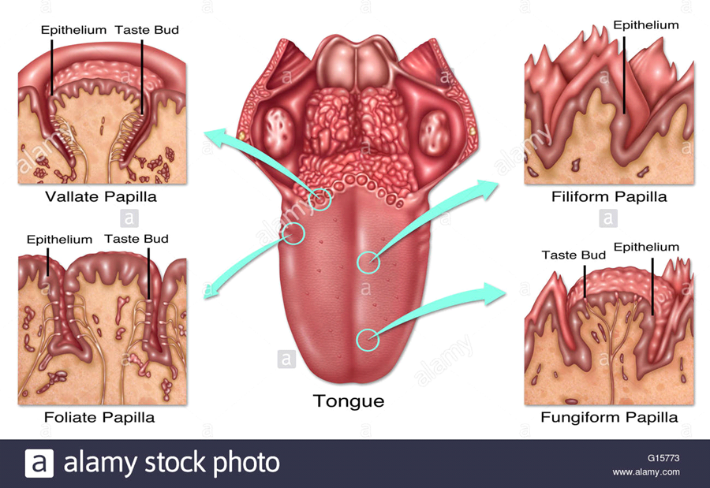
Taste Sensations;
• Sweet: detected at the apex
• Saltiness: detected at the anterolateral margins
• Sourness: detected at the posterolateral margins
• Bitterness: detected at the posterior part of the tongue

Muscles of the tongue
The tongue is a mass of muscles that is covered by a mucous membrane. All tongue muscles are paired. It comprises of the extrinsic muscles that alter the position of the tongue and intrinsic muscles that alter the shape.
Extrinsic muscles.
1. Genioglossus: this is the safety muscle of the tongue.
Origin: superior genial tubercle (mandible) above the origin of geniohyoid.
Insertion: fan shaped radiated fibres insert into mucous membrane of the tongue. Lowest fibres passing down to the hyoid body.
Action: Protrusion, central part depression, diversion to the opposite side
2. Hyoglossus:
Origin: Greater cornu and body of hyoid bone.
Insertion: side of the tongue between styloglossus and inferior longitudinal.
Actions: depresses the tongue.
3. Chondroglossus: part of hypoglossus separated from it by the genioglossus.
Origin: medial side and base of lesser cornua of hyoid.
Insertion: intrinsic musculature between hypoglossus and genioglossus.
4. Styloglossus:
Origin: styloid process near its apex.
Insertion: longitudinal part into the inferior longitudinal muscles. Oblique part into hypoglossus.
Action: draws the tongue upwards and backward.
5. Palatoglossus: a part of soft palate than the tongue.
Origin: palatine aponeurosis of soft palate.
Insertion: side of the tongue.
Action: elevates the posterior part of the tongue, approximates the palatoglossal folds to constrict the ororpharyngeal isthmus.
Intrinsic muscles:
Originates and insert within the substance of the tongue.
1. Superior longitudinal muscle:
Origin: sub mucous fibrous layer below the dorsum of the tongue and lingual septum.
Insertion: extends to the lingual margin.
Action: turns the apex and sides of the tongue upwards to make the dorsum concave.
2. Inferior longitudinal muscle: narrow band close to the inferior surface of the tongue.
Origin: root of the tongue and body of the hyoid bone.
Insertion: apex of the tongue.
Action: curls the tip inferiorly and shortens the tongue.
3. Transverse muscles:
Origin: median fibrous septum.
Insertion: fibrous tissue at the margins of the tongue.
Action: narrows and elongates the tongue.
4. Vertical muscles:
Origin: dorsum surface of the borders of the tongue.
Insertion: ventral surface of the borders of the tongue.
Action: flattens and broadens the tongue.

Arterial supply of the tongue.
The arteries of the tongue are derived from the lingual artery which arises from the external carotid artery. The lingual artery gives rise to the:
• Dorsal lingual arteries supply the posterior part. They do not communicate due to the lingual septum.
• Deep lingual arteries supply the anterior part. These arteries communicate with each other near the apex of the tongue.
• Sublingual artery: supplies the sublingual gland and floor of the mouth.
Venous drainage.
• Dorsal lingual vein: drains the dorsum and sides of the tongue.
• Deep lingual veins: drains the tip of the tongue and sublingual veins.
These veins terminate directly and indirectly into the internal jugular veins.
Lymphatic drainage.
It takes 4 routes:
• Lymph from the posterior 3rd drains into the superior deep cervical lymph nodes.
• Lymph from the medial part of the anterior 2/3 drains directly to the inferior deep cervical lymph nodes.
• Lymph from the lateral parts of the anterior 2/3 drains to the submandibular lymph nodes.
• The apex and frenulum drain to the submental lymph nodes.
• The posterior 3rd and medial part of the anterior 2/3 drain bilaterally
Innervation
1. Motor innervation: all muscles of the tongue (extrinsic and intrinsic) are supplied by the hypoglossal nerve CNXII except the palatoglossus which is supplied by the vagus nerve CNX.
2. Sensory innervation:
The anterior 2/3 of the tongue is supplied by: lingual nerve CNV3 for general sensation and chorda tympani (branch of facial nerve CNVII) for taste.
The posterior 3rd of the tongue and the vallate papillae are supplied by lingual branch of the glossopharyngeal nerve CNIX for sensation and taste. Contribution comes from the internal laryngeal branch of the vagus nerve CNX for general sensation and taste nerve supply

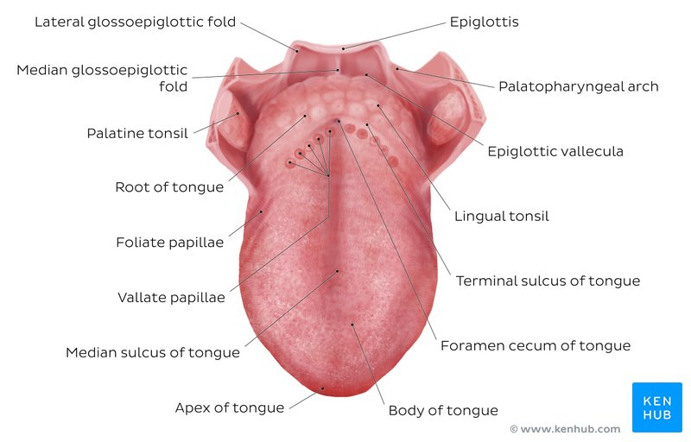
CLINICAL ANATOMY
- A bit tongue tied?
The tongue is attached anteroinferiorly by a piece of connective tissue called the frenulum, which lies in the midline. The process by which the frenulum is formed is the same by which your fingers are made, and is known as sculpting apoptosis. Just as some people may have webbed fingers if this process fails, it can result in excess frenulum. This is called being ‘tongue-tied’, and presents in children. There are varying degrees of severity of tongue-tie and in some cases it can restrict the movement of the tongue causing difficulties with breast feeding. This can be managed with simple surgery.
2. Aglossia: congenital defect resulting in partial development or complete absence of a tongue. It is commonly associated with craniofacial and limb defects.
3. Hemiglossia: failure of formation of one side lingual swelling.
4. Bifid tongue: aka cleft tongue is a tongue with groove or split running along the tip of the tongue. It is as a result of incomplete fusion of the distal tongue buds.2.

PARANASAL SINUSES
The paranasal sinuses are air-filled extensions of the respiratory part of the nasal cavity. There are four paired sinuses, named according to the bone in which they are located; maxillary, frontal, sphenoid and ethmoid.
Functions of Paranasal Sinus.
1. Lightening the weight of the head.
2. Humidifying and heating inhaled air.
3. Increases the resonance of speech.
4. Serves as a crumple zone to protect vital structures
Sinuses are formed in childhood by the nasal cavity eroding into surrounding bone. As they are outgrowths of the nasal cavity, they all drain back into it – openings to the paranasal sinuses are found on the roof and lateral walls of the nasal cavity. The inner surface is lined by a respiratory mucosa.
Frontal Sinuses: These are the most superior in location, found under the forehead. The frontal sinuses are variable in size, but always triangular-shaped. They drain into the nasal cavity via the frontonasal duct, which opens out at the hiatus semilunaris on the lateral wall.
Sphenoid Sinuses: The sphenoid sinuses also lie relatively superiorly, at the level of the spheno-ethmodial recess. They are found more posteriorly, and are related superiorly and laterally to the cranial cavity. The sphenoid sinuses drain out onto the roof of the nasal cavity. The relationships of this sinus are of clinical importance – the pituitary gland can be surgically accessed via passing through the nasal roof, into the sphenoid sinus and through the sphenoid bone.
Ethmoidal Sinuses: There are three ethmoidal sinuses; anterior, middle and posterior. They empty into the nasal cavity at different places:
Anterior – Hiatus semilunaris
Middle – Ethmoid bulla
Posterior – Superior meatus
Maxillary Sinuses: The largest of the sinuses. It is located laterally and slightly inferiorly to the nasal cavities. It drains into the nasal cavity at the hiatus semilunaris, underneath the frontal sinus opening. This is a potential pathway for spread of infection – fluid draining from the frontal sinus can enter the maxillary sinus.
Clinical Relevance: Sinusitis
As the paranasal sinuses are continuous with the nasal cavity, an upper respiratory tract infection can spread to the sinuses. Infection of the sinuses causes inflammation (particularly pain and swelling) of the mucosa, and is known as sinusitis. If more than one sinus is affected, it is called pansinusitis.
The maxillary nerve supplies both the maxillary sinus and maxillary teeth, and so inflammation of that sinus can present with toothache.
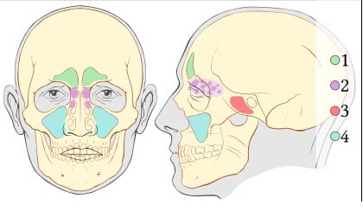
1. Frontal 2. Ethmoid 3. Sphenoid 4.Maxillary

