NAME: AJAYI TOLUWANIMI HANNAH
LEVEL: 200
COURSE: EMBRYOLOGY
ASSIGNMENT
DISCUSS OVULATION
Ovulation can be defined as the release of a mature secondary oocyte from the ovarian follicle. For the oocyte to fully mature, it has to undergo the first and second meiotic divisions. The first meiotic division is completed when there is an abrupt in the production of luteinizing hormone. This surge in the hormone causes the follicle to enter the pre-ovulatory mature vesicular stage. The now primary oocyte begins meiosis 2 but is arrested by cytostatic factors 3 hours before ovulation.
As ovulation deals with the release of a mature oocyte, before the oocyte is released 2 events must occur.
- Collagenase activity increases, which is an enzyme that digests the connective tissues that surround the follicle.
- Prostaglandin levels also increase, which causes muscular contractions in the ovarian wall.
The cells of the cumulus ophorus float out with the mature oocyte and rearrange themselves to form the corona radiate around the oocyte. At this stage, ovulation is said to be complete.
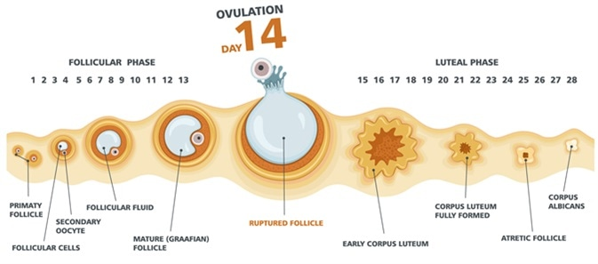

DIFFERENCIATE BETWEEN MEIOSIS I AND MEIOSIS II
MEIOSIS I | MEIOSIS II
Meiosis I is a heterotypic division | Meiosis ii is a homotypic division
Reduces the chromosome number in the daughter cells. | Equalizes the chromosome number of both parent and daughter cells
Homologous chromosomes are present at the beginning. | Chromosomes at the beginning are no longer homologous.
Crossing over, chiasma formation and synapsis occur during prophase 1 | No event takes place during prophase 2
It is a complex division and takes a longer time | It is a relatively fast process.
Preceded by interphase | No interphase stage occurs.
2 daughter cells are formed at telophase 1 | 4 daughter cells are formed at the end of telophase 2.

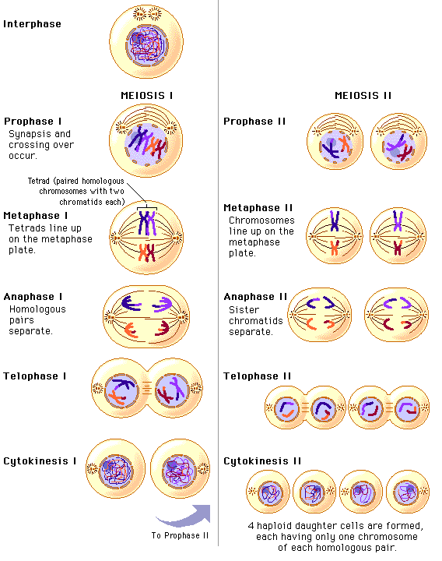

STAGES INVOLVED IN FERTILIZATION
- PASSAGE OF THE SPERM THROUGH THE CORONA RADIATA
During a process called capacitation there is removal of the glycoprotein material and seminar plasma protein on the region of the head of the sperm to allow it to penetrate the corona radiata.

- PENETRATION OF THE ZONA PELLUCIDA BY THE SPERM
The acrosome is fully involved as the cell moves to the zona pellucida. The acrosome binds to the pellucida. There are binding sites on the zona pellucida which are receptor sites to which the acrosome binds. Acrosin, which is a lysosomal enzyme, is released to let the sperm pass through.

- FUSION OF THE PLASMA MEMEBRANE OF THE SPERM AND OOCYTE
The plasma or cell membranes of the oocyte and sperm fuse and break down at the area of fusion.
The head and tail of the sperm enter the cytoplasm of the oocyte, but the sperm's plasma membrane remains behind

- COMPLETION OF THE SECOND MEIOTIC DIVISION AND FORMATION OF THE FEMALE PRONUCLEUS.
Second meiotic division is completed when the nucleus of the sperm enters the oocyte. The female nucleus becomes the pronucleus.

- THE FORMATION OF THE MALE PRONUCLEUS.
The tail of the sperm degenerates, while the nucleus enlarges to form the male pronucleus. As the mitochondria of the sperm are in its tail, the oocyte is the only gamete that gives energy to the oocyte.

- FORMATION OF THE ZYGOTE
The male and female pronuclei fuse together to give rise to the ootid which eventually gives rise to the zygote.
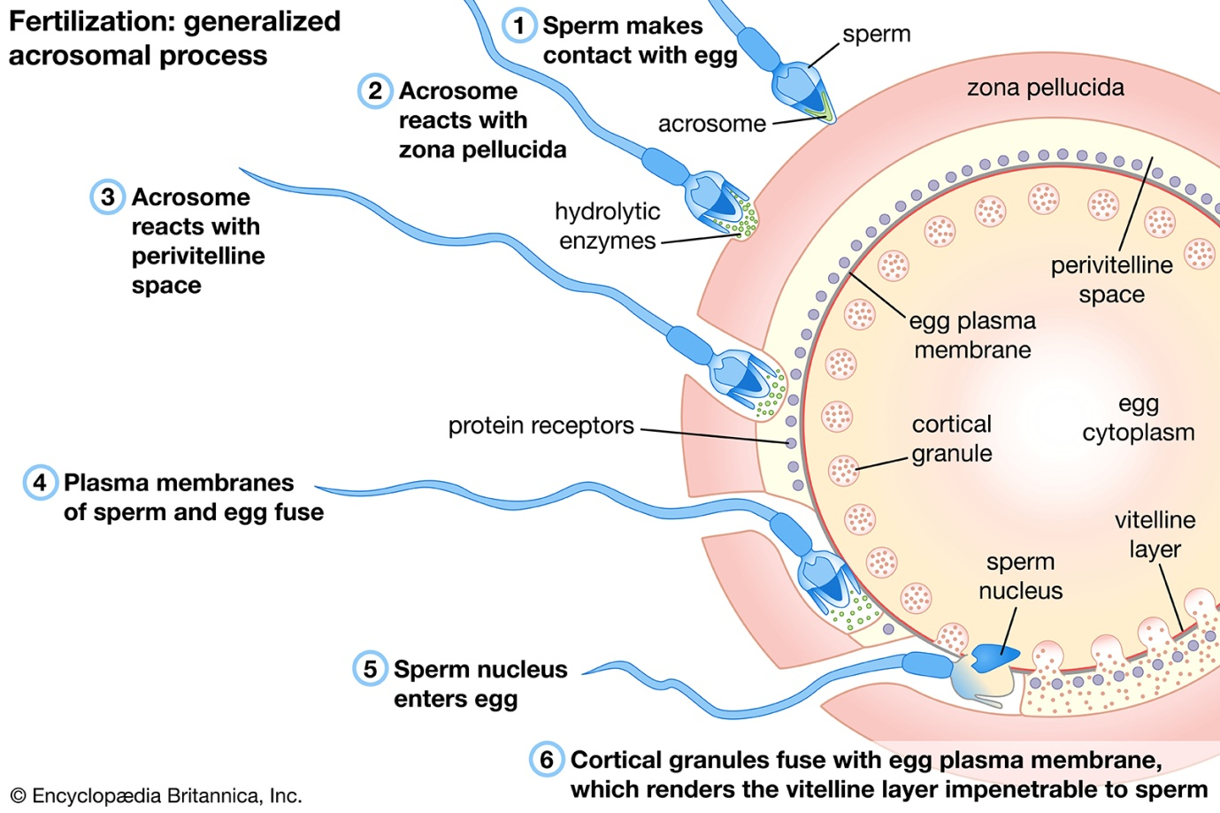

DIFFERENCIATE BETWEEN MONOZYGOTIC AND DIZYGOTIC TWINS
MONOZYGOTIC TWINS | DIZYGOTIC TWINS
Developed by the splitting of a fertilized embryo into 2. | Developed by two separate and simultaneous fertilization events.
Genetic codes are typically the same. | Genetic codes differ like any other sibling
Are always of the same sex | Sex may vary
Have the same physical features and are thus referred to as identical twins. | Have similar features like other siblings and are thus referred to as fraternal twins.

