NAME: IRERUKE EMMANUELLA OGHENETEGA
MATRIC NO: 17/MHS01/163
LEVEL: 300
DEPARTMENT: MBBS
COURSE TITLE: GROSS ANATOMY OF HEAD AND NECK
COURSE CODE: ANA 301

- Write an essay on the cavernous sinus
The human brain is a highly vascular organ responsible for coordinating a myriad of processes throughout the body. Therefore, it is important that a pathway exists to return blood that enters the cranium to systemic circulation. The cavernous sinuses are one of several drainage pathways for the brain that sits in the middle. In addition to receiving venous drainage from the brain, it also receives tributaries from parts of the face.
The left and right cavernous sinuses communicate by through the anterior and posterior intercavernous sinuses. The cavernous sinus drains to the superior and inferior petrosal sinuses, which then join the sigmoid sinus.
Structure
The cavernous sinuses are 1 cm wide cavities that extend a distance of 2 cm from the most posterior aspect of the orbit to the petrous part of the temporal bone. They are bilaterally paired collections of venous plexuses that sit on either side of the sphenoid bone. Although they are not truly trabeculated cavities like the corpora cavernosa of the penis, the numerous plexuses, however, give the cavities their characteristic sponge-like appearance.
The cavernous sinus is roofed by an inner layer of dura mater that continues with the diaphragma sellae that covers the superior part of the pituitary gland. The roof of the sinus also has several other attachments. Anteriorly, it attaches to the anterior and middle clinoid processes, posteriorly it attaches to the tentorium (at its attachment to the posterior clinoid process). Part of the periosteum of the greater wing of the sphenoid bone forms the floor of the sinus. The body of the sphenoid acts as the medial wall of the sinus while the lateral wall is formed from the visceral part of the dura mater.
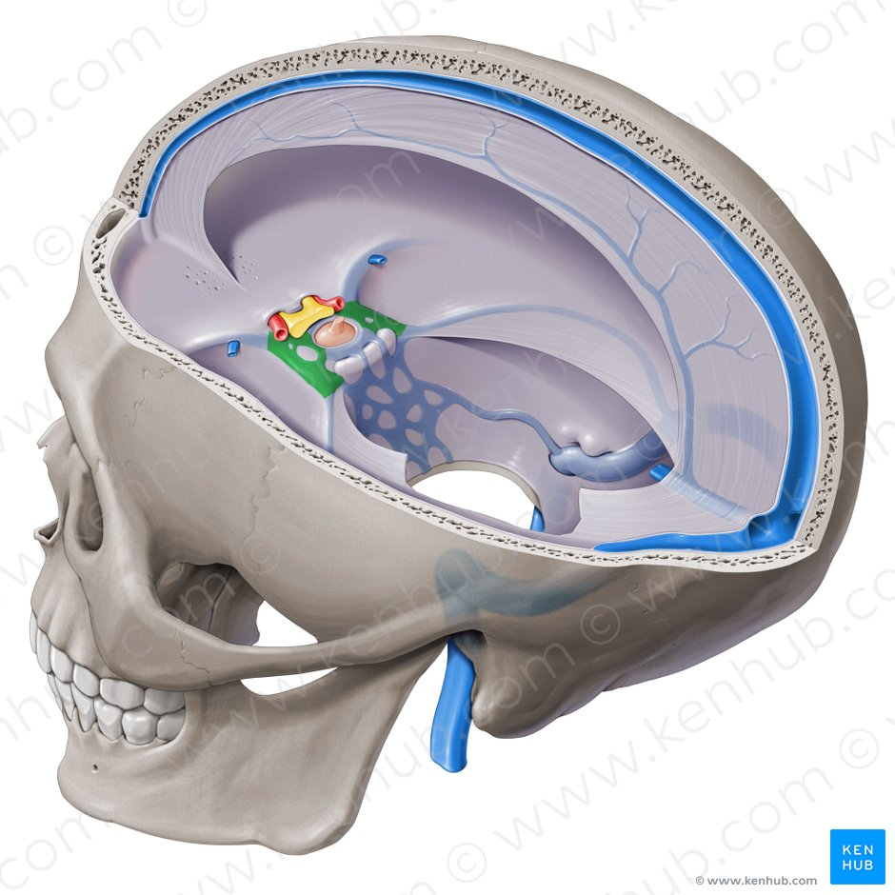
A DIAGRAM SHOWING THE CAVERNOUS SINUS

Contents
The cavernous sinus contains the internal carotid artery and several cranial nerves. Abducens nerve (CN VI) traverses the sinus lateral to the internal carotid artery. The remainder of the cranial nerves pass through the lateral wall of the carotid sinus, and from superior to inferior they are:
Oculomotor nerve (CN III)
Trochlear nerve (CN IV)
Trigeminal nerve (CN V) - ophthalmic and maxillary divisions.
The contents of the cavernous sinus can be easily remembered with the mnemonic Oh, COAT, that stands for the Oculmotor nerve (III), Internal Carotid artery, Ophthalmic nerve (V1), Abducens nerve (VI), Trochlear nerve (IV).

Internal carotid artery
In addition to the thin walled veins that traverse the cavernous sinus, a lone arterial vessel also uses the area as a conduit. The internal carotid artery (a branch of the common carotid artery) – along with its postganglionic sympathetic plexus from the superior cervical ganglion – gains access to the cavernous sinus posteriorly.
As the petrous part of the internal carotid artery leaves the carotid canal, it curves vertically and superiorly above foramen lacerum to enter the cavernous sinus. Here the artery is also referred to as the cavernous part.
Within the sinus, the internal carotid artery travels anteriorly, in a horizontal manner until it reaches the anterior limit of the sinus. Here it curves vertically and superiorly to exit the sinus through its roof and become the cerebral part of the internal carotid artery. It is noteworthy that the cavernous part of the internal carotid artery is the only arterial vessel that is completely surrounded by venous networks.

Abducent nerve
There are also other non-vascular structures that utilize the cavernous sinus as a pathway to their points of supply. Five cranial nerves (CN) use this pathway to gain access to their points of innervation. The first to be discussed is the abducent nerve (CN VI). This motor nerve leave the pons and gains access through the posterior part of the sinus after passing of the apical potion of the petrous temporal bone. It has also been known to access the cavernous sinus by way of the petrosal sinus, adjacent to the clivus.
Within the cavernous sinus, it takes an inferolateral course, relative to the internal carotid artery. It exits the sinus by way of the superior orbital fissure to gain access to the orbit, where it innervates the lateral rectus muscle of the eyeball.
Oculomotor nerve
The other nerves travelling through the cavernous sinus do so between the endothelial lining and the dura mater of its lateral wall. The most superior of the four nerves in the lateral wall is the oculomotor nerve (CN III). At the posterior aspect of the roof of the cavernous sinus, the free and attached edges of tentorium cerebelli forms a space through which CN III enters the lateral wall of the sinus. It takes an anterior, inferomedial course (relative to the other nerves in the lateral wall) towards the anterior extremity of the sinus.
Here it bifurcates into its superior and inferior rami that pass through the superior orbital fissure. Along with sympathetic fibers from the internal carotid plexus, CN III provides motor supply to inferior oblique, levator palpebrae superioris, and the inferior, medial and superior recti muscles.
Trochlear nerve
The smallest of the cranial nerves, the trochlear nerve (CN IV), enters the posterior aspect of the cavernous sinus after leaving the posterior part of the brainstem and decussating with the same nerve from the opposite side. It continues anteriorly in the lateral wall of the cavernous sinus, inferior to CN III and passes through the superior orbital fissure at the anterior aspect of the sinus. Once in the orbit, CN IV has the responsibility of innervating the muscles of the eyeball that are responsible for inferolateral motions.
Trigeminal nerve
Finally, two of the three branches of the trigeminal nerve (CN V) pass through the cavernous sinus. Prior to entering the cavernous sinus, the proximal portion of the nerve lies in Meckel’s cave, where it forms the trigeminal ganglion. After leaving the cave, the mandibular division (CN V3) courses inferiorly to pass through foramen ovale (without entering the cavernous sinus).
The other two branches, the ophthalmic and the maxillary (CN V1 and CN V2, respectively), travel through the lateral wall of the sinus. Both take courses inferior to CN III and CN IV, however, CN V2 is the most inferior of them all. Both CN V branches in the sinus travels horizontally. CN V2 leaves the sinus via foramen rotundum, while the three branches of CN V1 exit the cranial fossa via the superior orbital fissure. CN V1 and CN V2 are purely sensory and supply specific regions of the face.

Relations
There are numerous structures surrounding the cavernous sinus that are noteworthy. Medially, the sinus is adjacent to the lateral walls of the pituitary fossa with the pituitary gland, the sphenoid bone and its air sinus. The cerebral part of the internal carotid artery courses superiorly. Laterally, the medial aspect of the temporal lobe of each hemisphere lies adjacent to the sinus. And posteriosuperiorly, the uncus of the temporal lobe has a relation to the sinus.

Communications
The cavernous sinus is an unconventional venous system in the sense that it does not have a unidirectional flow of blood. Owing to the fact that there are no valves in the sinus and its connected veins, the direction of blood flow is dependent on venous pressure. The veins that communicate with the cavernous sinus are:
Superior ophthalmic vein
Inferior ophthalmic vein
Superficial middle cerebral vein
Middle meningeal vein
Hypophyseal veins

Superior ophthalmic vein
The cavernous sinus generally has five venous tributaries. The superior ophthalmic vein receives blood from the ethmoidal, nasofrontal, vorticose (drains the ocular choroid), and central retinal veins. It drains into the anterior part of the sinus via the superior orbital fissure.

Inferior ophthalmic vein
The inferior ophthalmic vein collects blood from the eyelids, lacrimal sac, and some vorticose contributions, as well as the anterior floor and medial wall of the orbit. In addition to draining to the cavernous sinus, it also drains to the pterygoid plexus.

Superficial middle cerebral vein
At the point where the internal carotid artery emerges, the superficial middle cerebral vein pierces the roof of the sinus. Here, it drains blood from the cortices that are adjacent to it as it courses through the lateral sulcus.

Middle meningeal vein
Finally, branches of the middle meningeal vein may join the sphenoparietal sinus on its way to the cavernous sinus. Before piercing the roof of the sinus, it travels along the edge of the lesser wing of the sphenoid between the layers of dura mater.

Hypophyseal veins
Additionally, efferent hypophyseal veins of both the adenohypophysis and neurohypophysis drain to the cavernous sinus.
Intercavernous sinuses and drainage
The left and right cavernous sinuses communicate by way of the anterior and posterior intercavernous sinuses. These vessels travel anteriorly and posteriorly (respectively) around the infundibulum of the pituitary gland, deep to the diaphragma sellae, between the layers of dura mater.The cavernous sinus in turn drains to the superior and inferior petrosal sinuses. Both sinuses join the sigmoid sinus, which then becomes the internal jugular vein. The internal jugular vein meets with the subclavian vein to become the left (or right) brachiocephalic vein.
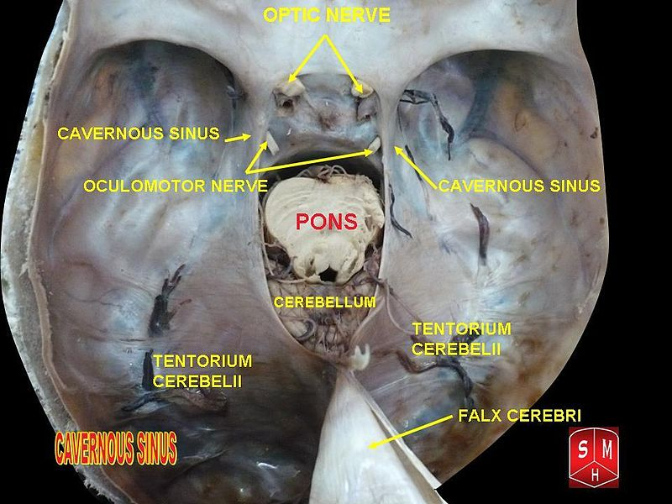
A DIAGRAM SHOWING THE CAVERNOUS SINUS

Clinical significance
Carotid-cavernous fistula
Head trauma resulting in rupture of the cavernous part of the internal carotid artery can produce what is known as a carotid-cavernous fistula. A pulsating exophthalmos can result as the venous pressure in the sinus would increase and reverse the flow of blood in the ophthalmic veins.
Cavernous sinus thrombosis
The sinus also has communicating branches from the sin of the face. Particularly in the ‘danger area’ (at the nasolabial crease and at the crease between the ala of the nose and the cheek), an infection can spread to the cavernous sinus, which can result in a cavernous sinus thrombosis. This condition can result in internal strabismus (crossed eyes) if the CN VI is damaged, doubled vision while looking downward if CN IV was damaged, or ophthalmoplegia (paralysis or weakness in muscles of movement of the eye).

- discuss the walls of the nose
The walls of the nose are divided into the lateral and medial walls of the nasal cavity
Lateral wall of the nasal cavity
The lateral wall of the nasal cavity is a region of the nasopharynx essential for humidifying and filtering the air we breathe in nasally.
Here we can find a structure called agger nasi. The agger nasi is also referred to as the ‘nasoturbinal concha’ or ‘nasal ridge.’ It can be described as a small mound or ridge found in the lateral side of the nasal cavity. The structure is located midway along the anterior aspect of the middle nasal concha. An abnormally enlarged form may restrict the drainage of the frontal sinus by obstructing the frontal recess area.
The lateral wall are made up of the nasal septum and nasal conchae

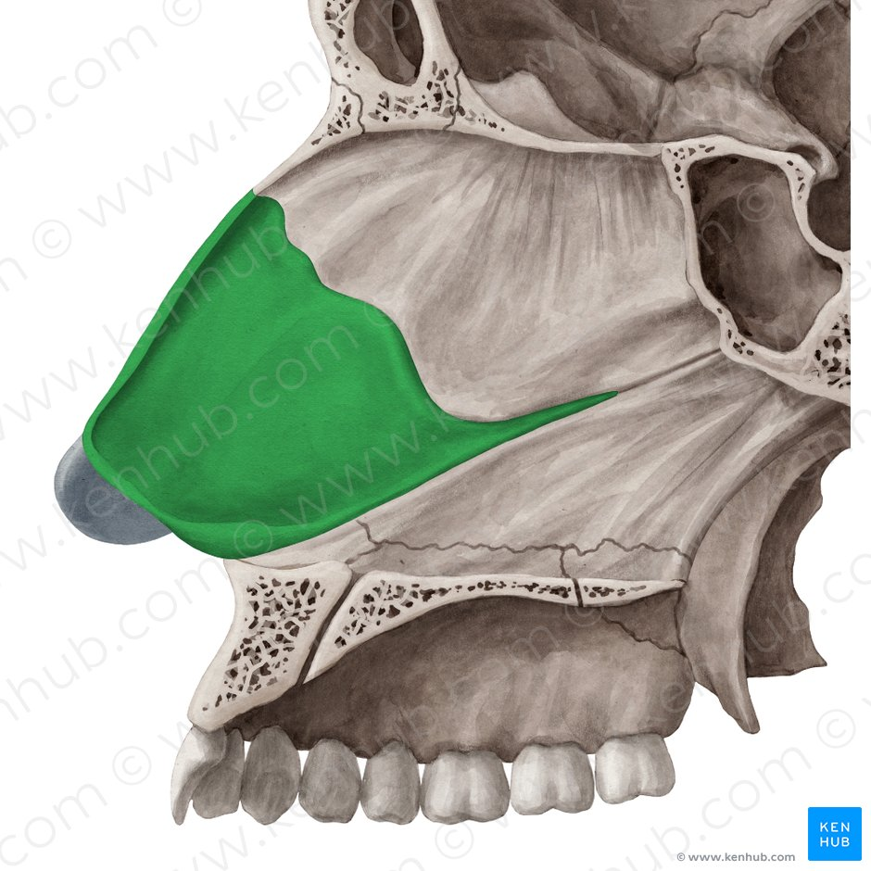

Nasal septum
The anterior nasal aperture is simply the area where the anterior bony aspects of both the maxilla and the nasal bone terminate and form an opening into the cartilaginous nasal vestibule. The structure is also referred to as the piriform aperture.
Three cartilages contribute to the nasal septum:
lesser alar cartilages are paired cartilages suspended in the fibro-fatty tissue that forms the lateral aspect of the nostril. The structures lie free from the other cartilages and provide the nostril with stability and form.
greater alar cartilages are paired cartilages that form part of the antero-superior nostril as well as the nasal tip. The structures give the tip of the nose stability and flexibility and are a crucial element of the cartilaginous apparatus of the nose.
lateral nasal cartilages are structures that articulate inferiorly with the greater alar cartilages and superiorly with the anterior nasal aperture formed by both the nasal bone superiorly and for a short part of its border with the perpendicular plate of the ethmoid bone. These structures form the cartilaginous part of the bridge of the nose and form in conjunction with the greater alar cartilages, the major structural appearance of the nose.
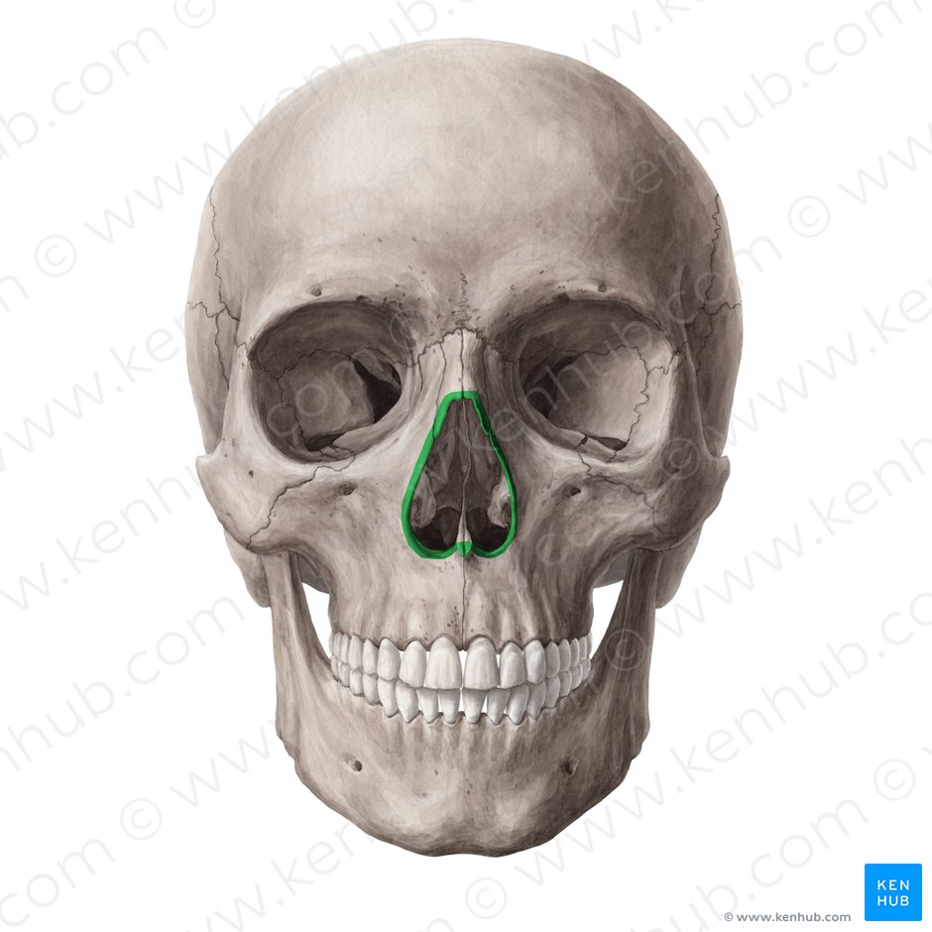

Nasal conchae
We can find 3 types of nasal conchae in the nasal cavity. Those are:
inferior nasal concha. It is the longest and broadest of the conchae and is formed by an independent bone (of the same name, inferior concha). The concha is covered by a mucous membrane that contains large vascular spaces and is one of the three that work to both humidify and clear the air that passes into the nasopharynx.
superior and middle nasal conchae arise from the perpendicular plate of the ethmoid bone. The middle nasal concha is found in between the superior and inferior nasal concha and plays a role in humidifying and clearing inspired air of micro-particles such as dirt. The superior nasal concha is a bony shelf located above the middle nasal concha and below the sphenoethmoidal recess. Similar to the middle nasal concha the superior concha is itself part of the ethmoid bone.

Bones of the lateral wall:
Ethmoid bone
Perpendicular plate of the palatine bone
The medial plate of the pterygoid process of the sphenoid bone
Medial surface of the lacrimal and maxillary bones
Inferior concha

Associated structures
The nasal surface of the maxilla forms the antero-lateral part of the bony nasal cavity. It is located inferior to the nasal bone and gives rise in part, to the inferior nasal concha. The sphenopalatine foramen is found in the posterior most region of the nasal cavity, at the back of the middle meatus. The foramen is formed by the processes on the superior border of the palatine bone, and the under surface of the sphenoidal body, which form a foramen. It connects the nasal cavity to the pterygopalatine fossa, and thus transmits the sphenopalatine artery and vein as well as the superior nasal and nasopalatine nerves.

The medial plate of the pterygoid process is an inferior projection of the sphenoid bone. The plate forms a laterally pointing hook like process at its most inferior point, known as the pterygoid hamulus. The tensor veli palatine muscle glides around this structure. The lateral surface of the medial plate forms the medial border of the pterygoid fossa, and the medial surface forms the lateral boundary of the choana of the adjacent nasal cavity.

The limen nasi is approximately 10mm in length and is defined as the boundary between the nasal cavity proper and the vestibule. It is relatively wide and superficial anteriorly but gradually narrows as it extends posteriorly towards the anterior region of the middle concha. It lies upon the upper edge of the lateral crus of the greater alar cartilage and detached pieces of cartilage may take part in its formation.

The inferior nasal meatus lies beneath the inferior nasal concha and the lateral nasal wall. It is broader in front than behind and extends the entire length of the lateral wall of the nose and the anterior third contains the termination of the nasolacrimal or ‘tear’duct. This opening is covered by a mucosal valve known as Hassner’s valve. The middle nasal meatus is located above the inferior and below the middle nasal concha. It is also part of the ethmoidal complex as it drains the maxillary, frontal and anterior ethmoidal sinuses. The superior meatus is located below the superior nasal concha and drains the posterior ethmoidal air cells.

The sphenoethmoidal recess is a small cleft like pocket located above the superior nasal concha and drains the sphenoid sinus. The sphenoethmoidal recess is a space found superior to the superior turbinate bone and drains the sphenoidal sinus as well as some of the ethmoidal sinuses. The frontal sinuses are situated between the brow ridges and lie between the two layers of the frontal bone. They are unlikely to be symmetrical and are not usually involved in sinusitis.

The sphenoidal sinus is contained within the body of the sphenoid bone itself. There is a great deal of variation in the shape and size of this sinus between individuals. The sinus drains into the sphenoethmoidal recess which is located superior to the choana. The main expansion of their size occurs during puberty and they perform a similar function to the other sinuses.

The nasal vestibule is the visible part of the internal nasal cavity from an external view. The vestibule is maintained by the greater and lesser alar cartilages and contains small hairs which trap dirt and small particles during inspiration. The vestibules are lined by stratified squamous epithelium, and are separate from the nasal cavity proper, which is lined with respiratory epithelium.

The Medial Wall of The Nasal Cavity
The medial wall of the nasal cavity comprises the nasal septum, the septal catilage and various bones of the skull.
Nasal skeleton
The nasal septum is a structure consisting of both bony and cartilaginous components. The bony components are the:
perpendicular plate of the ethmoid superoinferiorly
the vomer posteroinferiorly
the crests of the maxillary bone anteroinferiorly
the crest of the palatine bone inferior to the vomer
Ethmoid bone
The medial wall of the nasal cavity is formed by both bony elements and cartilage. Posteriorly the perpendicular plate of the ethmoid bone forms the superoposterior part of the bony nasal septum and articulates superiorly with the cribriform plate. The posterior border articulates superiorly with the sphenoidal crest and with the vomer by its inferior border. The cribriform plate is found in the midline on the anterior floor of the anterior cranial fossa. It can be descried as a thin bony plate of perforated bone through which the fibres of the olfactory nerve ascend and reach the entorhinal cortex. The plate is divided by the crista galae in the midline.
Maxillary bone
Further posteriorly than the ethmoid bone, the crest of both the maxilla and palatine bone complete the posterior septum. The anterior septum is formed entirely of the quadrangular cartilage which divides the cavity in the midline. The nasal septum can be deviated in some and is a sign of nasal trauma or abnormal growth.
Vomer
The vomer is an unpaired bone of the skull forms the inferior part of the septum. It is located in the mid sagittal plane and articulates with the ethmoid, both palatine bones and both maxillary bones.
Palatine bone
The horizontal plate of the palatine bone is a rectangular shaped bone that projects medially and forms a right angle with the perpendicular plate of the ethmoid. The nasal surface of the bone forms part of the inferior meatus of the nose, while the serrated anterior maxillary surface articulates with the maxilla. Laterally the bone articulates with the perpendicular plate, and superior portion of the plate forms the posterior part of the nasal cavity. The inferior surface of the plate is rough and provides attachment to the oral mucosa of the hard palate.
Nasal cartilage and associated structures
The septal cartilage is approximately 3-4mm thick. It divides the nasal cavity into two halves. The anteroinferior part of the cartilage has an expansion known as the ‘footplate’ which is 4-8mm wide. This foot plate lies in free contact with the membranous septum. The cartilage is expanded in other regions, namely the junction with the lateral nasal cartilage termed the posterior process. The cartilage is firmly adhered to the nasal bone by taut collagen fibres. The cartilage of the septum is also termed the ‘quadrangular cartilage’ due to its shape. The posterior nasal spine is a sharp pointed projection of the posterior border of the palatine bone. The musculus uvula gains its attachment here.
The pharyngeal tonsil is also known as the adenoid. It is a mass of lymphatic tissue located in the roof of the nasopharynx. The structure degrades with age and is almost entirely absent at puberty. The torus tubarius is also known as the tubar tonsil. It resides at the base of the cartilaginous section of the Eustachian tube.
The choana is an opening at the back of the nasal passage that empties into the nasopharynx, close to where the adenoids are. The passage way forms an outflow from the nasopharynx into the mouth and throat.

Floor of the nasal cavity
Hard palate
The pharyngeal opening of the auditory tube can be described as a triangular opening surrounded by a raised, firm prominence known as the ‘torus’. The most medial end of the cartilage causes the elevation of the mucous membrane. The hard palate is a horizontal plate of bone formed by both the palatine process of the maxilla, which forms 75% of the hard palate, and the horizontal plate of the palatine bone, which forms the remaining 25%.
This bony structure has numerous perforations to allow for the passage of nutrient vessels. Its function is to form a separation between the nasopharynx and oropharynx. Insufficiency in this structure can cause difficulty with swallowing.

Soft palate
The soft palate is also referred to as the ‘velum’. This is a continuation of the hard palate posteriorly but has no bony structure. This structure is constituted of five muscles crucial for swallowing. These are the:
tensor veli palatini (innervated by the mandibular branch of the trigeminal nerve)
palatoglossus
the palatopharyngeus which has a crucial role in breathing
the levator veli palatini which elevates the soft palate to encompass the bolus of food
the musculus uvulae which move the uvula
The uvula has an essential role in human speech and works with the posterior part of the tongue to create ‘guttural’ sounds.

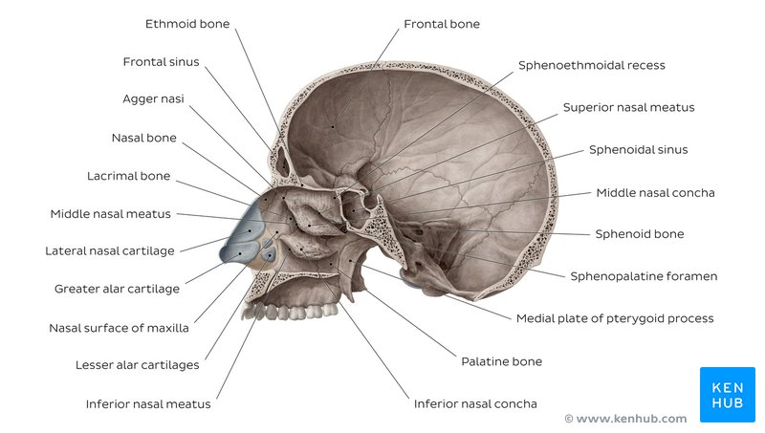

A DIAGRAM SHOWING THE BONES OF THE NASAL CAVITY
Clinical Significance
The nasal cavity functions to humidify, warm, filter, and act as a conduit for inspired air, as well as protect the respiratory tract through the use of the mucociliary system. The nasal cavity also houses the receptors responsible for olfaction. If any of the functions of the nasal cavity are compromised, the result is likely to manifest in signs and symptoms of clinically significant disease processes.

Sinusitis
Sinusitis is an inflammation of the different sinuses found in the head. That type of inflammation may result in different symptons inluding:
plugged nose;
nasal mucus;
and pain in the facial region.

