ASSIGNMENT.
QUESTIONS.
- Write an essay on the carvanous sinus.
- Discuss the walls of the nose.
ANSWERS.
- The cavernous sinus is part of the brain’s dural venous sinus and contains multiple neuro-vasculatures. It is situated bilaterally to the sella turcica and extends from the superior orbital fissure anteriorly to the petrous part of the temporal bone posteriorly, and is about 1 cm wide and 2 cm long. The venous blood that flows to the cavernous sinus is from the superior and anterior ophthalmic veins, superficial middle cerebral vein, and sphenoparietal sinus. The communication between the left and right cavernous sinuses is made by the intercavernous sinuses anterior and posterior to the infundibulum of the pituitary gland.
CONTENTS.
Apart from the blood which passes through a venous sinus, several anatomical structures, including some cranial nerves and their branches, also pass through the sinus.
Structures within the outer (lateral) wall of the compartment from superior to inferior:
- Oculomotor nerve
- Trochlear nerve
- Ophthalmic and maxillary branches of the trigeminal nerve
Structures passing through the midline (medial) wall:
- Abducens nerve
- Internal carotid artery accompanied by the Internal carotid plexus
These nerves, with the exception of CN V₂, pass through the cavernous sinus to enter the orbital apex through the superior orbital fissure. The maxillary nerve, division V₂ of the trigeminal nerve travels through the lower portion of the sinus and exits via the foramen rotundum. The maxillary branch passes external to, but immediately adjacent to, the lateral wall of the sinus)
A mnemonic exists to remember the orientation of the vertical and horizontal content of the sinus: O TOM CAT. (OTOM are the lateral wall contents from superior to inferior; CAT are the horizontal contents from medial to lateral)
The optic nerve lies just above and outside the cavernous sinus, superior and lateral to the pituitary gland on each side, and enters the orbital apex via the optic canal.

STRUCTURE AND FUCTION.
The cavernous sinus works as a conduit. Cranial nerves leaving the brainstem travel through the cavernous sinus before entering the orbit to innervate extraocular and intrinsic eye muscles. Also, different venous tributaries drain into the cavernous sinus. The superior ophthalmic vein collects venous blood from the ethmoidal, vorticose, central retinal, and nasofrontal veins before draining into the anterior part of the cavernous sinus through the superior orbital fissure. The inferior ophthalmic vein, on the other hand, receives blood from the lacrimal sac, eyelids, the inferior rectus and inferior oblique muscles, the vorticose vein, and from the anterior and medial wall of the orbit. It then runs posteriorly toward the lower part of the orbit and divides into two branches. One of these branches joins the cavernous sinus, while the other one drains into the pterygoid plexus. The superficial middle cerebral originates on the lateral surface of the hemisphere, runs in the lateral sulcus, and drains most of the temporal lobe into the cavernous sinus. The sphenoparietal sinus receives blood from some branches of the middle meningeal vein before draining into the cavernous sinus. It is noteworthy to mention that efferent hypophyseal veins also drain into the cavernous sinus. After collecting venous blood from these different veins, the cavernous sinus drains to the superior and inferior petrosal sinuses, which then join the sigmoid sinus to form the internal jugular vein. The internal jugular vein exits the brain through the jugular foramen and connects with the subclavian vein to become the right or left brachiocephalic vein.
BLOOD SUPPLY.
The common carotid artery bifurcates in the cervical region and gives rise to the external and internal carotid artery. The internal carotid artery travels superiorly and enters the skull via the carotid canal. After entering the carotid canal, the internal carotid makes a 90-degree turn and travels horizontally in the petrous part of the temporal bone - this is the petrous part of the internal carotid artery. The petrous part of the internal carotid then enters the cavernous sinus via the foramen lacerum. In the cavernous sinus, the internal carotid artery is also referred to as the cavernous part. The cavernous part travels horizontally and anteriorly until it reaches the anterior limit of the sinus, where it curves vertically, exits the sinus superiorly, and becomes the cerebral part of the internal carotid artery. It is important to mention that the cavernous part of the internal carotid artery is the only artery in the body that is surrounded completely by venous blood.
NERVE SUPPLY.
The nerves of the cavernous sinus are the oculomotor nerve (CN III), trochlear nerve (CN IV), ophthalmic nerve (V1), maxillary nerve (V2), abducens nerve (CN VI), and the sympathetic plexus around the internal carotid artery.
The CN III exits the midbrain ventrally at the interpeduncular fossa, pierces the dura, and enters the cavernous sinus, where it runs on the roof and lateral wall. After exiting the cavernous sinus, it goes through the superior orbital fossa. Within the superior orbital fossa, it splits into the superior and inferior division.
The CN IV is the only nerve exiting the midbrain dorsally. It originates from the trochlear nerve nucleus; it crosses the midline and emerges inferior to the inferior colliculus, situated in the posterior part of the midbrain. It then travels anteriorly around the midbrain, pierces and enters the dura mater near the tentorium cerebelli, and continues its course in the lateral wall of the cavernous sinus. After exiting the cavernous sinus, it enters the orbit through the superior orbital fissure to innervate the superior oblique muscle.
The ophthalmic nerve (V1) and the maxillary nerve (V2) are divisions of the trigeminal nerve (CN V). The CN V exits the brainstem from the ventrolateral pons and enters the Meckel’s cave, where the trigeminal ganglion lies. The V1 branches of the trigeminal ganglion pass through the inferior part of the cavernous sinus and after exiting the cavernous sinus, they enter the orbit via the superior orbital fissure. Also, the V2 branches of the trigeminal ganglion enter the cavernous sinus and exit the skull via the foramen rotundum.
The CN VI exits the brainstem ventrally at the pontomedullary junction, pierces the dura, and travels the longest intracranial distance of all the cranial nerves. After its long intracranial course, it enters the cavernous sinus, where it is surrounded by venous blood, like the internal carotid artery.
The sympathetic plexus around the internal carotid artery originates from the superior cervical ganglion, travels with the internal carotid artery, enters the skull through the carotid canal, and enters the cavernous sinus through the jugular foramen. Within the cavernous sinus, it gives sympathetic fibers to the CN III and V1.
CLINACAL SIGNIFICANCE.
Cavernous Sinus Syndrome
Cavernous sinus syndrome is a medical emergency and life-threatening disorder that presents with different symptoms depending on what structure is affected. A severe lesion involving the entire sinus will present with total ophthalmoplegia, due to CN III, IV, and VI injury, accompanied with fixed and dilated pupils due to compression of the superficial parasympathetic fibers of the CN III. Cavernous sinus syndrome can lead to Horner’s syndrome. Horner’s syndrome occurs when the sympathetic plexus around the internal carotid is damaged. When CN V1 and CN V2 are involved, sensory loss in the face, scalp, maxilla, nasal cavity, sinuses, and palate occurs. There are several causes of cavernous sinus syndrome, including metastatic tumor, meningioma, pituitary tumor, extension of nasopharyngeal tumors, granulomatous diseases, cavernous sinus thrombosis, and aneurysms of the cavernous part of the internal carotid artery. In case of rupture of a cavernous aneurysm, a carotid-cavernous fistula is created, leading to a pulsating exophthalmos on physical examination.
Facial veins and implication to cavernous sinus infection
Blood from the medial angle of the eye, lips, and nose usually drain via the facial vein. However, blood from these parts may also drain superiorly through the facial vein, to the superior ophthalmic, to the cavernous sinus. By doing so, it provides a pathway for infections from the face to spread to the cavernous sinus and from the sinus to the brain.
Another way for infections to spread from the face to the brain is via the inferior ophthalmic vein. In fact, the inferior ophthalmic vein communicates with the pterygoid plexus of veins, and the pterygoid plexus communicates with the cavernous sinus via the emissary's vein. Gravity dictates the blood flow from the cavernous sinus to the pterygoid plexus; however, in the case of inflammation or obstruction, the pressure gradient can be reversed. Because there are no valves in the brain’s venous sinus, blood will flow from the pterygoid plexus to the cavernous sinus carrying bacteria with it.
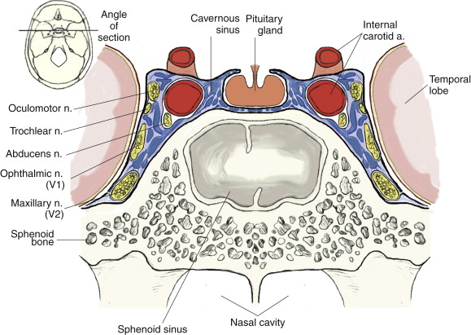DIAGRAM SHOWING THE CAVERNOUS SINUS.
- Lateral Wall of The Nasal Cavity.
The lateral wall of the nasal cavity is a region of the nasopharynx essential for humidifying and filtering the air we breathe in nasally.
Here we can find a structure called agger nasi. The agger nasi is also referred to as the ‘nasoturbinal concha’ or ‘nasal ridge.’ It can be described as a small mound or ridge found in the lateral side of the nasal cavity. The structure is located midway along the anterior aspect of the middle nasal concha. An abnormally enlarged form may restrict the drainage of the frontal sinus by obstructing the frontal recess area.
Nasal septum:

Bones and cartilages
The anterior nasal aperture is simply the area where the anterior bony aspects of both the maxilla and the nasal bone terminate and form an opening into the cartilaginous nasal vestibule. The structure is also referred to as the piriform aperture.
Three cartilages contribute to the nasal septum:
- Lesser alar cartilages are paired cartilages suspended in the fibro-fatty tissue that forms the lateral aspect of the nostril. The structures lie free from the other cartilages and provide the nostril with stability and form.
- Greater alar cartilages are paired cartilages that form part of the antero-superior nostril as well as the nasal tip. The structures give the tip of the nose stability and flexibility and are a crucial element of the cartilaginous apparatus of the nose.
- Lateral nasal cartilages are structures that articulate inferiorly with the greater alar cartilages and superiorly with the anterior nasal aperture formed by both the nasal bone superiorly and for a short part of its border with the perpendicular plate of the ethmoid bone. These structures form the cartilaginous part of the bridge of the nose and form in conjunction with the greater alar cartilages, the major structural appearance of the nose.

NASAL CONCHAE
We can find 3 types of nasal conchae in the nasal cavity. Those are:
- Inferior nasal concha. It is the longest and broadest of the conchae and is formed by an independent bone (of the same name, inferior concha). The concha is covered by a mucous membrane that contains large vascular spaces and is one of the three that work to both humidify and clear the air that passes into the nasopharynx.
- Superior and middle nasal conchae arise from the perpendicular plate of the ethmoid bone. The middle nasal concha is found in between the superior and inferior nasal concha and plays a role in humidifying and clearing inspired air of micro-particles such as dirt. The superior nasal concha is a bony shelf located above the middle nasal concha and below the sphenoethmoidal recess. Similar to the middle nasal concha the superior concha is itself part of the ethmoid bone.

Associated structures:
- The nasal surface of the maxilla forms the antero-lateral part of the bony nasal cavity. It is located inferior to the nasal bone and gives rise in part, to the inferior nasal concha.
- The sphenopalatine foramen is found in the posterior most region of the nasal cavity, at the back of the middle meatus. The foramen is formed by the processes on the superior border of the palatine bone, and the under surface of the sphenoidal body, which form a foramen. It connects the nasal cavity to the pterygopalatine fossa, and thus transmits the sphenopalatine artery and vein as well as the superior nasal and nasopalatine nerves.
- The medial plate of the pterygoid process is an inferior projection of the sphenoid bone. The plate forms a laterally pointing hook like process at its most inferior point, known as the pterygoid hamulus. The tensor veli palatine muscle glides around this structure. The lateral surface of the medial plate forms the medial border of the pterygoid fossa, and the medial surface forms the lateral boundary of the choana of the adjacent nasal cavity.
- The limen nasi is approximately 10mm in length and is defined as the boundary between the nasal cavity proper and the vestibule. It is relatively wide and superficial anteriorly but gradually narrows as it extends posteriorly towards the anterior region of the middle concha. It lies upon the upper edge of the lateral crus of the greater alar cartilage and detached pieces of cartilage may take part in its formation.
- The inferior nasal meatus lies beneath the inferior nasal concha and the lateral nasal wall. It is broader in front than behind and extends the entire length of the lateral wall of the nose and the anterior third contains the termination of the nasolacrimal or ‘tear’duct. This opening is covered by a mucosal valve known as Hassner’s valve.
- The middle nasal meatus is located above the inferior and below the middle nasal concha. It is also part of the ethmoidal complex as it drains the maxillary, frontal and anterior ethmoidal sinuses.
- The superior meatus is located below the superior nasal concha and drains the posterior ethmoidal air cells.
- The sphenoethmoidal recess is a small cleft like pocket located above the superior nasal concha and drains the sphenoid sinus. The sphenoethmoidal recess is a space found superior to the superior turbinate bone and drains the sphenoidal sinus as well as some of the ethmoidal sinuses. The frontal sinuses are situated between the brow ridges and lie between the two layers of the frontal bone. They are unlikely to be symmetrical and are not usually involved in sinusitis.
- The sphenoidal sinus is contained within the body of the sphenoid bone itself. There is a great deal of variation in the shape and size of this sinus between individuals. The sinus drains into the sphenoethmoidal recess which is located superior to the choana. The main expansion of their size occurs during puberty and they perform a similar function to the other sinuses.
- The nasal vestibule is the visible part of the internal nasal cavity from an external view. The vestibule is maintained by the greater and lesser alar cartilages and contains small hairs which trap dirt and small particles during inspiration. The vestibules are lined by stratified squamous epithelium, and are separate from the nasal cavity proper, which is lined with respiratory epithelium.
CLINICAL CORELATES.
- Sinusitis, also known as rhinosinusitis, is inflammation of the mucous membranes that line the sinuses resulting in symptoms. Common symptoms include thick nasal mucus, a plugged nose, and facial pain. Other signs and symptoms may include fever, headaches, a poor sense of smell, sore throat, and a cough. The cough is often worse at night. Serious complications are rare. It is defined as acute sinusitis if it lasts fewer than 4 weeks, and as chronic sinusitis if it lasts for more than 12 weeks.
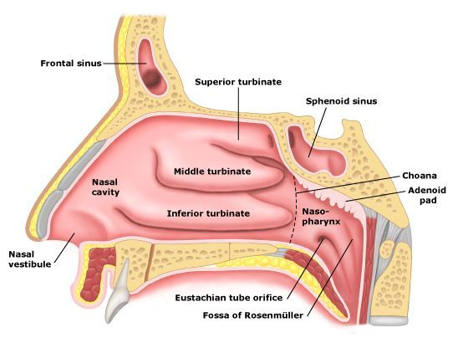DIAGRAM OF THE LATERAL NASAL WALL.
Medial Wall Of The Nasal Cavity.
The medial wall of the nasal cavity comprises the nasal septum, the septal catilage and various bones of the skull. The nasal septum is a structure consisting of both bony and cartilaginous components. The bony components are the:
- perpendicular plate of the ethmoid superoinferiorly
- the vomer posteroinferiorly
- the crests of the maxillary bone anteroinferiorly
- the crest of the palatine bone inferior to the vomer

Ethmoid bone
The medial wall of the nasal cavity is formed by both bony elements and cartilage. Posteriorly the perpendicular plate of the ethmoid bone forms the superoposterior part of the bony nasal septum and articulates superiorly with the cribriform plate. The posterior border articulates superiorly with the sphenoidal crest and with the vomer by its inferior border.
The cribriform plate is found in the midline on the anterior floor of the anterior cranial fossa. It can be descried as a thin bony plate of perforated bone through which the fibres of the olfactory nerve ascend and reach the entorhinal cortex. The plate is divided by the crista galae in the midline.

Maxillary bone.
Further posteriorly than the ethmoid bone, the crest of both the maxilla and palatine bone complete the posterior septum. The anterior septum is formed entirely of the quadrangular cartilage which divides the cavity in the midline. The nasal septum can be deviated in some and is a sign of nasal trauma or abnormal growth.

Palatine bone.
The horizontal plate of the palatine bone is a rectangular shaped bone that projects medially and forms a right angle with the perpendicular plate of the ethmoid. The nasal surface of the bone forms part of the inferior meatus of the nose, while the serrated anterior maxillary surface articulates with the maxilla. Laterally the bone articulates with the perpendicular plate, and superior portion of the plate forms the posterior part of the nasal cavity. The inferior surface of the plate is rough and provides attachment to the oral mucosa of the hard palate.
Nasal cartilage and associated structures.
The septal cartilage is approximately 3-4mm thick. It divides the nasal cavity into two halves. The anteroinferior part of the cartilage has an expansion known as the ‘footplate’ which is 4-8mm wide. This foot plate lies in free contact with the membranous septum. The cartilage is expanded in other regions, namely the junction with the lateral nasal cartilage termed the posterior process. The cartilage is firmly adhered to the nasal bone by taut collagen fibres.
The cartilage of the septum is also termed the ‘quadrangular cartilage’ due to its shape. The posterior nasal spine is a sharp pointed projection of the posterior border of the palatine bone. The musculus uvula gains its attachment here.
The pharyngeal tonsil is also known as the adenoid. It is a mass of lymphatic tissue located in the roof of the nasopharynx. The structure degrades with age and is almost entirely absent at puberty. The torus tubarius is also known as the tubar tonsil. It resides at the base of the cartilaginous section of the Eustachian tube.
The choana is an opening at the back of the nasal passage that empties into the nasopharynx, close to where the adenoids are. The passage way forms an outflow from the nasopharynx into the mouth and throat.
Floor of the nasal cavity:

Hard palate
The pharyngeal opening of the auditory tube can be described as a triangular opening surrounded by a raised, firm prominence known as the ‘torus’. The most medial end of the cartilage causes the elevation of the mucous membrane. The hard palate is a horizontal plate of bone formed by both the palatine process of the maxilla, which forms 75% of the hard palate, and the horizontal plate of the palatine bone, which forms the remaining 25%.
This bony structure has numerous perforations to allow for the passage of nutrient vessels. Its function is to form a separation between the nasopharynx and oropharynx. Insufficiency in this structure can cause difficulty with swallowing.

Soft palate.
The soft palate is also referred to as the ‘velum’. This is a continuation of the hard palate posteriorly but has no bony structure. This structure is constituted of five muscles crucial for swallowing. These are the:
- tensor veli palatini (innervated by the mandibular branch of the trigeminal nerve)
- palatoglossus
- the palatopharyngeus which has a crucial role in breathing
- the levator veli palatini which elevates the soft palate to encompass the bolus of food
- the musculus uvulae which move the uvula
The uvula has an essential role in human speech and works with the posterior part of the tongue to create ‘guttural’ sounds.
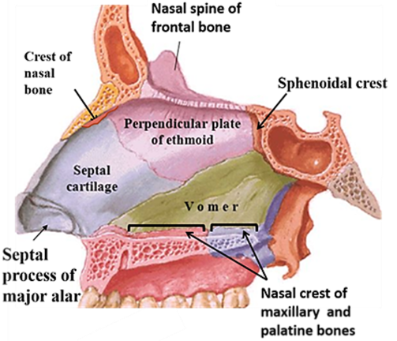
DIAGRAM OF THE LATERAL NASAL WALL.

