Anicho-Okoro Chiemela
15/Eng04/007
Elect/Elect Engineering
EEE 512 ASSIGNMENT

1) i) Working principle of 3G Network
As the use of 2G phones became more widespread and people began to use mobile phones in their daily lives, it became clear that demand for data services (such as access to the internet) was growing. Furthermore, if the experience from fixed broadband services was anything to go by, there would also be a demand for ever greater data speeds. The 2G technology was nowhere near up to the job, so the industry began to work on the next generation of technology known as 3G. The main technological difference that distinguishes 3G technology from 2G technology is the use of packet switching rather than circuit switching for data transmission. In the mid-2000s an evolution of 3G technology begun to be implemented, namely High-Speed Downlink Packet Access (HSDPA). It is an enhanced 3Gmobile telephony communications protocol in the High-Speed Packet Access (HSPA) family, also coined 3.5G, 3G+ or turbo 3G, which allows networks based on Universal Mobile Telecommunications System (UMTS) to have higher data transfer speeds and capacity. Current HSDPA deployments support down-link speeds of 1.8, 3.6, 7.2 and 14.0 Mbit/s. Further speed increases are available with HSPA+, which provides speeds of up to 42 Mbit/s downlink and 84 Mbit/s with Release 9 of the 3GPP standards.
UMTS; short for Universal Mobile Telecommunications System, is a 3G networking standard used throughout much of the world as an upgrade to existing GSM module.
UMTS makes use of WCDMA, a technology that shares much with CDMA networks used throughout the world, though it is not compatible with them.
The UMTS architecture takes advantage of the existing GSM and GPRS networks which serve as a core network in UMTS infrastructure.
The UMTS is made up of 3 main components:
a) User Equipment:
It is assigned to a single user and contains all the functions needed to access UMTS services. It contains: – Mobile Equipment (ME) : It is a radio terminal which is used to connect the UMTS subscriber with the fixed part of UMTS system via the radio interface.
– UMTS Subscriber Identity Module (USIM): A smartcard which contains the subscriber identity, authentication algorithms, encryption keys etc.
b) UMTS Terrestrial Radio Access Network (UTRAN):
It handles cell-level mobility. It is a system of base station and controller handling function related to mobility. It contains:
1. Nodes B (Base Stations):
• It converts the data between radio interface and the Iub interface connecting a Node B with the RNC. • It performs physical level processing such as channel coding, data interleaving, rate matching, modulation etc.
2. Radio Network Controllers (RNC):
• RNC’s controls and manages radio resources to Node B. • RNC performs the data-link layer processing and participates in handover operations. • RNC is considered a single access point of UTRAN for the core network. • It’s connected to a single MSC/VLR to route circuit-switched traffic and to a single SGSN to route packet switched traffic.
c) Core Network (CN):
The core network is shared with GSM and GPRS. The CN contains functions for intersystem handover, gateways to other networks and performs location management. It contains:
Home Location Register (HLR)
Mobile Station Controller / Visitor Location Register (MSC/VLR).
Gateway MSC: Connect UMTS to external circuit switch n/w (e.g PSTN)
Serving GPRS Support Node (SGSN): It serves the Packet-switched traffic.
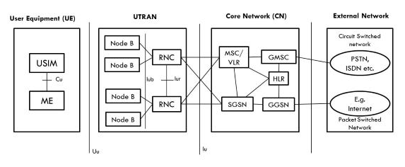

Working Principle of 4G network
4G essentially stands for ‘fourth generation communications system’ and it represents an upgrade from 3G by addressing the two major issues with the platform: speed and network congestion.
What is 4G? Everything about 4G Explained
If you're confused about 4G or mobile broadband in general, this guide will run you through everything you need to know.

What is 4G? Everything about 4G Explained
When 3G first hit the scene, it allowed mobile devices to access high-speed mobile internet for the first time. Before this, mobile internet services were only advanced enough to provide basic data services. This has now changed with the rise of 4G; the new wave of superfast mobile broadband that allows users to enjoy all the features of Wi-Fi on the go.

So what is 4G?
4G essentially stands for ‘fourth generation communications system’ and it represents an upgrade from 3G by addressing the two major issues with the platform: speed and network congestionHow does 4G work?
4G works much in the same way as 3G, simply faster. Using high-speed download and upload packets, 4G allows you to access broadband style speeds whilst away from your Wi-Fi. Users can often access speeds of up to 21Mb on the go, but this is, however, affected by location. A larger city, for example, will exhibit faster speeds than a small village.

4G is essentially a highly advanced radio system. You may even have seen masts dotted around the landscape. These masts broadcast the signals necessary for 4G to work and the challenge is for engineers and coders is to cram as much data into these signals as possible. By extension, this means the network is faster and more efficient.

How does 4G work? Like 3G, 4G is a protocol that sends and receives data in packets. However, 4G differs from 3G in how it works. 4G is entirely IP based, which means it uses internet protocols even for voice data.
The high-level network architecture of LTE is comprised of following three main components:
- The User Equipment (UE).
- The Evolved UMTS Terrestrial Radio Access Network (E-UTRAN).
- The Evolved Packet Core (EPC).
The evolved packet core communicates with packet data networks in the outside world such as the internet, private corporate networks or the IP multimedia subsystem. The interfaces between the different parts of the system are denoted Uu, S1 and SGi as shown below:
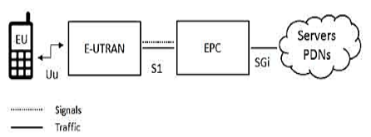
The User Equipment (UE)
The internal architecture of the user equipment for LTE is identical to the one used by UMTS and GSM which is actually a Mobile Equipment (ME). The mobile equipment comprised of the following important modules:
- Mobile Termination (MT) : This handles all the communication functions.
- Terminal Equipment (TE) : This terminates the data streams.
- Universal Integrated Circuit Card (UICC) : This is also known as the SIM card for LTE equipment’s. It runs an application known as the Universal Subscriber Identity Module (USIM).
The E-UTRAN (The access network)
The architecture of evolved UMTS Terrestrial Radio Access Network (E-UTRAN) has been illustrated below:
The E-UTRAN handles the radio communications between the mobile and the evolved packet core and just has one component, the evolved base stations, called eNodeB or eNB. Each eNB is a base station that controls the mobiles in one or more cells. The base station that is communicating with a mobile is known as its serving eNB.
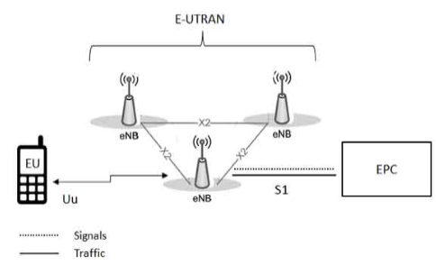
LTE Mobile communicates with just one base station and one cell at a time and there are following two main functions supported by eNB:
- The eBN sends and receives radio transmissions to all the mobiles using the analogue and digital signal processing functions of the LTE air interface.
- The eNB controls the low-level operation of all its mobiles, by sending them signaling messages such as handover commands.
Each eBN connects with the EPC by means of the S1 interface and it can also be connected to nearby base stations by the X2 interface, which is mainly used for signaling and packet forwarding during handover. A home eNB belongs to a closed subscriber group (CSG) and can only be accessed by mobiles with a USIM that also belongs to the closed subscriber group.
The Evolved Packet Core (EPC) (The core network)
The architecture of Evolved Packet Core (EPC) has been illustrated below:
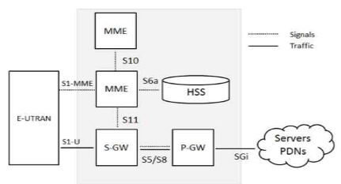
A brief description of each of the components shown in the above architecture:
- The Home Subscriber Server (HSS) component has been carried forward from UMTS and GSM and is a central database that contains information about all the network operator's subscribers.
- The Packet Data Network (PDN) Gateway (P-GW) communicates with the outside world that is packet data networks PDN, using SGi interface. Each packet data network is identified by an access point name (APN). The PDN gateway has the same role as the GPRS support node (GGSN) and the serving GPRS support node (SGSN) with UMTS and GSM.
- The serving gateway (S-GW) acts as a router, and forwards data between the base station and the PDN gateway.
- The mobility management entity (MME) controls the high-level operation of the mobile by means of signaling messages and Home Subscriber Server (HSS).
The interface between the serving and PDN gateways is known as S5/S8. This has two slightly different implementations, namely S5 if the two devices are in the same network, and S8 if they are in different networks.
LTE thus aims to provide a peak data rate of 100 Mbps in downlink and 50 Mbps in Uplink respectively.

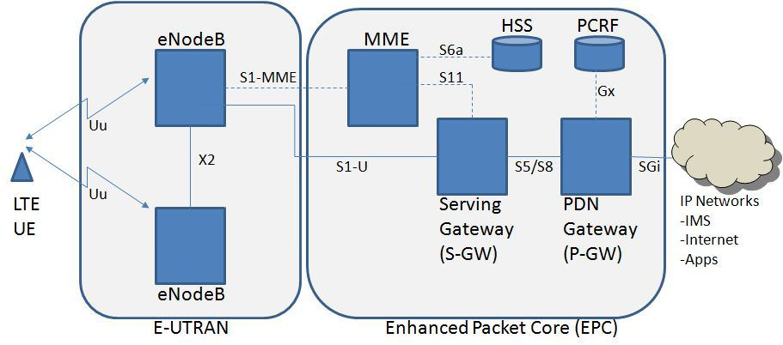

Working Principle of 5g Network
5G is the fifth generation telecommunication and wireless network standard which will be capable of handling greater data rates and network efficiency
5G technology will achieve its expected high efficiency using most modern modulation techniques and network terminologies like:

1. Carrier Aggregation

Carrier aggregation is a technique used in LTE advanced to improve the system efficiency. In carrier aggregation, two or more carrier signals are aggregated to support wider bandwidth which allows even up to 100 MHz.
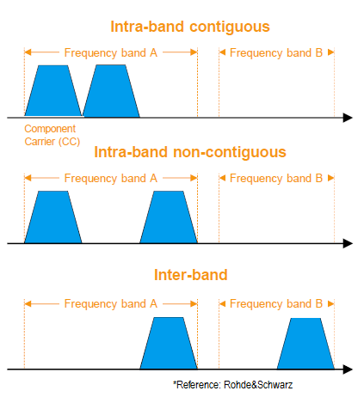
CA uses three techniques for aggregation: Intra-band contiguous: two carriers are transmitted at neighboring channels (as in the figure).Intra-band non contiguous: two carriers are transmitted with channel spacing. Inter-band: In this technique different LTE bands are used for transmission simultaneously.

2. Small Cell Concept

In order to increase network efficiency, the cell is sub divided into micro and Pico cells. Spectrum reusability allows to adding more users in a small geographical area and handle network more efficiently.

3. MIMO Concept

MIMO is a transmission technology with the usage of multiple antennas for transmission and reception. Simultaneous data transfer is possible using this technology thus offer efficient data rate. The more the number of antennas, the more transmission and reception can be done.

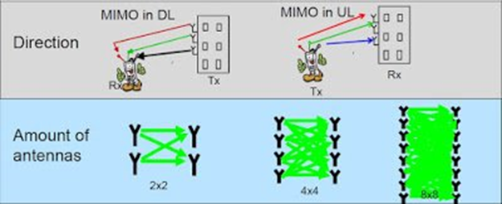

4. Wi-Fi off loading
Wi-fi offloading is one the main feature of the future networks. It allows the user to connect using wi-fi network and the cellular network can be allocated to other users. It would be suitable for some places where cellular network quality is poor and user still have the option to connect to the network without cellular reception.

5. Device to device communication
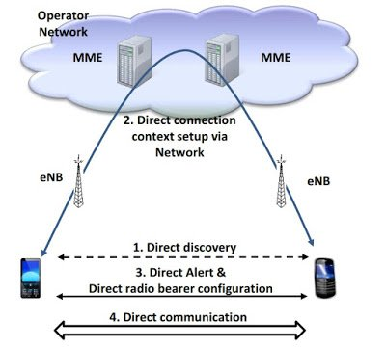

D2D communication is technique where network authorize two adjacent devices communicate each other directly. Network will have the control over the devices and allows an operator to determine the traffic routing between direct and network path. During the absence of network, one devices can connect to another device.

6. Cloud – Radio Network Access
C-RAN is a network technology used for effective communication with a centralized information processing carried out remotely within the cloud system. The signal will be processed at a remote location and the base stations will be connected with most efficient fiber optic connections. It gives lot of advantages in system implementation, maintenance and highly efficient.

ii) Advantages of 3G, 4G and 5G
Advantages of 3g
a) Faster data rates.
b) It supports multimedia applications such as video and photography.
c) Value added services like mobile television, GPS, video call and video conference.
d) High speed mobile internet access.
e) Increased capacity.
Disadvantages of 3g
a) Requires 3G compatible handsets.
b) The cost of upgrading to 3G device is expensive.
c) Power consumption is high.
d) 3G requires closer base stations which is expensive.

Advantages of 4g
- Quickly download files over a wireless network
- Extremely high voice quality
- Easily access Internet, IM, social networks, streaming media, video calling
- Higher bandwidth
- 4G is 10 times faster than 3G
Disadvantages of 4G
- New frequencies means new components in cell towers.
- Higher data prices for consumers
- Consumer is forced to buy a new device to support the 4G
- It is impossible to make your current equipment compatible

Advantages of 5g
- High resolution and bi-directional large bandwidth shaping.
- Technology to gather all networks on one platform.
- More effective and efficient.
- Technology to facilitate subscriber supervision tools for the quick action.

Disadvantages of 5g
- 5G is more costly compared to other Mobile Network Technology because many technical/ official engineers are required to install and maintain it.
- The risk of overcrowding the frequency range of the 5G wireless spectrum is greater as more devices are connected to one channel.
- 5G network Technology will take more time for security and privacy issues.
- Coverage indoor distance up to 2 meters and 300 meters outdoors can be achieved due to greater losses at higher frequencies as 5Gmm wave influences from such losses (rain losses, attenuation due to rain, etc.).
- The high cost of 5g infrastructure.

2) Differences between 2g, 3g, 4g and 5g in a tabular form
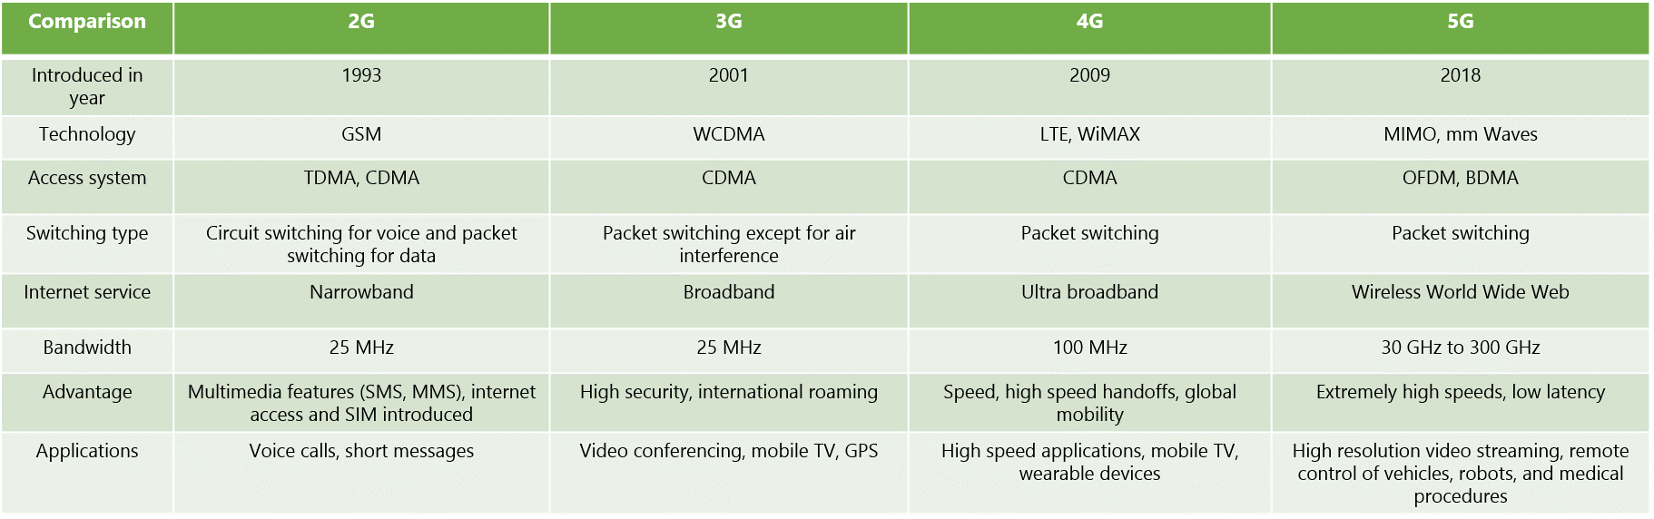

3) i) There is no correlation between the 5G technology and the Corona virus.
ii) Conspiracy theories that the novel coronavirus is caused by new telecommunications technology have gained traction over the past few weeks, despite a consensus among experts that such claims are wrong. 5G, or fifth-generation wireless technology, is a new global wireless standard being deployed around the world now. While previous mobile network generations relied on lower frequency wavelengths being transmitted across wider areas, the standard 5G spectrum is about a factor of 10 — an order of magnitude — higher than the previous four generations of cell networks. That increased information flow, coupled with more accurate antenna connectivity and decreased latency, makes a range of new real-time operations possible over the network. The frequencies of 5G waves are so much lower in power and still four orders of magnitude, or 10,000 times less, than ionizing waves, which are known to possibly be carcinogenic in large doses," Ted Rappaport, an electrical engineer, and professor at New York University’s Tandon School of Engineering. Also, nothing has been scientifically demonstrated that links electromagnetic radiation and virus proliferation. The World Health Organization issued a statement dispelling myths that 5G is caused by the coronavirus. “Viruses cannot travel on radio waves/mobile networks. COVID-19 is also spreading in many countries that do not have 5G mobile networks,” the WHO said on its website. With all these statements from reputable experts and bodies, we can authoritatively say that there is no correlation between the novel corona virus and the 5G technology. Also claims that the virus is caused by the new technology are not supported with facts or any form of research and should therefore be disregarded.

