AKINBUWA OLUWAFUNKE JOY
17/MHS01/042
MBBS/MHS
GROSS ANATOMY OF HEAD AND NECK

CARVERNOUS SINUS
The cavernous sinus is a paired dural venous sinus located within the cranial cavity. It is divided by septa into small ‘caves’ – from which it gets its name.
Each cavernous sinus has a close anatomical relationship with several key structures in the head, and is arguably the most clinically important venous sinus.
The dural venous sinuses are channels between the two layers of dura mater which are responsible for the venous drainage of the brain, skull, orbit and internal ear
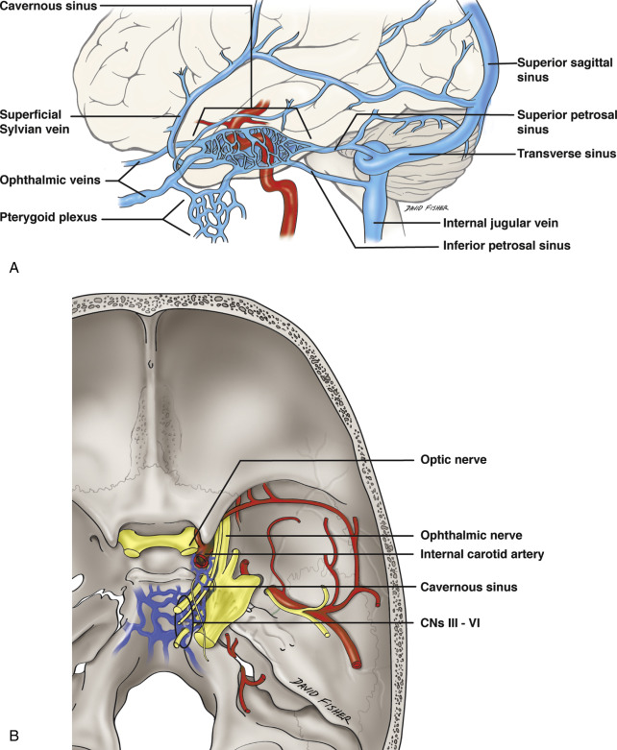
Structure
The cavernous sinuses are 1 cm wide cavities that extend a distance of 2 cm from the most posterior aspect of the orbit to the petrous part of the temporal bone. They are bilaterally paired collections of venous plexuses that sit on either side of the sphenoid bone. Although they are not truly trabeculated cavities like the corpora cavernosa of the penis, the numerous plexuses, however, give the cavities their characteristic sponge-like appearance.
The cavernous sinus is roofed by an inner layer of dura mater that continues with the diaphragma sellae that covers the superior part of the pituitary gland. The roof of the sinus also has several other attachments. Anteriorly, it attaches to the anterior and middle clinoid processes, posteriorly it attaches to the tentorium (at its attachment to the posterior clinoid process). Part of the periosteum of the greater wing of the sphenoid bone forms the floor of the sinus. The body of the sphenoid acts as the medial wall of the sinus while the lateral wall is formed from the visceral part of the dura mater.
Anatomical Location and Borders
The cavernous sinuses are located within the middle cranial fossa, on either side of the sella turcica of the sphenoid bone (which contains the pituitary gland). They are enclosed by the endosteal and meningeal layers of the dura mater.
The borders of the cavernous sinus are as follows:
Anterior – superior orbital fissure.
Posterior – petrous part of the temporal bone.
Medial – body of the sphenoid bone.
Lateral – meningeal layer of the dura mater running from the roof to the floor of the middle cranial fossa.
Roof – meningeal layer of the dura mater that attaches to the anterior and middle clinoid processes of the sphenoid bone.
Floor – endosteal layer of dura mater that overlies the base of the greater wing of the sphenoid bone.
Contents
Several important structures pass through the cavernous sinus to enter the orbit. The can be sub-classified by whether they travel through the sinus itself, or through its lateral wall:
Travels through cavernous sinus: | Travels through lateral wall of cavernous sinus:
- Abducens nerve (CN VI)  - Carotid plexus (post-ganglionic sympathetic nerve fibres)  - Internal carotid artery (cavernous portion) | - Oculomotor nerve (CN III)  - Trochlear nerve (CN IV)  - Ophthalmic (V1) and maxillary (V2) branches of the trigeminal nerve
The cavernous sinus is the only site in the body where an artery (internal carotid) passes completely through a venous structure. This is thought to allow for heat exchange between the warm arterial blood and cooler venous circulation.
Communications
The cavernous sinus is an unconventional venous system in the sense that it does not have a unidirectional flow of blood. Owing to the fact that there are no valves in the sinus and its connected veins, the direction of blood flow is dependent on venous pressure. The veins that communicate with the cavernous sinus are:
Superior ophthalmic vein
The cavernous sinus generally has five venous tributaries. The superior ophthalmic vein receives blood from the ethmoidal, nasofrontal, vorticose (drains the ocular choroid), and central retinal veins. It drains into the anterior part of the sinus via the superior orbital fissure.
Inferior ophthalmic vein
The inferior ophthalmic vein collects blood from the eyelids, lacrimal sac, and some vorticose contributions, as well as the anterior floor and medial wall of the orbit. In addition to draining to the cavernous sinus, it also drains to the pterygoid plexus.
Superficial middle cerebral vein
At the point where the internal carotid artery emerges, the superficial middle cerebral vein pierces the roof of the sinus. Here, it drains blood from the cortices that are adjacent to it as it courses through the lateral sulcus.
Middle meningeal vein
Finally, branches of the middle meningeal vein may join the sphenoparietal sinus on its way to the cavernous sinus. Before piercing the roof of the sinus, it travels along the edge of the lesser wing of the sphenoid between the layers of dura mater.
Hypophyseal veins
Additionally, efferent hypophyseal veins of both the adenohypophysis and neurohypophysis drain to the cavernous sinus.
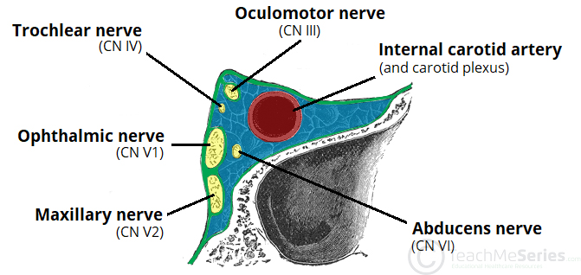
A useful mnemonic to remember the contents and their relation to one another is: O TOM CAT, where OTOM (oculomotor nerve, trochlear nerve, ophthalmic branch, maxillary branch) refers to the lateral wall contents from superior to inferior, and CAT (internal carotid artery, abducens nerve, trochlear nerve) refers to the horizontal contents, from medial to lateral.
Clinical significance
Carotid-cavernous fistula
Head trauma resulting in rupture of the cavernous part of the internal carotid artery can produce what is known as a carotid-cavernous fistula. A pulsating exophthalmos can result as the venous pressure in the sinus would increase and reverse the flow of blood in the ophthalmic veins.
Cavernous sinus thrombosis
The sinus also has communicating branches from the sin of the face. Particularly in the ‘danger area’ (at the nasolabial crease and at the crease between the ala of the nose and the cheek), an infection can spread to the cavernous sinus, which can result in a cavernous sinus thrombosis. This condition can result in internal strabismus (crossed eyes) if the CN VI is damaged, doubled vision while looking downward if CN IV was damaged, or ophthalmoplegia (paralysis or weakness in muscles of movement of the eye).

WALLS OF THE NOSE
The nasal cavity is divided into two lateral compartments separated down the middle by the nasal septum. The nasal cavity communicates anteriorly through the nostrils and posteriorly with the nasopharynx through openings called choanae. The nasal cavities and septum are lined with a mucous membrane and are richly vascularized by branches of the maxillary, facial, and ophthalmic arteries. The nasal cavity receives innervation via branches of the olfactory [cranial nerve (CN) I], ophthalmic (CN V-1), and maxillary nerves (CN V-2).

Boundaries of the Nasal Cavity
The nasal cavity is bordered by the following structures

- Roof. Formed by the nasal, frontal, sphenoid, and ethmoid bones (cribriform foramina, which transmits CN I for smell).
- Floor. Formed by the maxilla and the palatine bones. The incisive foramen transmits branches of the sphenopalatine artery and the nasopalatine nerve for general sensation from the nasal cavity and palate.
- Medial wall (nasal septum).

The medial wall of the nasal cavity comprises the nasal septum, the septal catilage and various bones of the skull.
Nasal skeleton
The nasal septum is a structure consisting of both bony and cartilaginous components. The bony components are the:
.Perpendicular plate of the ethmoid superoinferiorly
.The vomer posteroinferiorly
.The crests of the maxillary bone anteroinferiorly
.The crest of the palatine bone inferior to the vomer

Ethmoid bone
The medial wall of the nasal cavity is formed by both bony elements and cartilage. Posteriorly the perpendicular plate of the ethmoid bone forms the superoposterior part of the bony nasal septum and articulates superiorly with the cribriform plate. The posterior border articulates superiorly with the sphenoidal crest and with the vomer by its inferior border. The cribriform plate is found in the midline on the anterior floor of the anterior cranial fossa. It can be descried as a thin bony plate of perforated bone through which the fibres of the olfactory nerve ascend and reach the entorhinal cortex. The plate is divided by the crista galae in the midline.
Maxillary bone
Further posteriorly than the ethmoid bone, the crest of both the maxilla and palatine bone complete the posterior septum. The anterior septum is formed entirely of the quadrangular cartilage which divides the cavity in the midline. The nasal septum can be deviated in some and is a sign of nasal trauma or abnormal growth.
Vomer
The vomer is an unpaired bone of the skull forms the inferior part of the septum. It is located in the mid sagittal plane and articulates with the ethmoid, both palatine bones and both maxillary bones.
Palatine bone
The horizontal plate of the palatine bone is a rectangular shaped bone that projects medially and forms a right angle with the perpendicular plate of the ethmoid. The nasal surface of the bone forms part of the inferior meatus of the nose, while the serrated anterior maxillary surface articulates with the maxilla. Laterally the bone articulates with the perpendicular plate, and superior portion of the plate forms the posterior part of the nasal cavity. The inferior surface of the plate is rough and provides attachment to the oral mucosa of the hard palate.
Nasal cartilage
The septal cartilage is approximately 3-4mm thick. It divides the nasal cavity into two halves. The anteroinferior part of the cartilage has an expansion known as the ‘footplate’ which is 4-8mm wide. This foot plate lies in free contact with the membranous septum. The cartilage is expanded in other regions, namely the junction with the lateral nasal cartilage termed the posterior process. The cartilage is firmly adhered to the nasal bone by taut collagen fibres.
The cartilage of the septum is also termed the ‘quadrangular cartilage’ due to its shape. The posterior nasal spine is a sharp pointed projection of the posterior border of the palatine bone. The musculus uvula gains its attachment here.

- Lateral wall.

Formed by the superior, middle and inferior nasal conchae. In addition, the maxillary, sphenoid, and palatine bones contribute to the lateral wall. The lateral wall contains the following openings;
- Sphenoethmoidal recess.
- Superior meatus.
- Middle meatus.
- Inferior meatus.
- Sphenopalatine foramen.
The lateral wall of the nasal cavity is a region of the nasopharynx essential for humidifying and filtering the air we breathe in nasally.
It is irregular due to the presence of 3 shelf like bony projections called conchae. These conchae increase the surface area of the nose for effective air conditioning of inspired air. The conchae are Superior conchae, Middle conchae and Inferior conchae. The space below each conchae is called Meatus. This wall is didvied into:
1. Vestibule
2. Atrium
3. Posterior part containing the conchae
The skeleton of this wall is formed by :
1. Nasal bone
2. Frontal process of maxilla
3. Lacrimal bone
4. Inferior nasal conchae
5. Perpendicular plate of palatine bone
6. Medial pterygoid plate
The cartilaginous part includes:
1. Superior nasal cartilage
2. Inferior nasal cartilage
3. Small cartilages of ala
