MATRIC NO: 17/MHS01/275
NAME: OSUBOR STEPHANIE
COURSE: ANA 301

QUESTION 1
THE CARVENOUS SINUS
The cavernous sinus is a paired dural venous sinus located within the cranial cavity. It is divided by septa into small ‘caves’ – from which it gets its name.
Each cavernous sinus has a close anatomical relationship with several key structures in the head, and is arguably the most clinically important venous sinus.
Anatomical Location and Borders
The cavernous sinuses are located within the middle cranial fossa, on either side of the sella turcica of the sphenoid bone (which contains the pituitary gland). They are enclosed by the endosteal and meningeal layers of the dura mater.
The borders of the cavernous sinus are as follows:
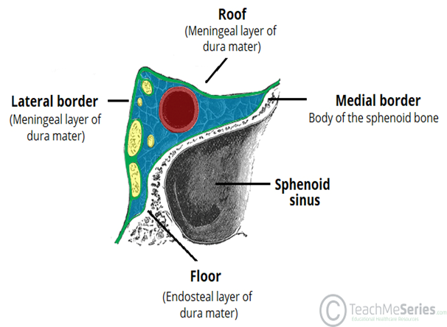
- Anterior – superior orbital fissure.
- Posterior – petrous part of the temporal bone.
- Medial – body of the sphenoid bone.
- Lateral – meningeal layer of the dura mater running from the roof to the floor of the middle cranial fossa.
- Roof – meningeal layer of the dura mater that attaches to the anterior and middle clinoid processes of the sphenoid bone.
- Floor – endosteal layer of dura mater that overlies the base of the greater wing of the sphenoid bone.
The cavernous sinus is the only site in the body where an artery (internal carotid) passes completely through a venous structure. This is thought to allow for heat exchange between the warm arterial blood and cooler venous circulation.
Several important structures pass through the cavernous sinus to enter the orbit. MNEMONICS: O TOM CAT, where OTOM (oculomotor nerve, trochlear nerve, ophthalmic branch, maxillary branch) refers to the lateral wall contents from superior to inferior, and CAT (internal carotid artery, abducens nerve, trochlear nerve) refers to the horizontal contents, from medial to lateral. They can be sub-classified by whether they travel through the sinus itself, or through its lateral wall:
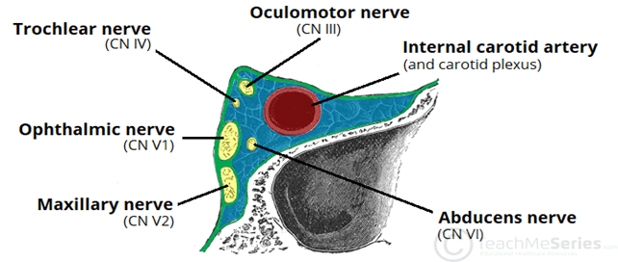
Travels through cavernous sinus:
- Abducens nerve (CN VI)
- Carotid plexus (post-ganglionic sympathetic nerve fibres)
- Internal carotid artery (cavernous portion)
Travels through lateral wall of cavernous sinus:
- Oculomotor nerve (CN III)
- Trochlear nerve (CN IV)
- Ophthalmic (V1) and maxillary (V2) branches of the trigeminal nerve

Dural Venous Sinus System
Each cavernous sinus receives venous drainage from:
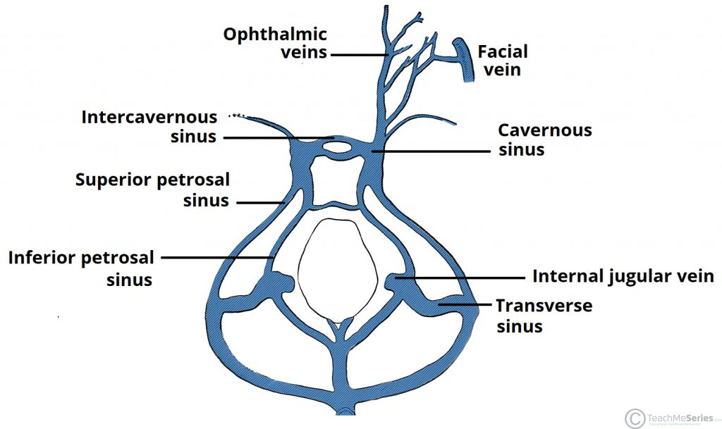
- Ophthalmic veins (superior and inferior) – these enter the cavernous sinus via the superior orbital fissure.
- Central vein of the retina – drains into the superior ophthalmic vein, or directly into the cavernous sinus.
- Sphenoparietal sinus – empties into the anterior aspect of the cavernous sinus.
- Superficial middle cerebral vein – contributes to the venous drainage of the cerebrum
- Pterygoid plexus – located within the infratemporal fossa.
It is important to note that the superior ophthalmic vein forms an anastomosis with the facial vein. Therefore, the ophthalmic veins represent a potential route by which infection can spread from an extracranial to an intracranial site.
The cavernous sinuses empty into the superior and inferior petrosal sinuses, and ultimately, into the internal jugular vein. The left and right cavernous sinuses are connected in the midline by the anterior and posterior intercavernous sinuses. They travel through the sella turcica of the sphenoid bone.
Clinical Significance - Cavernous Sinus Thrombosis
Cavernous sinus thrombosis (CST) refers to the formation of a clot within the cavernous sinus.
This most common cause of CST is infection; which typically spreads from an extracranial location such as the orbit, paranasal sinuses, or the ‘danger zone’ of the face. Infection is able to spread in this manner due to the anastomosis between the facial vein and superior ophthalmic veins.
Common clinical features include headache, unilateral periorbital oedema, proptosis (eye bulging), photophobia and cranial nerve palsies. The abducens nerve (CN VI) is most commonly affected.
Treatment is typically with antibiotic therapy. Where the cause is infection, thrombosis of the cavernous sinus can rapidly progress to meningitis.

QUESTION 2
WALLS OF THE NOSE
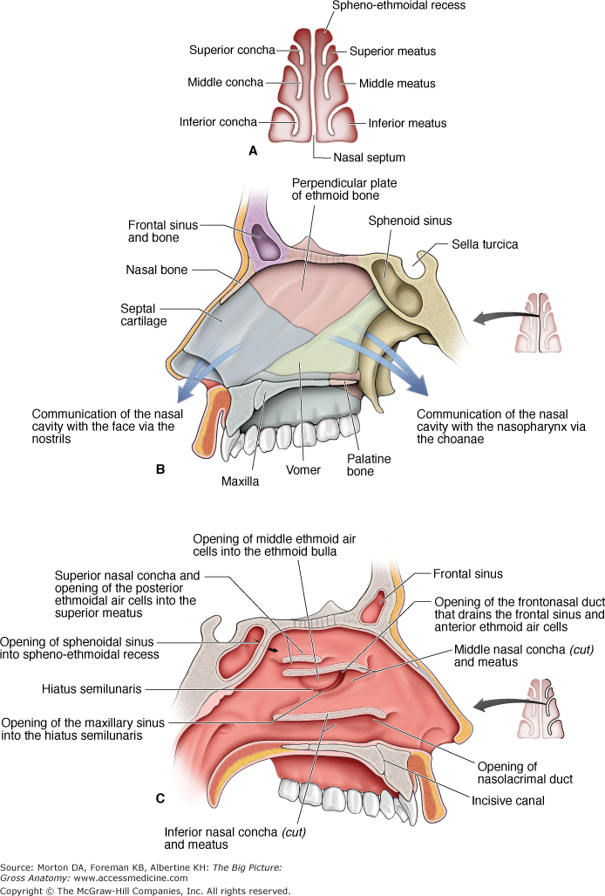
  - Medial wall of the nasal cavity
The medial wall of the nasal cavity comprises the nasal septum, the septal catilage and various bones of the skull.
Nasal skeleton
The nasal septum is a structure consisting of both bony and cartilaginous components. The bony components are the:
- perpendicular plate of the ethmoid superoinferiorly
- the vomer posteroinferiorly
- the crests of the maxillary bone anteroinferiorly
- the crest of the palatine bone inferior to the vomer
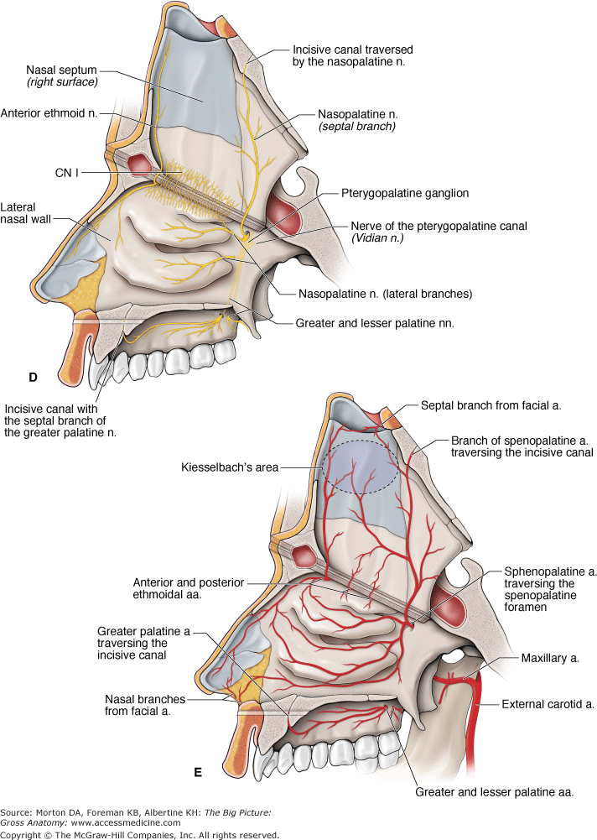
  - Lateral Wall of the nasal cavity
The lateral wall of the nasal cavity is a region of the nasopharynx essential for humidifying and filtering the air we breathe in nasally. The lateral wall is formed by the following:
- Nasal septum
Bones and cartilages
The anterior nasal aperture is simply the area where the anterior bony aspects of both the maxilla and the nasal bone terminate and form an opening into the cartilaginous nasal vestibule. The structure is also referred to as the piriform aperture.
Three cartilages contribute to the nasal septum:
- lesser alar cartilages are paired cartilages suspended in the fibro-fatty tissue that forms the lateral aspect of the nostril. The structures lie free from the other cartilages and provide the nostril with stability and form.
- greater alar cartilages are paired cartilages that form part of the antero-superior nostril as well as the nasal tip. The structures give the tip of the nose stability and flexibility and are a crucial element of the cartilaginous apparatus of the nose.
- lateral nasal cartilages are structures that articulate inferiorly with the greater alar cartilages and superiorly with the anterior nasal aperture formed by both the nasal bone superiorly and for a short part of its border with the perpendicular plate of the ethmoid bone. These structures form the cartilaginous part of the bridge of the nose and form in conjunction with the greater alar cartilages, the major structural appearance of the nose.
Nasal skeleton; ethmoid, frontal, lacrimal, nasal and palatine bones.
- Nasal conchae
We can find 3 types of nasal conchae in the nasal cavity. Those are:
- inferior nasal concha. It is the longest and broadest of the conchae and is formed by an independent bone (of the same name, inferior concha). The concha is covered by a mucous membrane that contains large vascular spaces and is one of the three that work to both humidify and clear the air that passes into the nasopharynx.
- superior and middle nasal conchae arise from the perpendicular plate of the ethmoid bone. The middle nasal concha is found in between the superior and inferior nasal concha and plays a role in humidifying and clearing inspired air of micro-particles such as dirt. The superior nasal concha is a bony shelf located above the middle nasal concha and below the sphenoethmoidal recess. Similar to the middle nasal concha the superior concha is itself part of the ethmoid bone.
They project into the nasal cavity, creating four pathways for the air to flow. These pathways are called meatuses:
- Inferior meatus – between the inferior concha and floor of the nasal cavity. The space inferior to the inferior nasal concha, with an opening for the nasolacrimal duct, which drains tears from the eye into the nasal cavity.
- Middle meatus – between the inferior and middle concha. The space inferior to the middle nasal concha, with openings for the frontal sinus via the nasofrontal duct, the middle ethmoidal air cells on the ethmoidal bulla, and the anterior ethmoidal air cells and maxillary sinus in the hiatus semilunaris.
- Superior meatus – between the middle and superior concha. The space inferior to the superior nasal concha, with openings from the posterior ethmoidal air cells.
- Spheno-ethmoidal recess – superiorly and posteriorly to the superior concha. The space between the superior nasal concha and the sphenoid bone, with openings from the sphenoid sinus.
Sphenopalatine foramen. An opening posterior to the middle nasal concha receives the nasopalatine nerve and the sphenopalatine artery from the pterygopalatine fossa into the nasal cavity.
The function of the conchae is to increase the surface area of the nasal cavity – this increases the amount of inspired air that can come into contact with the cavity walls. They also disrupt the fast, laminar flow of the air, making it slow and turbulent. The air spends longer in the nasal cavity, so that it can be humidified.
A structure called agger nasi, or ‘nasoturbinal concha’ or ‘nasal ridge’ is in the lateral wall. It can be described as a small mound or ridge found in the lateral side of the nasal cavity. The structure is located midway along the anterior aspect of the middle nasal concha. An abnormally enlarged form may restrict the drainage of the frontal sinus by obstructing the frontal recess area.
- Sinusitis
Sinusitis is an inflammation of the different sinuses found in the head. That type of inflammation may result in different symptons inluding:
- plugged nose;
- nasal mucus;
- and pain in the facial region.
The frontal bones overlies the frontal lobe of the brain and lies anteriorly forming the brow, forehead and one third of the anterior scalp. The bone contains the frontal sinus, which in sinusitis and nasal infections can become filled with fluid.

