NAME: ABASIAKARA SAMUEL UMANA
MATRIC NUMBER: 17/MHS01/311
COURSE: GROSS ANATOMY OF THE HEAD AND NECK
COURSE CODE: ANA 301

Anatomy of the tongue
The tongue in lay man's terms is a fleshy muscular organ in the mouth of a mammal, used for tasting,licking, swallowing and articulating speech. It is a unique organ located in the oral cavity that facilitates perception of gustatory stimuli but also plays important roles in mastication and deglutition. It is mobile and partly in the oral cavity and partly in the oropharynx.

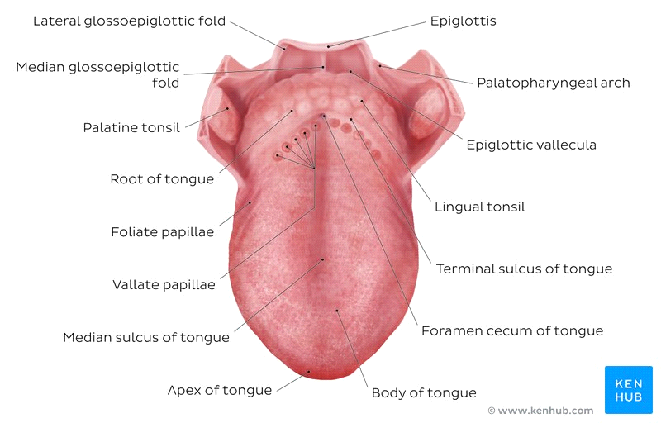

Functions of the tongue.
- It is used in detecting tatse in food and other substances.
- It is an important accessory organ in the digestive system as it is involved in mastication.
- Its intrinsic muscles are involved in speech.
- It plays a role in physical intimacy and sexuality.
Parts of the tongue.
The tongue is divided into 2 parts which are divided by the circumvallate papilae:
- Oral part which makes up the anterior 2/3 of the tongue.
- Pharyngeal part which makes up the posterior 1/3 of the tongue.
The tongue is subdivided into
- Apex/tip: is the anterior end of the body which rest against the incisor teeth. It is mobile.
- Body: is the anterior 2/3 of the tongue. It is related to the floor of the oral cavity.
- Root: part that rests on the floor of the mouth. It is attached to the mandible and hyoid bone.
- Lateral borders: related to the gum and tooth of inferior alveolar process
- Surfaces: the tongue has 2 surfaces:
- Ventral surface: it is the undersurafce of the tongue and its continuous with the floor of the mouth.
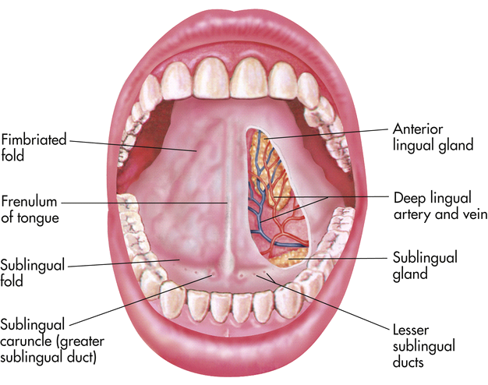

Lingual frenulum: runs vertically from yhe floor of the mouth to the undersurface of the tongue. It is involved in the movement of the tongue
Deep lingual veins: on either side of the frenulum
Plica fimbriata: mucosal fold on either side of the deep lingual veins
- Dorsal surface: this is the posterosuprerior surface of the tongue which is located partly in the oral cavity and partly in oropharynx. It is characterized by a V-shaped groove called the terminal sulcus or groove; separates the oral and pharyngeal surfaces. Posterior to the groove is the foramen cecum; apex of the V- shaped sulcus (a small depression). Thyroglossal duct; connects the foramen cecum with the thyroid gland in the neck. Lymphatic aggregations; located on the posterior 1/3. The dorsal surface also has papillae; tiny finger like projections which are on the anterior 2/3.
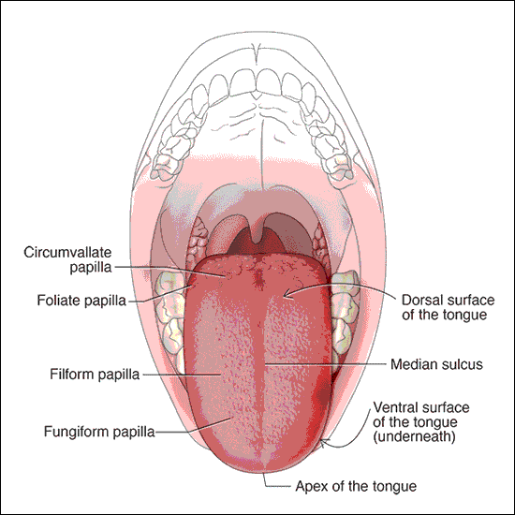

The papillae are of four types:
- Filiform papillae: small cone-shaped with oneor multi ends. They are present over the anterior 2/3 of the tongue. It acts as an abrasive coating for cleaning and grasping action. It does not contain taste buds.
- Fungiform papillae: these are round shaped and larger than filiform papillae. They are present on the tip and margins of the tongue. It has taste buds embedded in its surfaces. They respond to both sweet and sour tastes.
- Foliate papillae: red leaf-like mucosal ridges. They are present at the sides near the sulcus terminalis. It has numerous taste buds.
- Circumvallate papillae: these are large cylindrical structures. They are 8-12 in number and form a 'V' shaped row in front of sulcus terminalis.
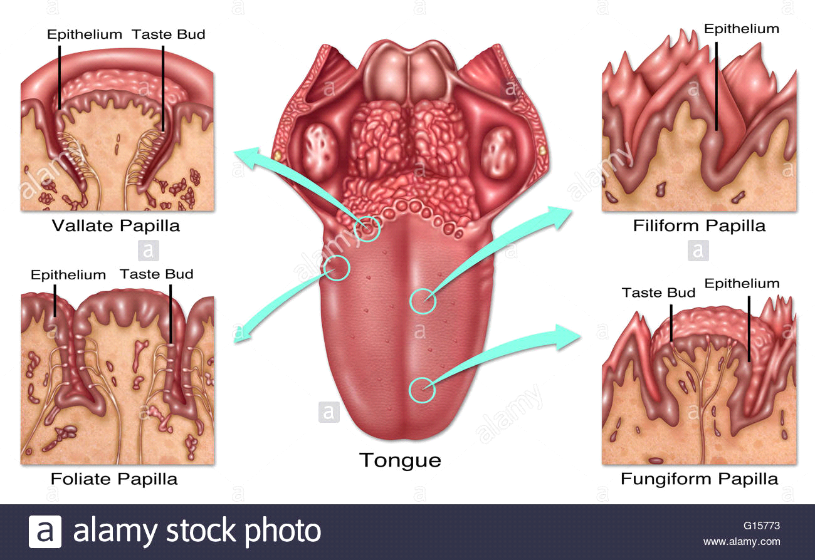

Taste Sensations;
- Sweet: detected at the apex
- Saltiness: detected at the anterolateral margins
- Sourness: detected at the posterolateral margins
- Bitterness: detected at the posterior part of the tongue
Muscles of the Tongue.
The tongue is a mass of muscles that is covered by a mucous membrane. All tongue muscles are paired. It comprises of the extrinsic muscles that alter the position of the tongue and intrinsic muscles that alter the shape.
Extrinsic muscles.
1. Genioglossus: this is the safety muscle of the tongue.
Origin: superior genial tubercle(mandible) above the origin of geniohyoid.
Insertion: fan shaped radiated fibres insert into mucous membrane of the tongue. Lowest fibres passing down to the hyoid body.
Action: Potrusion, central part depression, diversion to the opposite side
2. Hyoglossus:
Origin: Greater cornu and body of hyoid bone.
Insertion: side of the tongue between styloglossus and inferior longitudinal.
Actions: depresses the tongue.
3. Chondroglossus: part of hypoglossus separated from it by the genioglossus.
Origin: medial side and base of lesser cornua of hyoid.
Insertion: intrinsic musculature between hypoglossus and genioglossus.
4. Styloglossus:
Origin: styloid process near its apex.
Insertion: longitudinal part into the inferior longitudinal muscles. Oblique part into hypoglossus.
Action: draws the tongue upwards and backward.
5. Palatoglossus: a part of soft palate than the tongue.
Origin: palatine aponeurosis of soft palate.
Insertion: side of the tongue.
Action: elevates the posterior part of the tongue, approximates the palatoglossal folds to constrict the ororpharyngeal isthmus.
Intrinsic muscles: originates and insert within the substance of the tongue.
1. Superior longitudinal muscle:
Origin: submucous fibrous layer below the dorsum of the tongue and lingual septum.
Insertion: extends to the lingual margin.
Action: turns the apex and sides of the tongue upwards to make the dorsum concave.
2. Inferior longitudinal muscle: narrow band close to the inferior surface of the tongue.
Origin: root of the tongue and body of the hyoid bone.
Insertion: apex of the tongue.
Action: curls the tip inferiorly and shortens the tongue.
3. Transverse muscles:
Origin: median fibrous septum.
Insertion: fibrous tissue at the margins of the tongue.
Action: narrows and elongates the tongue.
4. Vertical muscles:
Origin: dorsum surface of the borders of the tongue.
Insertion: ventral surface of the borders of the tongue.
Action: flattens and broadens the tongue.
Arterial supply of the tongue.
The arteries of the tongue are derived from the lingual artery which arise from the external carotid artery. The lingual artery gives rise to the:
- Dorsal lingual arteries supply the posterior part. They do not communicate due to the lingual septum.
- Deep lingual arteries supply the anterior part. These arteries communicate with each other near the apex of the tongue.
- Sublingual artery: supplies the sublingual gland and floor of the mouth.
Venous drainage.
- Dorsal lingual vein: drains the dorsum and sides of the tongue.
- Deep lingual veins: drains the tip of the tongue and sublingual veins.
These veins terminate directly and indirectly into the internal jugular veins.
Lymphatic drainage.
It takes 4 routes:
- lymph from the posterior 3rd drains into the superior deep cervical lymph nodes.
- Lymph from the medial part of the anterior 2/3 drains directly to the inferior deep cervical lymph nodes.
- Lymph from the lateral parts of the anterior 2/3 drains to the submandibular lymph nodes.
- The apex and frenulum drain to the submental lymph nodes.
- The posterior 3rd and medial part of the anterior 2/3 drain bilaterally.
Innervation.
1. Motor innervation: all muscles of the tongue(extrinsic and intrinsic) are supplied by the hypoglossal nerve CNXII except the palatoglossus which is supplied by the vagus nerve CNX.
2. Sensory innervation:
The anterior 2/3 of the tongue is supplied by: lingual nerve CNV₃ for general sensation and chorda tympani(branch of facial nerve CNVII) for taste.
The posterior 3rd of the tongue and the vallate papillae are supplied by lingual branch of the glossopharyngeal nerve CNIX for sensation and taste. Contribution comes from the internal laryngeal branch of the vagus nerve CNX for general sensation and taste.
Clinical Anatomy.
1. Aglossia: congenital defect resulting in partial development or complete absence of a tongue. It is commonly associated with craniofacial and limb defects.
2. Hemiglossia: failure of formation of one side lingual swelling.
3. Bifid tongue: aka cleft tongue is a tongue with groove or split running along the tip of the tongue. It is as a result of incomplete fusion of the distal tongue buds.

Air Sinuses.
Air sinuses are popularly known as Paranasal Sinuses are air cavities that help circulate air that is breathed in and out of the respiratory system. They are located within the bones of the skull and facial bones. They are situated around the nasal cavity and they are paired.
There are FOUR paired paranasal sinuses which are named aaccording to the bone in which they are located:
- Maxillary sinuses
- Frontal sinuses
- Sphenoid sinuses
- Ethmoid sinuses
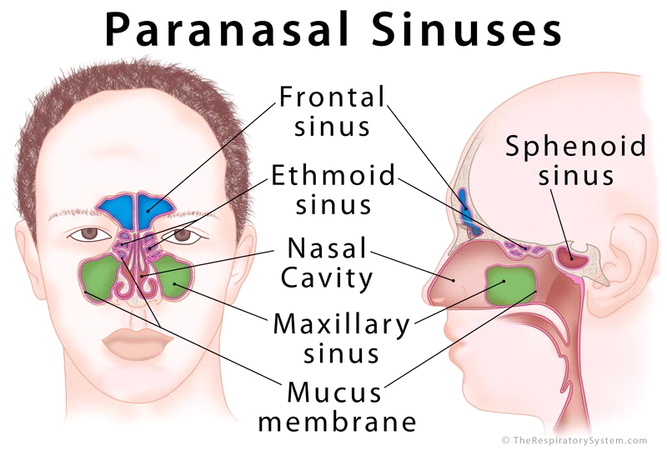

These sinuses are formed in childhood by the nasal cavity eroding into surrounding bone. Openings to the parranasal sinuses are found on the roof and lateral walls of the nasal cavity. The inner surface is lined by a respiratory mucosa.
Functions of Paranasal Sinus.
1. Lightening the weight of the head.
2. Humidifying and heating inhaled air.
3. Increases the resonance of speech.
4. Serves as a crumple zone to protect vital structures.
Development of Paranasal sinuses.
They appear as diverticula from nasal cavity. The enlargement of these sinuses is associated with overall enlargement of facial skeleton. They begin their development at the end of the 3rd month of development as outpouchings of the mucous membrane of the middle and superior nasal meatus.
The maxilary sinus is the 1st to develop around the 10th week. It develops ffrom the envagination from primitive ethmoid infundibulum in the lateral walls of the middle meatus. It is the largest sinus
The sphenoidal sinus starts developing at the 4th month by constricting the posterosuperior portion of the spheno-ethmoid recess. It continues growing in early adulthood and may invade the wings of the sphenoid.
The ethmoidal sinus starts developing at the 4th month by its cells invading the nasal capsule. The most anterior ethmoidal cells grow upward into the frontal bone which may form frontal sinus.
The frontal sinus starts its invagination at the 3-4 months and it does not invade the frontal bone till between 6months and 2 years.
Now lets look at the sinuses in detail;
1. Maxillary Sinuses: they are the largest of all the paranasal sinuses. They have thin walls which are often penetrated by long roots of the posterior maxillary teeth. The superior border of this sinus is the orbit, the inferior border is the maxillary alveolar bone and corresponding tooth roots, the medial border is made up of the nasal cavity and the lateral and anterior border are bound by the zygomatic bones. Lymph from this sinus drain into the submandibular lymph nodes. They receive blood from the;
>. Anterior superior alveolar artery.
>. Middle superior artery.
>. posterior superior alveolar artery.
They are innervated by the nerves accompanying the arteries
2. Frontal Sinuses: anteriorly, the frontal sinuses are contained by the forehead and superciliary arches, superiorly and posteriorly by the anterior cranial fossa and inferiorly by the orbit, anteriro ethmoidal sinuses and the nasal cavity. Medially the sinuses face one another separated by the midline. They are irregular in shape when compared. They start to develop after birth and reach full size and shape around 7-8 years of age. The lymph from these sinuses drain into the ethmoidal infundibulum and the lymph drains into the submandibular lymph nodes. It is innervated by the ophthalmic nerve. Blood supply is from;
>. Anterior ethmoidal artery.
>. Supraorbital artery.
>. Supratrochlear artery.
3. Sphenoidal sinuses: this is the most posterior of all sinuses in the head. They are large and irregular. Lateral to this sinus a cavernous sinus exists in the middle cranial fossa which allows for the passage of certain structures like the carotid artery and cranial nerve III, IV, V_{1,} V₂ , VI. The anterior wall; nasal cavity separates the pair of sinuses. The hypophyseal fossa, pituitary gland and optic chiasm superiorly and nasopharynx and pterygoid canal inferiorly. The lymphatic drainage is the same as the ethmoid sinus. It is innervated by the posterior ethmoidal nerve and orbital branch ofthe pterygopalantine ganglion. Blood supply is from;
>. Posterior ethmoidal artery.
>. Posterior lateral nasal branch.
4. Ethmoidal Sinuses: superior to the ethmoidal sinus is the anterior cranial fossa and the frontal bone. To the lateral side the orbitcan be found. Medially the nasalcavity is situated. The ethmoid sinuses are unique because they are the paranasal sinuses that are more complex than just a single cavity instead they make up to 3-18 ethmoidal cavities. They drain lymph from the anterior and middle ethmoid sinuses into the submandibular lymph nodes while the posterior ethmoid sinus drain into the retropharyngeal lymph nodes. It is innervated by the anterior and posterior ethmoidal nerves, posterior lateral superior nerve and inferior nasal nerve. Blood supply is from;
>. Anterior ethmoidal artery.
>. Posterior ethmoidal artery.

