ABASIAKARA UMANA SAMUEL
17/MHS01/311
GROSS ANATOMY OF HEAD AND NECK
ANA 301

CARVENOUS SINUS
The cavernous sinus is a paired dural venous sinus (channels between the two layers of dura mater which are responsible for the venous drainage of the brain, skull, orbit and internal ear) located within the cranial cavity. It is divided by septa into small ‘caves’ hence the name.
It is a true dural venous sinus and not a venous plexus.
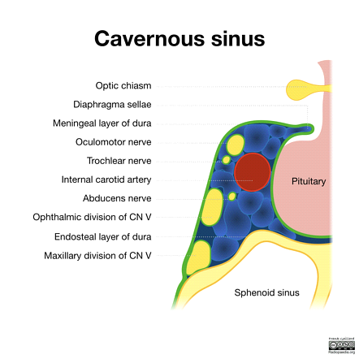

Location and Borders
The cavernous sinuses are located within the middle cranial fossa, on either side of the sella turcica of the sphenoid bone. They are enclosed by the endosteal and meningeal layers of the dura mater.
>. Anterior – superior orbital fissure.
>. Posterior – petrous part of the temporal bone.
>. Medial – body of the sphenoid bone.
>. Lateral – meningeal layer of the dura mater running from the roof to the floor of the middle cranial fossa.
>. Roof – meningeal layer of the dura mater that attaches to the anterior and middle clinoid processes of the sphenoid bone.
>. Floor – endosteal layer of dura mater that overlies the base of the greater wing of the sphenoid bone.
Contents:
Many important structures pass through the cavernous sinus to enter the orbit:
Travels through cavernous sinus:
>. Travels through lateral wall of cavernous sinus:
>. Abducens nerve (CN VI)
>. Carotid plexus (post-ganglionic sympathetic nerve fibres)
>. Internal carotid artery (cavernous portion)
Travels through lateral wall of cavernous sinus:
>. Oculomotor nerve (CN III)
>. Trochlear nerve (CN IV)
>. Ophthalmic (V1) and maxillary (V2) branches of the trigeminal nerve
The cavernous sinus is the only site in the body where an artery (internal carotid) passes completely through a venous structure. This is thought to allow for heat exchange between the warm arterial blood and cooler venous circulation.
The carvenous sinus also serves an important role as drainage from these structures:
1. Ophthalmic veins (superior and inferior) – these enter the cavernous sinus via the superior orbital fissure.
2. Central vein of the retina – drains into the superior ophthalmic vein, or directly into the cavernous sinus.
3. Sphenoparietal sinus – empties into the anterior aspect of the cavernous sinus.
4. Superficial middle cerebral vein – contributes to the venous drainage of the cerebrum
5. Pterygoid plexus – located within the infratemporal fossa.
The cavernous sinuses empty into the superior and inferior petrosal sinuses, and into the internal jugular vein. The left and right cavernous sinuses are connected in the midline by the anterior and posterior intercavernous sinuses. They travel through the sella turcica of the sphenoid bone.
Clinical Anatomy
It is clinically important because of its location, its close relationship to several cranial nerves and the internal carotid artery and the complex veins without valves it drains from.
1. Cavernous sinus thrombosis (CST) refers to the formation of a clot within the cavernous sinus.
This most common cause of CST is infection; which typically spreads from an extracranial location such as the orbit, paranasal sinuses, or the ‘danger zone’ of the face. Infection is able to spread in this manner due to the anastomosis between the facial vein and superior ophthalmic veins.
Common clinical features include headache, unilateral periorbital oedema, proptosis (eye bulging), photophobia and cranial nerve palsies. The abducens nerve (CN VI) is most commonly affected.
Treatment is typically with antibiotic therapy. Where the cause is infection, thrombosis of the cavernous sinus can rapidly progress to meningitis.

WALLS OF THE NOSE.
The nose is the primary organ of smell and it functions as part of the body's respiratory system. It is composed of External nose and Nasal cavity. The nose is made up of bones, cartilage and soft tissue which provide strong protection for the internal structures of the nose, movement and allows flexibility through muscle control.
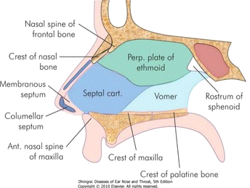

The walls of the external nose is made up of bones and cartilage
Anteriorly;
Nasal bone
Frontal part of nasal bone
Laterally;
Frontal processes of maxilla
Medially and Posteriorly;
Plates of hyaline cartilage

The Nasal cavity has;
1. A roof
2. A floor
3. Lateral wall
4. Medial wall
Roof
The roof is narrow and formed anteriorly by nasal bones and frontal bones, medially by cribiform plate of the ethmoidand posteriorly by the downward sloping body of the sphenoid
Floor
This also forms the roof of the mouth and it separates the nasal cavity from the oral cavity. It is made up of bones of the hard palate: the horizontal plate of the palatine bone posteriorly and palatine process of the maxilla anteriorly
Lateral wall
It is irregular due to the presence of 3 shelf like bony projections called conchae. These conchae increase the surface area of the nose for effective air conditioning of inspired air. The conchae are Superior conchae, Middle conchae and Inferior conchae. The space below each conchae is called Meatus. This wall is didvied into:
1. Vestibule
2. Atrium
3. Posterior part containing the conchae
The skeleton of this wall is formed by :
1. Nasal bone
2. Frontal process of maxilla
3. Lacrimal bone
4. Inferior nasal conchae
5. Perpendicular plate of palatine bone
6. Medial pterygoid plate
The cartilaginous part includes:
1. Superior nasal cartilage
2. Inferior nasal cartilage
3. Small cartilages of ala
Medial wall
This is also known as the nasal septum that divides the nasal cavity into right and left halves. It has osseous and cartilaginous parts. It has superior and inferior borders, right and left surfaces.
the bony and osseous part includes:
1. Perpendicular plate of the ethmoid
2. Vomer
The cartiliginous part includes:
1. Septal cartilage
2. Septal processes of the inferior nasal cartilages

