MATRIC NO: 17/mhs01/275
NAME: Osubor Stephanie
COURSE: ANA 301
QUESTION 1
Anatomy of the Tongue
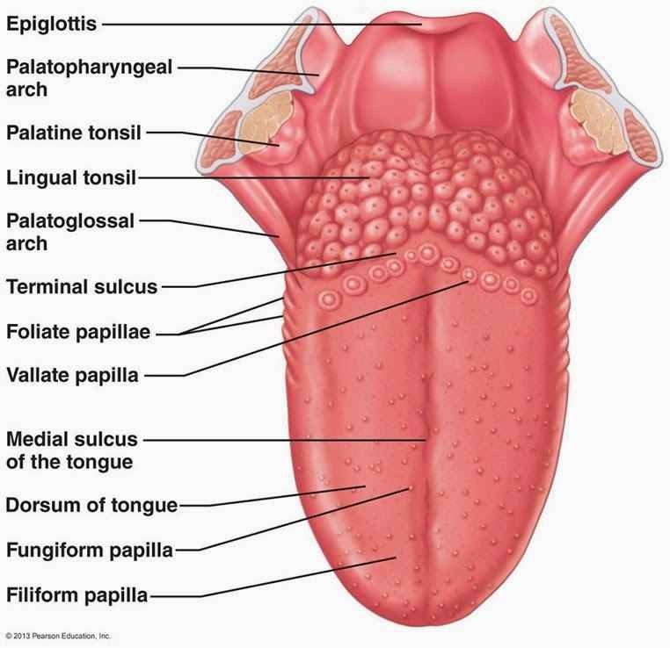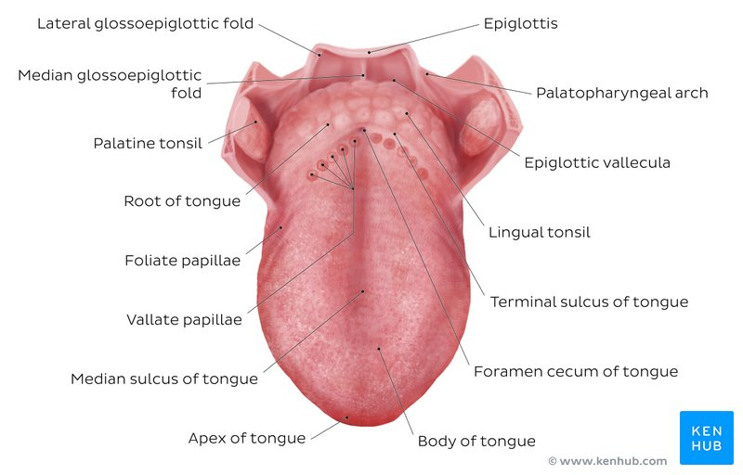

The tongue is a mass of muscle that is almost completely covered by a mucous membrane. It occupies most of the oral cavity and oropharynx. It is known for its role in taste, but it also assists with mastication (chewing), deglutition (swallowing), articulation (speech), and oral cleansing. Five cranial nerves contribute to the complex innervation of this multifunctional organ.
The embryologic origins of the tongue first appear at 4 weeks' gestation. The body of the tongue forms from derivatives of the first branchial arch. This gives rise to 2 lateral lingual swellings and 1 median swelling (known as the tuberculum impar). The lateral lingual swellings slowly grow over the tuberculum impar and merge, forming the anterior two thirds of the tongue. Parts of the second, third, and fourth branchial arches give rise to the base of the tongue. Occipital somites give rise to myoblasts, which form the intrinsic tongue musculature.
Histology
The lingual mucosa is covered by stratified squamous epithelium with varying degrees of keratinization. Since the dorsal surface of the oral tongue is more at risk for desiccation and abrasions from contact with food boluses of varying temperatures and textures, it is covered by epithelium that is keratinized. However, the ventral surface of the tongue as well as the pharyngeal part, are relatively well protected from the harsh environment. Therefore, the epithelia in these areas are non-keratinized. The epithelium is adherent to the underlying striated muscle fibers of the tongue. There is a fibrous raphe in the midline of the tongue that marks the point of fusion of the embryonic lateral lingual swellings. Posteriorly, there is a variable amount of adipose tissue within the pharyngeal tongue.
The dorsal mucosa of the oral tongue is characterized by numerous raised structures known as lingual papillae. They give the characteristic rough appearance of the dorsal surface that is not appreciated on the ventral surface of the tongue. The pharyngeal tongue also has raised dome-like structures throughout the mucosa. However, these are lymphatic aggregates (i.e. lingual tonsils) and should not be confused with papillae.
The lingual papillae
There are four types of lingual papillae found on the surface of the human tongue. These include:
- Filiform papillae are the most abundant of the four types of papillae. They are stretched, conical, grey-white papillae that are covered in a heavy coat of keratinized squamous epithelium. By making the dorsal surface of the tongue rough, these papillae provide friction to allow movement of the food bolus during chewing. It should be noted that these papillae do not possess taste buds.
- Fungiform papillae are weakly keratinized and less abundant than the filiform papillae. However, they are scattered across the entire dorsal surface of the tongue. These highly vascular, mushroom-shaped papillae contain a few taste buds on the apical aspect.
- Foliate papillae appear as bilaterally paired, parallel, longitudinal slits on the posterolateral margin of the tongue, near the sulcus terminalis. The mucosa is non-keratinized and the papillae are populated with numerous taste buds.
- Circumvallate (Vallate) papillae are organized linearly, as a set of four to six large papillae anterior to each limb of the sulcus terminalis (i.e. eight to twelve papillae in total). In longitudinal section, the characteristic furrow found within the papillae can be appreciated. These moats facilitate the drainage of serous salivary von Ebner glands that empty into the structure. The persistent lubrication creates a favorable environment for gustatory particles to dissolve so that they can be detected by the taste buds.
The taste buds
While taste buds are distributed throughout the entire oral cavity, they are at higher concentrations on the tongue. Each taste bud is clear, oval and covered by stratified squamous epithelium. A combination of elongated taste (gustatory), supportive, and basal stem cells can be found within each taste bud. The gustatory cells have an apical taste pore surrounded by numerous microvilli that binds dissolved molecules and brings them closer to the receptors responsible for taste. However, these cells have a relatively high turnover rate, as their shelf life is roughly seven to ten days. There are five gustatory sensations that are perceived by individuals. These are sweet, salty, sour, bitter, and umami. The microvilli found on the apical surface of the taste cells are equipped with various receptors that bind to varying molecules. The reaction generated from this compound-receptor interaction gives rise to varying action potentials that are subsequently perceived as taste.
Gross Anatomy
From anterior to posterior, the tongue has 3 surfaces: tip, body, and base. The tip is the highly mobile, pointed anterior portion of the tongue. Posterior to the tip lies the body of the tongue, which has dorsal (superior) and ventral (inferior) surfaces
The median sulcus of the tongue separates the body into left and right halves. The terminal sulcus, or groove, is a V-shaped furrow that separates the body from the base of the tongue. At the tip of this sulcus is the foramen cecum, a remnant of the proximal thyroglossal duct. The base of tongue contains the lingual tonsils, the inferiormost portion of Waldeyer’s ring.
Musculature
The tongue has 4 intrinsic and 4 extrinsic muscles (see Table 1 and the image below). ^{[4]} The muscles on each side of the tongue are separated by a fibrous lingual septum. Extrinsic muscles are so named because they originate outside the tongue and insert within it; intrinsic muscles are within the substance of the organ and do not insert on bone. Although the muscles do not act in isolation, intrinsic muscles generally alter the shape of the tongue, whereas extrinsic muscles alter its position.
Intrinsic Muscles
The intrinsic muscles only attach to other structures in the tongue. There are four paired intrinsic muscles of the tongue and they are named by the direction in which they travel: the superior longitudinal, inferior longitudinal, transverse and vertical muscles of the tongue. These muscles affect the shape and size of the tongue – for example, in tongue rolling – and have a role in facilitating speech, eating and swallowing.
- The superior longitudinal muscle runs along the upper surface of the tongue under the mucous membrane, and elevates, assists in retraction of, or deviates the tip of the tongue. It originates near the epiglottis, at the hyoid bone, from the median fibrous septum.
- The inferior longitudinal muscle lines the sides of the tongue, and is joined to the styloglossus muscle.
- The vertical muscle is located in the middle of the tongue, and joins the superior and inferior longitudinal muscles.
- The transverse muscle divides the tongue at the middle, and is attached to the mucous membranes that run along the sides.
Extrinsic Muscles
The extrinsic muscles are as follows:
- Genioglossus
Attachments: Arises from the mandibular symphsis. Inserts into the body of the hyoid bone and the entire length of the tongue.
Function: Inferior fibres protrude the tongue, middle fibres depress the tongue, and superior fibres draw the tip back and down
- Hyoglossus
Attachments: Arises from the hyoid bone and inserts into the side of the tongue
Function: Depresses and retracts the tongue

- Styloglossus
Attachments: Originates at the styloid process of the temporal bone and inserts into the side of the tongue
Function: Retracts and elevates the tongue
- Palatoglossus
Attachments: Arises from the palatine aponeurosis and inserts broadly across the tongue
Function: Elevates the posterior aspect of the tongue
Innervation: Motor innervation via the vagus nerve (CNX).
Vasculature
Similar to most of the head and neck region, the tongue derives its arterial blood supply from the external carotid artery. The lingual artery branches off the external carotid artery deep to the stylohyoid muscle. At first, it travels superomedially; after a short distance, it changes direction and moves anteroinferiorly. The hypoglossal nerve (cranial nerve XII) crosses over it laterally before it enters the tongue deep in the hyoglossus muscle.
Within the tongue, the lingual artery gives rise to its 3 main branches: the dorsal lingual, deep lingual, and sublingual arteries. The dorsal lingual artery supplies the base of the tongue. The deep lingual artery travels on the lower surface of the tongue to the tip. A branch to the sublingual gland and the floor of the mouth is known as the sublingual artery.
The veins of the tongue parallel the lingual artery branches. The deep lingual vein begins at the tip of the tongue and travels posteriorly to join the sublingual vein. This drains into the dorsal lingual vein, which accompanies the lingual artery. Directly or indirectly, this vein empties into the internal jugular vein.
Nerve supply (Innervation)
Motor innervation for all of the muscles of the tongue comes from the hypoglossal nerve--with the exception of the palatoglossus, which is supplied by the pharyngeal plexus (fibers from the cranial root of the spinal accessory nerve carried by the vagus nerve)
General sensation of the anterior two thirds of the tongue is supplied by the lingual nerve, a terminal branch of the third division of the trigerminal nerve V3). Taste sensation for this portion of the tongue is carried by the chorda tympani branch of the facial nerve. The posterior third of the tongue relays general and sensation via the lingual-tonsillar branch of the glossopharyngeal nerve. Some general and taste sensation from the base of tongue anterior to the epiglottis is carried by the internal laryngeal branch of the superior laryngeal nerve (CN X). Injury to the hypoglossal nerve (cranial nerve XII) results in deviation of the tongue toward the paralyzed side during protrusion. The tongue also atrophies over time on the paralyzed side.
Lymphatic drainage
The lymphatic drainage of the tongue is complex. Lymphatics from the tip of the tongue travel to the submental lymph nodes. This can be ipsilateral or bilateral depending on the site of the lesion. Lymph from the medial anterior two thirds of the tongue travels to the deep cervical lymph nodes, and lymph from the lateral anterior tongue goes to the submandibular nodes. The tongue-base lymphatics drain bilaterally into the deep cervical lymph nodes.
APPLIED ANATOMY
- Thrush (candidiasis): Candida albicans (a yeast) grows over the surface of the mouth and tongue. Thrush can occur in almost anyone, but it occurs more often in people taking steroids or with suppressed immune systems, the very young, and the elderly.
- Oral cancer: A growth or ulcer appears on the tongue and grows steadily. Oral cancer is more common in people who smoke and/or drink alcohol heavily.
- Macroglossia (big tongue): This can be broken down into various categories based on the cause. These include congenital, inflammatory, traumatic, cancerous, and metabolic causes. Thyroid disease, lymphangiomas, and congenital abnormalities are among some of the causes of an enlarged tongue.
- Geographic tongue: Ridges and colored spots migrate over the surface of the tongue, periodically changing its appearance. Geographic tongue is a harmless condition.
- Burning mouth/burning tongue syndrome: a relatively common problem. The tongue feels burned or scalded, or strange tastes or sensations develop. Apparently harmless, burning mouth syndrome may be caused by a mild nerve problem.
- Atrophic glossitis (bald tongue): The tongue loses its bumpy texture, becoming smooth. Sometimes this is due to anemia or a B vitamin deficiency.
- Canker sores (aphthous ulcers): Small, painful ulcers appear periodically on the tongue or mouth. A relatively common condition, the cause of canker sores is unknown; they are unrelated to the cold sores caused by herpes viruses. Canker sores are not contagious.
- Oral leukoplakia: White patches appear on the tongue that can’t be scraped off. Leukoplakia may be benign, or it can progress to oral cancer.
- Hairy tongue: Papillae can overgrow the surface of the tongue, giving it a white or black appearance. Scraping off the papillae corrects this harmless condition.
- Herpes stomatitis: The herpes virus can uncommonly cause cold sores on the tongue. Herpes virus cold sores are usually on the lip.
- Lichen planus: A harmless condition that can affect the skin or the mouth. The cause is unknown; however, it is believed to be caused by the immune system attacking the skin and lining of the mouth.
TREATMENTS
  - Steroid gel: Applying a prescription steroid gel like Lidex hastens the resolution of canker sores.
  - Silver nitrate: Doctors can apply this chemical to a canker sore, speeding healing and relieving pain.
  - Viscous lidocaine: Applied to the tongue, lidocaine gel provides immediate, though temporary, pain relief.
  - Antifungal medicines: Antifungal drugs can eliminate Candida albicans, the thrush-causing fungus. Swish-and-spit mouthwash and pills are both effective.
  - Tongue scraping: Simply scraping the tongue can usually remove the overgrown papillae causing black or white hairy tongue.
  - B vitamins: A B vitamin supplement can correct a vitamin deficiency, if present.
  - Tongue surgery: Surgery may be required to remove oral cancer or leukoplakia.

QUESTION 2
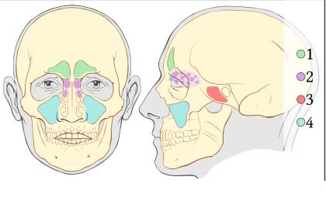
AIR SINUSES
These are the paranasal sinuses. The paranasal sinuses are air-filled extensions of the respiratory part of the nasal cavity. There are four paired sinuses, named according to the bone in which they are located; maxillary, frontal, sphenoid and ethmoid.
The function of the sinuses is not clear. It is thought that they may contribute to the humidifying of the inspired air. They also reduce the weight of the skull.
Sinuses are formed in childhood by the nasal cavity eroding into surrounding bone. As they are outgrowths of the nasal cavity, they all drain back into it – openings to the paranasal sinuses are found on the roof and lateral walls of the nasal cavity. The inner surface is lined by a respiratory mucosa.
- Frontal Sinuses: The frontal sinuses, superior to the eyes, in the frontal bone, which forms the hard part of the forehead. They are also innervated by the trigeminal nerve (CN Vi).These are the most superior in location, found under the forehead. The frontal sinuses are variable in size, but always triangular-shaped. They drain into the nasal cavity via the frontonasal duct, which opens out at the hiatus semilunaris on the lateral wall.
- Ethmoidal Sinuses: The ethmoidal sinuses, which are formed from several discrete air cells within the ethmoid bone between the nose and the eyes. They are innervated by the ethmoidal nerves, which branch from the nasociliary nerve of the trigeminal nerve (CN Vi).There are three ethmoidal sinuses; anterior, middle and posterior. They empty into the nasal cavity at different places:
- Anterior – Hiatus semilunaris
- Middle – Ethmoid bulla
- Posterior – Superior meatus
- Sphenoid Sinuses: The sphenoidal sinuses, in the sphenoid bone. They are innervated by the trigeminal nerve (CN Vi & Vii). The sphenoid sinuses also lie relatively superiorly, at the level of the spheno-ethmodial recess. They are found more posteriorly, and are related superiorly and laterally to the cranial cavity. The sphenoid sinuses drain out onto the roof of the nasal cavity. The relationships of this sinus are of clinical importance – the pituitary gland can be surgically accessed via passing through the nasal roof, into the sphenoid sinus and through the sphenoid bone.

- Maxillary Sinuses: The largest of the sinuses. It is located laterally and slightly inferiorly to the nasal cavities. It drains into the nasal cavity at the hiatus semilunaris, underneath the frontal sinus opening. This is a potential pathway for spread of infection – fluid draining from the frontal sinus can enter the maxillary sinus.
Clinical Relevance: Sinusitis
The paranasal sinuses are joined to the nasal cavity via small orifices called ostia. These become blocked easily by allergic inflammation, or by swelling in the nasal lining that occurs with a cold. If this happens, normal drainage of mucus within the sinuses is disrupted, and sinusitis may occur.
As the paranasal sinuses are continuous with the nasal cavity, an upper respiratory tract infection can spread to the sinuses. Infection of the sinuses causes inflammation (particularly pain and swelling) of the mucosa, and is known as sinusitis. If more than one sinus is affected, it is called pansinusitis.
The maxillary nerve supplies both the maxillary sinus and maxillary teeth, and so inflammation of that sinus can present with toothache.

