Name : Asuk Marvellous .A
Matric No: 17/MHS01/067

1. Discuss the anatomy of the tongue and comment on its applied anatomy

2. Write an essay on the air sinuses

THE TONGUE

Definition:
The tongue is a pink, unique, flexible, muscular organ located in the oral cavity, that not only facilitates the perception of gustatory stimuli, but also play important roles in mastication and deglutition
It is an integral component of the speech pathway as it helps in articulation.
It is about 10cm long
It has three main parts:
- THE TIP OR APEX: The tip or apex of the tongue is the most anterior, and most mobile aspect of the organ.
- THE BODY: The tip is followed by the body of the tongue. It has a rough dorsal (superior) surface that abuts the palate and is populated with taste buds and lingual papillae, and a smooth ventral (inferior) surface that is attached to the floor of the oral cavity by the lingual frenulum.
- THE BASE: The base of the tongue is the most posterior part of the organ. It is populated by numerous lymphoid aggregates known as the lingual tonsils along with foliate papillae along the posterolateral surface.
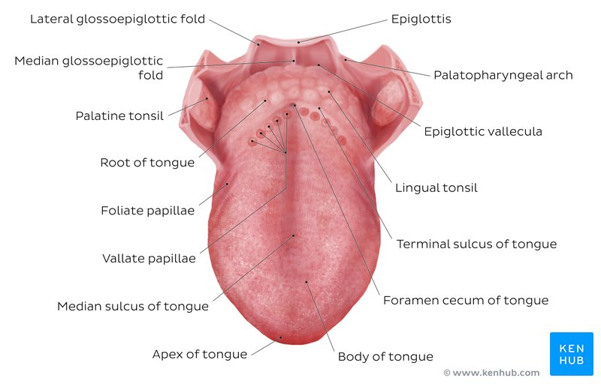

Relations of the Tongue
Anteriorly: Bounded by the Lower rows of the teeth
Posteriorly: Posterior to the base of the tongue is the dorsal surface of the epiglottis and laryngeal inlet, and the posterior wall of the oropharynx
Superiorly: Superiorly, it is bordered by the hard (anterior part) and soft (posterior part) palates
Inferiorly: The root of the tongue is continuous with the mucosa of the floor of the oral cavity; with the sublingual salivary glands and vascular bundles being located below the mucosa of the floor of the oral cavity.
Laterally: The Lower rows of the teeth, The palatoglossal and palatopharyngeal arches (along with the palatine tonsils) have lateral relations to the posterior third of the tongue

Functions:
- TASTE : Presence of taste buds on its dorsal surface, and each taste bud is equipped with the taste receptor cells that can sense particular classes of taste.
- MASTICATION: Used for crushing food against the hard palate
- SPEECH: The intrinsic muscles of the tongue enable the shaping of the tongue which facilitates speech.
- INTIMACY: It plays a role in physical intimacy
- SWALLOWING: The extrinsic muscles play an important role in pressing and molding the food bolus in preparation for the initial phase of swallowing.
Divisions of the Tongue:
- Anterior two-thirds$(2/3)$
- Posterior Third ($1/3)$
The Anterior two-thirds$(2/3)$
The presulcal tongue includes the apex and body of the organ. It terminates at the sulcus terminalis; which can be seen extending laterally in an oblique direction from the foramen cecum towards the palatoglossal arch. The mucosa of the dorsal surface of the oral tongue is made up of circumvallate, filiform, and fungiform papillae. There is also a longitudinal midline groove running in an anteroposterior direction from the tip of the tongue to the foramen cecum. This marks the embryological point of fusion of the lateral lingual swellings that formed the oral tongue. It also represents the location of the median lingual (fibrous) septum of the tongue that inserts in the body of the hyoid bone
On the lateral surface of the oral tongue are foliate papillae arranged as a series of vertical folds. The ventral mucosa of the oral tongue is comparatively unremarkable. It is smooth and continuous with the mucosa of the floor of the mouth and the inferior gingiva. The lingual veins are relatively superficial and can be appreciated on either side of the lingual frenulum. Lateral to the lingual veins are pleated folds of mucosa known as the plica fimbriata. They are angled anteromedially toward the apex of the tongue.
The Posterior Third ($1/3)$
The remainder of the tongue that lies posterior to the sulcus terminalis is made up by the base of the organ. It lies behind the palatoglossal folds and functions as the anterior wall of the oropharynx. Unlike the oral tongue, the pharyngeal tongue does not have any lingual papillae. Instead, its mucosa is populated by aggregates of lymphatic tissue known as the lingual tonsils. The mucosa is also continuous with the mucosa of the laterally located palatine tonsils, the lateral oropharyngeal walls, and the posterior epiglottis and glossoepiglottic folds.
Muscles of the Tongue
The muscles of the tongue are divided into the:
- Intrinsic Muscles;
- Extrinsic Muscles: These are muscles that extend outside of the organ to anchor it to surrounding bony structures
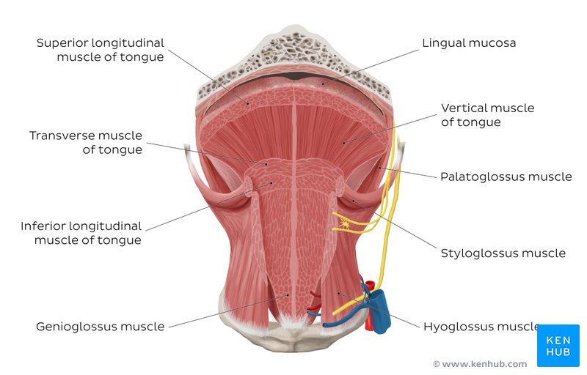

Intrinsic Muscles
: These set of muscles are confined to each half of the organ and contribute to altering the shape of the organ

Muscles | Origin | Insertion | Innervation | Blood supply | Action
Superior Longitudinal | Submucosa of posterior tongue, lingual septum | Apex, anterolateral margins of tongue | Hypoglossal Nerve CNXII | Lingual branch of external carotid artery | Retracts and broadens tongue, elevates apex of tongue
Inferior Longitudinal | Root of tongue, body of hyoid bone | Apex of tongue | Hypoglossal Nerve CNXII | Lingual branch of external carotid artery | Retracts and broadens tongue, lowers apex of the tongue
Transverse | Lingual septum | Lateral margin of Tongue | Hypoglossal Nerve CNXII | Lingual branch of external carotid artery | Narrows and elongates tongue
Vertical | Root of tongue, genioglossus | Lingual Aponeurosis | Hypoglossal Nerve CNXII | Lingual branch of external carotid artery | Broadens and elongates tongue

Extrinsic Muscles
While the shape of the tongue is determined by the intrinsic muscles of the tongue, movement of the organ within (and out of) the oral cavity is dependent on the extrinsic tongue muscles These are muscles that extend outside of the organ to anchor it to surrounding bony structures
Muscles | Origin | Insertion | Innervation | Blood supply | Action
Genloglossus | Superior mental spine of mandible | entire length of dorsum of tongue, lingual aponeurosis, body of hyoid bone | hypoglossal nerve (CN XII) | sublingual branch of lingual artery, submental branch of facial artery | depresses and protrudes tongue (bilateral contraction); deviates tongue contralaterally (unilateral contraction)
Hyoglossus | body and greater horn of hyoid bone | inferior/ventral parts of lateral tongue | hypoglossal nerve (CN XII) | sublingual branch of lingual artery, submental branch of facial artery | depresses and retracts tongue
Styloglossus | Anterolateral aspect of styloid process(of temporal bone) | blends with inferior longitudinal muscle (longitudinal part); blends with hyoglossus muscle (oblique part) | hypoglossal nerve (CN XII) | sublingual branch of lingual artery | retracts and elevates lateral aspects of tongue
Palatoglossus | palatine aponeurosis of soft palate | lateral margins of tongue, blends with intrinsic muscles of tongue | vagus nerve (CN X) (via branches of pharyngeal plexus) | ascending palatine branch of facial artery, ascending pharyngeal artery | elevates root of tongue, constricts isthmus of fauces

The Lingual Papillae
The dorsal mucosa of the oral tongue is characterized by numerous raised structures known as LINGUAL PAPILLAE They give the characteristic rough appearance of the dorsal surface that is not appreciated on the ventral surface of the tongue.
There are four types of lingual papillae found on the surface of the human tongue. These include:
- Filiform papillae are the most abundant of the four types of papillae. They are stretched, conical, grey-white papillae that are covered in a heavy coat of keratinized squamous epithelium. By making the dorsal surface of the tongue rough, these papillae provide friction to allow movement of the food bolus during chewing. It should be noted that these papillae do not possess taste buds.
- Fungiform papillae are weakly keratinized and less abundant than the filiform papillae. However, they are scattered across the entire dorsal surface of the tongue. These highly vascular, mushroom-shaped papillae contain a few taste buds on the apical aspect.
- Foliate papillae appear as bilaterally paired, parallel, longitudinal slits on the posterolateral margin of the tongue, near the sulcus terminalis. The mucosa is non-keratinized and the papillae are populated with numerous taste buds.
- Circumvallate (Vallate) papillae are organized linearly, as a set of four to six large papillae anterior to each limb of the sulcus terminalis (i.e. eight to twelve papillae in total). In longitudinal section, the characteristic furrow found within the papillae can be appreciated. These moats facilitate the drainage of serous salivary von Ebner glands that empty into the structure. The persistent lubrication creates a favorable environment for gustatory particles to dissolve so that they can be detected by the taste buds

The Taste Buds
Each taste bud is clear, oval and covered by stratified squamous epithelium. A combination of elongated taste (gustatory), supportive, and basal stem cells can be found within each taste bud.
There are five gustatory sensations that are perceived by individuals. These are sweet, salty, sour, bitter, and umami

Blood Supply And Lymphatic Drainage

Arterial Supply
The vascular supply to the tongue muscles is provided by derivatives of the lingual artery. This is a branch of the external carotid artery that traverses the region between the middle pharyngeal constrictor and hyoglossus in order to access the floor of the mouth. It takes a sharp superior turn at the anterior border of hyoglossus as it travels alongside CN IX. Of note, the tongue has good collateral supply as the lingual artery also anastomosis with the contralateral vessel. The named branches of the lingual artery are as follows:
- The dorsal lingual arteries are relatively small derivatives of the lingual artery that arise medial to hyoglossus. In addition to supplying the dorsal mucosa of the tongue, it also gives branches to the palatoglossus, soft palate, palatine tonsils, and epiglottis.
- Emerging at the anterior limit of the hyoglossus, the sublingual arteries course between the mylohyoid and genioglossus as it travels towards the sublingual glands in the floor of the oral cavity. As it arborizes, one of its branches anastomoses with the submental branches of the facial artery, while another traverses the gingiva of the mandible to anastomose with the analogous contralateral vessel.
- As the lingual artery terminates near the lingual frenulum on the ventral surface of the tongue, it is referred to as the deep lingual artery.
The lingual artery is supported by other branches of the external carotid artery. The facial artery gives off the ascending palatine and tonsillar arteries that also supply the tongue. The ascending pharyngeal branch of the external carotid artery also supplies the organ.
Venous Drainage
The veins of the tongue are named similarly to the arteries that they accompany. They are formed from numerous venous tributaries that eventually coalesce. As the deep lingual vein forms adjacent to the apex of the tongue, it courses along the ventral surface of the tongue (deep to the mucosa). As the deep lingual vein anastomosis with the sublingual vein, they become the vena comitans of CN XII. This venous network eventually drains to the lingual vein that later join the facial or the anterior division of the retromandibular veins. Here, they form the common facial vein, which is a tributary to the internal jugular vein. Alternatively, the venae comitantes may drain directly to the internal jugular vein.
The dorsal lingual veins are responsible for draining the lateral margins and dorsal surface of the tongue. They travel alongside the similarly named artery as they drain into the internal jugular vein.
Lymphatics
- The MARGINAL and CENTRAL GROUPS drain the anterior parts of the tongue,
- The DORSAL GROUP drains lymph from the posterior third of the organ
Innervation
All the muscles of the tongue are innervated by the hypoglossal nerve (also known as cranial nerve XII) with the exception of the palatoglossus muscle that is innervated by a branch of the pharyngeal plexus. Sensation, including touch and temperature, of the anterior two-thirds of the tongue’s surface, is supplied by the lingual nerve (a branch from the trigeminal nerve). Taste is a special sensation and it comes from the chorda tympani nerve, branching from the facial nerve. The back third of the tongue receives its general and special sensation innervation from a branch of the glossopharyngeal nerve. Just forward of the epiglottis is a small patch of the tongue that receives its special sensation from the internal laryngeal nerve, a branch of the vagus nerve.
Clinical Anatomy

Ankyloglossia: also known as tongue-tie, is a congenital oral anomaly that may decrease the mobility of the tongue tip and is caused by an unusually short, thick lingual frenulum, a membrane connecting the underside of the tongue to the floor of the mouth

Genioglossus muscle paralysis: When the gengioglossus muscle becomes paralyzed, the tongue falls backward, potentially obstructing the airway and increasing the risk of suffocation. Total relaxation of the tongue occurs during general anesthesia. As such, this shift of the tongue must be prevented to avoid blocking the airway. This is usually accomplished by inserting a temporary breathing tube during surgery.

Hypoglossal nerve injury: Trauma to the lower jaw (mandible) may cause a fracture that injures the hypoglossal nerve, resulting in paralysis and eventual shrinking of one side of the tongue. After the injury, the tongue deviates to the paralyzed side when protruded.

Lingual carcinoma: Cancer, or carcinoma, may affect the tongue. This is more likely due to infections from human papillomavirus (HPV) or from the use of tobacco, including chewing or smoking.3﻿ The back of the tongue has lymphatic drainage that may cause aggressive cancers to metastasize to the superior deep cervical lymph nodes on both sides of the neck. Cancers of the tongue may require surgical treatment, radiation therapy, and even chemotherapy if metastatic.

Thyroglossal duct cyst:Rarely, there can be a cystic remnant of the thyroglossal duct found within the root of the tongue. Most of these cysts lie close to the body of the hyoid bone, producing a painless swelling of the neck at the midline. It may connect with a fistula to the skin’s surface, leading to a non-healing sore (called a thyroglossal fistula) at the neck. Surgery may be required for the resolution of the problem.

Aberrant thyroid gland: The thyroid gland typically descends within the embryo along the thyroglossal duct. In some cases, remnants of the thyroid gland may remain behind. These may be found in the root of the tongue or even in the neck. In some cases, it may be treated with radioactive iodine and long-term thyroid replacement for post-surgical hypothyroidism is necessary.

Candidiasis: A yeast infection commonly known as thrush is caused by Candida albicans that may cause a white-colored plaque on the mucosa lining the tongue and mouth. It occurs more among the immune-suppressed, especially among the young and old.

Macroglossia: Literally a big tongue, this condition may affect the ability to swallow or breathe normally. It may occur in the setting of Down syndrome, weight gain, or hypothyroidism.

2. AIR SINUSES OTHERWISE KNOWN AS PARANASAL SINUSES:
Definition:
A group of four air-filled spaces that surround the nasal cavity.
Development Of The Air / Paranasal Sinus
Paranasal sinuses form developmentally through excavation of bone by air-filled sacs (pneumatic diverticula) from the nasal cavity. This process begins prenatally (intrauterine life), and it continues through the course of an organism's lifetime.
The results of experimental studies suggest that the natural ventilation rate of a sinus with a single sinus ostium (opening) is extremely slow. Such limited ventilation may be protective for the sinus, as it would help prevent drying of its mucosal surface and maintain a near-sterile environment with high carbon dioxide concentrations and minimal pathogen access. Thus composition of gas content in the maxillary sinus is similar to venous blood, with high carbon dioxide and lower oxygen levels compared to breathing air.
At birth only the maxillary sinus and the ethmoidal sinus are developed but not yet pneumatized; only by the age of seven they are fully aerated. The sphenoid sinus appears at the age of three, and the frontal sinuses first appear at the age of six, and fully develop during adulthood.

The Different Paranasal Sinuses include:
1. The Maxillary Sinuses:
2. The Frontal Sinuses:
3. The Ethmoidal Sinuses:
4. The Sphenoid Sinuses:
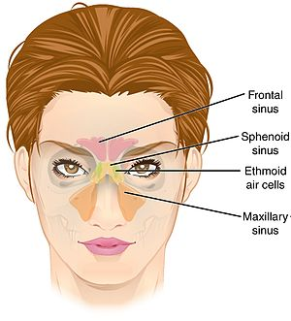
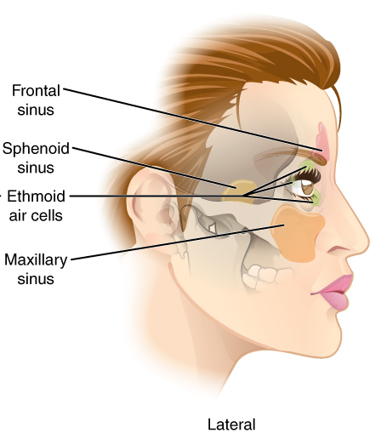

N/B:These sinuses are named for the facial bones in which they are located.

The Maxillary Sinuses
This is the largest of the paranasal sinuses, and are located under the eyes, in the maxillary bones ( they open in the back of the semilunar hiatus of the nose)
INNERVATION: it is innervated by the Trigerminal nerve CNVi (ophthalmic division of CNV)

The Frontal Sinuses
This is located above the eyes, in the frontal bone, which forms the hard part of the forehead.
INNERVATION: They are also innervated by the trigeminal nerve (CN Vi)

The Ethmoidal Sinuses
It is located between the eyes. They are formed from several discrete air cells within the ethmoid bone between the nose and the eyes.
INNERVATION: They are innervated by the ethmoidal nerves which branch from the nasociliary nerve of the trigeminal nerve (CN Va).

The Sphenoidal Sinus:
It is located behind the eyes, on the sphenoid bone.
INNERVATION: They are innervated by the Trigerminal Nerve CN Vi and Vii

Clinical Significance Of The Paranasal Sinus
- Sinusitis: Inflammation of the paranasal sinus by allergic reaction activities, or by swellings in the nasal linings as a result of coldblocking the sinus and the nasal cavity joined by small orifices calles ostia
- Cancer: Malignancies of the paranasal sinuses comprise approximately 0.2% of all malignancies. About 80% of these malignancies arise in the maxillary sinus. Men are much more often affected than women. They most often occur in the age group between 40 and 70 years. Carcinomas are more frequent than sarcomas. Metastases are rare.Tumours of the sphenoid and frontal sinuses are extremely rare.

