NAME : SELUWA TEMITOPE PETER
MATIC NO: 17/MHS01/295
DEPT: MBBS
COURSE: Gross Anatomy of Head and Neck

Nose and Oral cavity assisgnment

Question 1
Discuss the Anatomy of the tongue and comment on its applied anatomy.
INTRODUCTION
The tongue is a unique muscle in the body which serves a number of different purposes, including eating and speaking. In terms of the anatomy of the tongue, it contains no bones, nor is covered by an outer layer of skin. It is the muscular organ covered with mucous membrane that is responsible. The tongue is anchored to the mouth by webs of tough tissue and mucosa. The tether holding down the front of the tongue is called the frenum. In the back of the mouth, the tongue is anchored into the hyoid bone. The tongue is vital for chewing and swallowing food, as well as for speech.The four common tastes are sweet, sour, bitter, and salty. A fifth taste, called umami, results from tasting glutamate. The tongue’s main functions are articulation, forming words during speaking, and squeezing food into the oropharynx as part of swallowing. The tongue is also involved with chewing, taste, and oral cleansing.
PART OF TONGUE
The tongue has a root body, and apex.
- The root of the tongue: is the attached posterior portion, extending between the mandible, hyoid, and the nearly vertical posterior surface of the tongue.
- The body of the tongue is the anterior, approximately two thirds of the tongue between root and apex.
- The apex of the tongue is the anterior end of the body, which rests against the incisor teeth. The body and apex of the tongue are extremely mobile.
The tongue features two surfaces; the more extensive, superior and posterior surface and the inferior surface of the tongue which rests against the floor of the mouth. A midline groove divides the anterior part of the tongue into right and left parts.
The mucosa of the anterior part of the tongue is relatively thin and closely attached to the underlying muscle. It has a rough texture because of numerous small lingual papillae:
- Vallate papillae: large and flat topped, lie directly anterior to the terminal sulcus and are arranged in a V-shaped row. They are surrounded by deep circular trenches, the walls of which are studded with taste buds. The ducts of the serous glands of the tongue open into the trenches.
- Foliate papillae: small lateral folds of the lingual mucosa. They are poorly developed in humans.
- Filiform papillae: long and numerous, contain afferent nerve endings that are sensitive to touch. These scaly, conical projections are pinkish gray and are arranged in V-shaped rows that are parallel to the terminal sulcus, except at the apex, where they tend to be arranged transversely.
- Fungiform papillae: mushroom-shaped pink or red spots scattered among the filiform papillae, but most numerous at the apex and margins of the tongue.
The vallate, foliate, and most of the fungiform papillae contain taste receptors in the taste buds.
The inferior surface of the tongue is covered with a thin, transparent mucous membrane. This surface is connected to the floor of the mouth by a midline fold called the frenulum of the tongue.
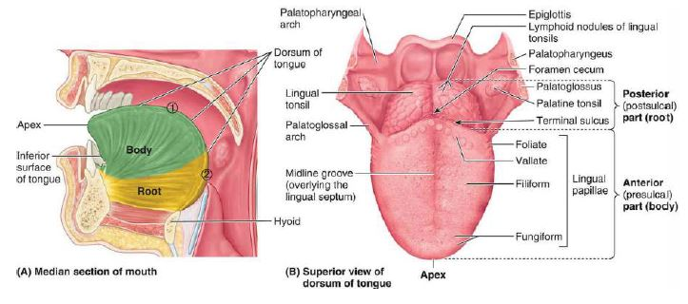

Muscles of the tongue
There are muscles that extend outside of the organ to anchor it to surrounding bony structures, known as extrinsic muscles. The other set of muscles are confined to each half of the organ and contribute to altering the shape of the organ, these are the intrinsic muscles.
Extrinsic Muscles of Tongue: The extrinsic muscles of the tongue; genioglossus, hyoglossus, styloglossus, and palatoglossus, originate outside the tongue and attach to it. They mainly move the tongue but they can alter its shape as well.
Intrinsic Muscles of Tongue: The superior and inferior longitudinal, transverse, and vertical muscles are confined to the tongue. They have their attachments entirely within the tongue and are not attached to bone. The superior and inferior longitudinal muscles act together to make the tongue short and thick and to retract the protruded tongue. The transverse and vertical muscles act simultaneously to make the tongue long and narrow, which may push the tongue against the incisor teeth or protrude the tongue from the open mouth especially when acting with the posterior inferior part of the genioglossus

Muscle | Origin | Insertion | Innervation | Function
Intrinsic
Superior longitudinal (just deep to surface of tongue) | Submucosal connective tissue at the back of the tongue and from the median septum of the tongue | Muscle fibers pass forward and obliquely to submucosal connective tissue and mucosa on margins of tongue | Hypoglossal nerve [XII] | Shortens tongue; curls apex and sides of tongue
Inferior longitudinal (between genioglossus and hyoglossus muscles) | Root of tongue (some fibers from hyoid) | Apex of tongue | Hypoglossal nerve [XII] | Shortens tongue; uncurls apex and turns it down-ward
Transverse | Median septum of the tongue | Submucosal connective tissue on lateral margins of tongue | Hypoglossal nerve [XII] | Narrows and elongates tongue
Vertical | Submucosal connective tissue on dorsum of tongue | Connective tissue in more ventral regions of tongue | Hypoglossal nerve [XII] | Flattens and widens
Extrinsic
Genioglossus | Superior mental tubercles | Body of hyoid; entire length of tongue | Hypoglossal nerve [XII] | Protrudes tongue; depresses center of tongue
Hyoglossus | Greater horn and adjacent part of body of hyoid bone | Lateral surface of tongue | Hypoglossal nerve [XII] | Depresses tongue
Styloglossus | Styloid process (anterolateral surface) | Lateral surface of tongue | Hypoglossal nerve [XII] | Elevates and retracts tongue
Palatoglossus | Inferior surface of palatine aponeurosis | Lateral margin of tongue | Vagus nerve [X] (via pharyngeal branch to pharyngeal plexus) | Depresses palate; moves palatoglossal fold toward midline; elevates back of the tongue

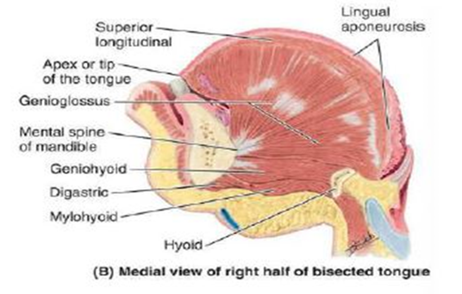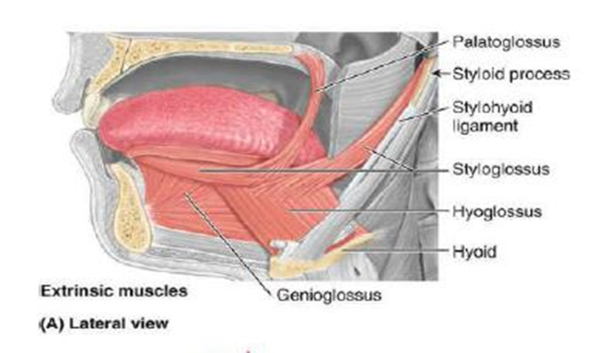
Innervation of the tongue
All muscles of the tongue, except the palatoglossus, receive motor innervation from CN XII, the hypoglossal nerve. Palatoglossus is a palatine muscle supplied by the pharyngeal plexus of CN X, the vagus nerve.
For general sensation, touch and temperature, the mucosa of the anterior two thirds of the tongue is supplied by the lingual nerve, a branch of CN V3, the mandibular branch of the trigeminal nerve. For special sensation, taste, this anterior two thirds of the tongue, except for the vallate papillae, is supplied the chorda tympani nerve, a branch of CN VII, the facial nerve. The chorda tympani join the lingual nerve in the infratemporal fossa and runs anteriorly in its sheath. The mucosa of the posterior third of the tongue and the vallate papillae are supplied by the lingual branch of the glossopharyngeal nerve, CN IX, for both general and special sensation. Twigs of the internal laryngeal nerve, a branch of the vagus nerve, CN X, supply mostly general but some special sensation to a small area of the tongue just anterior to the epiglottis. These mostly sensory nerves also carry parasympathetic secretomotor fibers to serous glands in the tongue.
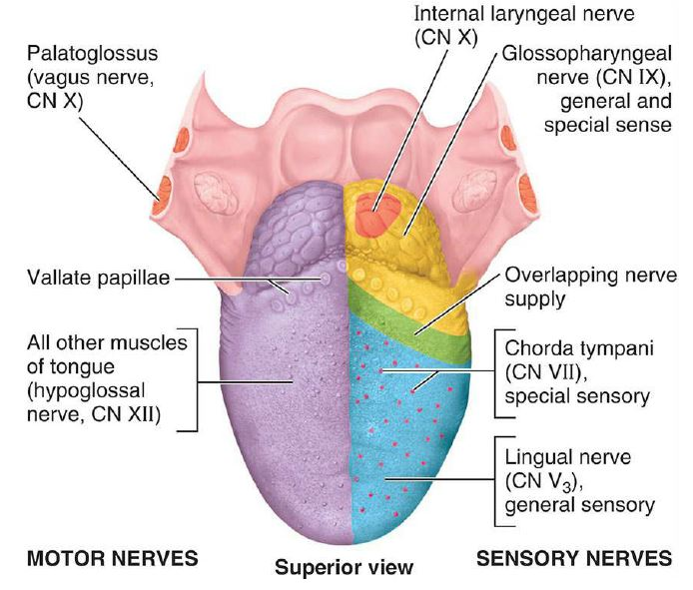
Vasculature of the tongue
Blood supply to the tongue is predominantly from the lingual artery, a branch of the external carotid artery between the superior thyroid artery and the facial artery, which departs at the level of the greater horn of the hyoid bone within the carotid triangle. After branching from the external carotid artery, the lingual artery passes deep to the hyoglossus muscle and superficial to the middle pharyngeal constrictor muscle. It then gives rise to the following four arteries: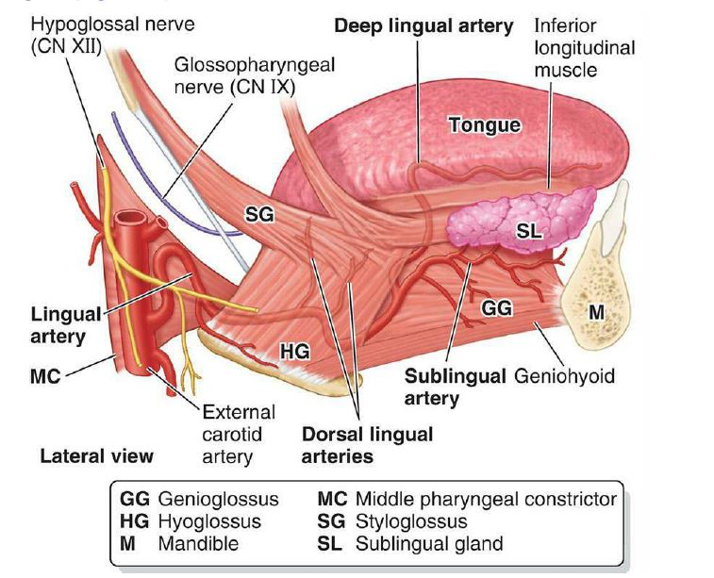
- The suprahyoid artery supplies the omohyoid, sternothyroid, and thyrohyoid muscles. They anastomose with the corresponding vessels from the opposite side.
- The dorsal lingual arteries arise beneath the hyoglossus muscle and pass to the posterior part of the dorsum of the tongue. They supply the mucous membrane of this region as well as the glossopalatine arch, lingual tonsils, soft palate, and epiglottis. They anastomose with their corresponding vessels on the opposite side.
- The sublingual artery branches at the anterior border of the hyoglossus muscle before passing between the genioglossus muscle and mylohyoid muscle to the sublingual gland. It supplies the sublingual gland before giving branches to the mylohyoid muscle. One branch from the sublingual artery passes posterior to the alveolar process of the mandible and anastomoses with the corresponding artery from the other side. A second branch of the sublingual artery pierces the mylohyoid muscle and anastomoses with the submental branch of the facial artery.
- The deep lingual artery, which is the termination of the lingual artery, passes between the genioglossus muscle and inferior longitudinal muscle.
The veins of the tongue are the dorsal lingual veins, which accompany the lingual artery. The deep lingual veins, which begin at the apex of the tongue, run posteriorly beside the lingual frenulum to join the sublingual vein. The sublingual veins in elderly people are often varicose, enlarged and tortuous. Some or all of the veins may drain into the Internal Jugular Vein, or they may do so indirectly, joining first to form a lingual vein that accompanies the initial part of the lingual artery
.

Most of the lymphatic drainage converges toward and follows the venous drainage; however, lymph from the tip of the tongue, frenulum, and central lower lip runs an independent course. Lymph from different areas of the tongue drains via four routes:
- Lymph from the root of the tongue drains bilaterally into the superior deep cervical lymph nodes.
- Lymph from the medial part of the body drains bilaterally and directly to the inferior deep cervical lymph nodes.
- Lymph from the right and left lateral parts of body drains to the submandibular lymph nodes on the ipsilateral side.
- The apex and frenulum drain to the submental lymph nodes, the medial portion draining bilaterally.
All lymph from the tongue ultimately drains to the deep cervical nodes and passes via the jugular venous trunks into the venous system at the right and left venous angles.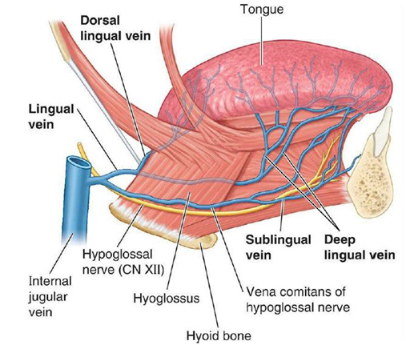
Clinical anatomy
The tongue tends to fall posteriorly, thus obstructing the airway. Paralysis or total relaxation of the genioglossus muscle presents a risk of suffocation, which can occur during general anesthesia. An artificial airway is made using intubation, which prevents the tongue from falling backward and blocking the airway.
Ludwig angina infection, once established, evolves to include the tongue. The tongue may enlarge to two or three times its usual size and tends to distend posteriorly into the hypopharynx, superiorly against the palate, and anteriorly out of the oral cavity. Any immediate posterior extension of this process will ultimately involve the epiglottis. The styloglossus muscle creates the connection between the submandibular parapharyngeal spaces, otherwise known as the buccopharyngeal gap, as it leaves the tongue and passes in between the middle and superior constrictor muscles before attaching to the styloid process. Cellulitis of the submandibular space may spread into the pharyngeal space and, from there, into the retropharyngeal space of the mediastinum.
Ankyloglossia or tongue-tie occurs due to an abnormal length of the frenulum linguae which causes limited manipulation of the tongue during speech and results in a speech impediment. In the most common form of ankyloglossia, the frenulum extends to the tip of the tongue. Ankyloglossia can be corrected by surgically severing the lingual frenulum.
Geographic tongue or migratory glossitis is a benign, asymptomatic condition characterized by the presence of large red patches with a greyish-white border covering the dorsum of an otherwise normal tongue. It is caused by inflammation of the mucous membrane of the tongue, which results in loss of lingual papillae. The lesions are known to migrate over time. The name arises from the map-like appearance of the tongue in this condition.

Question 2
Write an essay on the air sinuses.
The paranasal sinuses are a group of air-filled extensions of the respiratory part of the nasal cavity into the following cranial bones: frontal, ethmoid, sphenoid, and maxilla. They are named according to the bones in which they are located. The sinuses continue to invade the surrounding bone, and marked extensions are common in the crania of older people. The functions of paranasal sinuses include, decreasing the relative weight of the skull, increasing the resonance of the voice, providing a buffer against facial trauma, insulating sensitive structures from rapid temperature fluctuations in the nose, humidifying and heating inspired air, immunological defense.
There are 4 paired sinuses in humans. They are all in line with pseudostratified columnar epithelium.
- The maxillary sinuses: Largest of the paranasal sinuses, located under the eyes in the maxillary bones.
- The frontal sinuses: Located superior to the eyes within the frontal bone
- The ethmoid sinuses: Formed from several discrete air cells within the ethmoid bone between the nose and eyed
- The sphenoid sinuses: Located within the sphenoid bone
Frontal Sinus
The frontal sinus is located superior to the orbit and within the frontal bone. The typical volume at the adult stage is 4 to 7 mL. The frontal sinus drains into the frontal recess via the middle meatus. This drainage can be variable, either medial or lateral to the uncinate, depending on its attachment. The frontal sinus vasculature consists of the supraorbital and supratrochlear arteries and ophthalmic and supraorbital veins. Similarly, it's innervation is provided by the supraorbital and supratrochlear nerves, branches of the ophthalmic division on the trigeminal nerve, CNV1. Several anatomical spaces and structures are important to the frontal sinus:
- Frontal recess: Drainage space between the frontal sinus and semilunar hiatus that is bounded by the posterior wall of the agger nasi cell, lamina papyracea, and the middle turbinate.
- Frontal sinus infundibulum: Space that drains into the frontal recess that is located superior to the agger nasi cells
- Frontal cells: anterior ethmoid cells that pneumatize the frontal recess. These cells may cause obstruction or persistent sinus disease. They are located posterior and superior to the agger nasi cell, and there are 4 types as classified by Bent and Kuhn:
- Type I: Single cell above the agger nasi cell but below the floor of the frontal sinus
- Type II: Multiple cells above the agger nasi, may extend into the frontal sinus
- Type III: Single large cell that extends supraorbitally through the floor of the frontal sinus, attaches to the anterior table
Type IV: Single isolated cell that is contained within the frontal sinus

Sphenoid Sinus
The sphenoid sinuses are located centrally and posteriorly within the sphenoid bone. They drain into the sphenoethmoidal recess located within the superior meatus. The sphenopalatine artery supplies the sinus, and venous drainage is via the maxillary vein. Innervation is provided by the sphenopalatine nerve, which is comprised of parasympathetic fibers and CN V2. The typical adult size is 0.5 to 8 mL. Several important structures have a close anatomical relationship to the sphenoid sinus. The carotid artery is located adjacent to the lateral wall of the sinus, and in 25% of patients, it is dehiscent in this area. The optic nerve is also located adjacent to the lateral wall of the sinus and can be dehiscent in up to 5% of individuals.
Ethmoid Sinuses
There are 3 to 4 cells at birth and develop into 10 to 15 by adulthood for a total volume of 2 to 3 mL. They are located between the eyes. The anterior ethmoids drain into the ethmoid infundibulum, in the middle meatus. The posterior ethmoid sinuses drain into the sphenoethmoidal recess located in the superior meatus. The ethmoid sinuses are supplied by the anterior and posterior ethmoid arteries, respectively. These arteries are branches of the ophthalmic artery, which is a branch off of the internal carotid artery. Ethmoid sinus venous drainage is by the maxillary and ethmoid veins. The anterior and posterior ethmoid veins provide innervation.
The complex ethmoidal labyrinth can be reduced into a series of lamellae based on embryologic precursors. These lamellae are obliquely oriented and lie parallel to each other.
- The first lamella is the uncinate process.
- The second lamella corresponds to the ethmoid bulla.
- The third lamella is also known as the basal or ground lamella of the middle turbinate. This lamella serves as the division of the anterior and posterior ethmoids. The anterior part inserts vertically into the crista ethmoidalis. The middle portion attaches obliquely into the lamina papyracea. The posterior third attaches to the lamina papyracea as well but in a horizontal fashion.
- The fourth lamella is the superior turbinate.
The agger nasi cell is the most anterior of the anterior ethmoid cells. It is found anterior and superior to the middle turbinate attachment to the lateral wall. The posterior wall of the agger nasi cell forms the anterior wall of the frontal recess.
The ethmoid bulla is the largest of the anterior ethmoid cells that lies above the infundibulum. This structure is important because the anterior ethmoid artery courses over the roof of this cell.

Maxillary Sinus
The maxillary sinus is located under the eyes in the maxillary bone. Adjacent structures include the lateral nasal wall, the orbital floor, and the posterior maxillary wall which contains the pterygopalatine fossa. The maxillary sinus is innervated by the infraorbital nerve, which is a branch of the mandibular division of the trigeminal nerve, CN V2. The maxillary and facial arteries supply the sinus, and the maxillary vein supplies venous drainage. The maxillary sinus drains into the ethmoid infundibulum. There is typically only one ostium per maxillary sinus. The size of the maxillary sinus at adult stage is approximately 15 mL, making it the largest paranasal sinus.
Clinical anatomy
Paranasal sinuses are prone to inflammation and infection. If the paranasal sinuses become blocked from secretions or a mass, the drainage of mucus is interrupted, and sinusitis can result. The maxillary sinus may be involved from any process in the teeth or the gums. The frontal and maxillary sinuses may be involved in allergies. Depending on the cause, sinusitis is treated with corticosteroids, decongestant, nasal irrigation, and hydration. Rarely surgical intervention may be required to enhance drainage.
Malignancies of the paranasal sinuses are rare. The majority of cancers occur in the maxillary sinus and are more common in men than women. Maxillary sinus malignancies occur between ages 45 to 70, and the most frequent is a sarcoma. Even though metastases are rare, these malignancies are locally invasive and destructive.
Acute rhinosinusitis (ARS) and chronic rhinosinusitis (CRS) are both defined as symptomatic inflammation of the nose and paranasal sinuses. The 2 are distinguished based on the duration of the complaints. Generally speaking, acute rhinosinusitis is widely considered to be an infectious disorder. On the other hand, chronic rhinosinusitis is typically defined as an inflammatory disorder. In ARS, the underlying etiology is typically viral or bacterial, and occasionally fungal. The pathogenesis of ARS involves infection followed by tissue invasion.
The most widely accepted classification system divides CRS into CRS with and without nasal polyps (CRSwNP and CRSsNP, respectively) based on nasal endoscopy
