OVULATION
This is the release of mature secondary oocytes
Before ovulation there is a sudden increase in leuteinsing hormone causing meiosis I to be completed and meiosis II to be initiated but arrested at metaphase II by cytostatic factors. an avascular spot appears on the surface of the ovary called a stigma. For the mature oocytes to be released there is ;
- An increase in collagenase activity ( digestion of collagen fibers around the oocytes)
- Prostaglandin is produced to cause muscular contraction in the ovary
- The cumulus oophorus arrange themselves to form corona radiata
- The mature oocytes is released for either menstruation or pregnancy
DIFFERENSES BETWEEN MEIOSIS I AND MEIOSIS II
MEIOSIS I | MEIOSIS II
Two daughter cells are produced | Four daughter cells are produced
There is crossing over of chromosomes | There is no crossing over of chromosomes
Synapsis occurs | Synapsis does not occur
There is chiasma formation | There is no chiasma formation
Preceded by interphase | No interphase takes place
A more complex division | A less complex division
Centromere does not split | Centromere splits
Daughter cells have 46 homologous duplicated chromosomes | Daughter cells have 23 single stranded chromosomes
Sister chromatids have convergent arms in prophase I | Sister chromatids have convergent arms in prophase II
It is an heterotypic division | It is an homotypic division

STAGES OF FERTILAZATION
Fertilization is the union of the sperm and oocytes. it takes place in the ampulla of the ovary. It is approximately 24 hours, the stages involved are ;
- Passage of sperm through the corona radiata
- Penetration of the zona pellucida
- Fussion of the plasma membrane of the oocytes and the sperm
- Completion of the second meiotic division and formation of the female pronucleus
- Formation of male pronucleus
- Fussion of the two pronuclei to form a zygote

*Passage of the sperm through the corona radiata;capacitation occurs for the sperm to pass through the corona radiata.capacitation is the removal of the outer glycoprotein coat and seminal plasma protein from the plasma membrane of the covering of the sperm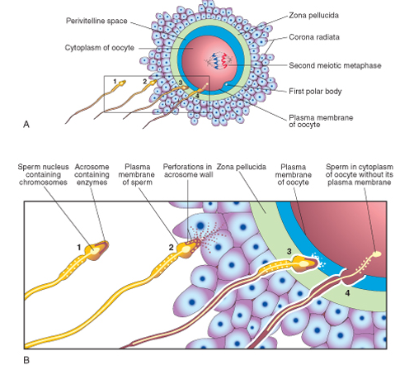
*Penetration of the zona pellucida;the acrosome of the sperm binds to the receptors on the zona pellucida of the oocyte then acrosince from the acrosome is released to assist the sperm to penetrate the zona pellucida.once the sperm penetrates the zona pellucida,the cortical granules release lysosomal cells into the binding sites on the zona pellucida to prevent polyspermy. 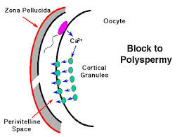
*Fusion of the plasma membrane of the oocytes and the sperm;the acrosome and the plasma membrane of the sperm breaks off while penetrating the plasma membrane of the oocytes but the nucleus and the remaining parts penetrates the oocyte membrane
*Completion of meiosis II and formation of female pronucleus;meiosis II is completed through the activation of the oocytes by the sperm forming mature oocytes and polar body.the nucleus of the female becomes the female pronucleus
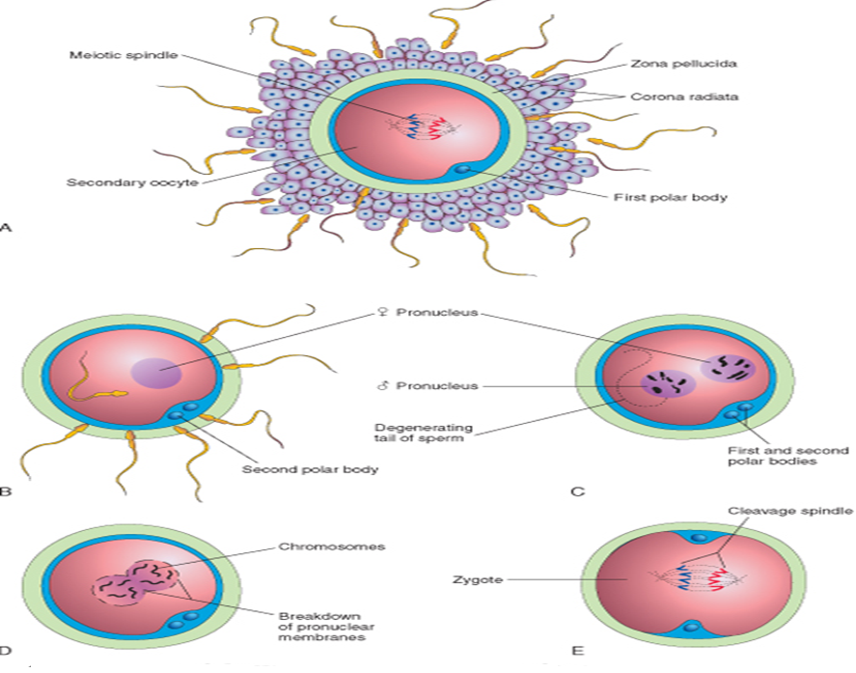
*Formation of the male pronucleus ;the tail of the sperm degenerates in the cytoplasm of the oocyte and enlarges to become the male pronucleus
*Formation of a zygote;the male pronucleus and female pronucleus fuses to form an ootid which becomes a zygote
DIFFERENCES BETWEEN MONOZYGOTIC AND DIZYGOTIC TWINS
MONOZYGOTIC TWINS | DIZYGOTIC TWINS
They result from the fertilization of one egg and one sperm | They result from the fertilization of two different eggs with two different sperm
They are identical twins | They are non-identical twins
Can be of the same sex or different sexes | They are mostly the same sex
They are genetically identical | They are genetically unidentical
Their share aminiotic sac,chorionic sac,placenta | They do not share aminiotic sac chorionic sac,placenta

