17/MHSO1/204
- Write an essay on carvanous sinus

THE CARVANOUS SINUS
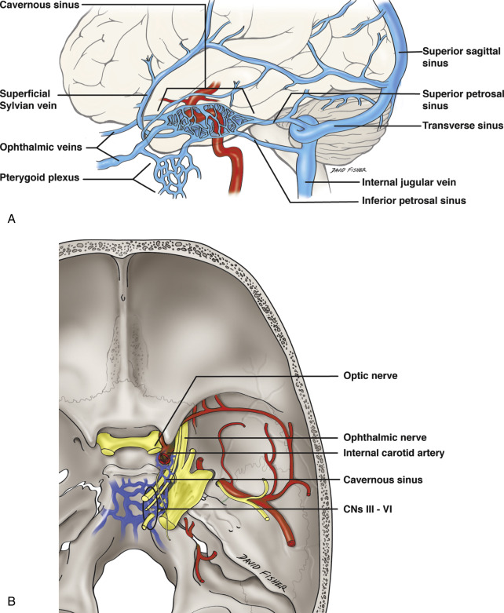
The cavernous sinuses are a pair of intradural venous compartments that lay between the periosteal and meningeal layers of the dura. They are located centrally within the skull in the anteromedial portion of the middle cranial fossa and are bordered medially by the pituitary gland and the body of the sphenoid bone. The cavernous sinus is a four-walled structure with a roof, and medial, lateral, and posterior walls in the shape of a “boat”.
The superior wall or the roof of the sinus consists of an anterior portion that is formed by the dural lining of the clinoid process and a posterior portion formed by the “oculomotor triangle,” which is a dural patch through which the oculomotor penetrates the sinus.
The lateral wall is formed of two dural layers: a thick external layer and an internal, semitransparent layer. It extends from the superior orbital fissure anteriorly to the medial border of Meckel’s cave posteriorly and from the lower border of the carotid sulcus inferiorly to the anterior petroclinoid ligament superiorly.
The medial wall consists of two parts, sellar and sphenoidal, both of which consist of one dural layer. The borders of the medial wall extend from the superior orbital fissure anteriorly to the lateral border of the dorsum sellae posteriorly, and from the lower border of the carotid sulcus inferiorly to the interclinoid ligament superiorly.
The posterior wall consists of two dural layers, the periostic and meningeal.
The cavernous sinuses consist of trabeculated cavities formed by the separation of the layers of the dura and located on either side of the sella turcica, superolaterally to the sphenoid air sinuses. The oculomotor and trochlear cranial nerves, along with the ophthalmic and maxillary branches of the trigeminal nerve, course along the lateral wall of the cavernous sinuses, whereas the abducens nerve and the carotid artery with its surrounding sympathetic plexus are located within the center of the sinus itself.

Nearby structures
- Above: optic tract, optic chiasma, internal carotid artery.
- Inferiorly: Foramen lacerum and the junction of the body and greater wing of sphenoid bone.
- Medially: Hypophysis cerebri or (pituitary gland) and sphenoidal air sinus.
- Laterally: temporal lobe with uncus.
- Anteriorly: superior orbital fissure and the apex of the orbit.
- Posteriorly: apex of petrous temporal bone.
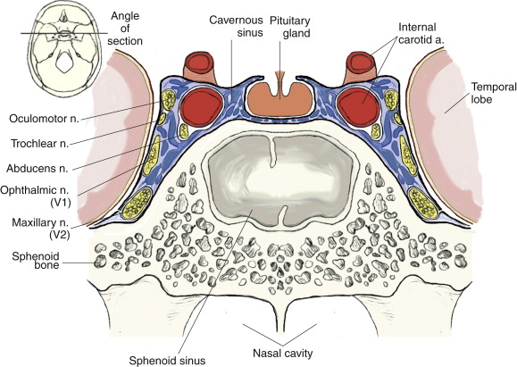

Venous connections
The cavernous sinus receives blood from:
- Superior and inferior ophthalmic veins
- Sphenoparietal sinus
- Superficial middle cerebral veins
- Inferior cerebral veins
Blood leaves the sinus via superior and inferior petrosal sinuses as well as via the emissary veins through the foramina of the skull (mostly through foramen ovale). There are also connections with the pterygoid plexus of veins via inferior ophthalmic vein, deep facial vein and emissary veins

Contents
Apart from the blood which passes through a venous sinus, several anatomical structures, including some cranial nerves and their branches, also pass through the sinus.
Structures within the outer (lateral) wall of the compartment from superior to inferior:
- Oculomotor nerve
- Trochlear nerve
- Ophthalmic and maxillary branches of the trigeminal nerve
Structures passing through the midline (medial) wall:
- Abducens nerve
- Internal carotid artery accompanied by the Internal carotid plexus
These nerves, with the exception of CN V₂, pass through the cavernous sinus to enter the orbital apex through the superior orbital fissure. The maxillary nerve, division V₂ of the trigeminal nerve travels through the lower portion of the sinus and exits via the foramen rotundum. The maxillary branch passes external to, but immediately adjacent to, the lateral wall of the sinus)
A mnemonic exists to remember the orientation of the vertical and horizontal content of the sinus: O TOM CAT. (OTOM are the lateral wall contents from superior to inferior; CAT are the horizontal contents from medial to lateral)
The optic nerve lies just above and outside the cavernous sinus, superior and lateral to the pituitary gland on each side, and enters the orbital apex via the optic canal.

CLINICAL ANATOMY
Intracranial haemorrhage
Bleeding into extradural space is classically from injury to middle meningeal artery from fracture of temporal bone. The haematoma between the dura and the skull bone compresses the brain. There is a lucid interval followed by rapid increase in intracranial tension. Approximately 15% are instantly fatal and a further 45% die due to re-bleed. In survivors, organization of blood clot can obliterate subarachnoid space causing hydrocephalus.

Cavernous Sinus Thrombosis
Infections of the face or orbit can be dangerous. An infected embolus that forms in a facial or orbital vein can readily pass into the cavernous sinus via an ophthalmic vein because these veins do not have valves. A cavernous sinus thrombosis can be fatal and must be treated aggressively with antibiotics.

Carotid cavernous sinus fistula
This is an abnormal communication between the internal carotid artery and the cavernous sinus caused by a tear in the artery wall, either traumatic or spontaneous. The sinus communicates directly with the veins of the orbit, so arterial pressure can be transmitted to the ophthalmic veins, which may become pulsatile. If arterial pressure is reduced because of this leak, a decrease in perfusion to ocular tissue will occur.

Cavernous Sinus Thrombophlebitis
Septic cavernous sinus thrombophlebitis is rare and should be suspected in any patient with orbital cellulitis who develops contralateral signs of orbital inflammation (lid swelling, proptosis, ophthalmoplegia). Spread to the opposite eye occurs through the cavernous sinus and usually occurs within 24 to 48 hours of the initial unilateral orbital findings.

- Discuss the walls of the nose
The nose is the part of the respiratory tract superior to the hard palate and contains the peripheral organ of smell. It includes the external nose and the nasal cavity, which is divided into right and left cavities by the nasal septum. The function of the nose includes breathing, olfaction, filtration of dust, humidification if the inspired air and reception and elimination of secretions from the paranasal sinuses and nasolacrimal ducts.

THE EXTERNAL NOSE
It is the visible portion that projects from the face. Its skeleton is mainly cartilaginous. The dorsum of the nose extends from the root of the nose to the apex of the nose.
The supporting skeleton of the nose is composed of bone and hyaline cartilage. The bony part of the nose consists of the nasal bones, frontal processes of the maxillae, the nasal part if the frontal bone and its nasal spine and the bony parts of the septum. The cartilaginous part of the nose consists of the main cartilages: two lateral cartilages, two alar cartilages and one septal cartilage. The U shaped alar cartilages are free and movable. They dilate or constrict the nares when the muscles acting on the nose contracts.

THE NASAL SEPTUM
It divides the chamber of the nose into two nasal cavities. The septum has a bony part and a soft mobile cartilaginous part. The septal cartilage has a tongue and groove articulation with the edges of the bony septum.

NASAL CAVITIES
It refers to either the entire cavity or the right or left half, depending on the context.
Boundaries of nasal cavities
The nasal cavities have a roof, floor and medial and lateral walls:
-The roof of the nasal cavities is curved and narrow, except at the posterior end, where the hollow body of the sphenoid forms the roof. It is divided into three parts (frontal, ethmoidal and sphenoidal) named from the bones forming each part.
-The floor of the nasal cavities is wider than the roof and is formed by the palatine processes of the maxillae and the horizontal plates of the palatine bone.
-The medial wall of the nasal cavities is formed by the nasal septum
-The lateral walls of the nasal cavities are irregular owing to three bony plates, the nasal conchae, which projects inferiorly, somewhat like louvers.
