Name: Nwapa Benedict Nzeregwu
Matric Number: 17/MHS01/333
Course Title: Gross Anatomy of Head and Neck
Course Code: ANA 301
Department: Medicine and Surgery
Assignment
- Discuss the Anatomy of the tongue and comment on its applied anatomy.
- Write an essay on the air sinuses.
Answers
- The Tongue
The tongue is a mobile muscular organ that can assume a variety of shapes and positions,it is partly in the oral cavity and partly in the oropharynx.The tongue is involved with mastication, taste, deglutition (swallowing), articulation, and oral cleansing;however, its main functions are forming words during speaking and squeezing food into the oropharynx when swallowing
Parts and Surfaces of the Tongue
The tongue has
- a root
- a body
- an apex
- a curved dorsum
- and an inferior surface
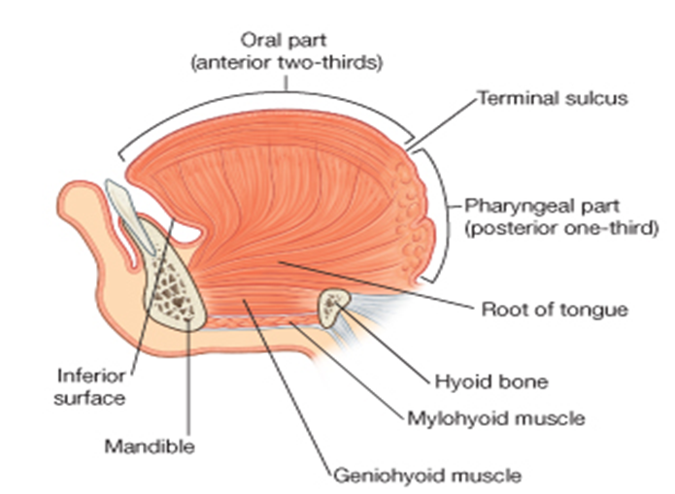
The root of the tongue:
- is the part of the tongue that rests on the floor of the mouth
- It is usually defined as the posterior third of the tongue
The body of the tongue:
- is the anterior two thirds of the tongue
The apex (tip) of the tongue:
- is the anterior end of the body, which rests against the incisor teeth
- note: The body and apex of the tongue are extremely mobile.
The dorsum (dorsal surface) of the tongue :
- is the posterosuperior surface, which is located partly in the oral cavity and partly in the oropharynx
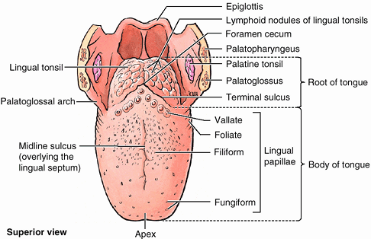
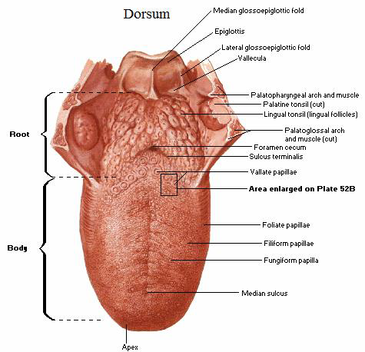
- The dorsum is characterized by a V-shaped groove called the terminal sulcus or groove (sulcus terminalis)
- posterior to this groove is foramen cecum.
- This small pit, frequently absent, is the non-functional remnant of the proximal part of the embryonic thyroglossal duct from which the thyroid gland developed
- The terminal sulcus divides the dorsum of the tongue into the:
- anterior (oral) part in the oral cavity proper
- posterior (pharyngeal) part in the oropharynx
- The margin of the tongue is related on each side to the lingual gingivae and lateral teeth
- The mucous membrane on the anterior part of the tongue is rough because of the presence of numerous small lingual papillae(small nipple like process):
- Vallate papillae: Large and flat topped, they lie directly anterior to the terminal sulcus and are arranged in a V-shaped row
- Foliate papillae: Small lateral folds of the lingual mucosa
- They are poorly developed in humans
- Filiform papillae: Long and numerous, they contain afferent nerve endings that are sensitive to touch
- Fungiform papillae: Mushroom shaped pink or red spots, they are scattered among the filiform papillae but are most numerous at the apex and margins of the tongue
- The vallate, foliate, and most of the fungiform papillae contain taste receptors in the taste buds
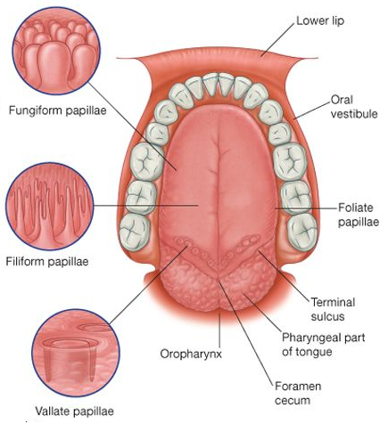
- The mucous membrane over the anterior part of the dorsum of the tongue is thin and closely attached to the underlying muscle
- A shallow midline groove of the tongue divides the tongue into right and left halves called the median sulcus
- The mucous membrane of the posterior part of the tongue is thick and freely movable
- It has no lingual papillae, but the underlying lymphoid nodules give this part of the tongue an irregular, cobblestone appearance
- The lymphoid nodules are known collectively as the lingual tonsil
- The pharyngeal part of the tongue constitutes the anterior wall of the oropharynx
- The inferior surface of the tongue is covered with a thin, transparent mucous membrane through which one can see the underlying veins
- This surface is connected to the floor of the mouth by a midline fold called the frenulum of the tongue
- The frenulum allows the anterior part of the tongue to move freely
- On each side of the frenulum, a deep lingual vein is visible through the thin mucous membrane
Note:
- There are four basic taste sensations: sweet, salty, sour, and bitter
- Sweetness is detected at the apex
- saltiness at the anterolateral margins
- sourness at the posterolateral margins
- bitterness at the posterior part of the tongue
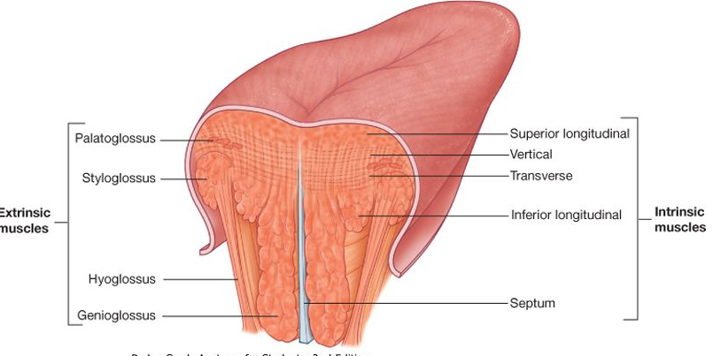
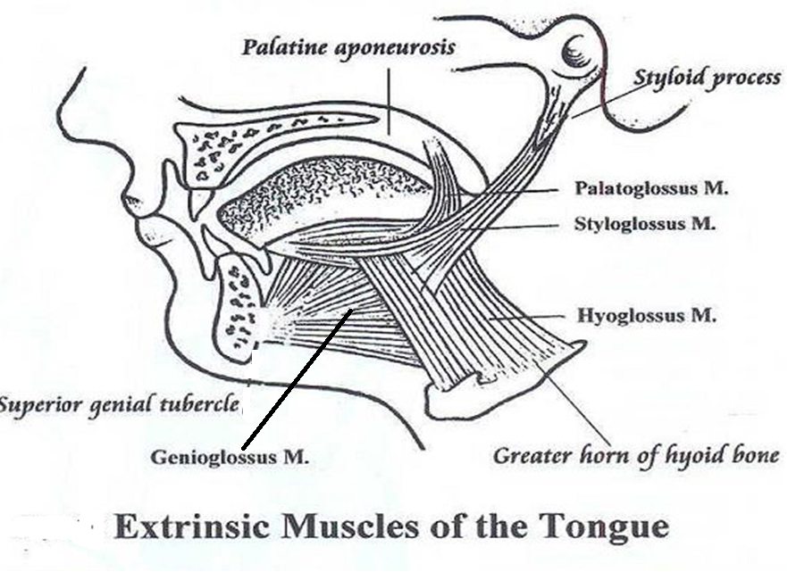
Intrinsic Muscles of the Tongue
They include:
- superior longitudinal muscle
- inferior longitudinal muscle
- transverse muscle
- vertical muscles
- They have their attachments entirely within the tongue and are not attached to bone
Vasculature of the Tongue
Arterial supply
- The arteries of the tongue are derived from the lingual artery, which arises from the external carotid artery
On entering the tongue, the lingual artery passes deep to the hyoglossus muscle and give rise to the:
- The dorsal lingual arteries which supply the posterior part (root);
- the deep lingual arteries supply the anterior part.
- The deep lingual arteries communicate with each other near the apex of the tongue.
- The dorsal lingual arteries are prevented from communicating by the lingual septum
Venous drainage
- The veins of the tongue are the dorsal lingual veins, which accompany the lingual artery;
- the deep lingual veins, which begin at the apex of the tongue, run posteriorly beside the lingual frenulum to join the sublingual vein
- The sublingual veins in elderly people are often varicose (enlarged and tortuous)
- All these lingual veins terminate, directly or indirectly, in the IJV
The lymphatic drainage of the tongue
- Lymph from the tongue takes four routes
- Lymph from the posterior third drains into the superior deep cervical lymph nodes
- Lymph from the medial part of the anterior two thirds drains directly to the inferior deep cervical lymph nodes
- Lymph from the lateral parts of the anterior two thirds drains to the submandibular lymph nodes
- The apex and frenulum drain to the submental lymph nodes
- The posterior third and the medial part of the anterior two thirds drain bilaterally
Innervation of the Tongue
Motor innervation
- All muscles of the tongue, except the palatoglossus (actually a palatine muscle supplied by the vagus nerve(X) of the pharyngeal plexus), receive motor innervation from the hypoglossal nerve (CN XII)
Sensory innervation
The anterior two thirds of the tongue are supplied by:
- the lingual nerve (CN V₃) for general sensation
- the chorda tympani, a branch of the facial nerve (CN VII) transferring nerve fibers to the lingual nerve, for taste
The posterior third of the tongue and the vallate papillae are supplied by:
- the lingual branch of the glossopharyngeal nerve (CN IX) for both general sensation and taste
- Another contribution is made by the internal laryngeal branch of the vagus (CN X) for general sensation and taste
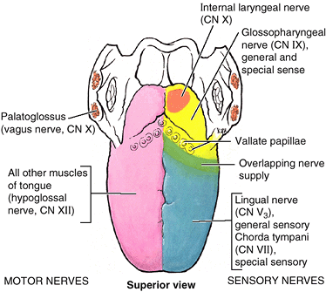
- Hence CN VII, CN IX, and CN X provide nerve fibers for taste; those from CN VII are ultimately conveyed by CN V₃
Clinical anatomy
Lingual Carcinoma
- A lingual carcinoma in the posterior part of the tongue metastasizes to the superior deep cervical lymph nodes on both sides, whereas a tumor in the anterior part usually does not metastasize to the inferior deep cervical lymph nodes until late in the disease.
- Because these nodes are closely related to the IJV, metastases from the tongue may be widely distributed through the submental and submandibular regions and along the IJVs in the neck.
Frenectomy
- An overly large lingual frenulum (tongue-tie/ ankyloglossa) interferes with tongue movements and may affect speech
- In unusual cases, a frenectomy (cutting the frenulum) in infants may be necessary to free the tongue for normal movement and speech
Thyroglossal Duct Cyst
- A cystic remnant of the thyroglossal duct, associated with development of the thyroid gland, may be found in the root of the tongue and be connected to a sinus that opens at the foramen cecum
- Surgical excision of the cyst may be necessary
- Most thyroglossal duct cysts are in the neck, close or just inferior to the body of the hyoid bone

- Air Sinuses
Air Sinuses are a group of four paired air-filled spaces that surround the nasal cavity. The maxillary sinuses are located under the eyes; the frontal sinuses are above the eyes; the ethmoidal sinuses are between the eyes and the sphenoidal sinuses are behind the eyes. The sinuses are named for the facial bones in which they are located.
Maxillary Sinus
The maxillary sinus is located under the eyes in the maxillary bone. Adjacent structures include the lateral nasal wall, the orbital floor, and the posterior maxillary wall which contains the pterygopalatine fossa. The maxillary sinus is innervated by the infraorbital nerve (CN V2). The maxillary and facial arteries supply the sinus, and the maxillary vein supplies venous drainage. As mentioned already, the maxillary sinus drains into the ethmoid infundibulum. There is typically only one ostium per maxillary sinus; however, cadaver studies have shown 10% to 30% have an accessory ostium. The size of the maxillary sinus at adult stage is approximately 15 mL, making it the largest paranasal sinus.
Frontal Sinus
The frontal sinus is located superior to the orbit and within the frontal bone. The typical volume at the adult stage is 4 to 7 mL. The frontal sinus drains into the frontal recess via the middle meatus. As noted previously, this drainage can be variable, either medial or lateral to the uncinate, depending on its attachment. The frontal sinus vasculature consists of the supraorbital and supratrochlear arteries and ophthalmic and supraorbital veins. Similarly, it's innervation is provided by the supraorbital and supratrochlear nerves (CNV1). Several anatomical spaces/structures are important to frontal sinus anatomy:
- Frontal recess: Drainage space between the frontal sinus and semilunar hiatus that is bounded by the posterior wall of the agger nasi cell, lamina papyracea, and the middle turbinate.
- Frontal sinus infundibulum: Space that drains into the frontal recess that is located superior to the agger nasi cells
- Frontal cells: anterior ethmoid cells that pneumatize the frontal recess. These cells may cause obstruction or persistent sinus disease. They are located posterior and superior to the agger nasi cell, and there are 4 types as classified by Bent and Kuhn:
- Type I: Single cell above the agger nasi cell but below the floor of the frontal sinus
- Type II: Multiple cells above the agger nasi, may extend into the frontal sinus
- Type III: Single large cell that extends supraorbitally through the floor of the frontal sinus, attaches to the anterior table
- Type IV: Single isolated cell that is contained within the frontal sinus
Sphenoid Sinus
The sphenoid sinuses are located centrally and posteriorly within the sphenoid bone. They drain into the sphenoethmoidal recess located within the superior meatus. The sphenopalatine artery supplies the sinus, and venous drainage is via the maxillary vein. Innervation is provided by the sphenopalatine nerve, which is comprised of parasympathetic fibers and CN V2. The typical adult size is 0.5 to 8 mL. Several important structures have a close anatomical relationship to the sphenoid sinus. The carotid artery is located adjacent to the lateral wall of the sinus, and in 25% of patients, it is dehiscent in this area. The optic nerve is also located adjacent to the lateral wall of the sinus and can be dehiscent in up to 5% of individuals.
Ethmoid Sinuses
- There are 3 to 4 cells at birth and develop into 10 to 15 by adulthood for a total volume of 2 to 3 mL. They are located between the eyes. The anterior ethmoids drain into the ethmoid infundibulum, in the middle meatus. The posterior ethmoid sinuses drain into the sphenoethmoidal recess located in the superior meatus. The ethmoid sinuses are supplied by the anterior and posterior ethmoid arteries, respectively. These arteries are branches of the ophthalmic artery, which is a branch off of the internal carotid artery. This is an important anatomical relationship to realize because endovascular embolization of the ethmoid arteries should be avoided when treating epistaxis due to the possibility of retrograde movement of the embolization material into the ICA resulting in possible CVA. Ethmoid sinus venous drainage is by the maxillary and ethmoid veins. The anterior and posterior ethmoid veins provide innervation.
- The complex ethmoidal labyrinth can be reduced into a series of lamellae based on embryologic precursors. These lamellae are obliquely oriented and lie parallel to each other.
- The first lamella is the uncinate process.
- The second lamella corresponds to the ethmoid bulla.
- The third lamella is also known as the basal or ground lamella of the middle turbinate. This lamella serves as the division of the anterior and posterior ethmoids. The anterior part inserts vertically into the crista ethmoidalis. The middle portion attaches obliquely into the lamina papyracea. The posterior third attaches to the lamina papyracea as well but in a horizontal fashion.
- The fourth lamella is the superior turbinate.
- The agger nasi cell is the most anterior of the anterior ethmoid cells. It is found anterior and superior to the middle turbinate attachment to the lateral wall. The posterior wall of the agger nasi cell forms the anterior wall of the frontal recess.
- The ethmoid bulla is the largest of the anterior ethmoid cells that lies above the infundibulum. This structure is important because the anterior ethmoid artery courses over the roof of this cell.
Clinical significance
- Inflammation
The air sinuses are joined to the nasal cavity via small orifices called ostia. These become blocked easily by allergic inflammation, or by swelling in the nasal lining that occurs with a cold. If this happens, normal drainage of mucus within the sinuses is disrupted, and sinusitis may occur. Because the maxillary posterior teeth are close to the maxillary sinus, this can also cause clinical problems if any disease processes are present, such as an infection in any of these teeth. These clinical problems can include secondary sinusitis, the inflammation of the sinuses from another source such as an infection of the adjacent teeth.^{[5]}
These conditions may be treated with drugs such as decongestants, which cause vasoconstriction in the sinuses; reducing inflammation; by traditional techniques of nasal irrigation; or by corticosteroid.
- Cancer
Malignancies of the paranasal sinuses comprise approximately 0.2% of all malignancies. About 80% of these malignancies arise in the maxillary sinus. Men are much more often affected than women. They most often occur in the age group between 40 and 70 years. Carcinomas are more frequent than sarcomas. Metastases are rare. Tumours of the sphenoid and frontal sinuses are extremely rare.

