NAME: AGU ONYEKACHI JOY
MATRICULATION NUMBER: 17/MHS01/036
COURSE: GROSS ANATOMY OF THE HEAD AND NECK

Question One: Write an essay on the cavernous sinus
The cavernous sinuses are 1 cm wide cavities that extend a distance of 2 cm from the most posterior aspect of the orbit to the petrous part of the temporal bone. They are bilaterally paired collections of venous plexuses that sit on either side of the sphenoid bone. Although they are not truly trabeculated cavities like the corpora cavernosa of the penis, the numerous plexuses, however, give the cavities their characteristic sponge-like appearance.
The cavernous sinus is roofed by an inner layer of dura mater that continues with the diaphragma sellae that covers the superior part of the pituitary gland. The roof of the sinus also has several other attachments. Anteriorly, it attaches to the anterior and middle clinoid processes, posteriorly it attaches to the tentorium (at its attachment to the posterior clinoid process). Part of the periosteum of the greater wing of the sphenoid bone forms the floor of the sinus. The body of the sphenoid acts as the medial wall of the sinus while the lateral wall is formed from the visceral part of the dura mater.
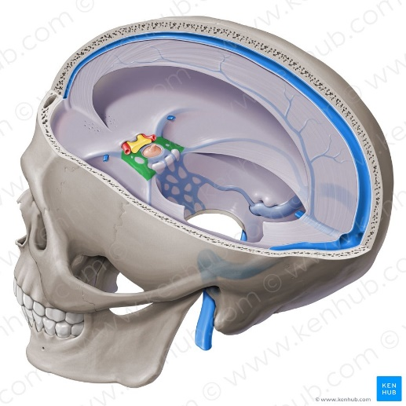The Cavernous Sinus
Contents of the Cavernous Sinus
The cavernous sinus contains the internal carotid artery and several cranial nerves. Abducens nerve (CN VI) traverses the sinus lateral to the internal carotid artery. The remainder of the cranial nerves pass through the lateral wall of the carotid sinus, and from superior to inferior they are:
- Oculomotor nerve (CN III)
- Trochlear nerve (CN IV)
- Trigeminal nerve (CN V) - ophthalmic and maxillary divisions.
Internal Carotid Nerve
In addition to the thin walled veins that traverse the cavernous sinus, a lone arterial vessel also uses the area as a conduit. The internal carotid artery (a branch of the common carotid artery) gains access to the cavernous sinus posteriorly. As the petrous part of the internal carotid artery leaves the carotid canal, it curves vertically and superiorly above foramen lacerum to enter the cavernous sinus. Here the artery is also referred to as the cavernous part. The internal carotid artery exits the cavernous sinus through its roof and becomes the cerebral part of the internal carotid artery.
Abducent Nerve
This motor nerve leaves the pons and gains access through the posterior part of the sinus after passing of the apical potion of the petrous temporal bone. It has also been known to access the cavernous sinus by way of the petrosal sinus, adjacent to the clivus. It exits the sinus by way of the superior orbital fissure to gain access to the orbit, where it innervates the lateral rectus muscle of the eyeball.
Oculomotor Nerve
The other nerves travelling through the cavernous sinus do so between the endothelial lining and the dura mater of its lateral wall. The most superior of the four nerves in the lateral wall is the oculomotor nerve (CN III). At the posterior aspect of the roof of the cavernous sinus, the free and attached edges of tentorium cerebelli forms a space through which CN III enters the lateral wall of the sinus. It takes a course toward the anterior extremity of the sinus where it bifurcates into its superior and inferior rami that pass through the superior orbital fissure. CN III provides motor supply to inferior oblique, levator palpebrae superioris, and the inferior, medial and superior recti muscles.

Trochlear Nerve
The smallest of the cranial nerves, the trochlear nerve (CN IV), enters the posterior aspect of the cavernous sinus after leaving the posterior part of the brainstem and decussating with the same nerve from the opposite side. It continues anteriorly in the lateral wall of the cavernous sinus, inferior to CN III and passes through the superior orbital fissure at the anterior aspect of the sinus. Once in the orbit, CN IV has the responsibility of innervating the muscles of the eyeball that are responsible for inferolateral motions.
Trigeminal Nerve
Two of the three branches of the trigeminal nerve (CN V) pass through the cavernous sinus. Prior to entering the cavernous sinus, the proximal portion of the nerve lies in Meckel’s cave, where it forms the trigeminal ganglion. After leaving the cave, the mandibular division (CN V3) courses inferiorly to pass through foramen ovale (without entering the cavernous sinus). The other two branches, the ophthalmic and the maxillary (CN V1 and CN V2, respectively), travel through the lateral wall of the sinus. Both take courses inferior to CN III and CN IV, however, CN V2 is the most inferior of them all. Both CN V branches in the sinus travels horizontally. CN V2 leaves the sinus via foramen rotundum, while the three branches of CN V1 exit the cranial fossa via the superior orbital fissure. CN V1 and CN V2 are purely sensory and supply specific regions of the face.
Relations of the Cavernous Sinus
There are numerous structures surrounding the cavernous sinus that are noteworthy. Medially, the sinus is adjacent to the lateral walls of the pituitary fossa with the pituitary gland, the sphenoid bone and its air sinus. The cerebral part of the internal carotid artery courses superiorly. Laterally, the medial aspect of the temporal lobe of each hemisphere lies adjacent to the sinus. And posteriosuperiorly, the uncus of the temporal lobe has a relation to the sinus.
Communications of the Cavernous Sinus
The cavernous sinus is an unconventional venous system in the sense that it does not have a unidirectional flow of blood. Owing to the fact that there are no valves in the sinus and its connected veins, the direction of blood flow is dependent on venous pressure. The veins that communicate with the cavernous sinus are:
- Superior ophthalmic vein
- Inferior ophthalmic vein
- Superficial middle cerebral vein
- Middle meningeal vein
- Hypophyseal veins
Intercavernous Sinuses and Drainage
The left and right cavernous sinuses communicate by way of the anterior and posterior intercavernous sinuses. These vessels travel anteriorly and posteriorly (respectively) around the infundibulum of the pituitary gland, deep to the diaphragma sellae, between the layers of dura mater. The cavernous sinus in turn drains to the superior and inferior petrosal sinuses. Both sinuses join the sigmoid sinus, which then becomes the internal jugular vein. The internal jugular vein meets with the subclavian vein to become the left (or right) brachiocephalic vein.
Clinical Significance
- Carotid-cavernous fistula: head trauma resulting in rupture of the cavernous part of the internal carotid artery can produce what is known as a carotid-cavernous fistula. A pulsating exophthalmos can result as the venous pressure in the sinus would increase and reverse the flow of blood in the ophthalmic veins.
- Cavernous sinus thrombosis: the sinus also has communicating branches from the sin of the face. Particularly in the ‘danger area’ (at the nasolabial crease and at the crease between the ala of the nose and the cheek), an infection can spread to the cavernous sinus, which can result in a cavernous sinus thrombosis. This condition can result in internal strabismus (crossed eyes) if the CN VI (abducent nerve) is damaged, doubled vision while looking downward if CN IV (trochlear nerve) was damaged, or ophthalmoplegia (paralysis or weakness in muscles of movement of the eye).

Question Two: Discuss the walls of the nose
The internal part of the nose is the nasal cavity. The two nasal cavities sit within the external nose and the adjacent skull. The cavities open anteriorly to the face through the two nares. Posteriorly the cavities communicate with the nasopharynx by two apertures called choanae. Besides the anterior and posterior apertures, each nasal cavity has a roof, floor, and lateral and medial walls. There are 12 cranial bones in total that contribute to the nasal cavity structure, which include the paired nasal, maxilla, palatine and lacrimal bones, as well as the unpaired ethmoid, sphenoid, frontal and vomer bones. Among all of them, the ethmoid bone is the most important element, for two reasons: first, it makes the greatest portion of the nasal skeletal framework by forming the roof and walls of the nasal cavities; and second, it contains ethmoidal cells which, as a group, are one of the four paranasal sinuses.
The Roof
This is curved and narrow, except at its posterior end. They are named from the bones forming each part. It is divided into three parts:
- frontonasal
- ethmoidal
- sphenoidal
The Floor of the Nasal Cavity
Hard palate
The pharyngeal opening of the auditory tube can be described as a triangular opening surrounded by a raised, firm prominence known as the ‘torus’. The most medial end of the cartilage causes the elevation of the mucous membrane. The hard palate is a horizontal plate of bone formed by both the palatine process of the maxilla, which forms 75% of the hard palate, and the horizontal plate of the palatine bone, which forms the remaining 25%. This bony structure has numerous perforations to allow for the passage of nutrient vessels. Its function is to form a separation between the nasopharynx and oropharynx. Insufficiency in this structure can cause difficulty with swallowing.
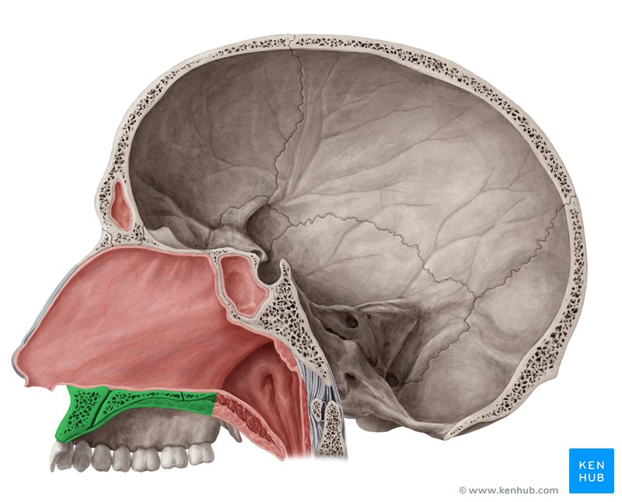Hard Palate
Soft Palate
The soft palate is also referred to as the ‘velum’. This is a continuation of the hard palate posteriorly but has no bony structure. This structure is constituted of five muscles crucial for swallowing. These are the:
- tensor veli palatini (innervated by the mandibular branch of the trigeminal nerve)
- palatoglossus
- the palatopharyngeus which has a crucial role in breathing
- the levator veli palatini which elevates the soft palate to encompass the bolus of food
- the musculus uvulae which move the uvula
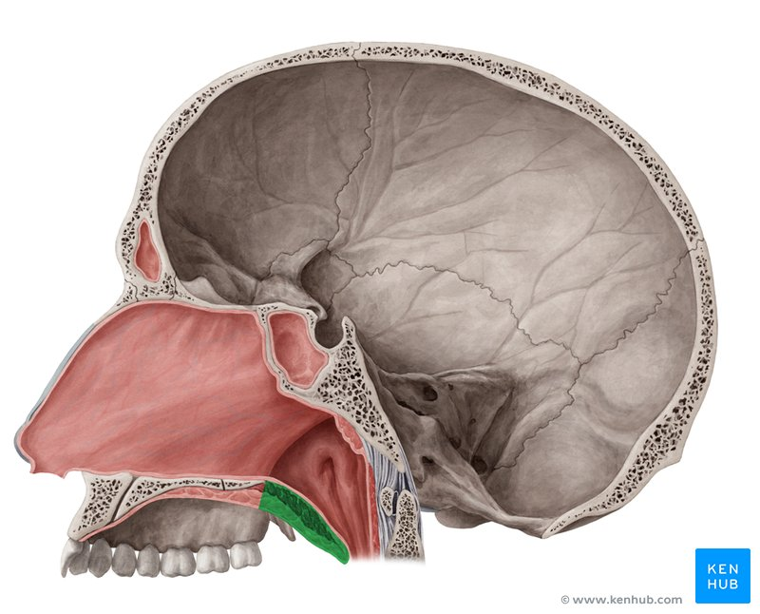Soft Palate
Lateral Wall of the Nasal Cavity
The lateral wall of the nasal cavity is a region of the nasopharynx essential for humidifying and filtering the air we breathe in nasally. Here we can find a structure called agger nasi. The agger nasi is also referred to as the ‘nasoturbinal concha’ or ‘nasal ridge.’ It can be described as a small mound or ridge found in the lateral side of the nasal cavity. The structure is located midway along the anterior aspect of the middle nasal concha. An abnormally enlarged form may restrict the drainage of the frontal sinus by obstructing the frontal recess area.
Nasal Conchae
- Inferior nasal concha.
It is the longest and broadest of the conchae and is formed by an independent bone (of the same name, inferior concha). The concha is covered by a mucous membrane that contains large vascular spaces and is one of the three that work to both humidify and clear the air that passes into the nasopharynx.
- Superior and Middle nasal conchae.
These arise from the perpendicular plate of the ethmoid bone. The middle nasal concha is found in between the superior and inferior nasal concha and plays a role in humidifying and clearing inspired air of micro-particles such as dirt. The superior nasal concha is a bony shelf located above the middle nasal concha and below the sphenoethmoidal recess. Similar to the middle nasal concha the superior concha is itself part of the ethmoid bone.
Medial Wall of the Nasal Cavity
The medial wall of the nasal cavity comprises the nasal septum, the septal cartilage and various bones of the skull.
The Nasal Septum
The nasal septum is a structure consisting of both bony and cartilaginous components. The bony components are the:
- perpendicular plate of the ethmoid superoinferiorly
- the vomer posteroinferiorly
- the crests of the maxillary bone anteroinferiorly
- the crest of the palatine bone inferior to the vomer
Nasal Cartilages and Associated Structures
The septal cartilage is approximately 3-4mm thick. It divides the nasal cavity into two halves. The anteroinferior part of the cartilage has an expansion known as the ‘footplate’ which is 4-8mm wide. This foot plate lies in free contact with the membranous septum. The cartilage is expanded in other regions, namely the junction with the lateral nasal cartilage termed the posterior process. The cartilage is firmly adhered to the nasal bone by taut collagen fibers. The cartilage of the septum is also termed the ‘quadrangular cartilage’ due to its shape. The posterior nasal spine is a sharp pointed projection of the posterior border of the palatine bone. The musculus uvula gains its attachment here.
The pharyngeal tonsil is also known as the adenoid. It is a mass of lymphatic tissue located in the roof of the nasopharynx. The structure degrades with age and is almost entirely absent at puberty. The torus tubarius is also known as the tubar tonsil. It resides at the base of the cartilaginous section of the Eustachian tube.
The choana is an opening at the back of the nasal passage that empties into the nasopharynx, close to where the adenoids are. The passage way forms an outflow from the nasopharynx into the mouth and throat.
Associated Structures
The nasal surface of the maxilla forms the antero-lateral part of the bony nasal cavity. It is located inferior to the nasal bone and gives rise in part, to the inferior nasal concha. The sphenopalatine foramen is found in the posterior most region of the nasal cavity, at the back of the middle meatus. The foramen is formed by the processes on the superior border of the palatine bone, and the under surface of the sphenoidal body, which form a foramen. It connects the nasal cavity to the pterygopalatine fossa, and thus transmits the sphenopalatine artery and vein as well as the superior nasal and nasopalatine nerves.
The medial plate of the pterygoid process is an inferior projection of the sphenoid bone. The plate forms a laterally pointing hook like process at its most inferior point, known as the pterygoid hamulus. The tensor veli palatine muscle glides around this structure. The lateral surface of the medial plate forms the medial border of the pterygoid fossa, and the medial surface forms the lateral boundary of the choana of the adjacent nasal cavity.
The limen nasi is approximately 10mm in length and is defined as the boundary between the nasal cavity proper and the vestibule. It is relatively wide and superficial anteriorly but gradually narrows as it extends posteriorly towards the anterior region of the middle concha. It lies upon the upper edge of the lateral crus of the greater alar cartilage and detached pieces of cartilage may take part in its formation.
The inferior nasal meatus lies beneath the inferior nasal concha and the lateral nasal wall. It is broader in front than behind and extends the entire length of the lateral wall of the nose and the anterior third contains the termination of the nasolacrimal or ‘tear’duct. This opening is covered by a mucosal valve known as Hassner’s valve. The middle nasal meatus is located above the inferior and below the middle nasal concha. It is also part of the ethmoidal complex as it drains the maxillary, frontal and anterior ethmoidal sinuses. The superior meatus is located below the superior nasal concha and drains the posterior ethmoidal air cells.
The sphenoethmoidal recess is a small cleft like pocket located above the superior nasal concha and drains the sphenoid sinus. The sphenoethmoidal recess is a space found superior to the superior turbinate bone and drains the sphenoidal sinus as well as some of the ethmoidal sinuses. The frontal sinuses are situated between the brow ridges and lie between the two layers of the frontal bone. They are unlikely to be symmetrical and are not usually involved in sinusitis.
The nasal vestibule is the visible part of the internal nasal cavity from an external view. The vestibule is maintained by the greater and lesser alar cartilages and contains small hairs which trap dirt and small particles during inspiration. The vestibules are lined by stratified squamous epithelium, and are separate from the nasal cavity proper, which is lined with respiratory epithelium.
Arterial Supply
The arterial supply to the medial and lateral walls of the nasal cavity is from five sources:
- Anterior ethmoidal artery (from the ophthalmic artery)
- Posterior ethmoidal artery (from the ophthalmic artery)
- Sphenopalatine artery (from the maxillary artery)
- Greater palatine artery (from the maxillary artery)
- Septal branch of the superior labial artery (from the facial artery)
The anterior part of the nasal septum is the site (Keisselbach area) of an anastomotic arterial plexus involving all five arteries supplying the septum.
Venous Drainage
A rich submucosal venous plexus deep to the nasal mucosa drains into the sphenopalatine, facial and ophthalmic veins.
Innervation
- Olfactory nerve
- Branches of the ophthalmic vein (V1) which include the anterior and posterior ethmoidal nerves
- Maxillary nerve (V2) which include;
- Posterior superior lateral nasal nerves
- Posterior superior medial nasal nerves
- Nasopalatine nerve
- Posterior inferior nasal nerves
Clinical Significance
1)Epistaxis
This is the clinical term for a nosebleed, which is usually caused by a trauma, sinus infection, rhinitis, an arid environment, hypertension, hematologic disorders, neoplasms. The most common form is anterior epistaxis which occurs along the septum and arises from Kiesselbach’s plexus. Posterior epistaxis is usually due to the maxillary artery. Depending on the area of the bleed, various treatments are available since the blood will either run out of the nose in an anterior case or down the throat in a posterior case.
2)Rhinitis
Rhinitis is another clinical term and its simple name is stuffy nose. An inflammation causes nasal congestion, sneezing, rhinorrhea or a runny nose and nasal itching. The most common cause is allergic rhinitis more commonly known as hay fever. This is systematically treated with decongestants, antihistamines and steroids.
3)Deviated Septum
A deviated septum means that the bony midline of the nasal cavity is off center, either due to a trauma or birth defects and this results in partial or total occlusion of one side of the cavity. The treatment is surgical and septoplasty is usually performed.

