OBE OLUWATOMILADE OLUWASEUN
18/ENG05/039
MECHATRONICS ENGINEERING
AFE 202; FOOD PRODUCTION AND HEALTH AWARENESS

Table of content
Chapter Title
1. Executive Summary
2. Introduction
3. Market and marketing
4. Project Engineering.
5. Materials, production and plants.
6. Location and site.
7. Conclusion.

CHAPTER TWO
INTRODUCTION
Bread is one of the most common staple food in Africa. You can purchase different varieties of bread of different shapes, tastes and sizes at affordable prices.
A healthier variety of breads are what we are in cognizance. For this brand perception that we formalize, we would like to linger the interest of the buyers and also the consumers with our version of Jenner’s Bakery. We would like to introduce varieties of flavors that consumers would not normally taste. Nowadays, people would choose an artificially made food product that has less healthy nutritional content over the conventional foods that is said to be “good for health lifestyle” that is available in the market. Promoting a healthy and convenient way of eating by introducing varieties of Jenner’s bakery to the public consumers would benefit the consumers with its health nutrition content it have.
- Background
Jenner’s bakery will be located at Number 5, Idanre Road, Adejare Street, Akure, Ondo State, Nigeria. It will be a sole-proprietorship business. The company will deal with the production of different types of bread and flavor such as coconut bread, vanilla flavored bread, ginger flavored bread, wheat bread, chocolate bread, banana bread, sliced bread and unsliced bread which will come in different sizes. The ingredients used in the bread preparation will be products gotten from Nigeria.
My desire to add value to my country by creating job opportunities for people, particularly for the youths in my community drove me into entrepreneurship. Aside my unflinching love for different types of freshly baked bread, I have discovered that too many bakeries in my area do not produce varieties of bread, particularly those I love to eat. There is an increase in .This has prompted me to open a bakery where I can put my skill and creativity to use whilst still adding value to others.
- History.
Bread is a staple food which is made and eaten in most countries around the world. Bread products have evolved to take many forms, each based on quite different and distinctive characteristics. Over the centuries, craft bakers have developed our traditional bread varieties using their available raw materials to achieve the desired bread quality. In some countries, the nature of bread making has retained its traditional form while in others, it has changed drastically. The proliferation of bread varieties is derived from the unique properties of wheat proteins to form gluten structures formed within the dough. The rubbery mass of gluten with its ability to deform, stretch, recover shape and trap gases is very important in the production of bread and all fermented products. Bread is the most consumable wheat-based bakery product. It contains high nutritive value. They are easy to digest and compact in size, therefore, its consumption is increasing day by day.
Objectives
1. To meet the needs of people in the society by providing them with freshly baked bread of different types.
2. To provide job opportunities for people, particularly the youths.
3. To earn profits.
4. To sustain economic growth.
CHAPTER 3
Market and Marketing Analysis
- Our products
Jenner’s bakery products include breads of different types or varieties and sizes. They include:
- Coconut bread,
- Wheat bread,
- Banana bread,
- Chocolate bread,
- French loaves,
- Sliced and unsliced bread.

- Nature of Market
Akure, the state capital of Ondo state has lots of economic activities thriving there. With the rise in industrial activities, many people are forced to be on the move so early that they find it difficult to eat homely made food. Bread remains one of the common and popular staple food that you will find in Nigeria today. It is consumed by all and sundry.
Due to the steady increase in population and increase in bread consumers, there is need to increase the number of bread producing bakeries. Despite the increase in the prices of bread, the demand for bread has not diminished but it has increased steadily. Middle and upper class families are increasingly looking for better tasty and healthier breads than those currently available in the market.

CHAPTER 4
Project Engineering
- Plants and equipment.
Raw materials required for bread production are: wheat flour, all purpose flour, water, sugar, salt, yeast and edible or baking fat.
Equipment required in bread production include: Oven, dough mixer, baking pans, source of power supply, bread wraps, proofing chamber, delivery vans, slicing machine, dough break or roller, dough cutter, working table (stainless steel), dough molder, trolley, extractor fan, weigh scale.
- Manufacturing process
Combine flour, sugar, salt, and yeast. Slightly mix the dry ingredients with your dough hook and add egg, butter and oil.
Put your mixer into speed 1 and let the egg, butter and oil mix with the dry ingredients. Place your fresh milk, evaporated milk and water in a microwavable container and heat it up for 45 seconds first, before pouring it into your Jenner’s bread.
Once the Jenner’s bread mix becomes overall wet, increase the speed to 2 and knead for 15 minutes in the mixer. Prepare a stainless steel large mixing bowl and wipe the inside with an oiled kitchen paper towel. Once the kneading is done, turn off the mixer and remove the dough hook and bowl out of the mixer stand. Lightly oil your hands and remove the dough. Tuck in the edges of the dough underneath to create a smooth top surface before placing it in your oiled mixing bowl. Cover the bowl with cling wrap.
If the weather is hot, just leave the bowl on your kitchen bench, but if it’s cold, pour some hot boiling water in a container and place it inside your oven (turned off) on the bottom level. Position the bread dough on a rack above the hot water container, close the oven’s door and leave it there for 1 hour (same amount of time if it’s on the kitchen bench) until it doubles in size.
Place two handful flour in the corners in the cleaned kitchen bench. Lightly flour your kneading area with a bit of your flour. Take out the risen bread dough out of the mixing bowl and knead/punch down the air out of it. If it gets too sticky, lightly flour your hands and pat the overall exterior of the dough.
Roll the dough till it becomes elongated. Using a 1/3 measuring cup, scoop some of the dough and level it up with your inner palm and with a sweeping motion (using your palm) cut the dough on the edges of the measuring cup.
Cup each bread dough portions with your right hand and roll it into a ball in an anti-clockwise motion. If it gets too sticky, dust your hands with some flour. Dip each dough into the bread crumbs. Before placing it in your baking tray, make the dough slightly oval shaped. Distance each dough portion about 2-2.5cm away from each other. Cover the baking tray with cling wrap loosely.
Let it rise for another hour (hot weather- leave it on the kitchen bench, cold weather- inside the oven with hot water underneath), it will double its size again.
Preheat your oven 200C and bake your tray of bread on the top second rack for 10-15 minutes.
Once cooked slide, the bread rolls into a wire cooling rack immediately.

- Technical Partners
- Manager:
Name: Mr. Adams Jeremiah
Responsibilities:
Oversees daily production
Oversees work schedules
Assigning employee tasks
Ensures product quality
Keeps facility running, and clean
Planning, organizing, directing and controlling all the employees of the organizations as well as its relationship to each other.
Job Qualifications:
A graduate of any management courses
Male, 35 years of age
Has 5 years working experience
Has a good moral character and a pleasing character
Salary scale: 80,000 Naira monthly.

- Book keeper/cashier.
Name: Mrs. Adedara Yewande
Responsibilities:
Responsible for monthly income statements and balance sheets.
Responsible for collection of payroll and receivables.
Responsible for managing cash.
Responsible for keeping records of sales.
Responsible for cash deposit.
Job Qualifications:
Female, 45 years old.
A graduate of four business related course.
Has 3 years working experience.
Has good moral character.
Is honest and has pleasing character.
Salary scale: 60,000 Naira monthly.

- Head baker.
Name: Mrs. Asiwaju Bethany
Responsibilities:
Designs and cost baked products recipes in liaison with Customer Service Management.
Ensures quality control and post production including maintenance of hygiene standards and accurate pack weights and QC audit of retail outlets as required.
Supervise and train production staff to efficiently and safely produce high volume, multiple baked products with minimum of wastage.
Calculate raw material needs and efficiently maintain stock levels to meet production requirements.
Oversee distribution to retail outlets in liaison with location manager.

Job Qualifications:
Female, 47 years
Has a bachelor degree
Has three years working experience
Has complete and thorough knowledge of baking processes for bread
Has a managerial and supervisory experience in high volume bakery production environment
Has good character, is responsible and hard working.
Salary Scale: 65,000 Naira monthly.

CHAPTER 5.
Materials, production and plant.

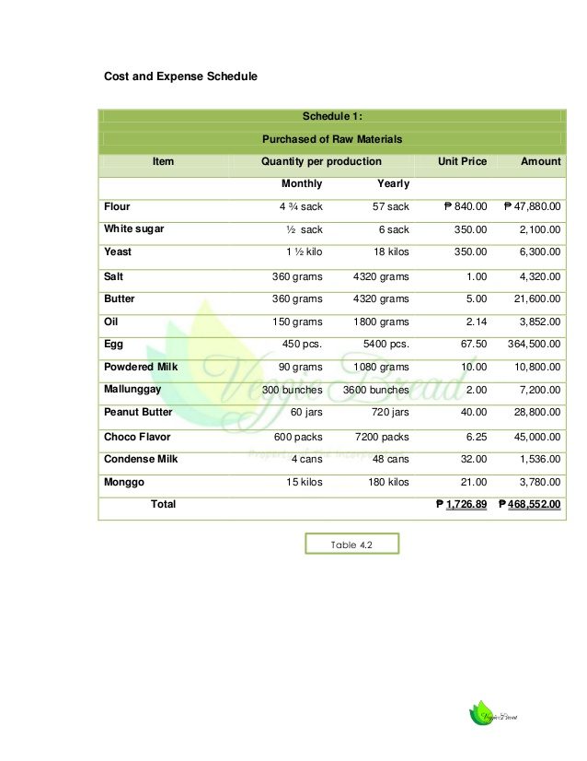

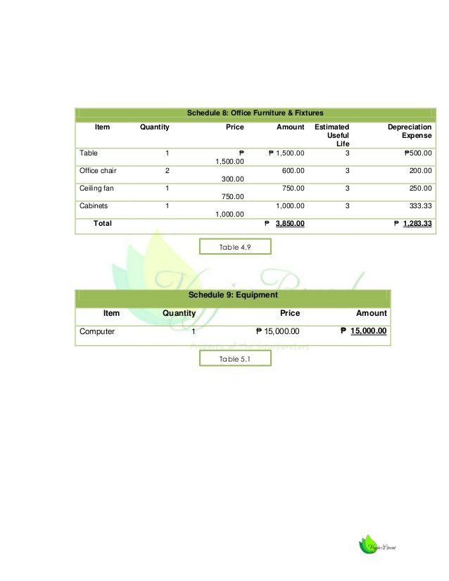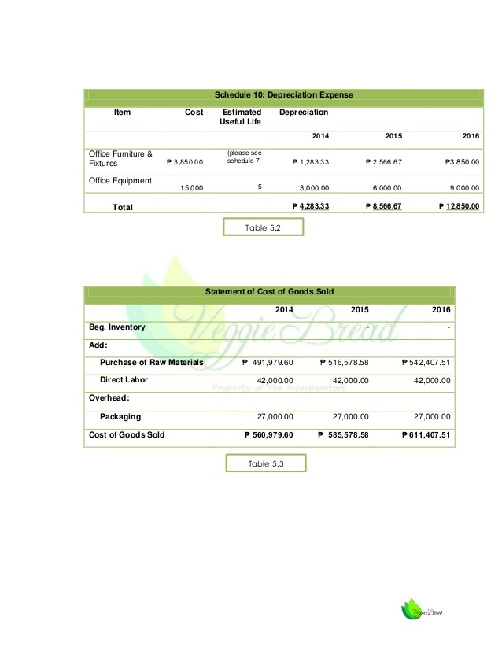

CHAPTER 6
Location and Site
- Plant Location.
The plant location shall be located at Number 5, Idanre Road, Adejare Street, Akure, Ondo State, Nigeria.

- Plant Layout.
The plant layout is tactically designed to support the smooth process of the proposed business (Jenner’s bakery). The display area is a place where all finished products that are ready to sell are being displayed. There would be a business office area which will cater to business related transactions. The bakery will be the place for customers to purchase the finished products of Jenner’s bread. The pantry will be the area where the Jenner’s bread will be made by the baker.
- Bakery or store.
This is a proposed perspective view of the Jenner’s bread bakery. This is where the Jenner’s bakery products will be displayed and with a relaxing design which promotes a healthy lifestyle that our products endures to customers.

- Office.
This is a proposed perspective view design or where the manager of the Jenner’s bread will be in the office.

- Pantry/baking area.
This is a proposed perspective view design of where the Jenner’s bakery products will be produced and done.

CHAPTER 7

Recommendation.
After bearing in mind the significant factors like the marketing, financial, technical and management and socio-economic study, it is therefore recommended that the Jenner’s Bakery will be pursued and the business establishes at number 5, Idanre Road, Adejare Street, Akure, Ondo State, Nigeria.

Conclusion.
Based on the research and study that we conducted, we therefore conclude that our business is feasible and viable in the market.

