OVBUDE IRENOISE DEBORAH

16/MHS03/026

ELECTRON MICROSCOPIC TECHNIQUE AND ULTRASTRUCTURE
ANA 402

DR OGEDENGBE OLUWATOSIN OLALEKAN

ASSIGNMENT
- WRITE AN ESSAY ON THE HISTORY OF MICROSCOPY.
- DIFFERENTIATE BETWEEN THE LIGHT MICROSCOPE AND ELECTRON MICROSCOPE.
- DIFFERENTIATE BETWEEN SEM AND TEM.

What is a Microscope?
A microscope is an instrument that can be used to observe small objects, even cells. The image of an object is magnified through at least one lens in the microscope. This lens bends light toward the eye and makes an object appear larger than it actually is. Microscopes let us view an invisible world – the objects around us that are too small to be seen with the naked eye (Science Learning Hub, 2014).

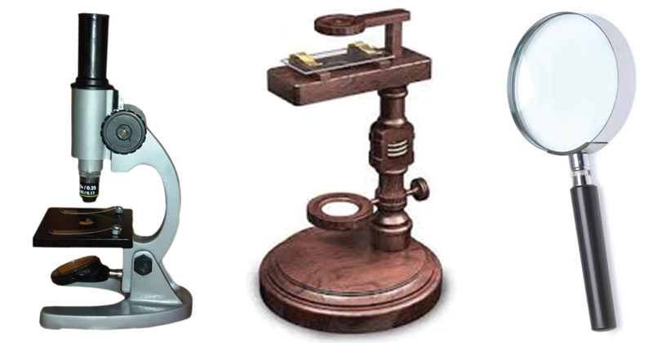
Fig.1. Simple Microscope.

What is Microscopy?
Microscopy is the technical field of using microscopes to view objects and areas of objects that cannot be seen with the naked eye these are objects that are not within the resolution range of the normal eye (University of Edinburgh, 2018).
HISTORY OF MICROSCOPY.
From ancient times, man has wanted to see things far smaller than could be perceived with the naked eye. However, it has been known for over 2000 years that glass bends light. In the 2nd Century BC, Claudius Ptolemy described a stick appearing to bend in a pool of water, and accurately recorded the angles to within half a degree. He then very accurately calculated the refraction constant of water (Vision Engineering, 2018).

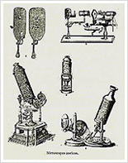
Fig. 2. Ancient Microscopes.

During the 1st century AD (year 100), glass had been invented and the Romans were looking through the glass and testing it. They experimented with different shapes of clear glass and one of their samples was thick in the middle and thin on the edges.
They discovered that if you held one of these “lenses” over an object, the object would look larger. These early lenses were called magnifiers or burning glasses. The word lens is actually derived from the Latin word lentil, as they were named because they resembled the shape of a lentil bean.
At the same time, Seneca described actual magnification by a globe of water. “Letters, however small and indistinct, are seen enlarged and more clearly through a globe of glass filled with water.” The lenses were not used much until the end of the 13th century when spectacle makers were producing lenses to be worn as glasses. Then, around 1600, it was discovered that optical instruments could be made by combining lenses (Vision Engineering, 2018).

Early Light Microscopes Developed

During the 1590s, two Dutch spectacle producers further experimented with these early lenses. Zaccharias Janssen and his father Hans Janssen realised that if you put a small object in a tube containing several lenses, the object would appear very large when at the end of the tube and was much more enlarged than when a simple magnifying glass was used. The pair only achieved a magnification of 9x and these early microscopes were more novelties than scientific instruments. In the late 17th Century, Anthony von Leeuwenhoek from Holland invented a single lens, hand-held microscope that could achieve a magnification of 270x (Fields, 2019).
Using this lens, he went on to develop the first microscope that could actually be made use of. Leeuwenhoek found he was able to see structures that noone had seen before such as blood cells and bacteria. In the same century, Englishman Robert Hooke was acknowledged as having discovered the smallest most basic unit of an organism the cell. He was also recognised as the first person to use a microscope with three lenses, the configuration used in today’s microscopes (Fields, 2019).
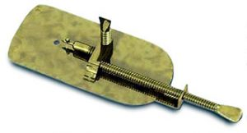
Fig. 3. Leeuwenhoek’s microscope

Leeuwenhoek’s microscope used a single convex glass lens attached to a metal holder and was focused using screws. Anthony Leeuwenhoek became more involved in science and with his new improved microscope was able to see things that no man had ever seen before. He saw bacteria, yeast, blood cells and many tiny animals swimming about in a drop of water. People did not realize that magnification might reveal structures that had never been seen before – the idea that all life might be made up of tiny components unseen by the unaided eye was simply not even considered (Vision Engineering, 2018).

Chronology of Microscope

Earlier microscopes, single lensmagnifying glasses with limited magnification, date at least as far back as the wide spread use of lenses in eyeglasses in the 13th century(Atti,1975) but more advanced compound microscopes first appeared in Europe around 1620 (William, 1996). The earliest practitioners of microscopy include Galileo Galilei, who found in 1610 that he could close focus his telescope to view small objects close up (Smith, 2014) and Cornelis Drebbel, who may have invented the compound microscope around 1620 (Raymond et.al., 2016) Antonie van Leeuwenhoek developed a very high magnification simple microscope in the 1670s and is often considered to be the first acknowledged microscopist and microbiologist (Ford, 1992).

14th century: spectacles first made in Italy

1590: Two Dutch spectacle-makers and father-and-son team, Hans and Zacharias Janssen, create the first microscope.

1667: Robert Hooke's famous "Micrographia" is published, which outlines Hooke's various studies using the microscope.

1675: Enter Anton van Leeuwenhoek, who used a microscope with one lens to observe insects and other specimen. Leeuwenhoek was the first to observe bacteria. 18th century: As technology improved, microscopy became more popular among scientists. Part of this was due to the discovery that combining two types of glass reduced the chromatic effect.

1830: Joseph Jackson Lister discovers that using weak lenses together at various distances provided clear magnification.

1878: A mathematical theory linking resolution to light wavelength is invented by Ernst Abbe.

1903: Richard Zsigmondy invents the ultramicroscope, which allows for observation of specimens below the wavelength of light.

1932: Transparent biological materials are studied for the first time using Frits Xernike's invention of the phase-contrast microscope.

1938: Just six years after the invention of the phase contrast microscope comes the electron microscope, developed by Ernst Ruska, who realized that using electrons in microscopy enhanced resolution.

1981: 3-D specimen images possible with the invention of the scanning tunneling microscope by Gerd Binnig and Heinrich Rohrer.

DIFFERENTIATE BETWEEN LIGHT AND ELECTRON MICROSCOPE.
Light Microscope
- A light microscope, on the other hand, is cheap to buy and maintain. It requires no special skills to use. As a result, it is suitable for most basic functions, and is very common in schools and other learning institutions.
- While a light microscope uses light to illuminate specimens and glass lenses to magnify images.
- A light microscope has a resolution of up to 0.3µm, i.e. 3 micrometers. This limits it as two close objects cannot be seen as separate.
- A light microscope can be used to view both dead and live specimens. This makes it important in studying live ones.
- A light microscope can view both live and dead specimens.
- Light microscopes have poor surface view.
- Light microscopes are generally simple to use.
- The lenses of the light microscopes are made of glass.
- Light microscopes are cheap to buy and have low maintenance costs.
- The images of a light microscope are viewed by the eyes through the eyepiece.
- Light microscopes have low magnification of up to 1,500x.
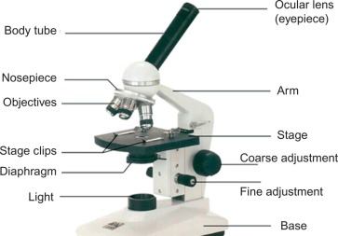
Fig. 4. Labeled Simple Light Microscope
Electron Microscope
- An electron microscope is very expensive to buy and requires special environments. This makes it expensive to maintain. In addition, it requires high technical skills to use and is therefore limited to specialized use such as research.
- An electron microscope uses a beam of electrons to illuminate specimens and magnetic lenses to magnify images.
- In an electron microscope, the resolution is about 0.0001µm, i.e. 0.01 nanometers. This resolution can be used in situations that require greater details, such as studying cell nuclei.
- By contrast, an electron microscope cannot be used to view living specimens as it uses electrons that are destructive to life.
- Electron microscopes views only dead specimens.
- Electron microscopes have good surface view and internal details.
- Electron microscope users require technical skills.
- The lenses of electron microscope are made of electromagnets.
- Electron microscopes are very expensive to buy and maintain.
- The images of an electron microscope are viewed on a photographic plate or zinc sulphate fluorescent screen.
- Electron microscopes have high magnification of up to 1,000,000x.

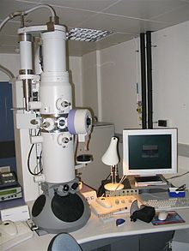
Fig. 5. Electron Microscope

DIFFERENTIATE BETWEEN SCANNING ELECTRON MICROSCOPE (SEM) AND TRANSMISSION ELECTRON MICROSCOPE (TEM).
Scanning Electron Microscope (SEM)
- SEM is Scanning Electron Microscope which is based on scattered electrons. It forms the image of sample after counts of scattered electrons.
- It provides 3D image but magnification is almost only 2 million times.
- SEM provides data about the surface of the analyzed object.
- SEM functions with Scattered, scanning electrons.
- SEM makes use of high tension of ~1 – 30 kV.
- SEM can scan specimens with any thickness.
- SEM has an optimal spatial resolution of ~0.5 nm.
- SEM Electrons are captured and counted by detectors, image on PC screen.
- It offers a lesser resolution compared to SEM.
- SEM requires little or no sample preparationas it is easy to use.
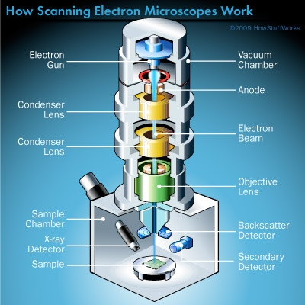
Fig. 6. Labeled Scanning Electron Microscope.

Transmission Electron Microscope (TEM)
- TEM is Transmission Electron Microscope in which electrons are directly pointed toward the sample.
- It delivers 2D image and has magnification upto 50 million.
- TEM enables data to be captured regarding the sample’s inner structure
- TEM functions with transmitted electrons
- It has high tension of about ~60 – 300 kV.
- It can scan a specimen with a thickness typically <150 nm.
- TEM has an optimal spatial resolution of < 50 pm.
- The Image formation of TEM is direct imaging on fluorescent screen or PC screen with CCD.
- TEM requires laborious sample preparation and trained users.
- TEM offers a greater resolution compared to SEM.
- TEM has more stringent requirements concerning the preparation of samples and the conditions of analysis.

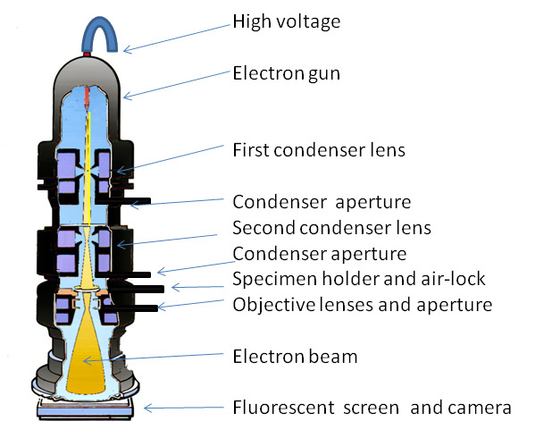
Fig. 7. Labeled Transmission Electron Microscope.

REFERENCES
- Science Learning Hub – Pokapū Akoranga Pūtaiao. (2014).Adaptations of marine organisms. Retrieved from www.sciencelearn.org.nz/resources/142-adaptations-of-marine-organisms.
- Atti Della Fondazione Giorgio Ronchi E Contributi Dell'Istituto Nazionale Di Ottica, Volume 30, La Fondazione-1975, page 554.
- William Rosenthal, Spectacles and Other Vision Aids: A History and Guide to Collecting, Norman Publishing, 1996, page 391 – 392.
- Raymond J. Seeger, Men of Physics: Galileo Galilei, His Life and His Works, Elsevier - 2016, page 24.
- Ford, Brian J. (1992). "From Dilettante to Diligent Experimenter: a Reappraisal of Leeuwenhoek as microscopist and investigator". Biology History. 5 (3).
- Vision Engineering ltd. (2018). https://www.visioneng.com/resources/history-of -the-microscope/.
- Fields, Deborah. (2019, February 26). Brief History of Microscopy. News-Medical. Retrieved on April 29, 2020 from https://www.news-medical.net/life-sciences/Brief-History-of-Microscopy.aspx.
- Microscope.com. (2020). https://www.microscope.com/education-center/microscopes-101/history-of-microscopes.

