ASSIGNMENT II
NAME: ADENIYI-OSO OLUWAPELUMI ENOCH
MATRIC NO: 17/MHS01/020
DEPARTMENT: MEDICINE AND SURGERY
COURSE: GROSS ANATOMY OF HEAD AND NECK

- Discuss the anatomy of the tongue and comment on its applied anatomy

Tongue is a pink, muscular organ located within the oral cavity proper. It is kept moist by the products of the major and minor salivary glands, which aids the organ as it facilitates deglutition, speech, and gustatory perception. While there is significant variability in the length of the tongue among individuals, on average, the organ is roughly 10 cm long. It has three main parts:
- The tip or apex of the tongue is the most anterior, and most mobile aspect of the organ.
- The tip is followed by the body of the tongue. It has a rough dorsal (superior) surface that abuts the palate and is populated with taste buds and lingual papillae, and a smooth ventral (inferior) surface that is attached to the floor of the oral cavity by the lingual frenulum.
- The base of the tongue is the most posterior part of the organ. It is populated by numerous lymphoid aggregates known as the lingual tonsils along with foliate papillae along the posterolateral surface

Anterior two-third of the tongue
The Tongue includes the apex and body of the organ. It terminates at the sulcus terminalis; which can be seen extending laterally in an oblique direction from the foramen cecum towards the palatoglossal arch. The mucosa of the dorsal surface of the oral tongue is made up of circumvallate, filiform, and fungiform papillae. There is also a longitudinal midline groove running in an anteroposterior direction from the tip of the tongue to the foramen cecum. This marks the embryological point of fusion of the lateral lingual swellings that formed the oral tongue. It also represents the location of the median lingual (fibrous) septum of the tongue that inserts in the body of the hyoid bone.
On the lateral surface of the oral tongue are foliate papillae arranged as a series of vertical folds. The ventral mucosa of the oral tongue is comparatively unremarkable. It is smooth and continuous with the mucosa of the floor of the mouth and the inferior gingiva. The lingual veins are relatively superficial and can be appreciated on either side of the lingual frenulum. Lateral to the lingual veins are pleated folds of mucosa known as the plica fimbriata. They are angled anteromedially toward the apex of the tongue.

Posterior two-third of the tongue
The tongue that lies posterior to the sulcus terminalis is made up by the base of the organ. It lies behind the palatoglossal folds and functions as the anterior wall of the oropharynx. Unlike the oral tongue, the pharyngeal tongue does not have any lingual papillae. Instead, its mucosa is populated by aggregates of lymphatic tissue known as the lingual tonsils. The mucosa is also continuous with the mucosa of the laterally located palatine tonsils, the lateral oropharyngeal walls, and the posterior epiglottis and glossoepiglottic folds.

Muscles of the Tongue.
All the muscles of the tongue are paired structures, with each copy being found on either side of the median fibrous septum. There are muscles that extend outside of the organ to anchor it to surrounding bony structures, known as extrinsic muscles. The other set of muscles are confined to each half of the organ and contribute to altering the shape of the organ; these are the intrinsic muscles.
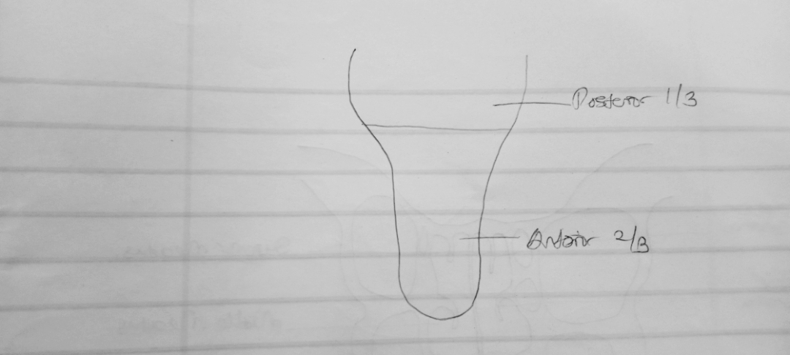

Intrinsic Muscles of the tongue.
The intrinsic tongue muscles are responsible for adjusting the shape and orientation of the organ. It is made up of four paired muscles
- Superior longitudinal muscle:
Origin - submucosa of posterior tongue, lingual septum
Insertion - anterolateral margins of tongue
Innervation - hypoglossal nerve (CN XII).
Blood supply- lingual branch of external carotid artery
Action - retracts and broadens tongue, elevates apex of tongue
- Transverse muscle:
Origin - lingual septum
Insertion - lateral margin of tongue
Innervation - hypoglossal nerve (CN XII)
Blood supply - lingual branch of external carotid artery
Action - narrows and elongates tongue

- Inferior longitudinal muscle:
Origin - root of tongue, body of hyoid bone
Insertion - apex of tongue
Innervation - hypoglossal nerve (CN XII)
Blood supply - lingual branch of external carotid artery
Action - retracts and broadens tongue, lowers apex of tongue

- Vertical muscle:
Origin - root of tongue, genioglossus muscle
Insertion - lingual aponeurosis
Innervation - hypoglossal nerve (CN XII)
Blood supply - lingual branch of external carotid artery
Action - broadens and elongates tongue

EXTRINSIC MUSCLES OF THE TONGUE.
The shape of the tongue is determined by the intrinsic muscles of the tongue, movement of the organ within (and out of) the oral cavity is dependent on the extrinsic tongue muscles. There are four pairs of extrinsic muscles, which can be viewed as those arising from above the tongue, and those that originate from below the tongue.

Styloglossus:
Origin - anterolateral aspect of styloid process (of temporal bone), stylomandibular ligament
Insertion - blends with inferior longitudinal muscle (longitudinal part); blends with hyoglossus muscle (oblique part)
Innervation - hypoglossal nerve (CN XII)
Blood supply - sublingual branch of lingual artery
Action - retracts and elevates lateral aspects of tongue

Genioglossus:
Origin - Superior mental spine of mandible
Insertion - entire length of dorsum of tongue, lingual aponeurosis, body of hyoid bone
Innervation - hypoglossal nerve (CN XII)
Blood supply - sublingual branch of lingual artery, submental branch of facial artery
Action - depresses and protrudes tongue (bilateral contraction); deviates tongue contralaterally (unilateral contraction)

Hyoglossus:
Origin - body and greater horn of hyoid bone
Insertion - inferior/ventral parts of lateral tongue
Innervation - hypoglossal nerve (CN XII)
Blood supply - sublingual branch of lingual artery, submental branch of facial artery
Action - depresses and retracts tongue

Palatoglossus:
Origin - palatine aponeurosis of soft palate
Insertion - lateral margins of tongue, blends with intrinsic muscles of tongue
Innervation - vagus nerve (CN X) (via branches of pharyngeal plexus)
Blood supply - ascending palatine branch of facial artery, ascending pharyngeal artery
Action - elevates root of tongue, constricts isthmus of fauces
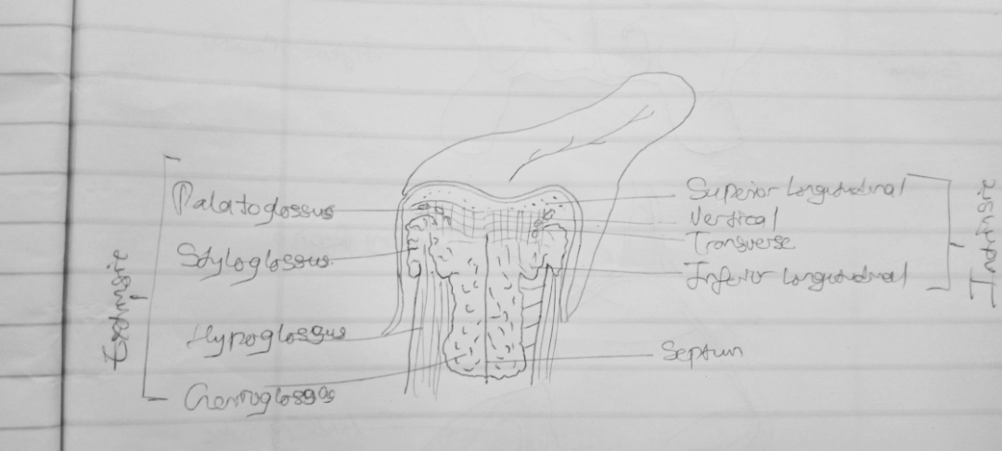

Clinical Anatomy .
Tongue Tied
The tongue is attached anteroinferiorly by a piece of connective tissue called the frenulum, which lies in the midline. The process by which the frenulum is formed is the same by which the fingers are made, and is known as sculpting apoptosis. This is called being ‘tongue-tied’, and presents in children. There are varying degrees of severity of tongue-tie and in some cases it can restrict the movement of the tongue causing difficulties with breast feeding. This can be managed with surgery.

- Write an essay on the Air sinuses.
Air sinuses are air-filled extensions of the respiratory part of the nasal cavity. There are four paired sinuses, named according to the bone in which they are located; maxillary, frontal, sphenoid and ethmoid.It is thought that they may contribute to the humidifying of the inspired air. They also reduce the weight of the skull.
As they are outgrowths of the nasal cavity, they all drain back into it – openings to the paranasal sinuses are found on the roof and lateral walls of the nasal cavity. The inner surface is lined by a respiratory mucosa.
Frontal Sinuses: These are the most superior in location, found under the forehead. The frontal sinuses are variable in size, but always triangular-shaped. They drain into the nasal cavity via the frontonasal duct, which opens out at the hiatus semilunaris on the lateral wall.
Sphenoid Sinuses: The sphenoid sinuses also lie relatively superiorly, at the level of the spheno-ethmodial recess. They are found more posteriorly, and are related superiorly and laterally to the cranial cavity. The sphenoid sinuses drain out onto the roof of the nasal cavity. The relationships of this sinus are of clinical importance – the pituitary gland can be surgically accessed via passing through the nasal roof, into the sphenoid sinus and through the sphenoid bone.
Ethmoidal Sinuses: There are three ethmoidal sinuses; anterior, middle and posterior. They empty into the nasal cavity at different places:
- Anterior – Hiatus semilunaris
- Middle – Ethmoid bulla
- Middle – Ethmoid bulla
- Posterior – Superior meatus
Maxillary Sinuses: The largest of the sinuses. It is located laterally and slightly inferiorly to the nasal cavities. It drains into the nasal cavity at the hiatus semilunaris, underneath the frontal sinus opening. This is a potential pathway for spread of infection fluid draining from the frontal sinus can enter the maxillary sinus.

