ASSIGNMENT I

NAME: ADENIYI-OSO OLUWAPELUMI ENOCH
MATRIC NO: 17/MHS01/020
DEPARTMENT: MEDICINE AND SURGERY
COURSE: GROSS ANATOMY OF HEAD AND NECK

QUESTION
- Write an essay on cavernous sinus

The cavernous sinus is located on either side of the pituitary fossa and body of the sphenoid bone between the endosteal and meningeal layers of the dura It spans from the apex of the orbit to the apex of the petrous temporal bone. Unlike other dural venous sinuses, it is divided by numerous fibrous septa into a series of small caves, which is where its name is derived from. The normal lateral wall should be either straight or concave.
The cavernous sinuses are located within the middle cranial fossa, on either side of the sella turcica of the sphenoid bone. They are enclosed by the endosteal and meningeal layers of the dura mater.
Borders of the Cavernous sinus includes:
- Anteriorly – by superior orbital fissure.
- Posteriorly – by petrous part of the temporal bone.
- Medially – by the body of the sphenoid bone.
- Laterally – Meningeal layer of the dura mater running from the roof to the floor of the middle cranial fossa.
- Roof – Meningeal layer of the dura mater that attaches to the anterior and middle clinoid processes of the sphenoid bone.
- Floor – Endosteal layer of dura mater that overlies the base of the greater wing of the sphenoid bone.

The cavernous sinus transmits multiple cranial nerves to the superior orbital fissure and foramen rotundum . These are:
- On the lateral wall
  - Oculomotor Nerve(CNIII)
  - Trochlear Nerve (CNIV)
  - Trigeminal Nerve (CNV)
    - Ophthalmic division
    - Maxillary division: within the very inferolateral aspect of the cavernous sinus wall or even outside the sinus rather than truly within it 4.
- Traversing the sinus
  - Abducens Nerve: inferolateral to the Internal Carotid Artery.
The Internal Carotid Artery enters the posterior inferior aspect of the sinus and bends upon itself as the carotid siphon (cavernous segment - C4). Two branches arise from this segment: meningohypophyseal trunk and inferolateral trunk.
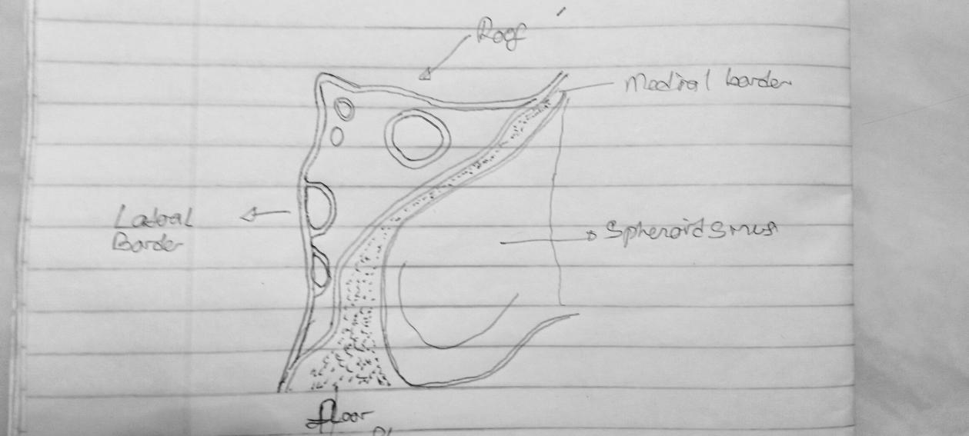

- Discuss the wall of the nose.
The nose is an olfactory and respiratory organ. It consists of nasal skeleton. The lateral wall of the nasal cavity is a region of the nasopharynx essential for humidifying and filtering the air we breathe in nasally.
Parts of the Lateral wall of the nose includes the:
- Nasal Septum
- Nasal Conchae
- Nasal septum: Nasal septum separate the left and right airway of the nasal cavity, dividing the two nostrils.Its cartilage and bones include:
Cartilages: Lesser alar cartilages, Greater alar cartilages, Lateral nasal cartilages. Bones: Anterior nasal aperture (piriform aperture) formed by maxilla and nasal bones
- Nasal Conchae: They project into the nasal cavity, creating four pathways for the air to flow. These pathways are called meatuses:
- Inferior meatus – between the inferior concha and floor of the nasal cavity.
- Middle meatus – between the inferior and middle concha.
- Superior meatus – between the middle and superior concha.
- Spheno-ethmoidal recess – superiorly and posteriorly to the superior concha.
The function of the conchae is to increase the surface area of the nasal cavity – this increases the amount of inspired air that can come into contact with the cavity walls. They also disrupt the fast, laminar flow of the air, making it slow and turbulent. The air spends longer in the nasal cavity, so that it can be humidified.
