NAME: ABUDU, PRECIOUS ESTHER
MATRIC NO: 17/MHS01/008
LEVEL: 300
DEPARTMENT: MEDICINE AND SURGERY
COURSE CODE: ANA 301
COURSE TITLE: GROSS ANATOMY OF THE HEAD AND NECK
ASSIGNMENT 2
Question
- Write an essay on the cavernous sinus.
- Discuss the walls of the nose.
Answers
- Cavernous sinus
The dural venous sinuses are channels between the two layers of dura mater which are responsible for the venous drainage of the brain, skull, orbit and internal ear. The dural sinuses are grouped into the sagittal, lateral (including the transverse, sigmoid, and petrosal sinuses), and cavernous sinuses.
The cavernous sinus is a paired dural venous sinus located within the cranial cavity. The cavernous sinuses are irregularly shaped, trabeculated cavities located at the base of the skull. Although they are not truly trabeculated cavities like the corpora cavernosa of the penis, the numerous plexuses, however, give the cavities their characteristic sponge-like appearance.
Most of the cavernous sinus is formed before birth. It first emerges as a collection of small venous canals consisting of only an endothelial layer. Throughout gestation, these canals gradually expand to form larger structures. In fact, after 13 weeks of gestation, the cavernous sinus appears as a faint cluster of small vessels, whereas after 27 weeks of gestation, the inferior venous pathways suddenly increase in size.
It is situated bilaterally to the sella turcica and extends from the superior orbital fissure anteriorly to the petrous part of the temporal bone posteriorly, and is about 1 cm wide and 2 cm long. These sinuses are just lateral and superior to the sphenoid sinus and are immediately posterior to the optic chiasm. It spans from the apex of the orbit to the apex of the petrous temporal bone. Unlike other dural venous sinuses, it is divided by numerous fibrous septa into a series of small caves, which is where its name is derived from.

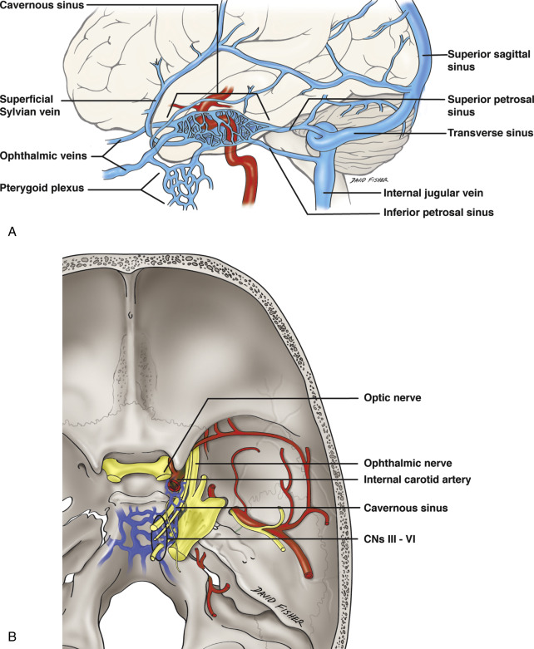
The cavernous sinus is roofed by an inner layer of dura matter that continues with the diaphragma sellae that covers the superior part of the pituitary gland. The roof of the sinus also has several other attachments. Anteriorly, it attaches to the anterior and middle clinoid processes, posteriorly it attaches to the tentorium (at its attachment to the posterior clinoid process). Part of the periosteum and endosteal dura matter overlying the base of the greater wing of the sphenoid bone forms the floor of the sinus. The body of the sphenoid acts as the medial wall of the sinus while the lateral wall is formed from by the meningeal layer of dura mater.
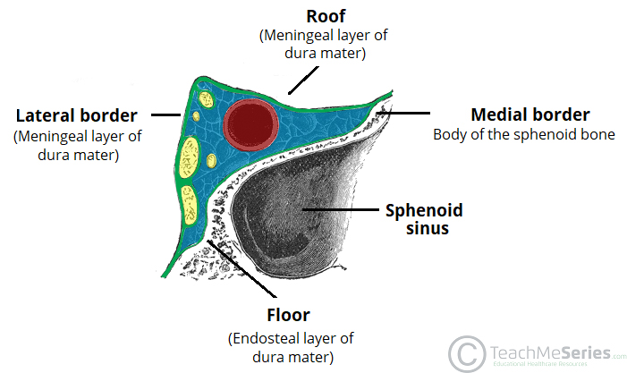
The relations of the cavernous sinus are:
- Superiorly: Middle cerebral artery, Optic chiasm
- Inferiorly: Sphenoid sinus
- Anteriorly: Apex of the orbit
- Posteriorly: Cerebral peduncle
- Medially: Pituitary fossa, Pituitary gland
- Laterally: Medial surface of Temporal lobe, Meckel’s cave (posteroinferiorly)

The cavernous sinuses receive blood from
- Inferior and Superior ophthalmic veins
- Intercavernous sinus
- Sphenoparietal sinus
- Superficial middle cerebral vein
- And occasionally
  - Central retinal vein
  - A frontal tributary of the middle meningeal vein

Drainage of the cavernous sinus is through:
- Superior petrosal sinus to the transverse sinus
- Inferior petrosal sinus directly to the jugular vein
- Venous plexus on the internal carotid artery to the basilar venous plexuses
- Emissary veins passing through the
  - Foramen vesalii
  - Foramen ovale: communicates between the cavernous sinuses and the pterygoid venus plexus
  - Foramen lacerum
Depending on the relative pressures the superior ophthalmic veins either drain to or from the cavernous sinus. Additionally, the cavernous sinuses connect to each other via anterior and posterior intercavernous sinuses. Also, efferent hypophyseal veins of both the adenohypophysis and neurohypophysis (anterior and posterior lobe of pituitary gland respectively) drain to the cavernous sinus.
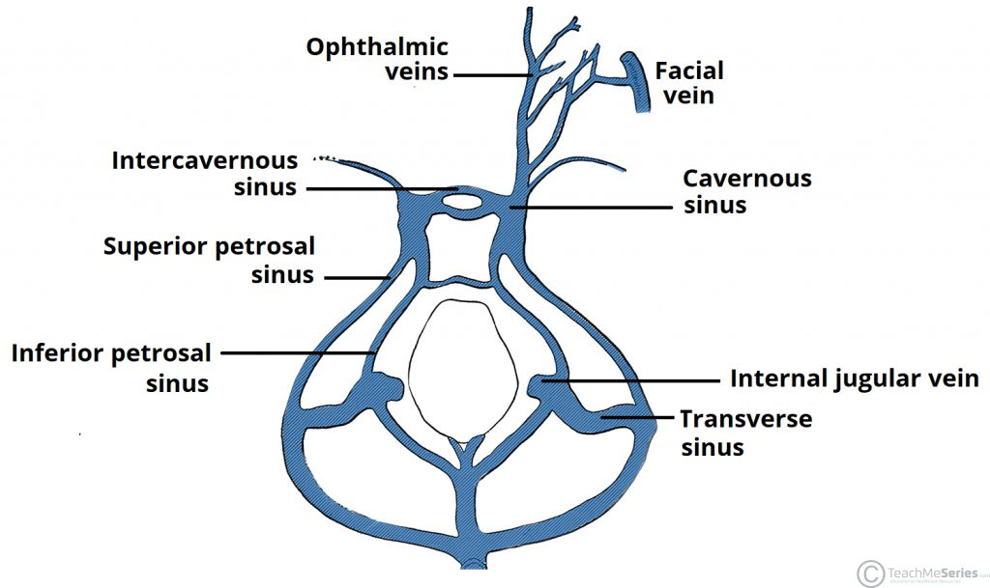
It is important to note that the superior ophthalmic vein forms an anastomosis with the facial vein. Therefore, the ophthalmic veins represent a potential route by which infection can spread from an extracranial to an intracranial site.
Contents of the cavernous sinuses are:
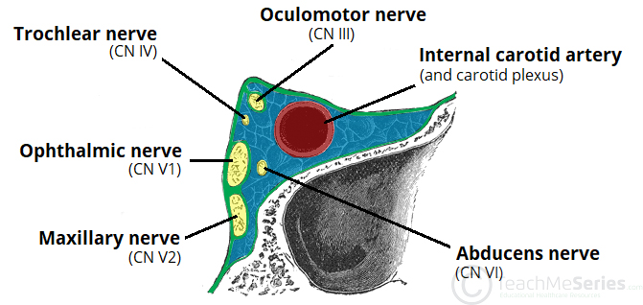
A useful mnemonic to remember the contents and their relation to one another is: O TOM CAT, where OTOM (oculomotor nerve, trochlear nerve, ophthalmic branch, maxillary branch) refers to the lateral wall contents from superior to inferior, and CAT (internal carotid artery, abducens nerve, trochlear nerve) refers to the horizontal contents, from medial to lateral.
Structures within the lateral wall of the compartment from superior to inferior are:
- Oculomotor nerve (CNIII): The oculomotor nerve (CN III) is the most superior nerve in the lateral wall of the sinus. As it reaches the anterior wall of the sinus, it divides into superior and inferior branches, which pass through the superior orbital fissure. CN III and the sympathetic plexus around the ICA innervate the levator palpebrae superioris, the inferior oblique, and superior, medial and inferior recti muscles of the orbit.
- Trochlear nerve (CNIV): It lies in the lateral wall of the sinus, below CN III. It leaves through the anterior wall of the sinus and enters the superior orbital fissure. It supplies the superior oblique muscle in the orbit.
- Ophthalmic (CNV₁) and maxillary(CNV₂) branches of the trigeminal nerve: They are branches of the trigeminal nerve (CN V). They lie below CN IV in the lateral wall of the cavernous sinus. The ophthalmic branch exits via the superior orbital fissure, while the maxillary nerve exits the sinus via the foramen rotundum.
Structures passing through the medial wall are:
- Abducens nerve (CNVI): traverses the sinus inferolateral to the internal carotid artery and exits by entering the superior orbital fissure anteriorly. It innervates the lateral rectus muscle once it reaches the orbit.
- Internal carotid artery (ICA): It enters the posterior inferior aspect of the cavernous sinus forming the cavernous part of the artery. Then it travels horizontally anteriorly within the sinus. Once it reaches the anterior wall of the sinus, it traverses vertically upwards towards the roof of the sinus and exits to form the cerebral part. It gives rise to two branches within the sinus: the meningohypophyseal branch and the inferolateral branch. It is clinically significant that this part of the internal carotid artery is the only artery which is surrounded by a network of veins.
- Carotid plexus of sympathetic nerves: these nerves arise from the superior cervical ganglion and surround the cavernous part of the internal carotid artery.
Additionally, in obese patients and in patients taking corticosteroids, fatty deposits may occasionally be seen within the cavernous sinus.
Clinical Anatomy
  - Cavernous sinus thrombosis (CST)
This condition was first described in 1831 by Bright. It is a late complication of infection in the dangerous (central) area of the face (e.g., furuncle on the nose, dental caries, etc.) or paranasal sinuses and a medical emergency requiring urgent management with a high incidence of morbidity and mortality. Infection is able to spread in this manner due to the anastomosis between the facial vein and superior ophthalmic veins. Common clinical features include headache, unilateral periorbital oedema, proptosis (eye bulging), photophobia and cranial nerve palsies.
The abducens nerve (CN VI) is most commonly affected. The common organisms involved in CST include Staph aureus, Strep pneumococcus, gram-negative bacteria, anaerobes as well as fungi like Rhizopus and Aspergillus. Diagnosis of CST is done clinically and confirmed with either CT scan or MRI with MR venogram, which is the study of choice. Treatment is typically with antibiotic therapy. Where the cause is infection, thrombosis of the cavernous sinus can rapidly progress to meningitis.
- Cavernous sinus syndrome (CSS)
The pituitary gland is located in a fossa between the two cavernous sinuses. As Pituitary tumors grow, they can expand towards and later compress the cavernous sinus. This can lead to cavernous sinus syndrome, which is characterized by ophthalmoplegia (paralysis of CN III, IV, VI), loss of sensation in the region of the ophthalmic and maxillary nerves as well as Horner’s syndrome due to compression of the sympathetic plexus around the internal carotid artery.
CSS can also be caused by tumors extending from the nasopharynx, pituitary or metastasis or even following CST.
- Carotid-cavernous fistula (CCF):
Head trauma resulting in rupture of the cavernous part of the internal carotid artery can produce what is known as a carotid-cavernous fistula. A pulsating exophthalmos (bulging of the eyes) can result as the venous pressure in the sinus would increase and reverse the flow of blood in the ophthalmic veins. Arterial dissection, collagen vascular diseases like Ehler Danlos syndrome and fibromuscular dysplasia could also be causes of CCF.
Patients may present, among other symptoms, with pulsatile proptosis, orbital congestion, chemosis, corneal exposure, diplopia, paralysis of CN III, IV, VI, and retinopathy. CT angiography is the test of choice. Usually, these fistulae resolve spontaneously. Persistent symptomatic fistulae require treatment, which consists of steroids in the acute phase to reduce edema, followed by definitive surgery. Endovascular approaches with obliteration of the fistula and restoration of arterial and venous flow lead to resolution of the fistula.
- Triangular space near the cavernous sinus:
Parkinson, in 1965, described a triangular space between the ophthalmic and trochlear nerves, to approach lesions around the cavernous part of the ICA. With the advent of radiosurgery and endovascular surgery, this direct approach through the triangular space is rarely required.
If endovascular surgery or occlusion of carotico-cavernous fistula fails, then direct surgery through this triangular space may be necessary. Also, in the case of certain tumors like meningiomas, schwannomas, pituitary adenomas, and chondromas, neurosurgeons may have to gain access to the tumors through this triangle.

- Walls of the nose
The nasal cavity is bordered by the following structures:
- Roof: Which is formed by the nasal, frontal, sphenoid, and ethmoid bones (cribriform foramina, which transmits CN I for smell). Connective tissue and skin cover the bony and cartilaginous components of the nasal dorsum.
- Floor: Formed by the palatine process of maxilla anteriorly and the horizontal plate of palatine bone posteriorly. The incisive foramen transmits branches of the sphenopalatine artery and the nasopalatine nerve for general sensation from the nasal cavity and palate.
The pharyngeal opening of the auditory tube can be described as a triangular opening surrounded by a raised, firm prominence known as the ‘torus’. The most medial end of the cartilage causes the elevation of the mucous membrane. The hard palate is a horizontal plate of bone formed by both the palatine process of the maxilla, which forms 75% of the hard palate, and the horizontal plate of the palatine bone, which forms the remaining 25%. This bony structure has numerous perforations to allow for the passage of nutrient vessels. Its function is to form a separation between the nasopharynx and oropharynx. Insufficiency in this structure can cause difficulty with swallowing.
The soft palate is also referred to as the ‘velum’. This is a continuation of the hard palate posteriorly but has no bony structure. This structure is constituted of five muscles crucial for swallowing. These are the:
- tensor veli palatini (innervated by the mandibular branch of the trigeminal nerve)
- palatoglossus
- the palatopharyngeus which has a crucial role in breathing
- the levator veli palatini which elevates the soft palate to encompass the bolus of food
- the musculus uvulae which move the uvula
The uvula has an essential role in human speech and works with the posterior part of the tongue to create ‘guttural’ sounds.
- Medial wall: Formed by the nasal septum, perpendicular plate of the ethmoid bone superoinferiorly, the vomer bones posteroinferiorly, and the septal cartilage.
The medial wall of the nasal cavity is formed by both bony elements and cartilage. Posteriorly the perpendicular plate of the ethmoid bone forms the superoposterior part of the bony nasal septum and articulates superiorly with the cribriform plate. The posterior border articulates superiorly with the sphenoidal crest and with the vomer by its inferior border.
The cribriform plate is found in the midline on the anterior floor of the anterior cranial fossa. It can be described as a thin bony plate of perforated bone through which the fibres of the olfactory nerve ascend and reach the entorhinal cortex. The plate is divided by the crista galae in the midline.
Further posteriorly than the ethmoid bone, the crest of both the maxilla and palatine bone complete the posterior septum. The anterior septum is formed entirely of the quadrangular cartilage which divides the cavity in the midline. The vomer is an unpaired bone of the skull forms the inferior part of the septum. It is located in the mid sagittal plane and articulates with the ethmoid, both palatine bones and both maxillary bones.
The horizontal plate of the palatine bone is a rectangular shaped bone that projects medially and forms a right angle with the perpendicular plate of the ethmoid. The nasal surface of the bone forms part of the inferior meatus of the nose, while the serrated anterior maxillary surface articulates with the maxilla. Laterally the bone articulates with the perpendicular plate, and superior portion of the plate forms the posterior part of the nasal cavity. The inferior surface of the plate is rough and provides attachment to the oral mucosa of the hard palate.
The septal cartilage is approximately 3-4mm thick. It divides the nasal cavity into two halves. The anteroinferior part of the cartilage has an expansion known as the ‘footplate’ which is 4-8mm wide. This foot plate lies in free contact with the membranous septum. The cartilage is expanded in other regions, namely the junction with the lateral nasal cartilage termed the posterior process. The cartilage is firmly adhered to the nasal bone by taut collagen fibres.
The cartilage of the septum is also termed the ‘quadrangular cartilage’ due to its shape. The posterior nasal spine is a sharp pointed projection of the posterior border of the palatine bone. The musculus uvula gains its attachment here.
The pharyngeal tonsil is also known as the adenoid. It is a mass of lymphatic tissue located in the roof of the nasopharynx. The structure degrades with age and is almost entirely absent at puberty. The torus tubarius is also known as the tubar tonsil. It resides at the base of the cartilaginous section of the Eustachian tube.
- Lateral wall: The lateral wall of the nasal cavity is a region of the nasopharynx essential for humidifying and filtering the air we breathe in nasally. Formed by the superior, middle and inferior nasal conchae and also the nasal septum. The agger nasi is also referred to as the ‘nasoturbinal concha’ or ‘nasal ridge.’ It can be described as a small mound or ridge found in the lateral side of the nasal cavity. The structure is located midway along the anterior aspect of the middle nasal concha. An abnormally enlarged form may restrict the drainage of the frontal sinus by obstructing the frontal recess area.
The anterior nasal aperture is simply the area where the anterior bony aspects of both the maxilla and the nasal bone terminate and form an opening into the cartilaginous nasal vestibule. The structure is also referred to as the piriform aperture. Three cartilages contribute to the nasal septum:
- Lesser alar cartilages are paired cartilages suspended in the fibro-fatty tissue that forms the lateral aspect of the nostril. The structures lie free from the other cartilages and provide the nostril with stability and form.
- Greater alar cartilages are paired cartilages that form part of the antero-superior nostril as well as the nasal tip. The structures give the tip of the nose stability and flexibility and are a crucial element of the cartilaginous apparatus of the nose.
- Lateral nasal cartilages are structures that articulate inferiorly with the greater alar cartilages and superiorly with the anterior nasal aperture formed by both the nasal bone superiorly and for a short part of its border with the perpendicular plate of the ethmoid bone. These structures form the cartilaginous part of the bridge of the nose and form in conjunction with the greater alar cartilages, the major structural appearance of the nose.
Inferior nasal concha: It is the longest and broadest of the conchae and is formed by an independent bone (of the same name, inferior concha). The concha is covered by a mucous membrane that contains large vascular spaces and is one of the three that work to both humidify and clear the air that passes into the nasopharynx.
Superior and middle nasal conchae arise from the perpendicular plate of the ethmoid bone. The middle nasal concha is found in between the superior and inferior nasal concha and plays a role in humidifying and clearing inspired air of micro-particles such as dirt. The superior nasal concha is a bony shelf located above the middle nasal concha and below the sphenoethmoidal recess. Similar to the middle nasal concha the superior concha is itself part of the ethmoid bone.
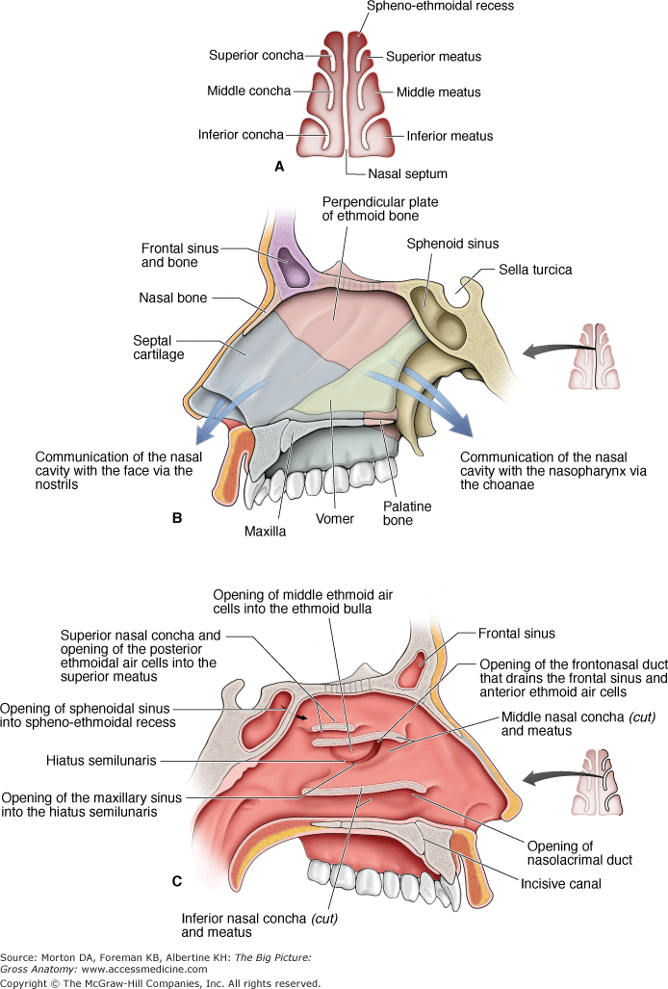
Associated structures of the lateral wall are:
The nasal surface of the maxilla forms the antero-lateral part of the bony nasal cavity. It is located inferior to the nasal bone and gives rise in part, to the inferior nasal concha. The sphenopalatine foramen is found in the posterior most region of the nasal cavity, at the back of the middle meatus. The foramen is formed by the processes on the superior border of the palatine bone, and the under surface of the sphenoidal body, which form a foramen. It connects the nasal cavity to the pterygopalatine fossa, and thus transmits the sphenopalatine artery and vein as well as the superior nasal and nasopalatine nerves.
The medial plate of the pterygoid process is an inferior projection of the sphenoid bone. The plate forms a laterally pointing hook like process at its most inferior point, known as the pterygoid hamulus. The tensor veli palatine muscle glides around this structure. The lateral surface of the medial plate forms the medial border of the pterygoid fossa, and the medial surface forms the lateral boundary of the choana of the adjacent nasal cavity.
The limen nasi is approximately 10mm in length and is defined as the boundary between the nasal cavity proper and the vestibule. It is relatively wide and superficial anteriorly but gradually narrows as it extends posteriorly towards the anterior region of the middle concha. It lies upon the upper edge of the lateral crus of the greater alar cartilage and detached pieces of cartilage may take part in its formation.
The sphenoidal sinus is contained within the body of the sphenoid bone itself. There is a great deal of variation in the shape and size of this sinus between individuals. The sinus drains into the sphenoethmoidal recess which is located superior to the choana. The main expansion of their size occurs during puberty and they perform a similar function to the other sinuses.
The nasal vestibule is the visible part of the internal nasal cavity from an external view. The vestibule is maintained by the greater and lesser alar cartilages and contains small hairs which trap dirt and small particles during inspiration. The vestibules are lined by stratified squamous epithelium, and are separate from the nasal cavity proper, which is lined with respiratory epithelium.
In addition, the maxillary, sphenoid, and palatine bones contribute to the lateral wall. The lateral wall contains the following openings:
- Sphenoethmoidal recess. The space between the superior nasal concha and the sphenoid bone, with openings from the sphenoid sinus.
- Superior meatus. The space inferior to the superior nasal concha, with openings from the posterior ethmoidal air cells.
- Middle meatus. The space inferior to the middle nasal concha, with openings for the frontal sinus via the nasofrontal duct, the middle ethmoidal air cells on the ethmoidal bulla, and the anterior ethmoidal air cells and maxillary sinus in the hiatus semilunaris.
- Inferior meatus. The space inferior to the inferior nasal concha, with an opening for the nasolacrimal duct, which drains tears from the eye into the nasal cavity.
- Sphenopalatine foramen. An opening posterior to the middle nasal concha receives the nasopalatine nerve and the sphenopalatine artery from the pterygopalatine fossa into the nasal cavity.
Vasculature of the nose
The nose has a very rich vascular supply – this allows it to effectively change humidity and temperature of inspired air. The nose receives blood from both the internal and external carotid arteries.
Internal carotid branches are:
- Anterior ethmoidal artery
- Posterior ethmoidal artery
- The ethmoidal arteries are branch of the ophthalmic artery. They descend into the nasal cavity through the cribriform plate
External carotid branches are:
- Sphenopalatine artery
- Greater palatine artery
- Superior labial artery
- Lateral nasal arteries
In addition to the rich blood supply, these arteries form anastomosis with each other. This is particularly prevalent in the anterior portion of the nose. The veins of the nose tend to follow the arteries. They drain into the pterygoid plexus, facial vein or cavernous sinus. In some individuals, a few nasal veins join with the sagittal sinus (a dural venous sinus). This represents a potential pathway by which infection can spread from the nose into the cranial cavity.
Innervations of the nasal cavity
Special sensory innervation refers to the ability of the nose to smell. This is carried out by the olfactory nerves. The olfactory bulb, part of the brain, lies on the superior surface of the cribriform plate, above the nasal cavity. Branches of the olfactory nerve run through the cribriform plate to provide special sensory innervation to the nose.
General sensory innervation to the septum and lateral walls is delivered by the nasopalatine nerve (branch of maxillary nerve) and the nasociliary nerve (branch of the ophthalmic nerve). Innervation to the external skin of the nose is supplied by the trigeminal nerve. The nasal cavity is innervated by autonomic fibers. Sympathetic innervation to the blood vessels of the mucosa causes them to constrict, while the control of secretion by the mucous glands is carried on postganglionic parasympathetic nerve fibers originating from the facial nerve.
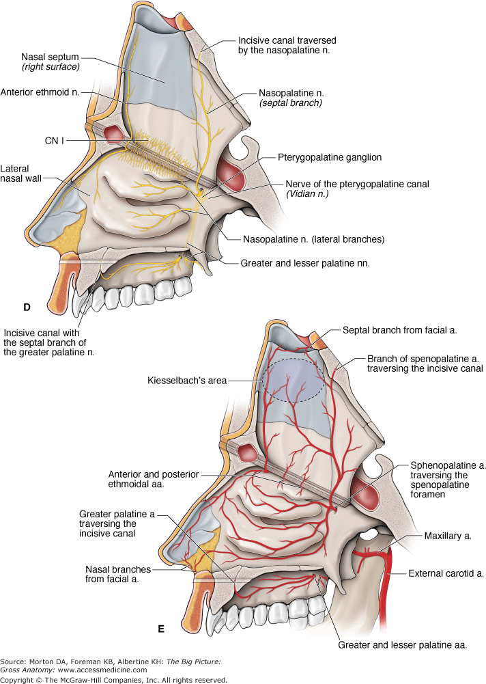
Clinical Anatomy
- Sinusitis: Sinusitis is an inflammation of the different sinuses found in the head. That type of inflammation may result in different symptoms including: plugged nose, nasal mucus, and pain in the facial region. The frontal bone overlies the frontal lobe of the brain and lies anteriorly forming the brow, forehead and one third of the anterior scalp. The bone contains the frontal sinus, which in sinusitis and nasal infections can become filled with fluid.
- Epistaxis: Epistaxis is the medical term for a nosebleed. Due to the rich blood supply of the nose, this is a common occurrence. It is most likely to occur in the anterior third of the nasal cavity – this area is known as the Kiesselbach area. The cause can be local (such as trauma), or systemic (such as hypertension).
- Rhinorrhea: Also known as “runny nose,” is evident by the clear fluid that leaks out of the nostrils. A runny nose usually accompanies the common cold. Rhinorrhea usually results from overproduction of mucus resulting from conditions such as sinusitis, hay fever, and allergic reactions.
- Cribriform plate fracture: A fracture of the cribriform plate can occur as a result of nose trauma. It is either fractured directly by the trauma, or by fragments of the ethmoid bone. A fractured cribriform plate can penetrate the meningeal linings of the brain, causing leakage of cerebro-spinal fluid. Exposing the brain to the outside environment like this increases the risks of meningitis, encephalitis and cerebral abscesses. The olfactory bulb lies on the cribriform plate and can be damaged irreversibly by the fracture. In this case, the patient may present with anosmia (loss of smell).

