NAME: KWAME-OKPU E.A OGHENEOVU
MAT NO: 17/MHS01/174
Course Title: Systemic Embryology
Course Code: ANA 206
Question
Write notes on the following:

I) Development of the lungs

II) Rotation of the stomach and the formation of the Omental bursa

III) Development of the esophagus

ANSWERS
I) Development of the lungs
Successful development and function of the lung requires the completion of both physical development, required for the structure of the lung, and biochemical development of the surfactant system, required for the stability of this very large surface area. The two processes clearly are related. Incomplete development of lung structure and premature birth prior to the development of the surfactant system will lead to respiratory compromise or insufficiency in the newborn.
There are five phases of structural lung development that occur at progressive times during gestation. The timing of the phases is approximate, with variation between fetuses, and in fact, there is no absolute agreement about the weeks that comprise each phase among various authors and texts. The embryonic stage is apparent in the 3 week old embryo. The lung bud develops from the foregut and in communication with it. Separation of the two lung buds comes about with fusion of the esophagotracheal ridges to form the esophagotracheal septum
When the embryo is 5 weeks old, two primary lung buds are identifiable. The lung buds go on to form their first subdivisions, with 3 lobar buds developing in the right lung bud and 2 lobar buds developing in the left. These are the forerunners of the right upper, middle and lower lobes and the left upper and lower lobes.
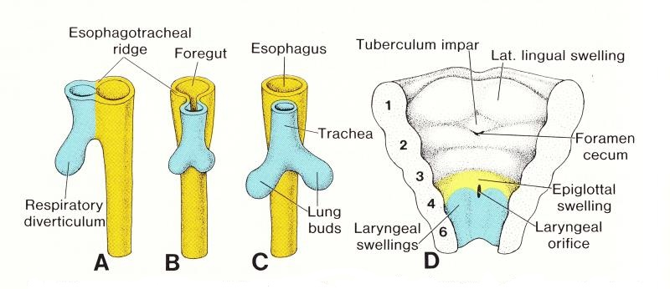
DEVELOPMENT OF THE LUNG BUDS
SOURCE: https://embryology4genius.weebly.com
Development progresses in the 8 week old embryo as the lobar buds subdivide and form the bronchopulmonary segments
Lung buds are lined by endodermally derived epithelium which differentiates into respiratory epithelium that lines the airways and specialized epithelium that lines the alveoli. The innervation of the lungs is derived from ectoderm, while the mesoderm is the origin of pulmonary blood vessels, smooth muscle, cartilage and other connective tissue. The pseudoglandular stage takes place between the 7th and 16th week of embryonic development. Conducting airways are formed by progressive branching. This is a demonstration of the power of 2n !! Eventually 16-25 generations of primitive airways are formed. Endodermal lung buds undergo branching only if they are exposed to bronchial mesoderm. The rate and extent of branching appear directly proportional to amount of mesenchyme present
All bronchial airways are formed by 16 weeks. After this time, further growth occurs by elongation and widening of existing airways. During this stage, the first differentiation of lung epithelium occurs. By 13 weeks cilia appear in the proximal airways. Mesenchyme is necessary for this epithelial differentiation to occur and there is a transition from formation of bronchial epithelial cells (ciliated columnar and goblet cells) to alveolar type II cells. Conversely, the differentiation of lung mesenchyme requires the presence of lung epithelium. The canalicular stage takes place between the 16th and 25th week. At this time the gas exchanging portion of the lung is formed and vascularized. There is a decrease of interstitial tissue and growth of the capillary network. By 20 weeks there is differentiation of the type I pneumocyte. The
type I pneumocyte is the primary structural cell of the alveolus, and gas exchange will occur across these very thin, membrane-like cells. Capillaries begin to grow in absolutely close proximity to the distal surface of the alveolar cells (if the potential alveolar space is considered proximal) about the same time, there is the appearance of lamellar bodies, also called inclusion bodies, in type II alveolar cells. The lamellar body is the site of surfactant storage, prior to its release into the alveolar The terminal sac, or saccular stage encompasses the period from 26 weeks until term. During this stage, there is a decrease in interstitial tissue, and a thinning of the airspace (=alveolar) walls as this stage progresses, there are recognizable Type I and Type II cells. The lamellarbodies of the Type II cells are the site of storage of surfactant, which is rich in phosphatidylinositol (vs. phospahatidyl choline and phosphatidyl glycerol in late gestation lungs), and is necessary for alveolar stability. The stability of the lung at birth correlates with the number of lamellar bodies present. In the absence of surfactant, the lung can maintain alveoli in an open state for only a very short time.
At birth, the air-containing space, later to become the alveolus, has been called a “primitive saccule”. There are approximately 20x106 saccules at birth. The saccules continue to mature following birth in the postnatal or alveolar stage. While these saccules are lined by mature Type I cells, the shape or geometry of the saccules does not achieve “adult” configuration until approximately 5 weeks after birth. The functioning alveolus is connected to an alveolar duct, is lined with Type I cells, which are in intimate contact to pulmonary capillaries, contain surfactant produced by Type II cells and have pores (pores of Kohn) connecting them to adjacent alveoli. The interstitial capillaries are exposed to two alveoli simultaneously. The air/blood interface consists of the Type I cell, a very thin basement membrane and the pulmonary capillary endothelium. At functional maturity, there are approximately 300x106 alveoli in the lung. This number of alveoli appears to be achieved by the age of 8. The development of the pulmonary arterial system follows a similar progression to that of the developing airways. Development of, and branching of the pulmonary artery mirrors bronchial branching, and later mirrors alveolar development
There are a number of physical influences on lung growth. Proper development of the lung is dependent on the presence of both lung liquid and amniotic fluid. The lung liquid is secreted by pulmonary epithelium. The volume of lung fluid is maintained by the activity of the upper airway which acts as a gatekeeper by controlling the resistance to efflux of fluid out of the lung and trachea during non-breathing periods, and by diaphragmatic movement associated with fetal breathing movements. The larynx is the major site of regulation of efflux and therefore of lung liquid volume. During fetal breathing movements, when the upper airway resistance is decreased, diaphragmatic movements help to maintain lung liquid volume. The experimental drainage of lung liquid leads to pulmonary hypoplasia. Amniotic fluid is also required for normal lung development. Amniotic fluid originates in the lung and fetal kidney. Oligohydramnios is associated with lung hypoplasia (Potters syndrome-renal agenesis, lack of fetal urine).
SUMMARY
Development of the lung can be divided into two phases, lung growth (structural development) and lung maturation (functional development). Lung growth can be influenced by a host of physical factors. Lung maturation and the achievement of functionality is primarily a biochemical process and is under the control of a number of different hormones. Lung growth proceeds through gestation. There is progressive branching of the airways and finally development of alveolar spaces capable of gas exchange in the last trimester. The surfactant system, composed of phospholipids that decrease surface tension within the alveoli and prevent alveolar collapse during exhalation, develops in the last trimester, and reaches maturity by approximately 36 weeks. Lung growth continues after birth as alveolar number continues to increase. The end result of the development of the lung is an organ with a tremendously large surface area that is approximately 50-100 m2, capable of exchanging oxygen and carbon dioxide across a very thin membrane.
DEVELOPEMENTAL ANOMALIES OF THE LUNGS
There are several well-known examples of failure of normal physical development of the lung.
TRACHEOESOPHAGEAL FISTULA: Tracheoesophageal fistula is an abnormal connection in one or more places between the esophagus (the tube that leads from the throat to the stomach) and the trachea (the tube that leads from the throat to the windpipe and lungs). Normally, the esophagus and the trachea are two separate tubes that are not connected. TE fistula often occurs with another birth defect known as esophageal atresia. The esophagus is a tube that leads from the throat to the stomach. With esophageal atresia, the esophagus does not form properly while the fetus is developing before birth, resulting in two segments; one part that connects to the throat, and the other part that connects to the stomach. However, the two segments do not connect to each other.

Since the esophagus is in two segments, liquid that a baby swallows cannot pass normally through the esophagus and reach the stomach. Milk and other fluids cannot be digested if the esophagus does not connect to the stomach, they are fives types of tracheoesophageal fistula:
Type A Proximal and distal esophageal bud—a normal esophagus with a missing mid-segment.
Type B Proximal esophageal termination on the lower trachea with distal esophageal bud.
Type C Proximal esophageal atresia (esophagus continuous with the mouth ending in a blind loop superior to the sternal angle) with a distal esophagus arising from the lower trachea or carina. (Most common, up to 90% of cases.)
Type D Proximal esophageal termination on the lower trachea or carina with distal esophagus arising from the carina.
Type E (or H-Type) A variant of type D: if the two segments of esophagus communicate, this is sometimes termed an H-type fistula due to its resemblance to the letter H. TEF without EA.
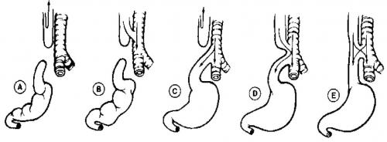
DIAGRAM SHOWING THE FIVE TYPES OF TRACHEOESOPHAGEAL FISTULA
SOURCE: https://pedclerk.bsd.uchicago.edu/
CONGENITAL LOBAR OVERINFLATION
CLO, also referred to as congenital lobar emphysema, is characterized by progressive lobar overexpansion, usually with compression of the remaining (ipsilateral) lung. The underlying cause can be secondary to an intrinsic cartilaginous abnormality with resultant weak or absent bronchial cartilage or extrinsic compression of an airway (eg, by a large pulmonary artery or a bronchogenic cyst)

II) Rotation of the stomach and the formation of the Omental bursa
ROTATION OF THE STOMACH
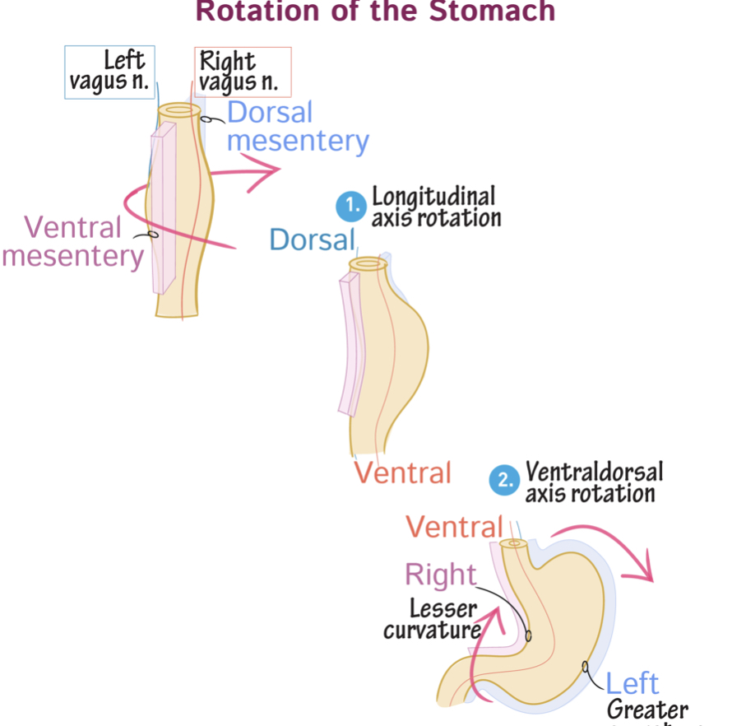
DIAGRAM SHOWING THE ROTATION OF THE STOMACH
SOURCE: https://www.drawittoknowit.com/
The rotation of the stomach Begins in week 5 it Starts as a spindle-shaped tube With Ventral and dorsal mesenteries attach the tube to the body walls, the portion of the dorsal mesentery that anchors the stomach can be more specifically referred to as the dorsal mesogastrium, Branches of the left and right vagus nerves (CN X) lie on ventral and dorsal surfaces with fibers from the right and left vagal plexuses intermixing with each other and the celiac plexus, to some degree
Second Diagram
Differential growth of the stomach and clockwise rotation along the longitudinal axis alters the course of the vagus nerve branches, The right vagus nerve now innervates the anterior/ventral surface of the stomach, The left vagus nerve lies on the posterior aspect Notice that the cephalic and caudal ends remain in the midline.

Third Diagram
As the stomach rotates along the ventral-dorsal (aka, antero-posterior) axis, the caudal end is displaced towards the right, as the cephalic end towards the left;
The ventral and dorsal mesenteries are also displaced to the right and left, respectively.
Lesser curvature = ventral mesentery attachment.
Greater curvature = dorsal mesentery attachment.
Though not shown here, the ventral mesentery gives rise to the falciform ligament, which secures the liver ventrally, and, the lesser omentum, which connects the liver and stomach and proximal duodenum.
The dorsal mesentery gives rise to the greater omentum, the apron-like fold of mesentery that attaches to the greater curvature of the stomach and drapes over the small intestine.
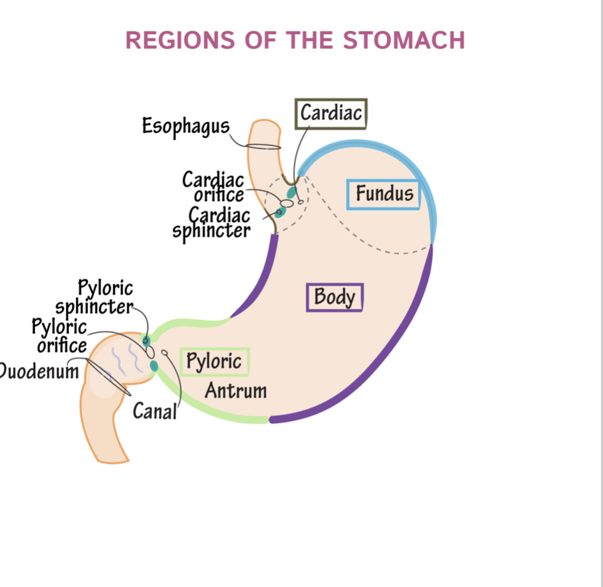
DIAGRAM SHOWING THE MATURE AND FULLY ROTATED STOMACH
SOURCE: https://www.drawittoknowit.com/

FORMATION OF THE OMENTAL BURSA
The omental bursa or lesser sac is a hollow space that is formed by the greater and lesser omentum and its adjacent organs. It communicates with the greater sac via the epiploic foramen of winslow, which is known as the general cavity of the abdomen that sits within the peritoneum, but outside the lesser sac.
This space has well-defined borders which are represented by certain organs or their parts, so they are quite easy to spot and form a mental image of the omental bursa. In addition, like anything in anatomy, the omental bursa doesn't just exist as a standalone and isolated entity, but rather it communicates with several other spaces and recesses found throughout the body.
Key facts about the omental bursa
Borders | Anteriorly - quadrate lobe of liver, gastrocolic ligament, lesser omentum  Left - left kidney, left adrenal gland  Posteriorly - pancreas  Right - epiploic foramen, lesser omentum, greater sac
Communications | Superior recess, splenic recess, inferior recess, folds and recesses around the cecum and duodeum
Clinical | Congenital anomalies, hematomas, bilomas, abscess, pancreatitis, neoplasms, hydatid cyst, tuberculosis infection, mechanical irritation

Embryology
During embryonic development, the peritoneum is anchored to the gut in the midline of the abdomen anteriorly, with the dorsal mesentery securing it posteriorly. The mesenteric layers develop in an anterior direction around the upper alimentary canal, carrying the blood supply and creating the ventral mesentery.
Due to the growth of the organs, they gradually become larger and have to shift in order to fit into the abdominal cavity. The stomach rotates 90 degrees, the spleen is displaced to the left and the liver moves to the right. The peritoneum twists with these movements which lead to the formation of the falciform ligament, the lesser omentum and the coronary ligaments of the liver . Throughout this entire process, the cavity of the lesser sac is created.
Clinical aspects
The lesser sac has seven distinctly categorized pathological groups under which its potential disorders may be listed:
- Congenital anomalies include duplication cysts and cystic lymphangiomas.
- A hematoma or a biloma are classed as traumatic injuries.
- Inflammatory states could be due to an abscess, a pseudocyst or even acute pancreatitis.
- Neoplastic changes may lead to the growth of a stromal tumor, a leiomyoblastoma, a leiomyosarcoma, a liposarcoma, a schwannoma, both benign and malignant pancreatic neoplasms that may have endocrine involvement or not, hepatic tumors and desmoid tumors.
- A hydatid cyst indicates a parasitic infestation.
- The only infective cause of a lesser sac disorder as yet known of is tuberculosis.
- Mechanical irritation could potentially be caused by hernias of the cecum, transverse colon, small intestine and gallbladder.
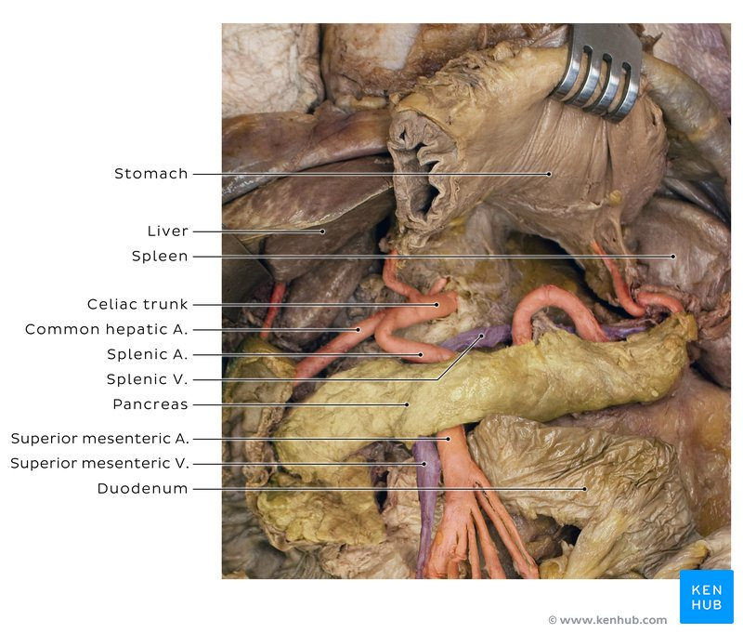
DIAGRAM SHOWING THE OMENTAL BURSA IN A CADEVER AND IT’S BOUNDARIES
SOURCE: https://www.kenhub.com/en/library/anatomy/
NOTE: Omental bursa is located posterior to the stomach. Therefore, it's very easy to find it during a cadaveric dissection by simply lifting the stomach. It communicates with the greater peritoneal sac via the omental foramen.

III) Development of the esophagus
In early embryogenesis, the esophagus develops from the endodermal primitive gut tube. The ventral part of the embryo abuts the yolk sac. During the second week of embryological development, as the embryo grows, it begins to surround parts of the sac. The enveloped portions form the basis for the adult gastrointestinal tract. The sac is surrounded by a network of vitelline arteries. Over time, these arteries consolidate into the three main arteries that supply the developing gastrointestinal tract: the celiac artery, superior mesenteric artery, and inferior mesenteric artery. The areas supplied by these arteries are used to define the midgut, hindgut and foregut.
The surrounded sac becomes the primitive gut. Sections of this gut begin to differentiate into the organs of the gastrointestinal tract, such as the esophagus, stomach, and intestines The esophagus develops as part of the foregut tube.[21] The innervation of the esophagus develops from the pharyngeal arches.
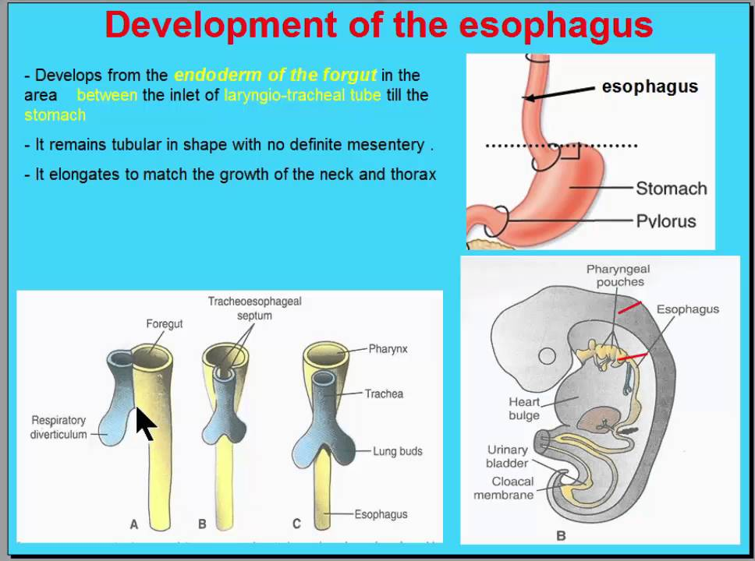
DIAGRAM SHOWING THE DEVLOPMENT OF THE ESOPHAGUS
SOURCE: https://www.slideshare.net/

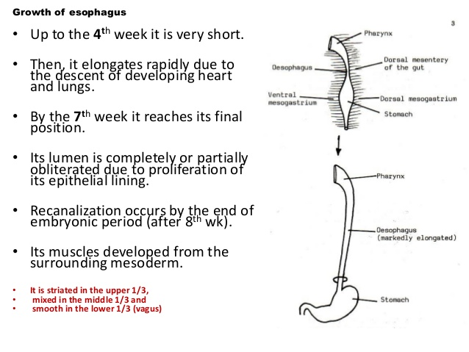
DIAGRAM SHOWING THE DEVLOPMENT OF THE ESOPHAGUS
SOURCE: https://www.slideshare.net/

REFERENCES
- DiFiore JW, Wilson JM. Lung development. Seminars in Pediatric Surgery 3:221-32, 1994.
- Harding R, Hooper SB. Regulation of lung expansion and lung growth before birth. J. Appl.Physiol. 81:209-24, 1996.
- Gregory GA, Kitterman JA, Phibbs RH, Tooley WH, Hamilton WK. Treatment of the idiopathic respiratory distress syndrome with continuous positive airway pressure. N. Eng. J. Med. 284:1333-40, 1971.
- Whitsett JA, Weaver TE. Hydrophobic surfactant proteins in lung function and disease. N. Eng. J Med 347:2141-48, 20
- Umbilicus, Peritoneum. "Abdominal Wall, Umbilicus, Peritoneum, Mesenteries...-HVIL."

