NAME: NWOKPOR NNAEMEKA COLLINS
MATRIC NO: 17/MHS01/211
COLLEGE: COLLEGE OF MEDICINE AND HEALTH SCIENCES
DEPARTMENT: MEDICINE AND SURGERY
COURSE: GROSS ANATOMY OF HEAD AND NECK.
LECTURER: DR OGEDENGBE.

- ANATOMY OF TONGUE AND ITS APPLIED ASPECTS

- INTRODUCTION
- PARTS AND SURFACES
- MUSCLES
- VASCULAR SUPPLY
- INNERVATION
- LYMPHATIC DRAINAGE
- APPLIED ANATOMY

INTRODUCTION
The tongue is a mobile muscular organ that can assume a variety of shapes and positions.
It is partly in the oral cavity and partly in the oropharynx.
The tongue is involved with mastication, taste, deglutition (swallowing), articulation, and oral cleansing; however, its main functions are forming words during speaking and squeezing food into the oropharynx when swallowing.
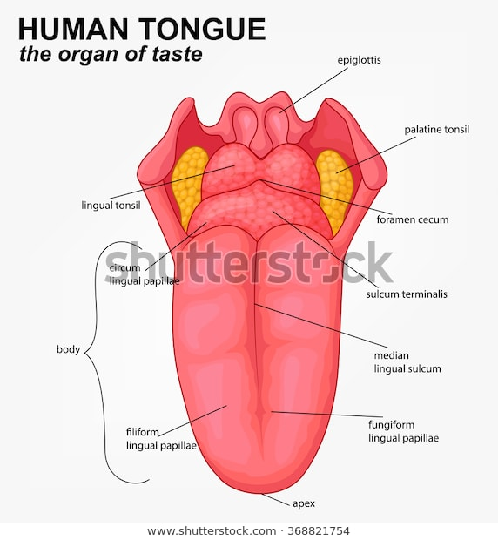

MUSCLES OF THE TONGUE
Muscles of the tongue are derived from occipital myotomes, which at first are closely related to developing cranium and later migrate inferiorly and anteriorly around the pharynx ad enter tongue.
They carry along with them the fibres of Hypoglossal Nerve.
PARTS AND FUNCTIONS
It has a fixed root, a mobile body and a tip that can take on a variety of shapes and positions.
TIP:-
- Anterior end of the body.
- Rest on upper incisors.
BODY:-
- Anterior two-thirds of the tongue.
- Upper and lower surface.
ROOT:-
- Attached to styloid process, soft palate above
- And to mandible, hyoid bone below.

EXTERNAL SURFACE
The tongue has a:
- Ventral Surface
- Dorsal Surface.
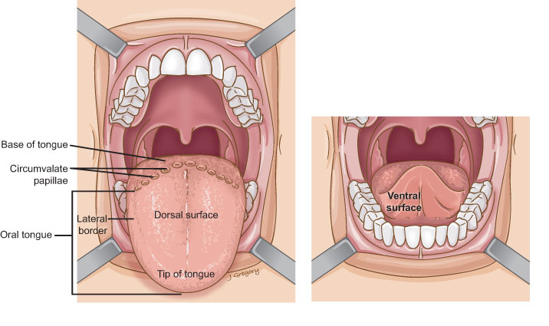

VENTRAL SURFACE: The sublingual surface of the tongue is covered with thin, transparent mucosa, which shows a median fold called the ‘Frenulum linguae'.
On either side of frenulum, there is a prominence produced by deep lingual veins.
More laterally there is a fold called Plica fimbricata.

DORSAL SURFACE: It is convex in all directions.
- Oral part: Anterior two-third
- Pharyngeal part: Posterior one-third
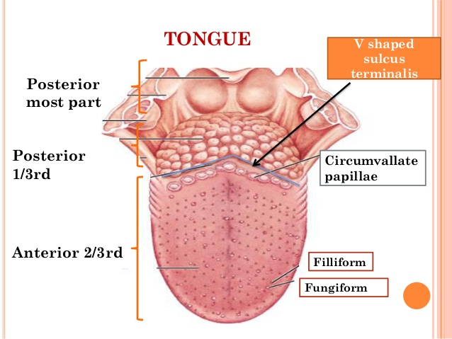

Dorsal Surface – Anterior two-third (ORAL PART)
The dorsal mucosa covered by filiform, fungiform, foliage and circumvallate papillae.
Circumvallate Papillae
Vallate papillae:
- Large and flat topped
- They are large in size; 1-2mm in diameter, 8-12 in number.
- Lie directly anterior to the terminal sulcus.
- Walls are studded with taste buds.
- Each papilla is a cylindrical projection surrounded by a circular sulcus.
Filiform Papilla
- Most numerous and cover most of the Presulcal area of dorsum of tongue.
- Pinpoint cone-shaped projections of the mucosa that ends in one or more points.
- Gives velvety appearance to the tongue.
- They are smallest papillae.
- Covered with keratin
- Increase the friction between the tongue and food.
Fungiform Papilla
- These are mushroom shaped.
- More numerous near tip and margins of tongue but some of them scattered over the dorsum.
Foliate Papillae
- Bilaterally at the sides of the tongue near sulcus terminalis.
- Bounded by narrow fold of mucous membrane.
- Has numerous taste buds.

TASTE BUDS
Present in relation to circumvallate papilla, fungiform papillae and foliate papilla.
The taste buds are located in the walls and grooves of the papillae.
Opens on surface as taste pores.
Taste buds contain the taste receptor cells, which are also known as Gustatory cells.
On average, the human tongue has 2000-8000 taste buds.
TASTE SENSATION
Gustatory receptors detect following types of taste sensation.
Sweet: tip
Umani: middle
Bitter: base
Sour: lateral margin
Salty: anterolateral

Muscles of the Tongue
- The tongue is essentially a mass of muscles that is mostly covered by mucous membrane
- extrinsic muscles alter the position of the tongue while intrinsic muscles alter its shape
- The four intrinsic and four extrinsic muscles in each half of the tongue are separated by a median fibrous lingual septum, which merges posteriorly with the lingual aponeurosis
Extrinsic Muscles of the Tongue
These include:
- genioglossus
- Hyoglossus
- styloglossus
- palatoglossus
- They originate outside the tongue and attach to it
- They mainly move the tongue but they can alter its shape as well

Intrinsic Muscles of the Tongue
They include:
- superior longitudinal muscle
- inferior longitudinal muscle
- transverse muscle
- vertical muscles
- They have their attachments entirely within the tongue and are not attached to bone

VASCULATURE OF THE TONGUE
Arterial supply
- The arteries of the tongue are derived from the lingual artery, which arises from the external carotid artery
On entering the tongue, the lingual artery passes deep to the hyoglossus muscle and give rise to the:
- The dorsal lingual arteries which supply the posterior part (root);
- the deep lingual arteries supply the anterior part.
- The deep lingual arteries communicate with each other near the apex of the tongue.
- The dorsal lingual arteries are prevented from communicating by the lingual septum

Venous drainage
- The veins of the tongue are the dorsal lingual veins, which accompany the lingual artery;
- the deep lingual veins, which begin at the apex of the tongue, run posteriorly beside the lingual frenulum to join the sublingual vein
- The sublingual veins in elderly people are often varicose (enlarged and tortuous)
All these lingual veins terminate, directly or indirectly, in the IJV

The lymphatic drainage of the tongue
- Lymph from the tongue takes four routes
- Lymph from the posterior third drains into the superior deep cervical lymph nodes
- Lymph from the medial part of the anterior two thirds drains directly to the inferior deep cervical lymph nodes
- Lymph from the lateral parts of the anterior two thirds drains to the submandibular lymph nodes
- The apex and frenulum drain to the submental lymph nodes
- The posterior third and the medial part of the anterior two thirds drain bilaterally
Innervation of the Tongue
Motor innervation
- All muscles of the tongue, except the palatoglossus (actually a palatine muscle supplied by the vagus nerve(X) of the pharyngeal plexus), receive motor innervation from the hypoglossal nerve (CN XII)
Sensory innervation
The anterior two thirds of the tongue are supplied by:
- the lingual nerve (CN V₃) for general sensation
- the chorda tympani, a branch of the facial nerve (CN VII) transferring nerve fibers to the lingual nerve, for taste
The posterior third of the tongue and the vallate papillae are supplied by:
- the lingual branch of the glossopharyngeal nerve (CN IX) for both general sensation and taste
- Another contribution is made by the internal laryngeal branch of the vagus (CN X) for general sensation and taste

- Hence CN VII, CN IX, and CN X provide nerve fibers for taste; those from CN VII are ultimately conveyed by CN V₃

CLINICAL ANATOMY
Lingual Carcinoma
- A lingual carcinoma in the posterior part of the tongue metastasizes to the superior deep cervical lymph nodes on both sides, whereas a tumor in the anterior part usually does not metastasize to the inferior deep cervical lymph nodes until late in the disease.
- Because these nodes are closely related to the IJV, metastases from the tongue may be widely distributed through the submental and submandibular regions and along the IJVs in the neck.

Frenectomy
- An overly large lingual frenulum (tongue-tie/ ankyloglossa) interferes with tongue movements and may affect speech
In unusual cases, a frenectomy (cutting the frenulum) in infants may be necessary to free the tongue for normal movement and speech

Thyroglossal Duct Cyst
- A cystic remnant of the thyroglossal duct, associated with development of the thyroid gland, may be found in the root of the tongue and be connected to a sinus that opens at the foramen cecum
- Surgical excision of the cyst may be necessary
Most thyroglossal duct cysts are in the neck, close or just inferior to the body of the hyoid bone

Question 2
AIR SINUSES
The paranasal sinuses are air cavities that help circulate the air that is breathed in and out of the respiratory system. They are situated around the nasal cavity and they are all paired and sometimes symmetrical, while always being bilateral. There are four different pairs of sinuses and they are called the:
- maxillary sinuses
- frontal sinuses
- sphenoidal sinuses
- ethmoidal sinuses
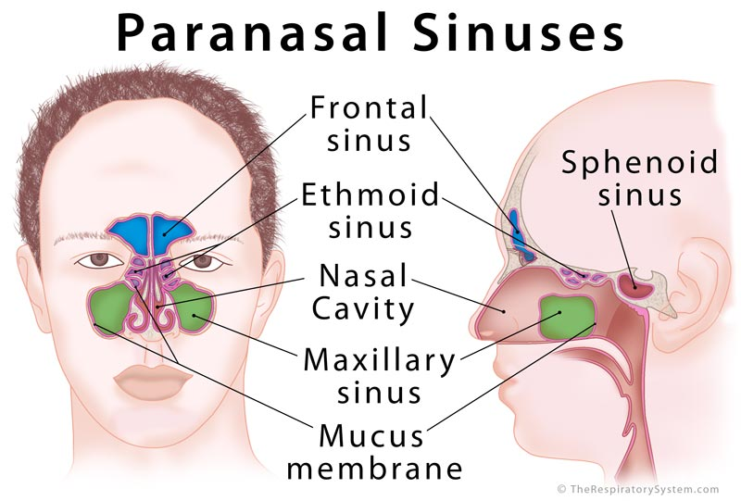

  - Maxillary sinuses: are the largest of the all the paranasal sinuses. They have thin walls which are often penetrated by the long roots of the posterior maxillary teeth. The superior border of this sinus is the bony orbit, the inferior is the maxillary alveolar bone and corresponding tooth roots, the medial border is made up of the nasal cavity and the lateral and anterior border are limited by the cheekbones.
Posteriorly, two anatomical spaces known as the pterygopalatine fossa and the infratemporal fossa exist.
Vascularization, innervation and lymphatics.
The blood supply includes a contribution from the:
- anterior superior alveolar artery
- middle superior artery
- posterior superior alveolar artery
Innervation occurs through nerves of the same names as the arteries.
The submandibular lymph nodes are the main destination during lymphatic drainage.
  - Frontal sinuses: Anteriorly, the frontal sinuses are contained by the forehead and the superciliary arches, superiorly and posteriorly by the anterior cranial fossa and inferiorly by the bony orbit, the anterior ethmoidal sinuses and the nasal cavity. Medially the sinuses face one another, separated by the midline.
This pair of sinuses are irregular in shape when compared to one another and is underdeveloped at birth. They reach their full size and shape around seven to eight years of age.
They drain primarily into the ethmoidal infundibulum and the corresponding lymph drainage occurs via the submandibular lymph nodes. It is innervated by the ophthalmic nerve, including the supraorbital and supratrochlear branches.
The frontal sinuses are supplied by the:
- anterior ethmoidal artery
- supraorbital artery
- supratrochlear artery
  - Sphenoidal sinuses: The most posterior of all the sinuses in the head, the sphenoidal sinuses are large and irregular, just like their septum, which is made by the sphenoid bone. Laterally, a cavernous sinus exists which is part of the middle cranial fossa and also the carotid artery and cranial nerves III, IV, V/I, V/II and VI can be found. The anterior wall separates this pair of sinuses from the nasal cavity, as does the hypophyseal fossa, the pituitary gland and the optic chiasm superiorly and the nasopharynx and pterygoid canal inferiorly.
The lymphatic drainage occurs in the same way as the posterior ethmoid sinus. The posterior ethmoidal artery and the posterior lateral nasal branches supply the sphenoidal sinuses.
The posterior ethmoidal nerve and the orbital branch of the pterygopalatine ganglion innervate them.
  - Ethmoidal sinuses:
- Superior to the ethmoidal sinus is the anterior cranial fossa and the frontal bone, laterally the orbit can be found, while the nasal cavity is situated medially. The ethmoid sinuses are unique because they are the only paranasal sinuses that are more complex than just a single cavity.
- On each side of the midline, anywhere from three to eighteen ethmoidal air cells may be grouped together. These air cells are smaller individual sinuses grouped together to form one large one which encompass the anterior, middle and posterior nasal meatuses.
The anterior and middle ethmoid sinuses send their lymphatic drainage to the submandibular lymph nodes while the posterior ethmoid sinus sends its own to the retropharyngeal lymph nodes.
The anterior and posterior ethmoidal arteries, as well as the posterior lateral nasal branches provide an ample blood supply to this region. Meanwhile the anterior and posterior ethmoidal nerves and the posterior lateral superior and inferior nasal nerves help innervate it.
Applied anatomy
The most common disorder affecting the paranasal sinuses is infection, a condition that is known as sinusitis.
Sinusitis: It is an extremely common outpatient case which presents as an inflammation of the epithelia of the sinuses. The causes can be either a viral or bacterial infection, or an allergic reaction, The inflammation can be acute or chronic and the maxillary sinuses are most frequently affected. Antivirals, antibiotics and antihistamines are prescribed in persistent cases.

