NAME: NWOKPOR NNAEMEKA COLLINS
MATRIC NO: 17/MHS01/211
COLLEGE: COLLEGE OF MEDICINE AND HEALTH SCIENCES
DEPARTMENT: MEDICINE AND SURGERY
COURSE: GROSS ANATOMY OF HEAD AND NECK.
LECTURER: DR OGEDENGBE.

(1.) WRITE AN ESSAY ON CAVERNOUS SINUS
The cavernous sinus within the human head is one of the dural venous sinusescreating a cavity called the lateral sellar compartment bordered by the temporal bone of the skull and the sphenoid bone, lateral to the sella turcica.

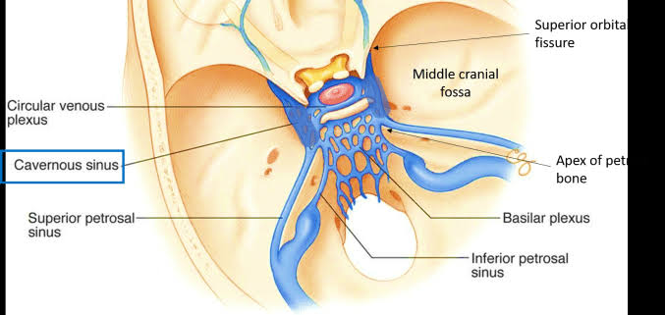

Source of the cavernous sinus
middle cerebral vein, sphenoparietal sinus, superior ophthalmic vein, Inferior ophthalmic
The cavernous sinus is one of the dural venous sinuses of the head. It is a network of veins that sit in a cavity, approximately 1 x 2 cm in size in an adult. The carotid siphon of the internal carotid artery, and cranial nerves III, IV, V (branches V1 and V2) and VI all pass through this blood filled space.

Nearby structures
Above: optic tract, optic chiasma, internal carotid artery.
Inferiorly: Foramen lacerum and the junction of the body and greater wing of sphenoid bone.
Medially: Hypophysis cerebri or (pituitary gland) and sphenoidal air sinus.
Laterally: temporal lobe with uncus.
Anteriorly: superior orbital fissure and the apex of the orbit.
Posteriorly: apex of petrous temporal bone.

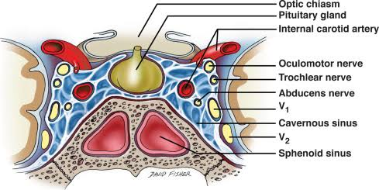

Venous connections
The cavernous sinus receives blood from:
Superior and inferior ophthalmic veins
Sphenoparietal sinus
Superficial middle cerebral veins
Inferior cerebral veins
Blood leaves the sinus via superior and inferior petrosal sinuses as well as via the emissary veins through the foramina of the skull (mostly through foramen ovale). There are also connections with the pterygoid plexus of veins via inferior ophthalmic vein, deep facial vein and emissary veins

Contents
Apart from the blood which passes through a venous sinus, several anatomical structures, including some cranial nerves and their branches, also pass through the sinus

Structures within the outer (lateral) wall of the compartment from superior to inferior:

Oculomotor nerve
Trochlear nerve
Ophthalmic and maxillary branches of the trigeminal nerve
Structures passing through the midline (medial) wall
Abducens nerve
Internal carotid artery accompanied by the Internal carotid plexus
These nerves, with the exception of CN V2, pass through the cavernous sinus to enter the orbital apex through the superior orbital fissure. The maxillary nerve, division V2 of the trigeminal nerve travels through the lower portion of the sinus and exits via the foramen rotundum. The maxillary branch passes external to, but immediately adjacent to, the lateral wall of the sinus
The optic nerve lies just above and outside the cavernous sinus, superior and lateral to the pituitary gland on each side, and enters the orbital apex via the optic canal.

Function
Venous drainage
As a venous sinus, the cavernous sinus receives blood from the superior and inferior ophthalmic veins and from superficial cortical veins, and is connected to the basilar plexus of veins posteriorly. The cavernous sinus drains by two larger channels, the superior and inferior petrosal sinuses, ultimately into the internal jugular vein via the sigmoid sinus, also draining with emissary vein to pterygoid plexus.

Clinical significance
It is the only anatomic location in the body in which an artery travels completely through a venous structure. If the internal carotid artery ruptures within the cavernous sinus, an arteriovenous fistula is created (more specifically, a carotid-cavernous fistula). Lesions affecting the cavernous sinus may affect isolated nerves or all the nerves traversing through it.

(2.) DISCUSS THE WALLS OF THE NOSE

External nose
The external nose presents a root (or bridge), a dorsum, and a free tip or apex. The two inferior openings are the nostrils (or nares), bounded laterally by the ala and medially by the nasal septum. The superior part of the nose is supported by the nasal, frontal, and maxillary bones; the inferior part includes several cartilages. The continuous free margin of the nasal bones and maxillae in a dried skull is termed the piriform aperture.

Nasal cavity
The nasal cavity extends in an antero-posterior direction from the nostrils, or nares, to the choanae. The choanae are the posterior apertures of the nose. Each choana is bounded medially by the vomer, inferiorly by the horizontal plate of the palatine bone, laterally by the medial pterygoid plate, and superiorly by the body of the sphenoid bone. Posteriorly, the nasal cavity communicates with the nasopharynx, which in many respects may be regarded as the posterior portion of the cavity. The nasal cavity is related to the anterior and middle cranial fossae, orbit, and paranasal sinuses and is separated from the oral cavity by the hard palate. In addition to the nostrils and choanae, the nasal cavity presents openings for the paranasal sinuses and the nasolacrimal duct. Further openings, covered by mucosa in vivo, are found in a dried skull, e.g., the sphenopalatine foramen. The nasal cavity is divided into right and left halves (each of which may be termed a nasal cavity) by the nasal septum. Each half has a roof, floor, and medial and lateral walls.

The roof:
The roof of the nasal cavity is formed by nasal cartilages and several bones, chiefly the nasal and frontal bones, the cribriform plate of the ethmoid, and the body of the sphenoid. The floor, wider than the roof, is formed by the palatine process of the maxilla and the horizontal plate of the palatine bone, i.e., by the palate. The medial wall, or nasal septum, is formed (from anteiror to posterior) by (1) the septal cartilage (destroyed in a dried skull), (2) the perpendicular plate of the ethmoid bone, and (3) the vomer . It is usually deviated to one side. The lowest part of the septum (the columella) is membranous and mobile.

Floor:
Formed by the maxilla and the palatine bones. The incisive foramen transmits branches of the sphenopalatine artery and the nasopalatine nerve for general sensation from the nasal cavity and palate.

Medial wall (nasal septum):
Formed by the perpendicular plate of the ethmoid bone, the vomer bone, and the septal cartilage.

The lateral wall:
The lateral wall is uneven and complicated and is formed by several bones: nasal, maxilla, lacrimal and ethmoid, inferior nasal concha, perpendicular plate of palatine, and medial pterygoid plate of sphenoid. The lateral wall presents three or four medial projections termed nasal conchae, which overlie passages (meatuses). The inferior concha is a separate bone; the others are portions of the ethmoid bone. The conchae were formerly known as turbinates. The lateral wall contains the following openings:
Sphenoethmoidal recess. The space between the superior nasal concha and the sphenoid bone, with openings from the sphenoid sinus.
Superior meatus. The space inferior to the superior nasal concha, with openings from the posterior ethmoidal air cells.
Middle meatus. The space inferior to the middle nasal concha, with openings for the frontal sinus via the nasofrontal duct, the middle ethmoidal air cells on the ethmoidal bulla, and the anterior ethmoidal air cells and maxillary sinus in the hiatus semilunaris.
Inferior meatus. The space inferior to the inferior nasal concha, with an opening for the nasolacrimal duct, which drains tears from the eye into the nasal cavity.
Sphenopalatine foramen. An opening posterior to the middle nasal concha receives the nasopalatine nerve and the sphenopalatine artery from the pterygopalatine fossa into the nasal cavity.

