NAME: JONATHAN WISDOM OVUNDAH
MATRIC NUMBER: 16/MHS03/016
COURSE TITLE: ANA 402
COURSE CODE: ELECTRON MICROSCOPIC TECHNIQUE AND ULTRASTRUCTURE
LECTURER: Dr. OGEDENGBE OLUWATOSIN OLALEKAN

ASSIGNMENT
- Write an essay on the history of microscopy.
- Differentiate between the light microscope and electron microscope.
- Differentiate between SEM and TEM.

- Microscopy History
Three Dutch spectacle makers Hans Jansen, his son Zacharias Jansen, and Hans Lippershey have received credit for inventing the compound microscope about 1590. The first portrayal of a microscope was drawn about 1631 in the Netherlands. It was clearly of a compound microscope, with an eyepiece and an objective lens. This kind of instrument, which came to be made of wood and cardboard, often adorned with polished fish skin, became increasingly popular in the mid-17th century and was used by the English natural philosopher Robert Hooke to provide regular demonstrations for the new Royal Society. These demonstrations commenced in 1663, and two years later Hooke published a folio volume titled Micrographia, which introduced a wide range of microscopic views of familiar objects (fleas, lice, and nettles among them). In this book he coined the term cell.

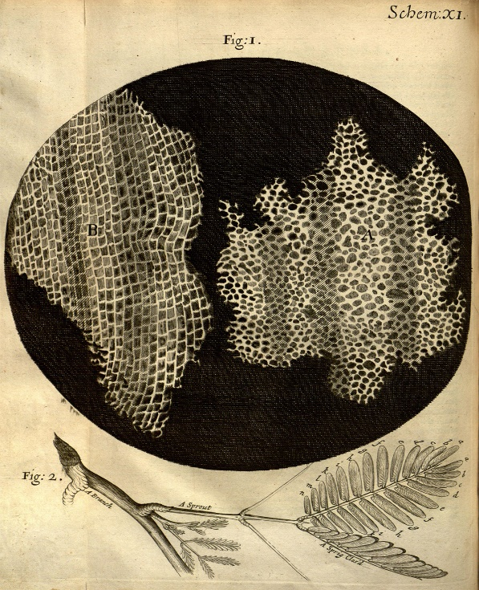
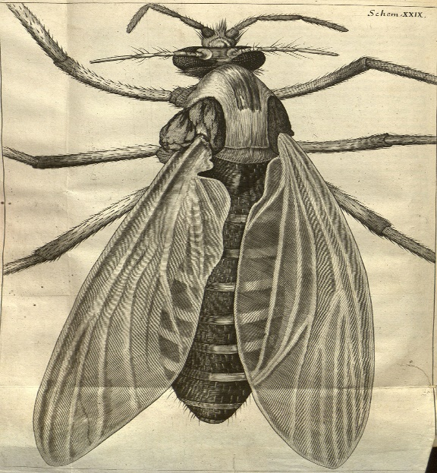

Robert Hooke’s drawings
Robert Hooke’s drawings of the cellular structure of cork and a sprig of sensitive plant from micrographia (1665)
From micographia by Robert hooke, 1665

Hidden in the unnumbered pages of Micrographia’s preface is a description of how a single high-powered lens could be made into a serviceable microscope, and it was using this design that the Dutch civil servant Antonie van Leeuwenhoek began his pioneering observations of freshwater microorganisms in the 1670s. He made his postage-stamp-sized microscopes by hand, and the best of them could resolve details around 0.7 μm. His fine specimens discovered in excellent condition at the Royal Society more than three centuries later prove what a great technician he was. Using his simple microscope, Leeuwenhoek effectively launched microbiology in 1674, and single-lensed microscopes remained popular until the 1850s. In 1827 they were used by Scottish botanist Robert Brown to demonstrate the ubiquity of the cell nucleus, a term he coined in 1831.
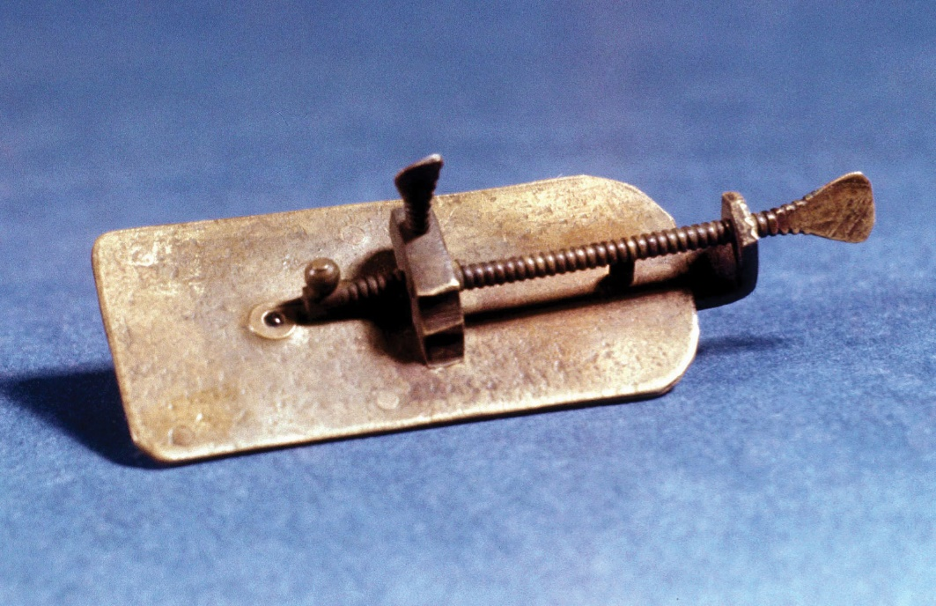
Microscope made by Antonie van Leeuwenhoek.
Simple microscopes using single lenses can generate fine images; however, they can also produce spurious colours due to chromatic aberration, in which different wavelengths of light do not come to the same focus. The aberrations were worse in the compound microscopes of the time, because the lenses magnified the aberrations at least as much as they magnified the images. Although the compound microscopes were beautiful objects that conferred status on their owners, they produced inferior images. In 1733 the amateur English optician Chester Moor Hall found by trial and error that a combination of a convex crown-glass lens and a concave flint-glass lens could help to correct chromatic aberration in a telescope, and in 1774 Benjamin Martin of London produced a pioneering set of colour-corrected lenses for a microscope.
The appearance of new varieties of optical glasses encouraged continued development of the microscope in the 19th century, and considerable improvements were made in understanding the geometric optics of image formation. The concept of an achromatic (non-colour-distorting) microscope objective was finally introduced in 1791 by Dutch optician Francois Beeldsnijder, and the English scientist Joseph Jackson Lister in 1830 published a work describing a theoretical approach to the complete design of microscope objectives. The physics of lens construction was examined by German physicist Ernst Abbe. In 1868 he invented an apochromatic system of lenses, which had even better colour correction than achromatic lenses, and in 1873 he published a comprehensive analysis of lens theory. Light microscopes that were produced in the closing quarter of the 19th century reached the effective limits of optical microscopy. Subsequent instruments, such as phase-contrast microscopes, interference microscopes, and confocal microscopes, solved specific problems that had arisen during the study of specimens such as living cells.

In 1932, Frits Zernike develops phase contrast illumination, which allows the imaging of transparent samples. By using interference rather than absorption of light, transparent samples, such as cells, can be imaged without having to use staining techniques.

In 1942, Ernst Ruska builds the first scanning electron microscope (SEM), which transmits a beam of electrons across the surface of a specimen.

In 1957, Marvin Minsky patents the principle of confocal imaging. Using a scanning point of light, confocal microscopy gives slightly higher resolution than conventional light microscopy and makes it easier to view ‘virtual slices’ through a thick specimen.

In 1962, Osamu Shimomura, Frank Johnson and Yo Saiga discovered green fluorescent protein (GFP) in the jellyfish Aequorea victoria. GFP fluoresces bright green when exposed to blue light.

In 1972, Godfrey Hounsfield and Allan Cormack develop the computerised axial tomography (CAT) scanner. With the help of a computer, the device combines many X-ray images to generate cross-sectional views as well as three-dimensional images of internal organs and structures.

In 1973, John Venables and CJ Harland observe electron backscatter patterns (EBSP) in the scanning electron microscope. EBSP provide quantitative microstructural information about the crystallographic nature of metals, minerals, semiconductors and ceramics.

In 1978, Thomas and Christoph Cremer develop the first practical confocal laser scanning microscope, which scans an object using a focused laser beam.
In 1981, Gerd Binnig and Heinrich Rohrer invent the scanning tunnelling microscope (STM). The STM ‘sees’ by measuring interactions between atoms, rather than by using light or electrons. It can visualise individual atoms within materials.
In 1986, The Nobel Prize in Physics is awarded jointly to Ernst Ruska (for his work on the electron microscope) and to Gerd Binnig and Heinrich Rohrer (for the scanning tunnelling microscope).

In 1992, Douglas Prasher reports the cloning of GFP. This opens the way to widespread use of GFP and its derivatives as labels for fluorescence microscopy (particularly confocal laser scanning fluorescence microscopy).

In 1993-1996, Stefan Hell pioneers a new optical microscope technology that allows the capture of images with a higher resolution than was previously thought possible. This results in a wide array of high-resolution optical methodologies, collectively termed super-resolution microscopy.

In 2010, Researchers at UCLA use a cryoelectron microscope to see the atoms of a virus.

In 2014, Nobel Prize in Chemistry was awarded to Eric Betzig, Stefan Hell and William Moerner for the development of super-resolved fluorescence microscopy which allows microscopes to now ‘see’ matter smaller than 0.2 micrometres.

2) Differentiate between Light and Electron microscope
Difference Between Electron Microscope And Light Microscope
Light Microscope | Electron Microscope
Uses light ( approx 400-700 nm) as an illuminating source | Uses electron beams (approx 1 nm) as an illuminating source.
Lower magnification than an electron microscope | Higher magnification
No risk of radiation leakage | Risk of radiation leakage
Specimen preparation takes about a few minutes or an hour | Specimen preparation takes several days
Both live and dead specimen can be seen | Only dead and the dried specimen can be seen
The image formation depends upon the light absorption from the different zones of the specimen | The image formation depends upon the electron scattering
The image is seen through the ocular lens. No screen needed | The image is received on a zinc sulphate fluorescent screen
Useful magnification of 500x to 1500x | Direct magnification as high as 16000x and photographic magnification as high as 1000000 x
Low resolution | High resolution
Inexpensive and requires low maintenance cost | Expensive and high maintenance

Other differences include;
Fixation – LM uses formaldehyde while EM uses Glutaraldehyde
Embedding – LM uses wax while EM makes use of Resin
Stains- LM uses water soluble dyes while EM uses heavy metals

3) Differentiate between SEM and TEM

Properties | Scanning Electron Microscopy (SEM) | Transmission Electron Microscopy (TEM)
Light Source | SEM is based on scattered electrons, i.e. electrons emitted from the surface of a specimen. It is the EM analog of a stereo light microscope. | Electrons are used as “light source”. TEM is based on transmitted electrons and operates on the same basic principles as the light microscope.
Purpose | SEM provides detailed images of the surfaces of cells. SEM focuses on the sample’s surface and its composition, so SEM shows only the morphology of samples. | Transmission electron microscope is used to view thin specimens (tissue sections, molecules, etc). TEM can show many characteristics of the sample, such as internal composition, morphology, crystallization, etc.
Sample Preparation | Sample is coated with a thin layer of heavy metal such as gold or palladium. | The sample in TEM has to be cut thinner (70-90 nm) because electrons cannot penetrate very far into materials.
Resolution | SEM can resolve objects as close as 20 nm. | TEM has a much higher resolution than SEM. It can resolve objects as close as 1 nm i.e. down to near-atomic levels.
Magnification | The magnifying power of SEM is up to 50,000X. | The magnifying power of TEM is up to 2 million times.
Processing of sample (s) | SEM allows for a large amount of sample to be analyzed at a time | With TEM only a small amount of samples can be analyzed at a time.
Image formation | Secondary or backscattered electrons arising from the interaction of electron beam and metal-coated specimen are collected and the resulting image is displayed on a computer screen. | Transmitted electrons hit a fluorescent screen giving rise to a “shadow image” of the specimen with its different parts displayed in varied darkness according to their density. The image can be studied directly by the operator or photographed with a camera.
3D picture | SEM provides a 3-dimensional image | TEM provides a 2-dimensional picture.
Current Applications | To study topography and atomic composition of specimens, process control and also, for example, the surface distribution of immuno-labels | To image the interior of cells (in thin sections), the structure of protein molecules (contrasted by metal shadowing), the organization of molecules in viruses and cytoskeletal filaments (prepared by the negative staining technique), and the arrangement of protein molecules in cell membranes (by freeze-fracture).

