NAME: AKINPELU ABOLAJI OLUWASEGUNFUNMI
MATRIC NO: 17/MHS01/044
COURSE TITLE: GROSS ANATOMY OF THE HEAD AND NECK
COURSE CODE: ANA301
ASSIGNMENT TITLE: ASSIGNMENT 2

QUESTION
- WRITE AN ESSAY ON THE CAVERNOUS SINUS
- DISCUSS THE WALLS OF THE NOSE

- The cavernous sinus is a paired dural venous sinus located within the cranial cavity. It is divided by septa into small caves- from which it gets its name.

ANATOMICAL LOCATION AND BORDERS
The cavernous sinuses are located within the middle cranial fossa, on either side of the sella turcica of the sphenoid bone (which contains the pituitary gland). They are enclosed by the endosteal and meningeal layers of the dura mater.
The borders of the cavernous sinus are:
- Anterior- superior orbital fissure
- Posterior – petrous part of the temporal bone
- Medial – body of the sphenoid bone
- Lateral – meningeal layer of the dura mater running from the roof to the floor of the middle cranial fossa
- Roof – meningeal layer of the dura mater attaches to the anterior and middle clinoid processes of the sphenoid bone.
- Floor – endosteal layer of the dura mater that overlies the base of the greater wing of sphenoid.
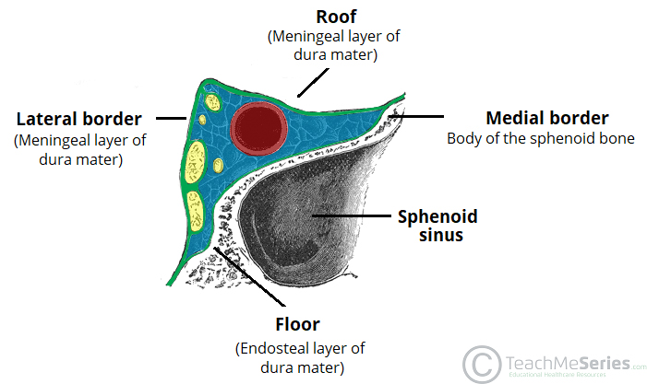
CONTENTS
Several important structures pass through the cavernous sinus to enter the orbit. They can be sub-classified by whether they travel through the sinus itself or through the lateral wall:
TRAVELS THROUGH CAVERNOUS SINUS: | TRAVELS THROUGH LATERAL WALL OF CAVERNOUS SINUS:
- Abducens nerve (CN VI) | - Oculomotor nerve (CN III)
- Carotid plexus(post-ganglionic sympathetic nerve fibers) | - Trochlear nerve(CN IV)
- Internal carotid artery(cavernous portion) | - Ophthalmic (V1) and maxillary (V2) branches of the trigeminal nerve
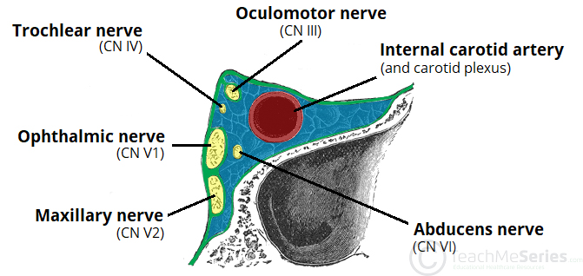
DURAL VENOUS SINUS SYSTEM
Each cavernous sinus receives venous drainage from:
- Ophthalmic veins (superior and inferior)- these enter the cavernous sinus via the superior orbital fissure
- Central vein of the retina – drains into the superior ophthalmic vein, or directly into the cavernous sinus.
- Sphenoparietal sinus – empties into the anterior aspect of the cavernous sinus
- Superficial middle cerebral vein – contributes the venous drainage of the cerebrum
- Pterygoid plexus – located within the infratemporal fossa.
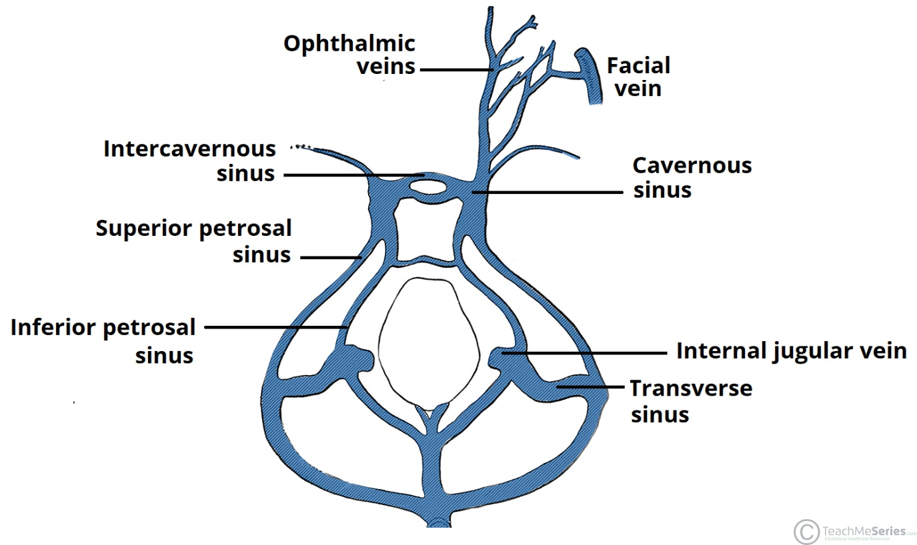
It is important to note that the superior ophthalmic vein forms an anastomosis with the facial vein. Therefore the ophthalmic vein represents a potential route by which infection can spread from an extra cranial to an intracranial site.
The cavernous sinuses empty into the superior and inferior petrosal sinuses, and ultimately, into the internal jugular vein. The left and right cavernous sinuses are connected to the midline by the anterior and posterior inter cavernous sinuses. They travel through the sella turcica of the sphenoid bone.
CLINICAL SIGNIFICANCE:
- CAVERNOUS SINUS THROMBOSIS:
Cavernous sinus thrombosis(CST) refers to the formation of a clot within the cavernous sinus
The most cause of CST is infection; which typically spreads through an extra cranial location such as the orbit, paranasal sinus or the danger zone of the face. Infection is able spread in this manner due to the anastomosis between the facial vein and superior ophthalmic veins.
The abducens nerve (CN VI) is most commonly affected
Treatment is typical with antibiotic therapy. Where the cause is infection, thrombosis of the cavernous sinus can rapidly progress to meningitis.

Nasal Cavity
It is divided into right and left halves by the nasal septum. The nasal cavity is entered anteriorly through the nares. It opens posteriorly into the nasopharynx through the choanae.
Boundaries/ Walls of the Nasal Cavity:
Roof, floor, medial wall, lateral wall
The roof : is curved and narrow, except at its posterior end. It is divided into 3 parts: frontonasal, ethmoidal, sphenoidal. They are named from the bones forming each part.
The floor: is wider than the roof. It is formed by the; palatine processes of the maxilla and horizontal plates of the palatine bone.
The medial wall :formed by the nasal septum.
The lateral walls : are irregular owing to three bony plates, the nasal conchae, which project inferiorly, somewhat like louvers.
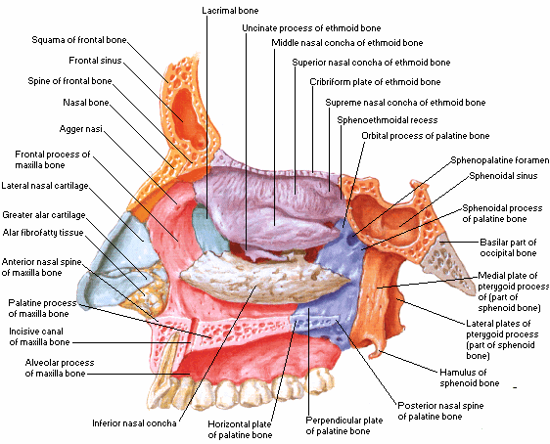
Features on the lateral wall of the nasal cavity
There is the presence of nasal conchae and they curve inferomedially
The nasal conchae include; Superior nasal concha, middle nasal concha, inferior nasal concha.
The nasal cavity is thus divided into 5 passages:
I) a posterosuperiorly placed sphenoethmoidal recess
3 laterally located nasal meatus:
II) superior
III) middle
IV) inferior
V) medially placed common nasal meatus into which the four lateral passages open
The sphenoethmoidal recess : lying superoposterior to the superior concha, receives the opening of the sphenoidal sinus, an air-filled cavity in the body of the sphenoid.
The superior nasal meatus : is a narrow passage between the superior and the middle nasal conchae. The posterior ethmoidal sinuses open into this superior nasal meatus through one or more orifices.
The middle nasal meatus: is longer and deeper than the superior one. The anterosuperior part of this passage leads into a funnel-shaped opening, the ethmoidal infundibulum through which it communicates with the frontal sinus through a passage known as the frontonasal duct. The anterior ethmoidal cells opens directly or indirectly on the ethmoidal infundibulum. The ethmoidal infundibulum leads inferiorly into a semi-circular groove called the semilunar hiatus. The maxillary sinus opens into the semilunar hiatus. Superior to the semilunar hiatus is a rounded elevation called the ethmoidal bulla. The ethmoidal bulla is only visible when the middle concha is removed. The bulla is a swelling formed by middle ethmoidal cells that form the ethmoidal sinuses. Anterior and inferior to the semilunar hiatus is a hook like process called the uncinate process of the ethmoid bone. This process articulates with the inferior nasal concha.
The inferior nasal meatus : is a horizontal passage inferolateral to the inferior nasal concha. The nasolacrimal duct, which drains tears from the lacrimal sac, opens into the anterior part of this meatus.
The common nasal meatus : is the medial part of the nasal cavity between the conchae and the nasal septum, into which the lateral recesses and meatus open.
The arterial supply
The arterial supply of the medial and lateral walls of the nasal cavity is from five sources:
- Anterior ethmoidal artery (from the ophthalmic artery)
- Posterior ethmoidal artery (from the ophthalmic artery)
- Sphenopalatine artery (from the maxillary artery)
- Greater palatine artery (from the maxillary artery)
- Septal branch of the superior labial artery (from the facial artery)
Venous drainage :
A rich submucosal venous plexus deep to the nasal mucosa drains into the sphenopalatine, facial, and ophthalmic veins.
Innervation :
- olfactory nerve
- branches of the ophthalmic [V1] which include the anterior and posterior ethmoidal nerves.
- maxillary [V2] nerves which include;
Posterior superior lateral nasal nerves
Posterior superior medial nasal nerves
Nasopalatine nerve
Posterior inferior nasal nerves

