NAME: Ekpunobi Uche Sophia
MATRIC NO: 17/MHS01/109
DEPT: MBBS
COURSE: Gross Anatomy of the Head and Neck
ASSIGNMENT: 1. Discuss the Anatomy of the tongue and comment on its applied anatomy.
2. Write an essay on the air sinuses.
ANSWERS
- Anatomy of the Tongue.
The tongue is a pink, muscular organ located within the oral cavity proper. It is kept moist by the products of the major and minor salivary glands, which aids the organ as it facilitates deglutition, speech, and gustatory perception. While there is significant variability in the length of the tongue among individuals, on average, the organ is roughly 10 cm long. It has three main parts:
The tip or apex: the most anterior and most mobile aspect of the tongue
The body: it has a rough superior surface that abuts the palate and is populated with taste buds and lingual papillae, and a smooth inferior surface that is attached to the floor of the oral cavity by the lingual frenulum.
The base: it is the most posterior part of the organ. It is populated by numerous lymphoid aggregates known as the lingual tonsils along with foliate papillae along the posterolateral surface.
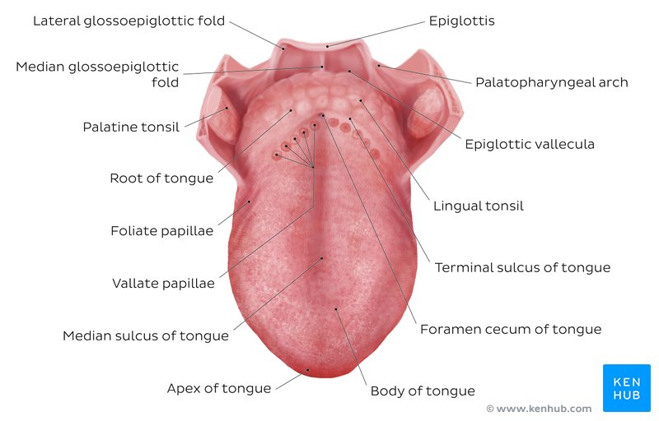
Figure 1: Diagram of the Tongue
Relations of the Tongue:
The tongue is limited anteriorly and laterally by the upper and lower rows of teeth.
Superiorly, it is bordered by the hard and soft palates.
Inferiorly, the root of the tongue is continuous with the mucosa of the floor of the oral cavity with the sublingual salivary glands and vascular bundles being located below the mucosa of the floor of the oral cavity.
The palatoglossal and palatopharyngeal arches (along with the palatine tonsils) have lateral relations to the posterior third of the tongue.
Posterior to the base of the tongue is the dorsal surface of the epiglottis and laryngeal inlet, and the posterior wall of the oropharynx.
The tongue is divided embryologically into an anterior and a posterior part. The anterior part of the tongue is also called the oral or presulcal part of the tongue while the posterior part of the tongue is referred to as the pharyngeal or postsulcal part of the tongue.
Anterior two thirds of the Tongue:
The presulcal tongue includes the apex and body of the tongue; it terminates at the sulcus terminalis. The mucosa of the superior surface of the oral tongue is made up of circumvallate, filiform, and fungiform papillae. There is a longitudinal midline groove running in an anteroposterior direction from the tip of the tongue to the foramen cecum which marks the embryological point of fusion of the lateral lingual swellings that formed the oral tongue. It also represents the location of the median lingual (fibrous) septum of the tongue that inserts in the body of the hyoid bone. On the lateral surface of the oral tongue are foliate papillae arranged as a series of vertical folds. The ventral mucosa of the oral tongue is comparatively unremarkable. It is smooth and continuous with the mucosa of the floor of the mouth and the inferior gingiva.
Posterior third of the Tongue:
The remainder of the tongue that lies posterior to the sulcus terminalis is made up by the base of the tongue; it lies behind the palatoglossal folds and functions as the anterior wall of the oropharynx. Unlike the oral tongue, the pharyngeal tongue does not have any lingual papillae. Instead, its mucosa is populated by aggregates of lymphatic tissue known as the lingual tonsils. The mucosa is also continuous with the mucosa of the laterally located palatine tonsils, the lateral oropharyngeal walls, and the posterior epiglottis and glossoepiglottic folds.
Muscles of the Tongue
The tongue is chiefly a muscular organ with some amount of fatty and fibrous tissue distributed throughout its substance. All the muscles of the tongue are paired structures, with each copy being found on either side of the median fibrous septum. There are muscles that extend outside of the organ to anchor it to surrounding bony structures, known as extrinsic muscles, and muscles that are confined to each half of the tongue and contribute to altering the shape of the tongue, known as intrinsic muscles.
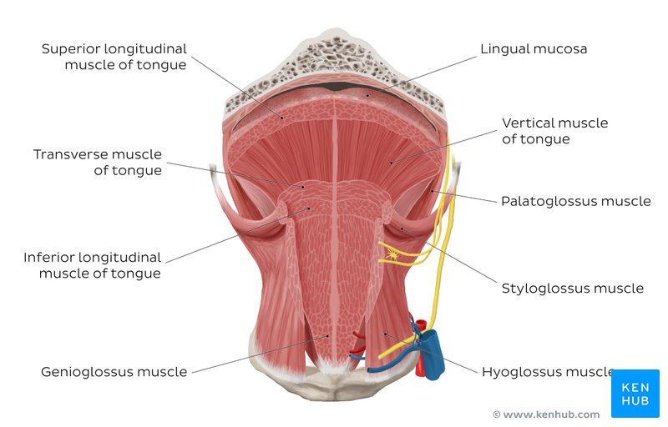
Figure 2: Muscles of the Tongue

Intrinsic tongue muscles
They are responsible for adjusting the shape and orientation of the tongue. It is made up of four paired muscles:
Superior longitudinal | Origin - submucosa of posterior tongue, lingual septum  Insertion - apex/anterolateral margins of tongue  Innervation - hypoglossal nerve (CN XII)  Blood supply - lingual branch of external carotid artery  Action - retracts and broadens tongue, elevates apex of tongue
Inferior longitudinal | Origin - root of tongue, body of hyoid bone  Insertion - apex of tongue  Innervation - hypoglossal nerve (CN XII)  Blood supply - lingual branch of external carotid artery  Action - retracts and broadens tongue, lowers apex of tongue
Transverse muscle | Origin - lingual septum  Insertion - lateral margin of tongue  Innervation - hypoglossal nerve (CN XII)  Blood supply - lingual branch of external carotid artery  Action - narrows and elongates tongue
Vertical muscle | Origin - root of tongue, genioglossus muscle  Insertion - lingual aponeurosis  Innervation - hypoglossal nerve (CN XII)  Blood supply - lingual branch of external carotid artery  Action - broadens and elongates tongue

Extrinsic tongue muscles
While the shape of the tongue is determined by the intrinsic muscles of the tongue, movement of the organ within and out of the oral cavity is dependent on the extrinsic tongue muscles. There are four pairs of extrinsic muscles, which can be viewed as those arising from above the tongue, and those that originate from below the tongue. They include:

Genioglossus | Origin - Superior mental spine of mandible  Insertion - entire length of dorsum of tongue, lingual aponeurosis, body of hyoid bone  Innervation - hypoglossal nerve (CN XII)  Blood supply - sublingual branch of lingual artery, submental branch of facial artery  Action - depresses and protrudes tongue (bilateral contraction); deviates tongue contra laterally (unilateral contraction)
Hyoglossus | Origin - body and greater horn of hyoid bone  Insertion - inferior/ventral parts of lateral tongue  Innervation - hypoglossal nerve (CN XII)  Blood supply - sublingual branch of lingual artery, submental branch of facial artery  Action - depresses and retracts tongue
Styloglossus | Origin - anterolateral aspect of styloid process (of temporal bone), stylomandibular ligament  Insertion - blends with inferior longitudinal muscle (longitudinal part); blends with hyoglossus muscle (oblique part)  Innervation - hypoglossal nerve (CN XII)  Blood supply - sublingual branch of lingual artery  Action - retracts and elevates lateral aspects of tongue
Palatoglossus | Origin - palatine aponeurosis of soft palate  Insertion - lateral margins of tongue, blends with intrinsic muscles of tongue  Innervation - vagus nerve (CN X) (via branches of pharyngeal plexus)  Blood supply - ascending palatine branch of facial artery, ascending pharyngeal artery  Action - elevates root of tongue, constricts isthmus of fauces
Histology
The lingual mucosa is covered by stratified squamous epithelium with varying degrees of keratinization. The dorsal surface of the oral tongue is covered by epithelium that is keratinized, the ventral surface of the tongue as well as the pharyngeal part, are covered with epithelium that is non-keratinized. The epithelium is adherent to the underlying striated muscle fibers of the tongue. There is a fibrous raphe in the midline of the tongue that marks the point of fusion of the embryonic lateral lingual swellings. Posteriorly, there is a variable amount of adipose tissue within the pharyngeal tongue.
The dorsal mucosa of the oral tongue is characterized by numerous raised structures known as lingual papillae. They give the characteristic rough appearance of the dorsal surface that is not appreciated on the ventral surface of the tongue. The pharyngeal tongue also has raised dome-like structures throughout the mucosa. However, these are lymphatic aggregates (i.e. lingual tonsils) and should not be confused with papillae.
The lingual papillae
There are four types of lingual papillae found on the surface of the human tongue. These include:
- Filiform papillae: the most abundant of the four types of papillae. They are stretched, conical, grey-white papillae that are covered in a heavy coat of keratinized squamous epithelium. It should be noted that these papillae do not possess taste buds.
- Fungiform papillae: they are weakly keratinized and less abundant than the filiform papillae. However, they are scattered across the entire dorsal surface of the tongue. These highly vascular, mushroom-shaped papillae contain a few taste buds on the apical aspect.
- Foliate papillae: they appear as bilaterally paired, parallel, longitudinal slits on the posterolateral margin of the tongue, near the sulcus terminalis. The mucosa is non-keratinized and the papillae are populated with numerous taste buds.
- Circumvallate (Vallate) papillae: they are organized linearly, as a set of four to six large papillae anterior to each limb of the sulcus terminalis.

The taste buds
While taste buds are distributed throughout the entire oral cavity, they are at higher concentrations on the tongue. Each taste bud is clear, oval and covered by stratified squamous epithelium. A combination of elongated taste (gustatory), supportive, and basal stem cells can be found within each taste bud. The gustatory cells have an apical taste pore surrounded by numerous microvilli that binds dissolved molecules and brings them closer to the receptors responsible for taste. However, these cells have a relatively high turnover rate, as their shelf life is roughly seven to ten days.
Blood Supply and Lymphatic Drainage
Arterial Supply:
The arterial supply to the tongue muscles is provided by derivatives of the lingual artery. This is a branch of the external carotid artery that traverses the region between the middle pharyngeal constrictor and hyoglossus in order to access the floor of the mouth. It takes a sharp superior turn at the anterior border of hyoglossus as it travels alongside the glossopharyngeal nerve (CN IX). The named branches of the lingual artery are: dorsal lingual arteries, sublingual arteries and deep lingual artery.
The lingual artery is supported by other branches of the external carotid artery. The facial artery gives off the ascending palatine and tonsillar arteries that also supply the tongue. The ascending pharyngeal branch of the external carotid artery also supplies the tongue.
Venous Drainage:
The veins accompany the arteries and have similar names.

Lymphatic Drainage:

The marginal and central groups drain the anterior parts of the tongue. The marginal lymph vessels will carry lymph to the submandibular nodes or to the jugulo-omohyoid nodes the central region may go to the deep cervical nodes, with a particular preference for the jugulo-omohyoid or jugulodigastric nodes.

The dorsal group drains lymph from the posterior third of the tongue. They pass laterally on either side to eventually join the marginal vessels in their course to the jugulo-omohyoid and jugulodigastric vessels.
Innervation:
The tongue has multiple sources of innervations based on its embryological origins. The nerve supply to the tongue can be grouped based as efferent fibers that carry motor impulses, general sensory that conveys touch and proprioception, and special afferent that conveys gustatory impulses.
Clinical Anatomy
- Thrush (candidiasis): Candida albicans (a yeast) grows over the surface of the mouth and tongue. Thrush can occur in almost anyone, but it occurs more often in people taking steroids or with suppressed immune systems, the very young, and the elderly.
- Oral cancer: A growth or ulcer appears on the tongue and grows steadily. Oral cancer is more common in people who smoke and/or drink alcohol heavily.
- Macroglossia (big tongue): This can be broken down into various categories based on the cause. These include congenital, inflammatory, traumatic, cancerous, and metabolic causes. Thyroid disease, lymphangiomas, and congenital abnormalities are among some of the causes of an enlarged tongue.

- Air Sinuses.
They are air cavities that help circulate the air that is breathed in and out of the respiratory system. They are situated around the nasal cavity and they are all paired and sometimes symmetrical, while always being bilateral. There are four different pairs of sinuses and they are called the:
- Maxillary sinuses: they are the largest of the all the air sinuses. They have thin walls which are often penetrated by the long roots of the posterior maxillary teeth. The superior border of this sinus is the bony orbit, the inferior is the maxillary alveolar bone and corresponding tooth roots, the medial border is made up of the nasal cavity, and the lateral and anterior borders are limited by the cheekbones.
- Frontal sinuses: anteriorly, the frontal sinuses are contained by the forehead and the superciliary arches, superiorly and posteriorly by the anterior cranial fossa and inferiorly by the bony orbit, the anterior ethmoidal sinuses and the nasal cavity. Medially the sinuses face one another, separated by the midline. This pair of sinuses is irregular in shape when compared to one another and is underdeveloped at birth. They reach their full size and shape around seven to eight years of age.
- Sphenoidal sinuses: the most posterior of all the sinuses in the head, the sphenoidal sinuses are large and irregular, just like their septum, which is made by the sphenoid bone. Laterally, a cavernous sinus exists which is part of the middle cranial fossa and also the carotid artery and cranial nerves III, IV, V/I, V/II and VI can be found. The anterior wall separates this pair of sinuses from the nasal cavity, as does the hypophyseal fossa, the pituitary gland and the optic chiasm superiorly and the nasopharynx and pterygoid canal inferiorly.
- Ethmoidal Sinuses: superior to the ethmoidal sinus is the anterior cranial fossa and the frontal bone, laterally the orbit can be found, while the nasal cavity is situated medially. The ethmoid sinuses are unique because they are the only paranasal sinuses that are more complex than just a single cavity. On each side of the midline, anywhere from three to eighteen ethmoidal air cells may be grouped together. These air cells are smaller individual sinuses grouped together to form one large one which encompass the anterior, middle and posterior nasal meatuses.
Applied Anatomy
Sinusitis
It is an extremely uncommon outpatient case which presents as an inflammation of the epithelia of the sinuses. The cause can be either a viral or bacterial infection, or an allergic reaction. The inflammation can be acute or chronic and the maxillary sinuses are most frequently affected. Antivirals, antibiotics and antihistamines are prescribed in persistent cases.

