NAME: ERUVWETOPHURE JEMILAND
MATRIC NO: 17/MHS01/121
COURSE: GROSS ANATOMY (HEAD AND NECK)
DEPT: MBBS
LEVEL: 300L
QUESTION 1(THE ANATOMY OF THE TONGUE AND ITS APPLIED ANATOMY)
THE TONGUE
The tongue is a flexible muscular organ found partly in the oral cavity and in the oropharynx. The base of the tongue is attached to the floor and oral cavity, while its apex is free and mobile.
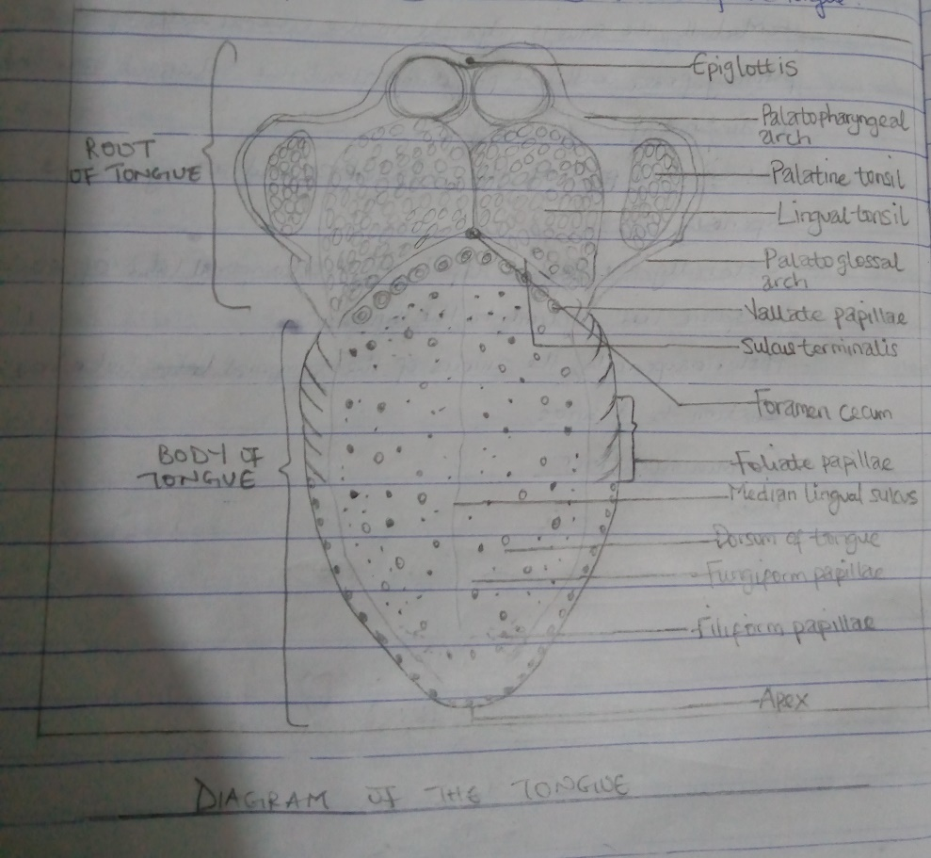

FUNCTIONS OF THE TONGUE
- It facilitates the movement of food during mastication and assists in squeezing food into the oropharynx when swallowing.
- It is important in the articulation of speech.
- It is used for detecting taste.
- It is used as a means of oral cleansing-natural means of cleaning the oral cavity.
PARTS OF THE TONGUE
- The root of the tongue: it rests on the floor of the mouth and is usually defined as the posterior third of the tongue.
- The body of the tongue: it is the anterior two third of the tongue. It is mobile.
- The apex of the tongue: it is the anterior end of the body, which rests against the incisor teeth. It is mobile.
SURFACES OF THE TONGUE
- The dorsum of the tongue (upper surface): it is the posterosuperior surface, which is located partly in the oral cavity and partly in the oropharynx. The dorsum is characterized by a V-shaped groove called the terminal sulcus or groove. The terminal sulcus divides the dorsum of the tongue into;
- anterior (oral) part-which is the oral cavity
- Posterior (pharyngeal) part-which is in the oropharynx.
The mucous membrane on the anterior part of the tongue is rough because of the presence of numerous small lingual papillae. The papillae found in the human tongue include;
-vallate papillae
-foliate papillae
-filiform papillae
-fungiform papillae.
NB: all the papillae except filiform act as a taste receptor.
A shallow line on the upper surface of the tongue divides the tongue into left and right halves; this line is known as the median sulcus.
- The inferior surface of the tongue: it is covered with a thin, transparent mucous membrane, through which the underlying veins can be seen. This surface is connected to the mouth of the floor by a midline fold called the frenulum of the tongue. The frenulum allows the anterior part of the tongue to move freely. A deep lingual vein is seen through the thin mucous membrane on both side of the frenulum.
TASTE AND SITE OF TASTE
- sweetness- it is detected at the apex
- saltiness- at the anterolateral margins
- sourness-at the posterolateral margins
- Bitterness-at the posterior part of the tongue

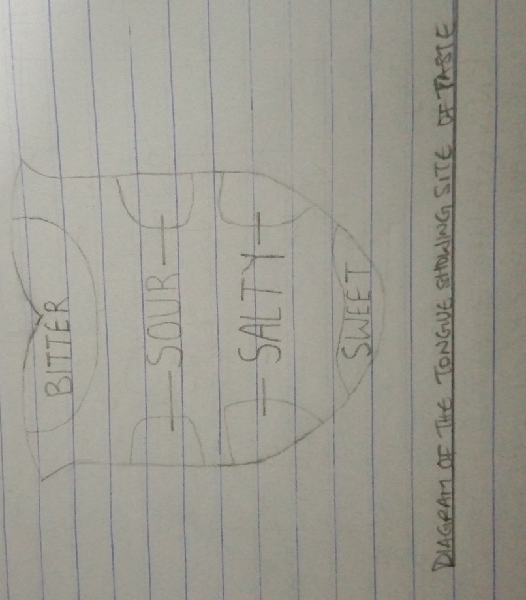

MUSCLES OF THE TONGUE
There are two types of muscles in the tongue. Muscles that makeup the inside of the tongue (intrinsic muscles) and muscles that are located outside the tongue and are only attached to the tongue in specific regions (extrinsic muscles)
The four extrinsic and intrinsic muscles on each half of the tongue gives rise to a total of 8 tongue muscles.
The four extrinsic and four intrinsic muscles in each half of the tongue are separated by the lingual septum, which merges posteriorly with the lingual aponeurosis.
EXTRINSIC MUSCLES
They alter the position of the tongue, they include:
- Genioglossus: depresses and protrudes tongue (bilateral contraction); deviates tongue contra laterally (unilateral contraction
- Hyoglossus: depresses and retracts tongue
- Styloglossus: retracts and elevates lateral aspects of tongue
- Palatoglossus: elevates root of tongue, constricts isthmus of fauces
INTRINSIC MUSCLES
They alter the shape of the tongue. They include;
- Superior longitudinal muscle: retracts and broadens tongue, elevates apex of tongue.
- inferior longitudinal muscle: retracts and broadens tongue, lowers apex of tongue
- transverse muscle: narrows and elongates tongue
- vertical muscle: broadens and elongates tongue

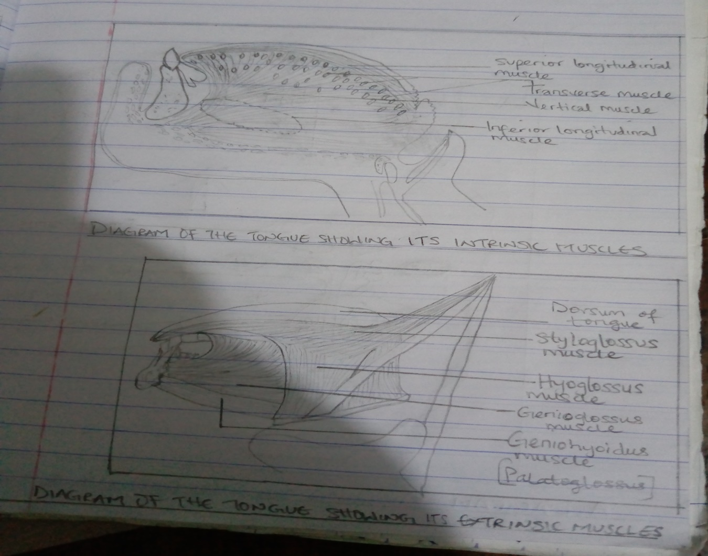

VASCULATURE OF THE TONGUE
ARTERIAL SUPPLY
The primary artery of the tongue is the lingual artery, which arises from the external carotid artery. On entering the tongue, the lingual artery passes deep to the hyoglossus muscle and give rise to the;
- dorsal lingual arteries which supply the posterior part
- the deep lingual arteries which supply the anterior part
VENOUS DRAINAGE
- The dorsal lingual veins which accompany the dorsal lingual artery.
- The deep lingual vein, which begins at the apex of the tongue, run posteriorly beside the lingual frenulum to join the sublingual vein.
- The sublingual vein, which is often abnormally swollen in elderly people.
- All lingual veins terminate in the internal jugular vein
LYMPHATIC DRAINAGE
- Lymph from the posterior third drains into the superior deep cervical lymph nodes.
- Lymph from the medial part of the anterior two thirds drains directly to the inferior deep cervical lymph nodes.
- Lymph from the lateral parts of the anterior two thirds drains to the submandibular lymph nodes.
- The apex and frenulum drain into the submental lymph node.
APPLIED ANATOMY
- Lingual Carcinoma
A lingual carcinoma in the posterior part of the tongue metastasizes to the superior deep cervical lymph nodes on both sides, whereas a tumor in the anterior part usually does not metastasize to the inferior deep cervical lymph nodes until late in the disease.
Because these nodes are closely related to the internal jugular vein, metastases from the tongue may be widely distributed through the submental and submandibular regions and along the internal jugular veins in the neck.

- Frenectomy
An overly large lingual frenulum (tongue-tie/ ankyloglossa) interferes with tongue movements and may affect speech
In unusual cases, a frenectomy (cutting the frenulum) in infants may be necessary to free the tongue for normal movement and speech

QUESTION 2(AN ESSAY ON AIR SINUSES)

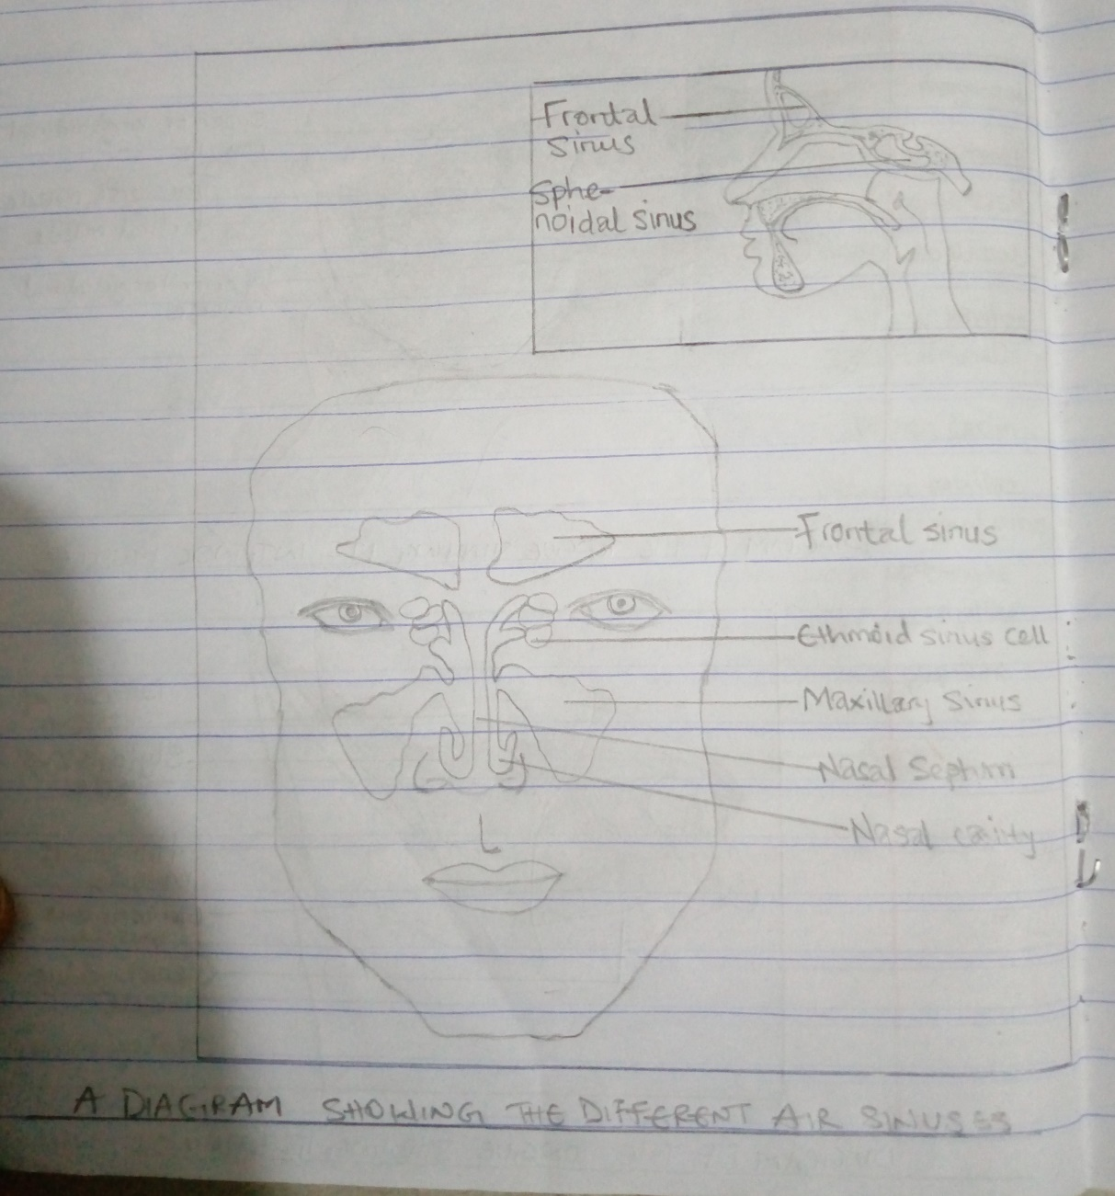

The air (paranasal) sinuses are air cavities that help circulate the air that is breathed in and out of the respiratory system. They are situated around the nasal cavity and they are all paired and sometimes symmetrical, while always being bilateral. There are four different pairs of sinuses, they include;
- Maxillary sinuses
- Frontal sinuses
- Sphenoidal sinuses
- Ethmoidal sinuses
- THE MAXILLARY SINUSES
They are the largest of all the air sinuses. They have thin walls which are often penetrated by the long roots of the posterior maxillary teeth.
BORDERS OF THE MAXILLARY SINUSES
- The superior border: bounded by the bony orbit
- The inferior border: bounded by the nasal cavity
- Lateral and anterior border: bounded by the cheeks bones
- Posterior border: bounded by the pterygopalatine and infratemporal fossa.
VASCULARIZATION
The blood supply includes a contribution from the;
- Anterior superior alveolar artery
- Middle superior artery
- Posterior superior alveolar artery
INNERVATION
This sinus is innervated by branches of the maxillary nerve, which include;
- Anterior superior alveolar nerve
- Middle superior nerve
- Posterior superior alveolar nerve
LYMPHATIC DRAINAGE
Lymph is drained in the submandibular lymph nodes.
- THE FRONTAL SINUSES
- Anteriorly, the frontal sinuses are contained by the forehand and the superciliary arches
- Superiorly and posteriorly, the sinuses are contained by the anterior cranial fossa
- Inferiorly by the bony orbit, the anterior ethmoidal sinuses and the nasal cavity
- Medially the sinuses face one another separated by the midline(contralateral sinus)
This pair of sinuses is irregular in shape when compared to one another and is underdeveloped at birth. They reach their full size and shape around seven to eight years of age.
VASCULARIZATION
The frontal sinuses are supplied by the;
- Anterior ethmoidal artery
- Supraorbital artery
- Supratrochlear artery
INNERVATION
It is innervated by the ophthalmic nerve, including the supraorbital and supratrochlear branches.
LYMPHATIC DRAINAGE
They drain primarily into the ethmoidal infundibulum and the corresponding lymph drainage occurs via the submandibular lymph nodes.
- THE SPHENOIDAL SINUSES
It is the most posterior of all the sinuses. The sphenoidal sinuses are large and irregular, just like their septum, which is made by the sphenoid bone.
- The anterior wall is made up of the nasal cavity
- The superior wall is made up of the hypophyseal fossa, the pituitary gland and the optic chiasm.
- The inferior wall is made up of the nasopharynx and pterygoid canal
VASCULARIZATION
The sphenoidal sinuses is supplied by the posterior ethmoidal artery and the posterior lateral nasal branches.
INNERVATION
This sinus is innervated by the posterior ethmoidal nerve and the orbital branch of the pterygopalatine ganglion.
LYMPHATIC DRAINAGE
The lymph drain into the submandibular lymph nodes.
- ETHMOIDAL SINUSES
- Superior to the ethmoidal sinus is the anterior cranial fossa and the frontal bone
- Laterally, the orbit can be found
- Medially, the nasal cavity is situated
The ethmoid sinuses are unique because they are the only paranasal sinuses that are more complex than just a single cavity.
On each side of the midline, anywhere from three to eighteen ethmoidal air cells may be grouped together. These air cells are smaller individual sinuses grouped together to form one large one which encompass the anterior, middle and posterior nasal meatuses.
VASCULARIZATION
The ethmoidal sinus is supplied by;
- The anterior and posterior ethmoidal arteries
- The posterior lateral nasal branches
INNERVATION
The ethmoidal sinuses is innervated by the;
- Anterior and posterior ethmoidal nerves
- Posterior lateral superior nerve and
- Inferior nasal nerve
LYMPHATIC DRAINAGE
The anterior and middle ethmoid sinuses send their lymphatic drainage to the submandibular lymph nodes.
The posterior ethmoid sinus sends its own to the retropharyngeal lymph nodes.
CLINICAL RELATION
SINUSITIS
Sinusitis is an extremely common outpatient case which presents an inflammation of the epithelia of the sinuses. The causes can be either a viral or bacterial infection, or an allergic reaction.
The inflammation can be acute or chronic and the maxillary sinuses are the most frequently affected.

