MATRIC NO: 17/MHS01/245
COURSE:ANA 310- GROSS ANATOMY OF HEAD AND NECK
- GROSS ANATOMY OF THE TONGUE

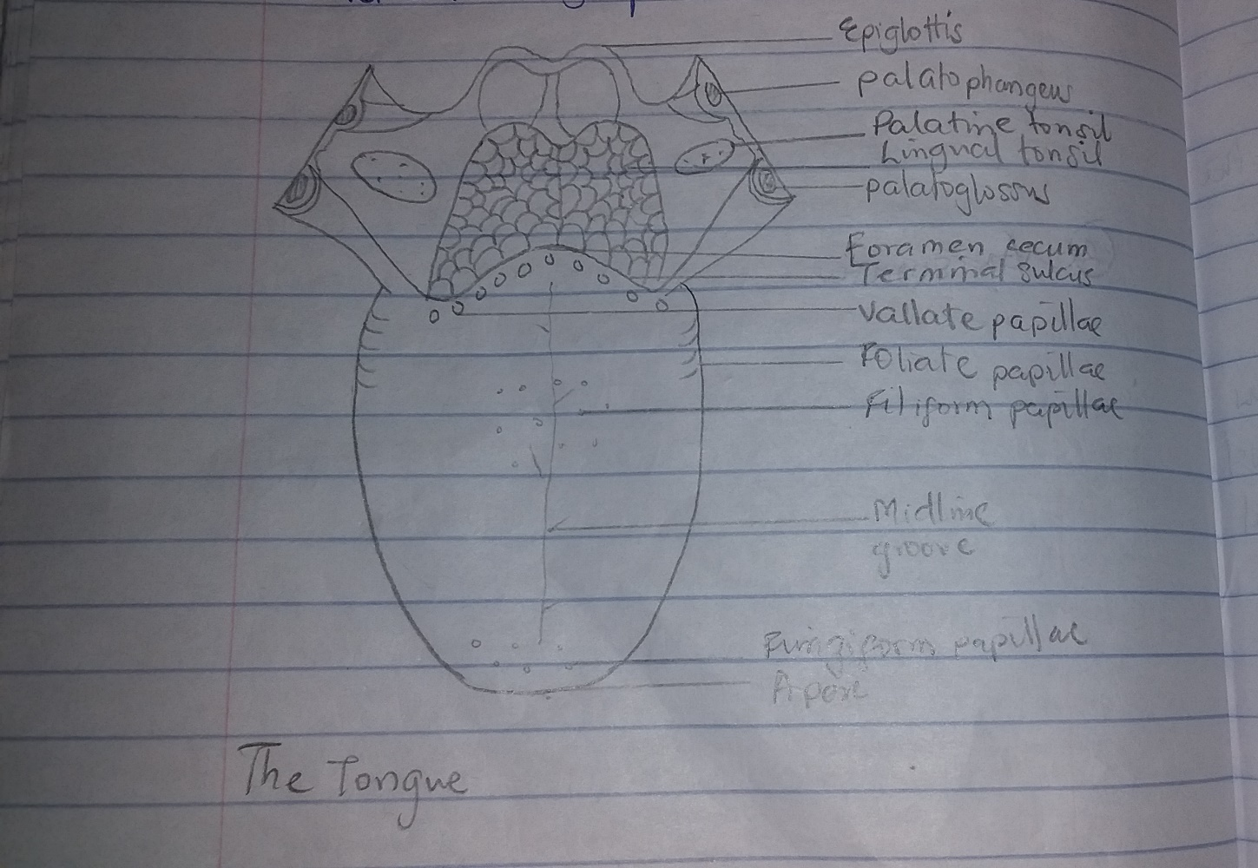

- Introduction
It is a mobile muscular organ covered with mucous membrane. It can assume a variety of shapes and positions. It is partly in the oropharynx and partly in the oral cavity. Functions of the tongue include:
- Articulation
- Squeezing food into the oropharynx as part of deglutition (swallowing)
- Mastication
- Taste
- Oral cleansing

- Parts and surface of the tongue: The tongue has a root, body and an apex
The root of the tongue is attached to the posterior portion, extending between the mandible, hyoid and the nearby vertical surface of the tongue
The body of the tongue is the anterior, approximately two-thirds of the tongue between the root and the apex
The apex of the tongue is the anterior end of the body which rests against the incisor teeth.
- The tongue has 2 surfaces; the more extensive, superior and posterior surface is the dorsum of the tongue and the inferior surface which rests against the floor of the mouth.
- The dorsum of the tongue is characterised by V-shaped grove. The terminal sulcus of the tongue, the angle of which points posteriorly to foramen cecum.
- The terminal sulcus divides the dorsum transversely into the presulcal anterior part and a postsulcal posterior part in the oropharynx.
- The mucosa of the anterior part of the tongue is relatively thin and closely attached to the underlying muscle. It has a rough texture because of numerous small lingual papillae
- Vallate papillae: it is large and flat topped, lie directly anterior to the terminal sulcus and are arranged in a -shaped row
- Foliate papillae: small lateral folds of the lingual mucosa. They are poorly developed in humans
- Filiform papillae: long and numerous, contain afferent nerve endings that are sensitive to touch. These scaly, conical projections are pinkish gray and are arranged in V-shaped rows that are parallel to the terminal sulcus, except at the apex, where they tend to be arranged transversely.
- Fungiform papillae: Mushroom shaped pink or red spots scattered among the filiform papillae but most numerous at the apex and margins of the tongue.
- The mucosa of the posterior part of the tongue is thick and freely movable. It has no lingual papillae, but the underlying lymphoid nodules give this part of the tongue an irregular appearance. The lymph nodules are collectively known as lingual tonsil.
- The inferior surface of the tongue is covered with a thin, transparent mucous membrane. This surface is connected to the floor of the mouth by a midline fold called the frenulum of the tongue.
- A sublingual caruncle is present on each side of the base of the lingual frenulum that includes the opening of the submandibular duct from the submandibular salivary gland

Muscles of the tongue
The extrinsic and intrinsic muscles in each half of the tongue are separated by a median, fibrous lingual septum, that emerges posteriorly with the lingual aponeurosis.
Extrinsic muscles alter the position of the tongue. They are genioglossus, hyoglossus, styloglossus and palatoglossus. They originate outside the tongue and attach to it.
Intrinsic muscles of the tongue alter its shape. The superior and inferior longitudinal, transverse and vertical muscles. The superior and inferior longitudinal act together to make the tongue short and thick. The transverse and vertical muscles act simultaneously to make the tongue long and narrow, which may push it against the incisor teeth or protrude the tongue from the mouth.
Innervation of the tongue
All muscles of the tongue except palatoglossus receive the motor innervation from CNXII, hypoglossal nerve. Palatoglossus is supplied by the pharyngeal plexus. For general sensation, the mucosa of the anterior two-thirds is supplied by lingual nerve, a branch on CNV₃. For special sensation, this part of the tongue except vallate papillae is supplied by the chorda tympani, a branch of CNVII. The mucosa of the posterior third of the tongue and the vallate papillae are supplied by the lingual branch of CNIX, glossopharyngeal nerve.
Vasculature of the tongue
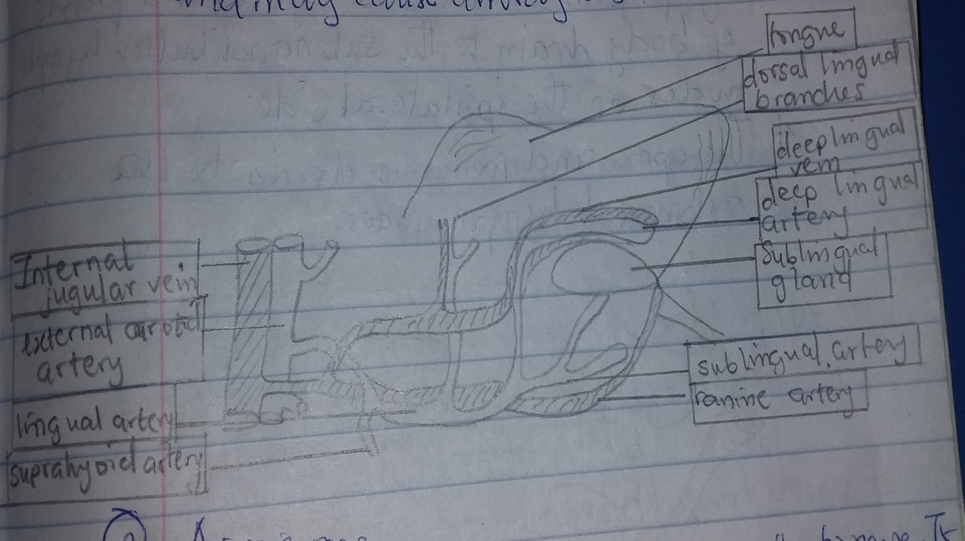

Arterial supply
The arteries of the tongue are from the lingual artery which arises from the external carotid artery. The dorsal lingual arteries supply the root of the tongue and the deep lingual arteries supply the lingual body.
Venous drainage
The veins are the dorsal lingual veins; the deep lingual veins which begin at the apex of the tongue and run posteriorly beside the lingual frenulum to join the sublingual vein. Some or all may drain directly into the internal jugular vein or indirectly by first joining to form a lingual vein.
Lymphatic drainage
- Lymph from the root drains bilaterally into the superior deep cervical lymph nodes
- Lymph from the medial part of the body drain bilaterally and directly into the inferior deep cervical lymph nodes
- Lymph from the right and left lateral parts of the body drain to the submandibular lymph nodes on the ipsilateral side.
- The apex and the frenulum drain into the submental lymph nodes.
CLINICAL SIGNIFICANCE
- Pierre-robin syndrome
It causes glossoptosis among other symptoms. This particular defect causes the tongue to be displaced posteriorly and may cause airway obstruction or apnea
- Glossitis: this refers to an inflammation of the tongue. It causes the tongue to swell in size, change in colour and develop a different appearance on the surface. Certain diseases can cause glossitis, especially those where nutritional deficiencies occur, such as celiac disease, protein-calorie malnutrition, and pernicious anaemia.

2. AIR SINUSES (PARANASAL SINUSES)
They are air-filled extensions of the respiratory part of the nasal cavity into the frontal, ethmoid, sphenoid and maxilla bones. The names of the sinuses follow the bones. The sinuses continue to invade the surrounding bone and marked extensions are common in the crania of the elderly.
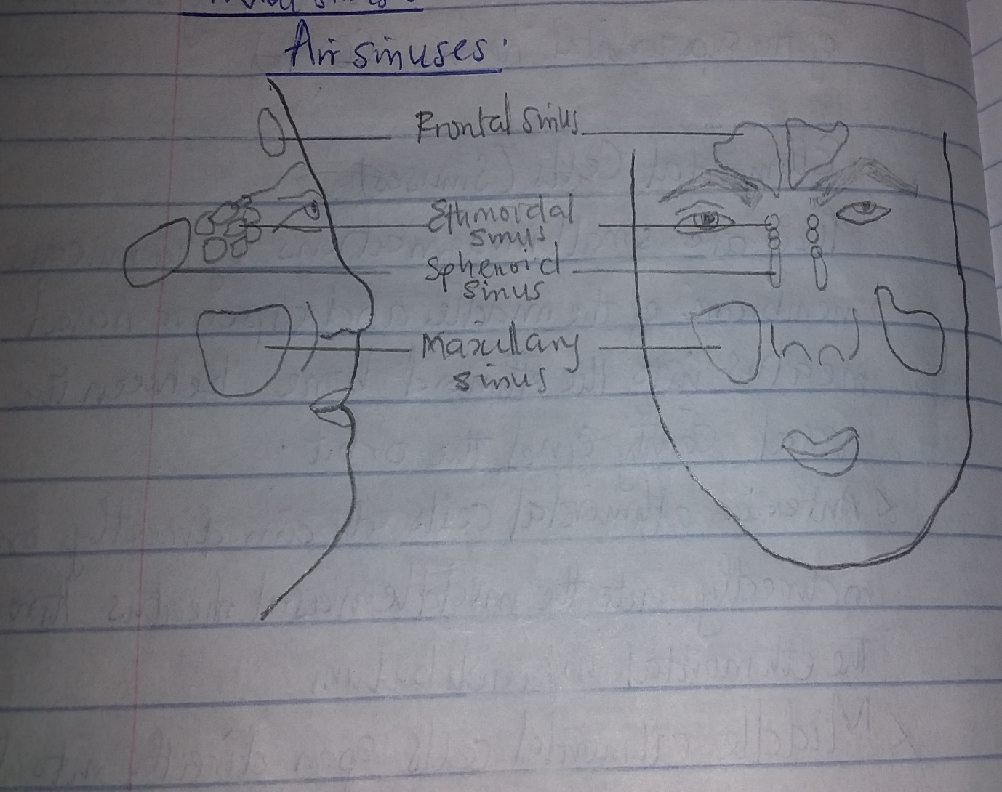
Frontal sinuses
The left and right sinuses are between the outer and inner tables of the frontal bone, posteriorly to the superciliary arches and the root of the nose. The frontal sinuses each drain through a frontonasal duct into the ethmoidal infundibulum which opens into the semilunar hiatus of the middle nasal meatus. They are innervated by branches of the supraorbital nerves (CNV₁)
Ethmoidal cells (sinuses)
They are small invaginations of the mucous membrane of the middle and superior nasal meatus into the ethmoid bone between the nasal cavity and the orbit.
- Anterior ethmoidal cells drain directly or indirectly into the middle nasal meatus through the ethmoidal infundibulum
- Middle ethmoidal cells open directly into the middle meatus
- Posterior ethmoidal cells open directly into the superior meatus.
The ethmoidal cells are supplied by the anterior and posterior ethmoidal branches of the nasociliary nerves (CNV₁)
Sphenoidal sinuses
They are located in the body of the sphenoid, but theymay extend into the wings of this bone. They are unevenly divided and separated by a bony septum. The posterior ethmoidal artery and nerves that accompany the arteries supply the sphenoidal sinuses
Maxillary sinuses
They are the largest of the paranasal sinuses. They occupy the bodies of the maxillae and communicate with the middle nasal meatus
- The apex of the maxillary sinus extends toward and often into the zygomatic bone
- The base of the maxillary sinus forms the inferior part of the lateral wall of the nasal cavity
- The roof of the maxillary sinus is formed by the floor of the orbit
- The floor of the maxillary sinus is formed by the alveolar part of the maxilla.
The roots of the maxillary teeth particularly the first two molars, often produce conical elevations in the floor of the sinus. The arterial supply of the maxillary sinus is mainly from superior alveolar branches of the maxillary artery. Innervation of the maxillary sinus is from the anterior, middle and posterior superior alveolar nerves, which are branches of the maxillary nerves.

