NAME: SUOWARI OYINEBI PASCHELIA
MATRIC NUMBER: 17/MHS01/299
DEPARTMENT: MEDICINE AND SURGERY
HEAD AND NECK ASSIGNMENT
- Write an essay on the cavernous sinus
- Discuss the walls of the nose
ANSWERS
- CAVERNOUS SINUS
The cavernous sinus is a paired dural venous sinus located within the cranial cavity. It is divided by septa into small ‘caves’ from which it gets its name.
Each cavernous sinus has a close anatomical relationship with several key structures in the head, and is the most clinically important venous sinus.
The cavernous sinuses are 1 cm wide cavities that extend a distance of 2 cm from the most posterior aspect of the orbit to the petrous part of the temporal bone. They are bilaterally paired collections of venous plexuses that sit on either side of the sphenoid bone. The cavernous sinus is roofed by an inner layer of dura mater that continues with the diaphragma sellae that covers the superior part of the pituitary gland. The roof of the sinus also has several other attachments. Anteriorly, it attaches to the anterior and middle clinoid processes, posteriorly it attaches to the tentorium (at its attachment to the posterior clinoid process). Part of the periosteum of the greater wing of the sphenoid bone forms the floor of the sinus. The body of the sphenoid acts as the medial wall of the sinus while the lateral wall is formed from the visceral part of the dura mater.
The cavernous sinus is located on either side of the pituitary fossa and body of the sphenoid bone between the endosteal and meningeal layers of the dura. It spans from the apex of the orbit to the apex of the petrous temporal bone. Unlike other dural venous sinuses, it is divided by numerous fibrous septa into a series of small caves, which is where its name is derived from. The normal lateral wall should be either straight or concave. The cavernous sinuses are one of several drainage pathways for the brain that sits in the middle. In addition to receiving venous drainage from the brain, it also receives tributaries from parts of the face. The left and right cavernous sinuses communicate by through the anterior and posterior intercavernous sinuses. The cavernous sinus drains to the superior and inferior petrosal sinuses, which then join the sigmoid sinus.
The cavernous sinuses are located within the middle cranial fossa, on either side of the Sella turcica of the sphenoid bone (which contains the pituitary gland). They are enclosed by the endosteal and meningeal layers of the dura mater.

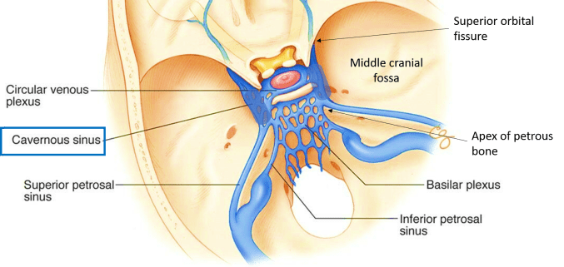

BORDERS OF THE CAVERNOUS SINUS
The borders of the cavernous sinus are as follows:
- Anterior – superior orbital fissure.
- Posterior – petrous part of the temporal bone.
- Medial – body of the sphenoid bone.
- Lateral – meningeal layer of the dura mater running from the roof to the floor of the middle cranial fossa.
- Roof – meningeal layer of the dura mater that attaches to the anterior and middle clinoid processes of the sphenoid bone.
- Floor – endosteal layer of dura mater that overlies the base of the greater wing of the sphenoid bone.
CONTENTS OF THE CAVERNOUS SINUS
The cavernous sinus contains the internal carotid artery and several cranial nerves. Abducens nerve (CN VI) traverses the sinus lateral to the internal carotid artery. The remainder of the cranial nerves pass through the lateral wall of the carotid sinus, and from superior to inferior they are:
- Oculomotor nerve (CN III)
- Trochlear nerve (CN IV)
- Trigeminal nerve (CN V) - ophthalmic and maxillary divisions.

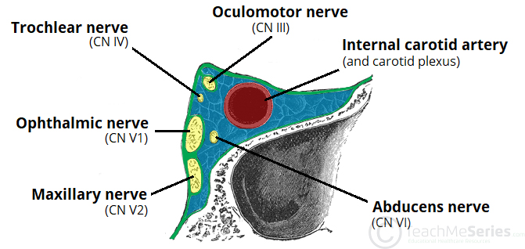
CLINICAL SIGNIFICANCE
- Carotid-cavernous fistula: Head trauma resulting in rupture of the cavernous part of the internal carotid artery can produce what is known as a carotid-cavernous fistula. A pulsating exophthalmos can result as the venous pressure in the sinus would increase and reverse the flow of blood in the ophthalmic veins.
- Cavernous sinus thrombosis: The sinus also has communicating branches from the sin of the face. Particularly in the ‘danger area’ (at the nasolabial crease and at the crease between the ala of the nose and the cheek), an infection can spread to the cavernous sinus, which can result in a cavernous sinus thrombosis. This condition can result in internal strabismus (crossed eyes) if the CN VI is damaged, doubled vision while looking downward if CN IV was damaged, or ophthalmoplegia (paralysis or weakness in muscles of movement of the eye).

- WALLS OF THE NOSE
The nose has two walls:
- MEDIAL WALL
It is formed by the nasal septum. The nasal septum is a structure consisting of both bony and cartilaginous components. The bony components are the:
- Perpendicular plate of the Ethmoid bone: The medial wall of the nasal cavity is formed by both bony elements and cartilage. Posteriorly the perpendicular plate of the ethmoid bone forms the superoposterior part of the bony nasal septum and articulates superiorly with the cribriform plate. The posterior border articulates superiorly with the sphenoidal crest and with the vomer by its inferior border.
- The Vomer: The vomer is an unpaired bone of the skull forms the inferior part of the septum. It is located in the mid sagittal plane and articulates with the ethmoid, both palatine bones and both maxillary bones.
- Crests of the Maxillary bone: Further posteriorly than the ethmoid bone, the crest of both the maxilla and palatine bone complete the posterior septum. The anterior septum is formed entirely of the quadrangular cartilage which divides the cavity in the midline. The nasal septum can be deviated in some and is a sign of nasal trauma or abnormal growth.
- Crest of the Palatine bone: The horizontal plate of the palatine bone is a rectangular shaped bone that projects medially and forms a right angle with the perpendicular plate of the ethmoid. The nasal surface of the bone forms part of the inferior meatus of the nose, while the serrated anterior maxillary surface articulates with the maxilla. Laterally the bone articulates with the perpendicular plate, and superior portion of the plate forms the posterior part of the nasal cavity. The inferior surface of the plate is rough and provides attachment to the oral mucosa of the hard palate.
The septal cartilage divides the nasal cavity into two halves. The anteroinferior part of the cartilage has an expansion known as the ‘footplate’ which lies in free contact with the membranous septum. The cartilage is expanded in other regions, namely the junction with the lateral nasal cartilage termed the posterior process. The cartilage is firmly adhered to the nasal bone by taut collagen fibres.
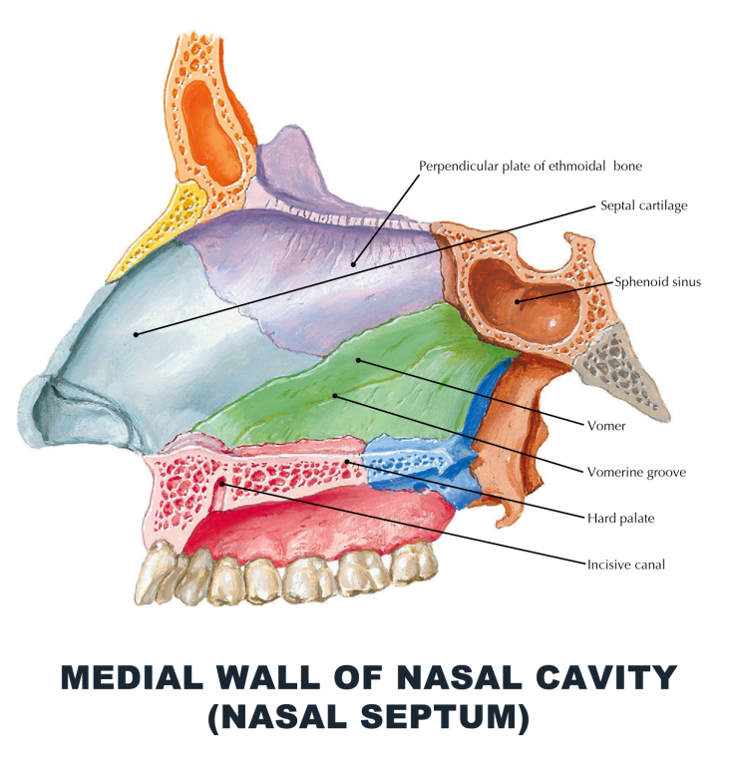

- LATERAL WALL
The Lateral wall is subdivided into three parts, they are:
- A small depressed area in the anterior part called the vestibule
- The middle part known as the atrium of the meatus
- The posterior part which contains the conchae
The Lateral wall of the nose is irregular owing to the presence of three shelf-like bony projections called conchae. There are three conchae – inferior, middle and superior.
- Inferior nasal concha: It is the longest and broadest of the conchae and is formed by an independent bone (of the same name, inferior concha). The concha is covered by a mucous membrane that contains large vascular spaces and is one of the three that work to both humidify and clear the air that passes into the nasopharynx.
- Middle nasal conchae arise from the perpendicular plate of the ethmoid bone: The middle nasal concha is found in between the superior and inferior nasal concha and plays a role in humidifying and clearing inspired air of micro-particles such as dirt.
- The superior nasal conchae: It is a bony shelf located above the middle nasal concha and below the sphenoethmoidal recess. Similar to the middle nasal concha the superior concha is itself part of the ethmoid bone.
They project into the nasal cavity, creating four pathways for the air to flow. These pathways are called meatuses:
- Inferior meatus – between the inferior concha and floor of the nasal cavity.
- Middle meatus – between the inferior and middle conchae
- Superior meatus – between the middle and superior conchae
- Spheno-ethmoidal recess – superiorly and posteriorly to the superior conchae
The function of the conchae is to increase the surface area of the nasal cavity – this increases the amount of inspired air that can come into contact with the cavity walls. They also disrupt the fast, laminar flow of the air, making it slow and turbulent. The air spends longer in the nasal cavity, so that it can be humidified.
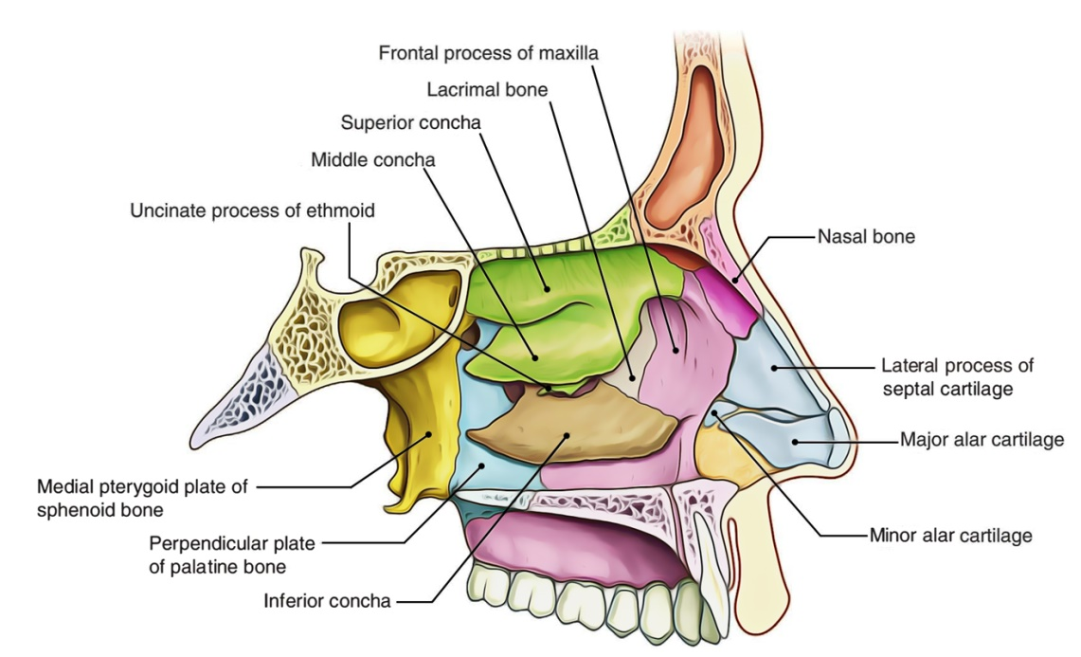
CLINICAL SIGNIFICANCE
Sinusitis: It is an inflammation of the different sinuses found in the head. That type of inflammation may result in different symptoms including: plugged nose, nasal mucus and pain in the facial region.
The frontal bone contains the frontal sinus, which in sinusitis and nasal infections can become filled with fluid.

