NAME: OYEDELE TEMILOLA EMMANUELLA
MATRIC NUMBER: 18/MHS01/324
DEPARTMENT: MEDICINE AND SURGERY
COURSE: EMBRYOLOGY
LECTURER: DOCTOR OGEDENGBE OLUWATOSIN OLALEKAN.

QUESTION
1) Discuss ovulation
2) Differentiate between meosis1 and meosis2
3) Discuss the stages involved in fertilization
4) differentiate between monozygotic twins and dizygotic twins

ANSWER
- Ovulation is the release of eggs from the ovaries. In women, this event occurs when the ovarian follicles rupture and release the secondary oocyte ovarian cells. In other words, it is the release of a secondary oocyte from the ovarian follicle. Around the middle of the ovarian cycle, the ovarian follicle under the influence of FSH and LH, undergoes sudden growth spurt, producing a cystic swelling or bulge on the surface of the ovary. A small avascular spot, the stigma, soon appears on the swelling. Before ovulation, the secondary oocyte and some cells of the cumulus oophorus detach from the interior of the distended follicle. Ovulation is triggered by a surge of LH peak by 12 to 24 hours. The LH surge, elicited by the high oestrogen level in the blood, appears to cause the stigma to balloon out, forming a vesicle. The stigma soon ruptures, expelling the secondary oocyte with the follicular fluid. Expulsion of the oocytes is the result of intrafollicular pressure, and possibly by contraction of smooth muscle in the theca externa (sheath) owing to stimulation by prostaglandins. Mitogen-activated protein kinases 3 and 1 (MAPK 3/1), also known as extra cellular signal-regulated kinesis 1 and 2 (ERK1/2) , in ovarian follicular cells seem to regulate signalling pathways that control ovulation. Plasmins are matrix metalloproteins appear also to play a role in controlling rupture of the follicle the expelled secondary oocyte is surrounded by the zona pellucida and one or more layers of follicular which are radially arranged as the corona radiata forming the oocyte-cumulus complex. The LH surge also seems to induce resumption of the first meiotic division of the primary oocyte. Hence, mature ovarian follicle contain secondary oocytes. The zona pellucida is composed of 3 glycoproteins (ZPA, ZPB and ZPC) which usually form a network of filaments with multiple pores. Binding of the sperm to the zona pellucida (sperm-oocyte interaction) is a complex and critical event during fertilization.
Mittelschmerz and ovulation
A variable amount of abdominal pain, mittelschmerz, accompanies ovulation in some women. In these cases, ovulation results in slight bleeding in the peritoneal cavity, which results in sudden constant pain in the lower abdomen. Mittelschmerz may be used as a secondary indicator of ovulation, but there are better primary indicators, such as elevation of basal body temperature.
Anovulation
Some women do not ovulate (cessation of ovulation, or anovulation) because of an inadequate release of gonadotropins. In some of these women, ovulation can be induced by the administration of gonadotropins or an ovulatory agent such as clomiphene citrate. This drug stimulates the release of pituitary gonadotropins (FSH and LH), resulting in maturation of several ovarian follicles and multiple ovulations. The incidence of a multiple pregnancy increase significantly when ovulation is induced. Rarely do more than seven embryos survive. 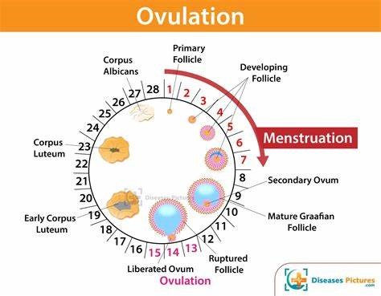

MEIOSIS 1 | MEIOSIS 2
Meiosis 1 is a heterotypic division, reducing the chromosome number in the daughter cell by half, compared to the parent cell. | Meiosis 2 is a homotypic division, equalizing the chromosome number of both parent and daughter cells.
Two daughter cells are produced from a single parent cell at the end of meiosis 1 | The two daughter cells produced at meiosis 1 are separately divided to produce four cells.
Chromosomal cross-over occurs during prophase 1, by exchanging the genetic material between non-sister chromatids. | No chromosomal cross-over occurs during prophase 2.
Meiosis 1 is a more complex division. Thus, it takes more time. | Meiosis 2 is comparatively simple and less time is taken for the division.
Interphase is followed by meiosis 1. | No Interphase takes place prior to themeiosis 2. A resting phase, interkinesis can occur.
Homologous chromosomes are present at the beginning of meiosis 1. | Individual, bivalent chromosomes are present at the beginning of meiosis 2.
Cohesin protein complexes at the arms of the homologous chromosomes are cleaved. | Cohesins at the centromeres are cleaved in order to separate the two sister chromatids.

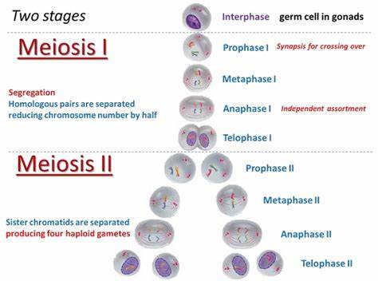
- Fertilization, union of a sperm nucleus, of paternal origin, with an egg nucleus, of maternal origin, to form the primary nucleus of an embryo. In all organisms the essence of fertilization is, in fact, the fusion of the hereditary material of two different sex cells, or gametes, each of which carries half the number of chromosomes typical of the species. It is the union of the sperm and oocyte. The usual site of fertilization is the ampulla of the uterine tube. If the oocyte is not fertilized here, it slowly passes along the tube to the body of the uterus, where it degenerates and is resorbed. The fertilization process takes approximately 24 hours. The stages involved include:
- Passage of sperm through the corona radiata
- Penetration of the zona pellucida
- Fusion of the plasma membrane of the oocyte and the sperm
- Completion of the second meiotic division of oocyte and formation of female pronucleus
- Formation of the male pronucleus
- The 2 pronuclei fuse into a single diploid aggregation of chromosomes, the ootid becomes a zygote.
- Passage of a sperm through the corona radiata:
For sperms to pass through the corona radiata, they must have been capacitated (removal of the glycoprotein coat and seminal plasma proteins from the plasma membrane that overlies the acrosomal region of the spermatozoa). Movement of the tail of the sperm are also important in the penetration of the corona radiata.
- Penetration of the zona pellucida:
Passage of a sperm through the zona pellucida is the important phase in the initiation of fertilization. The zona is a glycoprotein shell surrounding the egg that facilitates and maintains sperm binding and induces the acrosome reaction. The intact acrosome of the sperm binds with a zona glycoprotein (ZP3/ zona protein 3) on the zona pellucida. Release of acrosomal enzymes (acrosin) allows sperm to penetrate the zona pellucida, thereby coming in contact with the plasma membrane of the oocyte. As soon as the head of a sperm comes in contact with the oocyte surface, the permeability of the zona pellucida changes. When a sperm comes in contact with the oocyte surface, lysosomal enzymes are released from cortical granules lining the plasma membrane of the oocyte. Only one sperm seems to be able to penetrate the oocyte
- Fusion of plasma membranes of the oocyte and sperm
The plasma or cell membranes of the oocyte and sperm fuse and break down at the area of fusion. The head and tail of the sperm enter the cytoplasm of the oocyte, but the sperm's plasma membrane remains behind.
- Completion of the second meiotic division of oocyte and formation of female pronucleus
Penetration of the oocyte by a sperm activates the oocyte into completing the second meiotic division and forming a mature oocyte and a second polar body. Following decondensation of the maternal chromosomes, the nucleus of the mature ovum/oocyte is now called the female pronucleus.
- Formation of the male pronucleus
Within the cytoplasm of the oocyte, the nucleus of the sperm enlarges to form the male pronucleus and the tail of the sperm degenerates. Since all sperm mitochondria degenerate, all mitochondria within the zygote are of maternal origin (i.e., all mitochondrial DNA is of maternal origin). Morphologically, the male and female pronuclei are indistinguishable. The oocyte now contains 2 pronuclei, each having haploid number of chromosomes (23). The oocyte containing two haploid pronuclei is called an ootid.
- The 2 pronuclei fuse into a single diploid aggregation of chromosomes, the ootid becomes a zygote
The chromosomes in the zygote become arranged on a cleavage spindle in preparation for cleavage of the zygote.
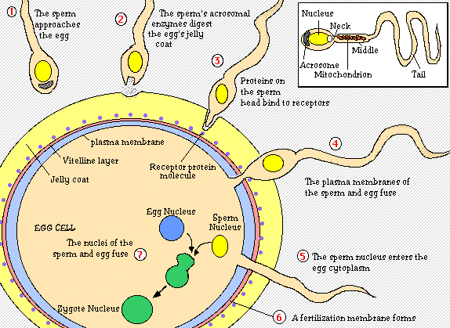

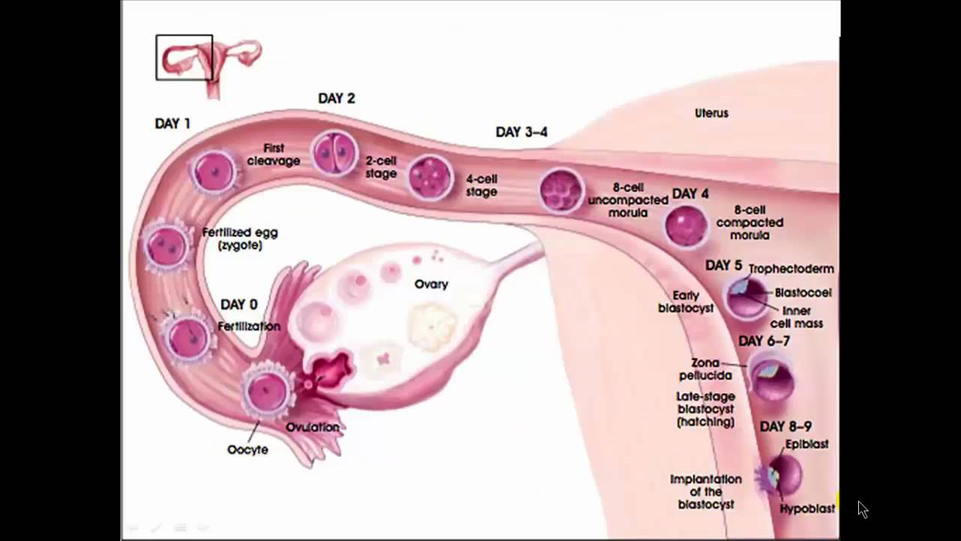

MONOZYGOTIC TWINS | DIZYGOTIC TWINS
Monozygotic twins result from the fertilization of one egg and one sperm | Dizygotic twins result from the fertilization of two different eggs with two different sperms.
They are called identical twins | They are called fraternal twins
The cause is unknown | The cause either by IVF, certain fertility drugs or hereditary predisposition
Appearance is extremely similar but may be affected by environmental factors | Appearance is similar like that of any other siblings
Gender is the same | Gender may be different
Blood types are the same | Blood types are the same
They can be dichorionic/diamniotic or monochorionic/diamniotic or monochorionic/monoamniotic | They are only diamniotic/dichorionic
Bear a high risk for Twin to Twin Transfusion Syndrome (TTTS) | Bear a low risk for Twin to Twin Transfusion Syndrome (TTTS)
They are genetically identical | They are genetically non identical
One-third of the twins in the world are monozygotic | Two-third of the twins in the world are dizygotic

