ISIAVWE MALCOLM EBRUPHIYOR
15/ENG04/032
DIGITAL COMMUNICATIONS ASSIGNMENT

3G ARCHITECTURE
UMTS (Universal Mobile Telecommunications System) 1. UMTS, short for Universal Mobile Telecommunications System, is a 3G networking standard used throughout much of the world as an upgrade to existing GSM module.
- UMTS makes use of WCDMA, a technology that shares much with CDMA networks used throughout the world, though it is not compatible with them.
- Base level UMTS networks are generally capable of downlink speeds as 384 kbps.
- The UMTS architecture takes advantage of the existing GSM and GPRS networks which serve as a core network in UMTS infrastructure.
The UMTS is made up of 3 main components: a) User Equipment:
It is assigned to a single user and contains all the functions needed to access UMTS services. It contains: – Mobile Equipment (ME) : It is a radio terminal which is used to connect the UMTS subscriber with the fixed part of UMTS system via the radio interface Uu.
– UMTS Subscriber Identity Module (USIM): A smartcard which contains the subscriber identity, authentication algorithms, encryption keys etc.
b) UMTS Terrestrial Radio Access Network (UTRAN):
It handles cell-level mobility. It is a system of base station and controller handling function related to mobility. It contains:
1. Nodes B (Base Stations):
• It converts the data between Uu radio interface and the Iub interface connecting a Node B with the RNC. • It performs physical level processing such as channel coding, data interleaving, rate matching, modulation etc.
2. Radio Network Controllers (RNC):
• RNC’s controls and manages radio resources to Node B. • RNC performs the data-link layer processing and participates in handover operations. • RNC is considered a single access point of UTRAN for the core network. • It’s connected to a single MSC/VLR to route circuit-switched traffic and to a single SGSN to route packet switched traffic.
c) Core Network (CN):
The core network is shared with GSM and GPRS. The CN contains functions for intersystem handover, gateways to other networks and performs location management. It contains:
- Home Location Register (HLR)
- Mobile Station Controller / Visitor Location Register (MSC/VLR).
- Gateway MSC: Connect UMTS to external circuit switch n/w (e.g PSTN)
- Serving GPRS Support Node (SGSN): It serves the Packet-switched traffic.
- Gateway GPRS Support Node (GGSN): Connects UMTS to external packet switched. (e.g. Internet)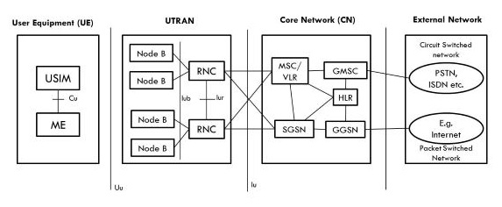
Key features and facilities of 3G :
- Faster data rates.
- Support multimedia applications such as video and photography.
- Value added services like mobile television, GPS, video call and video conference.
- High speed mobile internet access.
- Increased capacity.
Disadvantages :
- Requires 3G compatible handsets.
- The cost of upgrading to 3G device is expensive.
- Power consumption is high.
- 3G requires closer base stations which is expensive.

4G ARCHITECTURE
- 4G stands for fourth generation cellular system.
- 4G is evaluation of 3G to meet the forecasted rising demand.
- It is an integration of various technologies including GSM,CDMA,GPRS,IMT-2000 ,Wireless LAN.
- Data rate in 4G system will range from 20 to 100 Mbps.
Features:
- Fully IP based Mobile System.
- It supports interactive multimedia, voice, streaming video, internet and other broadband service.
- It has better spectrum efficiency.
- It supports Ad-hoc and multi hop network.
4 G Architecture
- Figure shows Generic Mobile Communication architecture.
- 4 G network is an integration of all heterogeneous wireless access networks such as Ad-hoc, cellular, hotspot and satellite radio component.
- Technologies used in 4 G are smart antennas for multiple input and multiple output (MIMO), IPv6, VoIP, OFDM and Software defined radio (SDR) System.
Smart Antennas:
- Smart Antennas are Transmitting and receiving antennas.
- It does not require increase power and additional frequency.
IPV6 Technology:
- 4G uses IPV6 Technology in order to support a large number of wireless enable devices.
- It enables a number of application with better multicast, security and route optimization capabilities.
VoIP:
- It stands for Voice over IP.
- It allows only packet to be transferred eliminating complexity of 2 protocols over the same circuit.
OFDM:
- OFDM stands for Orthogonal Frequency Division Multiplexing.
- It is currently used as WiMax and WiFi.
SDR:
- SDR stands for Software Defined Radio.
- It is the form of open wireless architecture.
Advantages:
- It provides better spectral efficiency.
- It has high speed, high capacity and low cost per bit.
Disadvantage:
- Battery usage is more.
- Hard to implement.
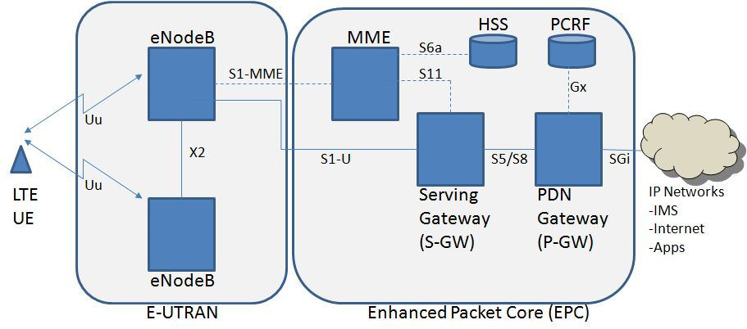
MME- Mobility Management Entity
It is used for Paging ,Authentication, Handover and Selection of Serving Gateway
SGW- Serving gateway
It is used to Routing and Forwarding user data packet.
PDN-GW Packet Data Network Gateway
It is used for user equipment (UE) IP allocation
HSS -Home Subscriber Server
It is a user Database used for service subscriber, user identification and addressing
PCRF -Policy and Charging Rule Function
It provide quality of service and charging
eNode B-evolved Node B
It is used as radio resources management and radio bearer control

5G ARCHITECTURE
Architecture of 5G is highly advanced, its network elements and various terminals are characteristically upgraded to afford a new situation. Likewise, service providers can implement the advance technology to adopt the value-added services easily.
However, upgradeability is based upon cognitive radio technology that includes various significant features such as ability of devices to identify their geographical location as well as weather, temperature, etc. Cognitive radio technology acts as a transceiver (beam) that perceptively can catch and respond radio signals in its operating environment. Further, it promptly distinguishes the changes in its environment and hence respond accordingly to provide uninterrupted quality service.
Architecture of 5G
As shown in the following image, the system model of 5G is entirely IP based model designed for the wireless and mobile networks.
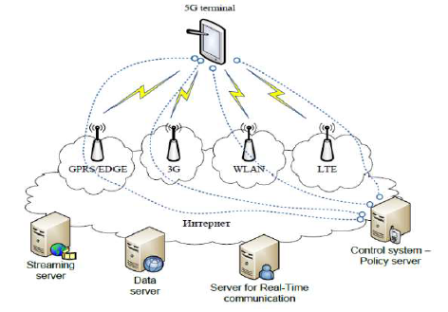
The system comprising of a main user terminal and then a number of independent and autonomous radio access technologies. Each of the radio technologies is considered as the IP link for the outside internet world. The IP technology is designed exclusively to ensure sufficient control data for appropriate routing of IP packets related to a certain application connections i.e. sessions between client applications and servers somewhere on the Internet. Moreover, to make accessible routing of packets should be fixed in accordance with the given policies of the user (as shown in the image given below).
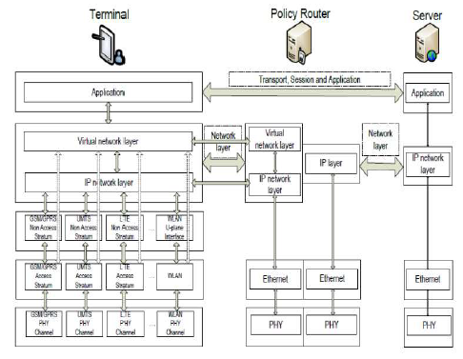
The Master Core Technolog

Advantages of 4G:
- Quickly download files over a wireless network
- Extremely high voice quality
- Easily access Internet, IM, social networks, streaming media, video calling
- Higher bandwidth
- 4G is 10 times faster than 3G
Disadvantages of 4G:
- New frequencies means new components in cell towers.
- Higher data prices for consumers
- Consumer is forced to buy a new device to support the 4G
- It is impossible to make your current equipment compatible with the 4G network
ADVANTAGES OG 5G
- High resolution and bi-directional large bandwidth shaping.
- Technology to gather all networks on one platform.
- More effective and efficient.
- Technology to facilitate subscriber supervision tools for the quick action.

DISADVANTAGES OF 5G
- 5G is more costly compared to other Mobile Network Technology because many technical/ official engineers are required to install and maintain it.
- The risk of overcrowding the frequency range of the 5G wireless spectrum is greater as more devices are connected to one channel.
- 5G network Technology will take more time for security and privacy issues.
- Coverage indoor distance up to 2 meters and 300 meters outdoors can be achieved due to greater losses at higher frequencies as 5Gmm wave influences from such losses (rain losses, attenuation due to rain, etc.).
- THE HIGH COST OF 5G INFRASTRUCTURE

Question 2
In tabular form, establish adequate differences between 2G, 3G, 4G and 5G
Differences btw 1g 2g 3g 4g 5g

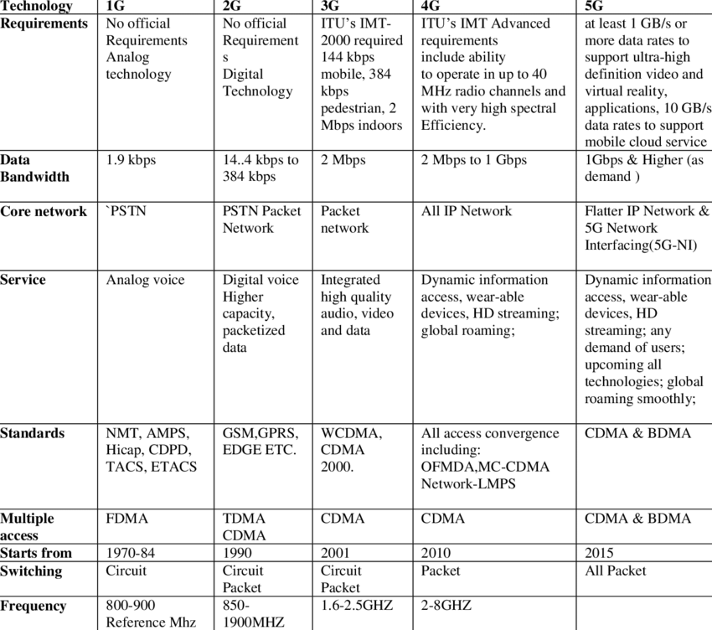

QUESTION 3
Recently in Nigerian there has been a widespread of opinion that the advent of 5G
evolution will aid the spread of the corona virus which has become a pandemic all over the
world.
(i) Is there any correlation between 5G and Corona virus
(ii) Do you support the state, if yes or No, in not more than 500 words Justify your answer to
(i) and (ii)

  - No
  - No
JUSTIFICATION FOR (i) and (ii)

“Nothing has been scientifically demonstrated that links electromagnetic radiation and virus proliferation,”
5G, or fifth-generation wireless technology, is a new global wireless standard being deployed around the world now. While previous mobile network generations relied on lower frequency wavelengths being transmitted across wider areas, the standard 5G spectrum is about a factor of 10 — an order of magnitude — higher than the previous four generations of cell networks. That increased information flow, coupled with more accurate antenna connectivity and decreased latency, makes a range of new real-time operations possible over the network.
"The frequencies of 5G waves are so much lower in power and still four orders of magnitude, or 10,000 times less, than ionizing waves, which are known to possibly be carcinogenic in large doses," Ted Rappaport, an electrical engineer, and professor at New York University’s Tandon School of Engineering and School of Medicine said in an interview with USTODAY News

