NAME: OYEBOADE Rukayah Kiitan
MATRIC NO: 17/ENG08/004
DEPARTMENT: Biomedical Engineering
COURSE CODE: BME316
COURSE TITLE: Computer Application to BME

ASSIGNMENT

Exercise 2.1

Code

%CRT qualification test
commandwindow
clc
syms nyha sixmd ef
nyha=[3 4 2 3]
sixmd = [250 170 210 200]
ef= [30 25 40 33]
patient=[1 2 3 4]
table = [patient' nyha' sixmd' ef']
a=CRTqualification(3, 250, 30);
b = CRTqualification(4, 170, 25);
c= CRTqualification(2, 210, 40);
d = CRTqualification(3, 200, 33);
function [a]=CRTqualification(nyha, sixmwd, ef)
if (nyha >=3 & nyha <= 4) & (sixmwd<225) & (ef < 35)
a = "yes"
else
a = "no"
end
end

Result

nyha =
3 4 2 3

sixmd =
250 170 210 200

ef =
30 25 40 33
patient =
1 2 3 4

table =
1 3 250 30
2 4 170 25
3 2 210 40
4 3 200 33

a =
"no"

a =
"yes"

a =
"no"

a =
"yes"

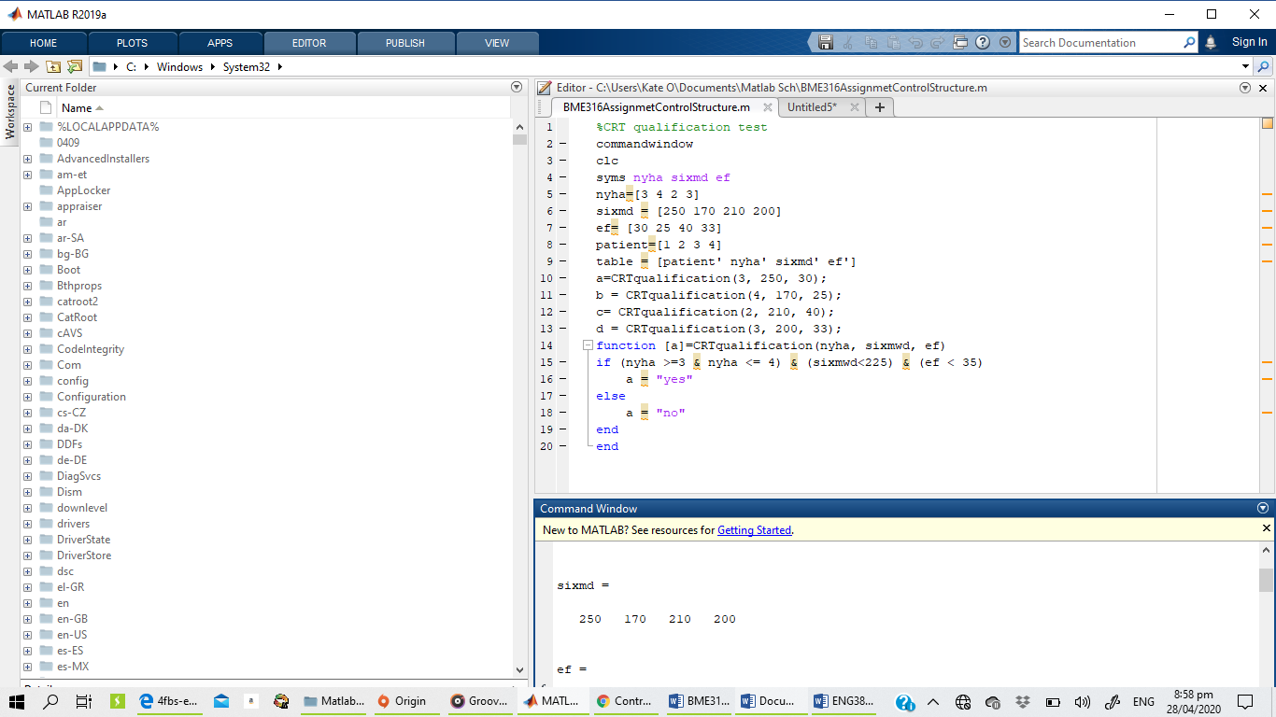

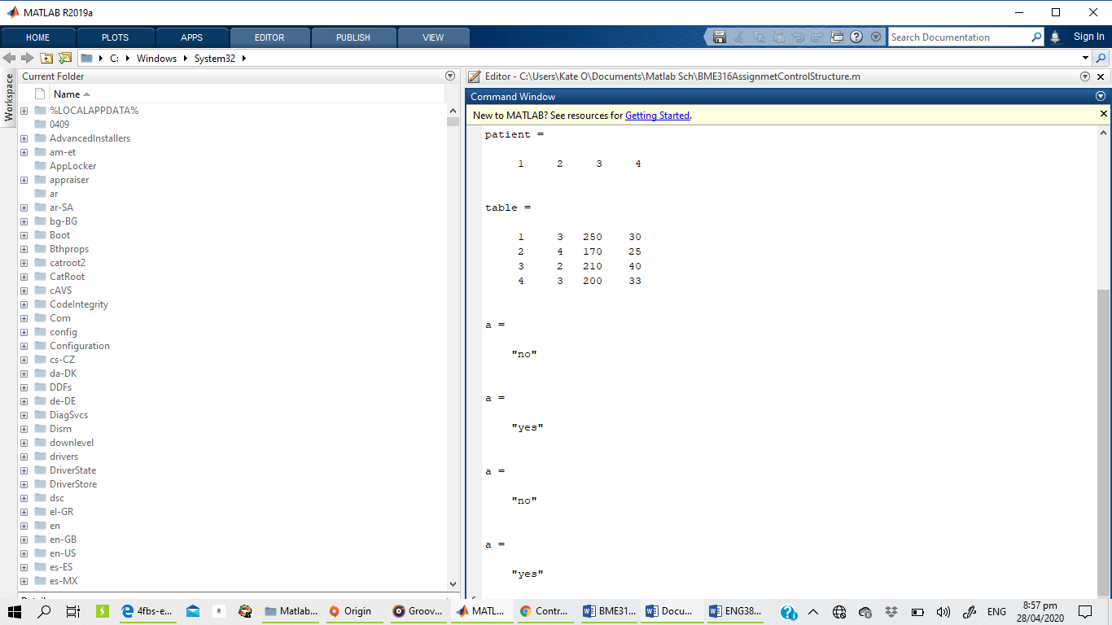
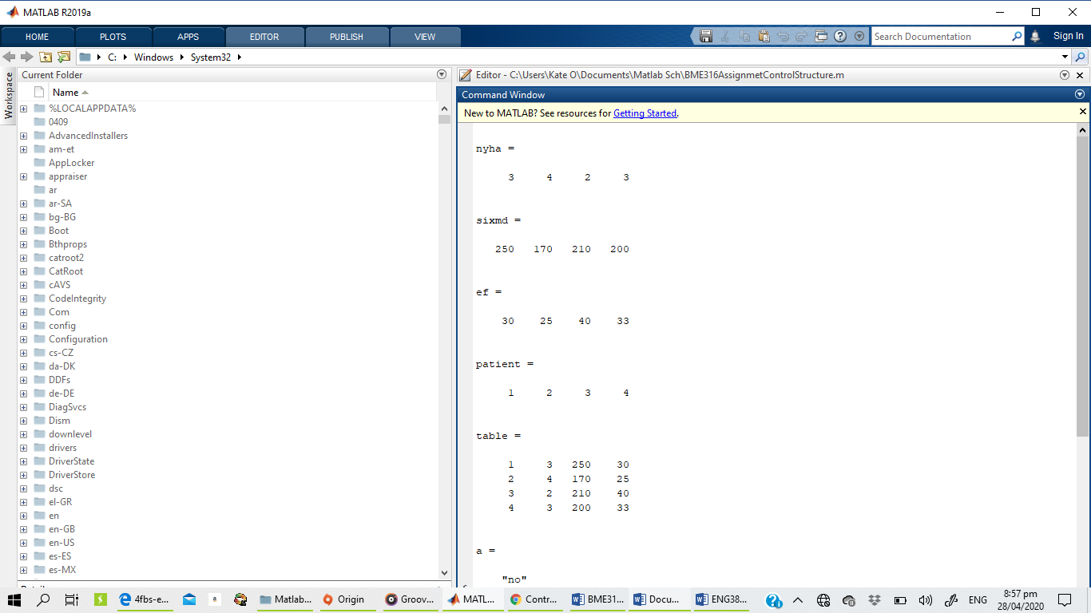

EXERCISE 2.2

Codes

%CRT qualification test
commandwindow
clc
syms nyha_pre sixmwd_pre ef_pre nyha_post sixmwd_post ef_post
nyha_post=[3 2]
sixmwd_post = [220 230]
ef_post= [30 45]
patient=[2 4]
table = [patient' nyha_post' sixmwd_post' ef_post']
a = CRTqualification(4, 170, 25, 3, 220, 30);
b = CRTqualification(3, 200, 33, 2, 230, 45);
function [a]=CRTqualification(nyha_pre, sixmwd_pre, ef_pre, nyha_post, sixmwd_post, ef_post)
if (nyha_pre >=3 & nyha_pre <= 4)& (sixmwd_pre<225) & (ef_pre<35)
a ="Yes"
else
a = "no"
end
if (nyha_post >=2 & nyha_post <= 3) & (sixmwd_post<247.5) & (ef_post < 38.5)
a = "yes"
else
a="no"
end
end

Result

nyha_post =
3 2

sixmwd_post =
220 230

ef_post =
30 45

patient =
2 4

table =
2 3 220 30
4 2 230 45

a =
"Yes" (pre)
a =
"yes" (post)
a =
"Yes" (pre)
a =
"no" (post)
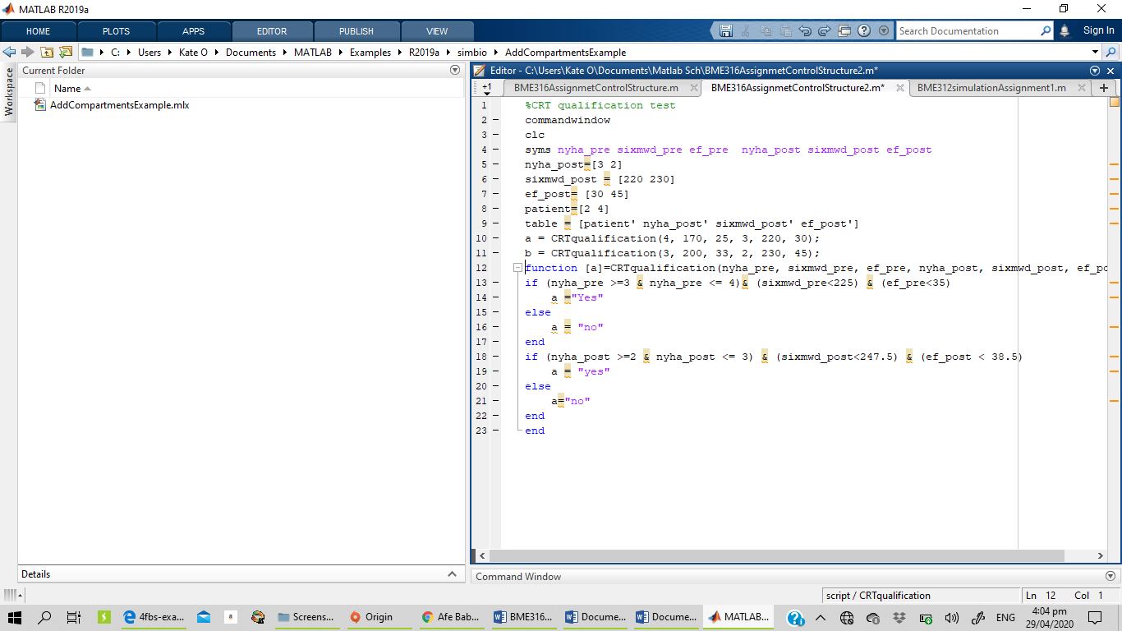
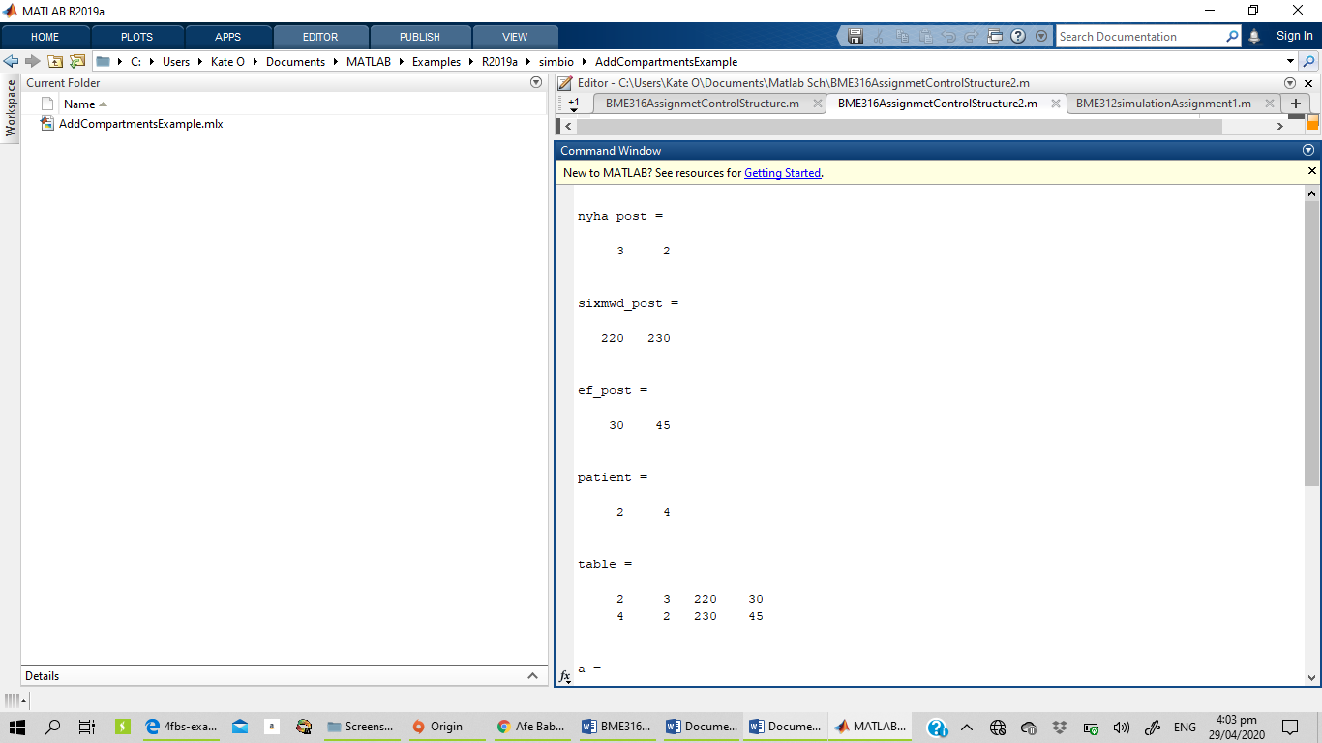
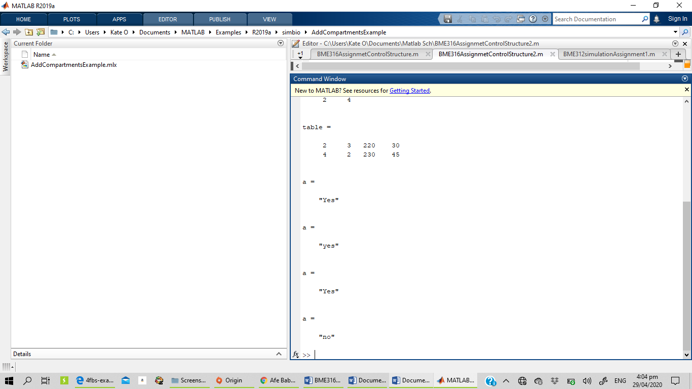

Exercise 2.3
Codes
commandwindow
clear clc
c = 2
a = 5
b = 3
a + b * c
a^ b + c
2 * a ==2 && c - 1 == b
b + 1 : 6

Result

c =
2

a =
5

b =
3

ans =
11

ans =
127

ans =
logical
0

ans =
4 5 6

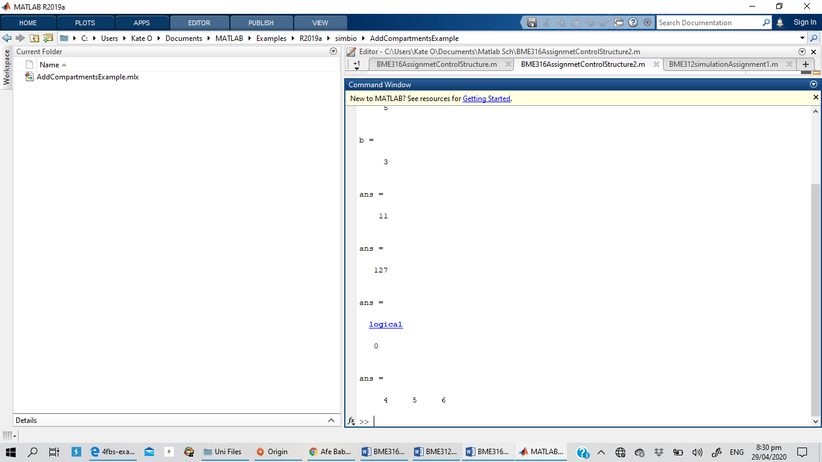
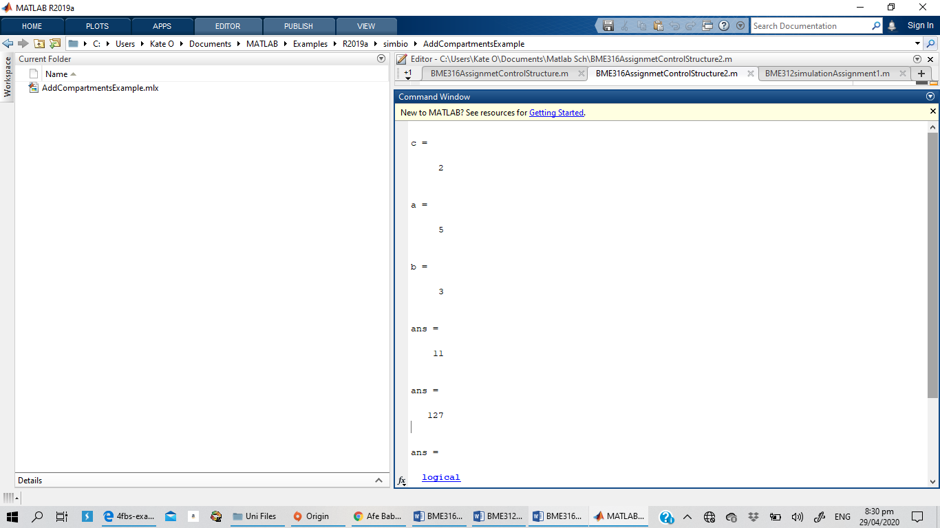
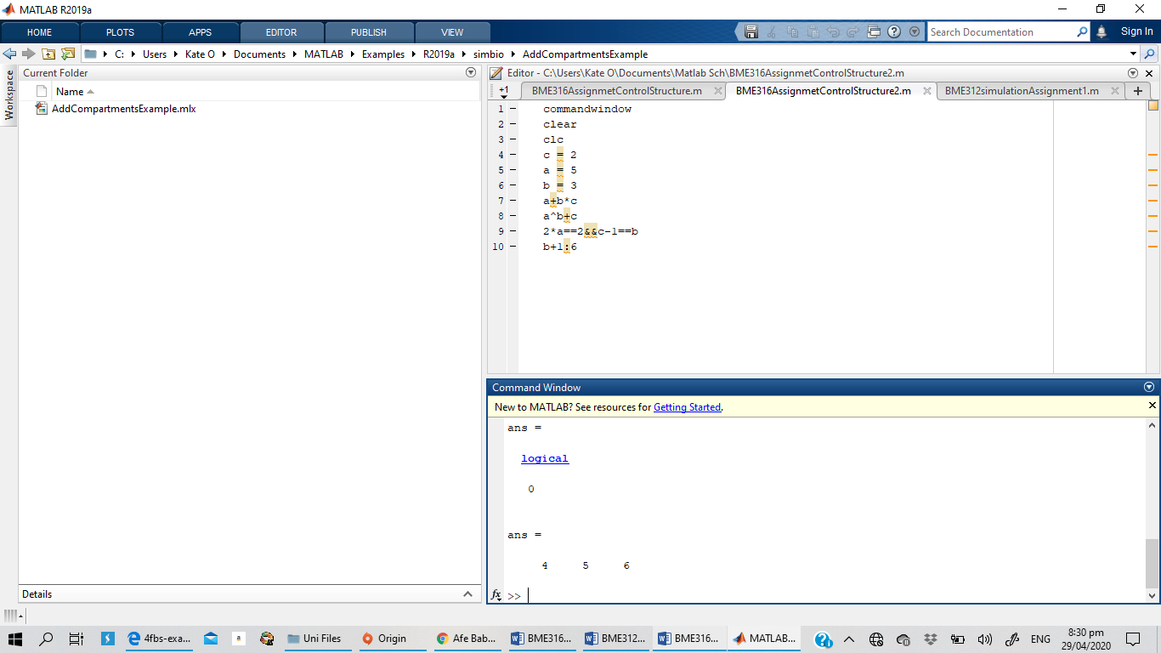
Exercise 2.7
Codes
commandwindow
clear
clc
syms x
x= 0:0.0001:2*pi
sol= sin(x)+(1/2)*cos(x)
sol'

