ANATOMY OF THE TONGUE
The tongue is the muscular organ found in the vertebrate mouth. It is attached via muscles to the hyoid bone, mandible, styloid process, palate, and pharynx and divided into two parts by the V-shaped sulcus terminalis. These two parts, an anterior two thirds and a posterior one third, are structurally and developmentally distinct. The foramen cecum at the apex of the sulcus terminalis indicates the site of embryonic origin of the thyroglossal duct.
The following papillae cover the tongue and are used for taste perception:
- Vallate papillae are arranged in a V-shape anterior to the sulcus terminalis and studded with numerous taste buds. Innervation is by the glossopharyngeal nerve (CN IX).
- Fungiform papillae are mushroom-shaped papillae with erythematous domes, located on the lateral aspects and at the apex of the tongue.
- Filiform papillae are slim, cone-shaped projections organized in rows parallel to the sulcus terminalis.
- Foliate papillae are rarely found in humans (vestigial).
Another important part of the tongue is the lingual tonsil, a collection of nodular lymphatic tissue towards the posterior one-third of the dorsum of the tongue. 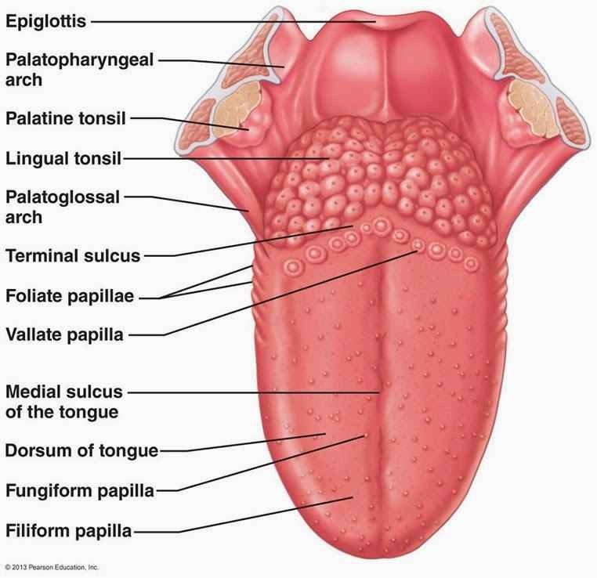

Structure and Function
The functions of the tongue include taste, speech, and food manipulation in the oral cavity.
Taste Functions
Chemicals that interact with the taste buds in the tongue are referred to as "tastants." Taste buds themselves are found within the various papillae of the tongue. Tastants interact with gustatory cell receptors in the taste buds, resulting in transduction of a taste sensation. The five broad categories of taste receptors are (1) sweet, (2) salty, (3) sour, (4) bitter, and (5) umami. The lingual papillae are divided into the vallate (or circumvallate), fungiform, filiform, and foliate papillae. More than half of the taste buds are located on the vallate papillae at the junction of the oral and oropharyngeal tongue or tongue base.
Speech Functions
Speech is produced in part by manipulation of the tongue in the mouth against the teeth and palate within the oral cavity. The intrinsic muscles of the tongue are involved primarily in shaping the tongue for speech.
Food Manipulation Functions
The tongue moves food around the mouth within the oral cavity by pressing it against the hard palate and out to the sides to enable mastication. It enables the formation of the food bolus in the oral preparatory phase of swallowing. It also takes part in the oral phase of swallowing by elevating and sweeping posteriorly to propel the food bolus past the anterior tonsillar pillar, triggering the swallowing reflex.

Embryology
Tongue development begins in the embryo at approximately four weeks' gestation. Initially, two lateral lingual swellings and one medial swelling, called the tuberculum impar, form from the first pharyngeal arch. A second median swelling, known as the copula or hypobranchial eminence, develops from the mesoderm of the second, third, and fourth pharyngeal arches. A final third median swelling forms from the posterior portion of the fourth arch and develops into the epiglottis. Directly posterior to this swelling is the laryngeal orifice, which is accompanied on either side by the arytenoid swellings.
The lateral lingual swellings increase in size, eventually merging and overlapping the tuberculum impar. The merger of these two swellings forms the anterior two-thirds of the tongue. The mucosa overlying this part of the tongue originates from the first arch; thus, the sensory innervation to this area is from the mandibular branch of the trigeminal nerve (CN V3). Meanwhile, the second, third, and fourth portions of the pharyngeal arch, which make up the copula, develop into the posterior one-third of the tongue. The mucosa overlying this part of the tongue has sensory innervation from the glossopharyngeal nerve (CN XI), which is a sign that the third arch overlaps that of the second. The third arch derivatives typically are associated with glossopharyngeal sensory innervation.
The epiglottis and epiglottic region of the tongue develop from the third median swelling, which arises from the posterior fourth pharyngeal arch. Innervation of this region is by the superior laryngeal nerve, which reflects its development from the fourth pharyngeal arch.
The muscles of the tongue predominantly derive from myoblasts that originate in occipital somites and thus are innervated by the hypoglossal nerve (CN XII).

Blood Supply and Lymphatics
Blood supply to the tongue is predominantly from the lingual artery, a branch of the external carotid artery between the superior thyroid artery and the facial artery, which departs at the level of the greater horn of the hyoid bone within the carotid triangle. After branching from the external carotid artery, the lingual artery passes deep to the hyoglossus muscle and superficial to the middle pharyngeal constrictor muscle. It then gives rise to the following four arteries:
- The suprahyoid artery supplies the omohyoid, sternothyroid, and thyrohyoid muscles. They anastomose with the corresponding vessels from the opposite side.
- The dorsal lingual arteries arise beneath the hyoglossus muscle and pass to the posterior part of the dorsum of the tongue. They supply the mucous membrane of this region as well as the glossopalatine arch, lingual tonsils, soft palate, and epiglottis. They anastomose with their corresponding vessels on the opposite side.
- The sublingual artery branches at the anterior border of the hyoglossus muscle before passing between the genioglossus muscle and mylohyoid muscle to the sublingual gland. It supplies the sublingual gland before giving branches to the mylohyoid muscle. One branch from the sublingual artery passes posterior to the alveolar process of the mandible and anastomoses with the corresponding artery from the other side. A second branch of the sublingual artery pierces the mylohyoid muscle and anastomoses with the submental branch of the facial artery.
- The deep lingual artery, which is the termination of the lingual artery, passes between the genioglossus muscle and inferior longitudinal muscle.

Nerves
The hypoglossal nerve (CN XII) provides motor innervation to all of the intrinsic and extrinsic muscles of the tongue except for the palatoglossus muscle, which is innervated by the vagus nerve (CN X). It runs superficial to the hyoglossus muscle. Lesions of the hypoglossal nerve cause deviation of the tongue to the ipsilateral (i.e., damaged) side.
Taste to the anterior two-thirds of the tongue is achieved through innervation from the chorda tympani nerve, a branch of the facial nerve (CN VII). General sensation to the anterior two-thirds of the tongue is by innervation from the lingual nerve, a branch of the mandibular branch of the trigeminal nerve (CN V3). The lingual nerve is located deep and medial to the hyoglossus muscle and is associated with the submandibular ganglion.
On the other hand, taste to the posterior one-third of the tongue is accomplished through innervation from the glossopharyngeal nerve (CN IX), which also provides general sensation to the posterior one-third of the tongue.
Taste perception also is performed by both the epiglottis and the epiglottic region of the tongue, which receives taste and general sensation from innervation by the internal laryngeal branch of the vagus nerve (CN X). Damage to the vagus nerve (CN X) causes contralateral deviation (i.e., away from the injured side) of the uvula. 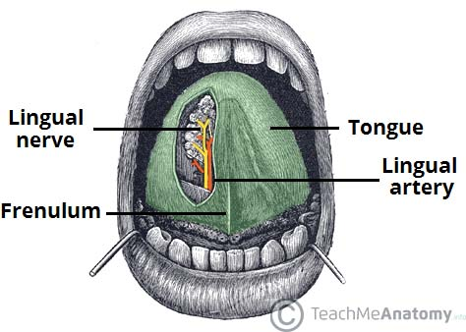

Muscles
The tongue's intrinsic muscles include the following:
- The superior longitudinal lingual muscle, which shortens the tongue and curls it upward.
- The inferior longitudinal lingual muscle, which shortens the tongue and curls it downward.
- The transverse lingual muscle, which elongates and narrows the tongue.
- The vertical lingual muscle, which flattens the tongue.
The tongue's extrinsic muscles include the following:
- The genioglossus muscle, which protrudes the tongue, and is innervated by the hypoglossal nerve (CN XII).
- The styloglossus muscle, which draws up the sides of the tongue to create a trough for swallowing following adequate mastication. The pair of styloglossus muscles works together on each side to retract the tongue. The styloglossus muscle is innervated by the hypoglossal nerve (CN XII).
- The hyoglossus muscle, which depresses and retracts the tongue and is innervated by the hypoglossal nerve (CN XII).
- The palatoglossus muscle, which elevates the posterior tongue, closes the oropharyngeal isthmus, aids in the initiation of swallowing, and prevents the spill of saliva from the vestibule into the oropharynx by maintaining the palatoglossal arch. It is the only extrinsic muscle of the tongue that is not innervated by the hypoglossal nerve; instead, it is innervated by the vagus nerve (CN X).

Physiologic Variants
- Ankyloglossia ("tongue-tie") occurs due to an abnormal length of the frenulum linguae which causes limited manipulation of the tongue during speech and results in a speech impediment. In the most common form of ankyloglossia, the frenulum extends to the tip of the tongue. Ankyloglossia can be corrected by surgically severing the lingual frenulum.
- Fissured tongue ("scrotal tongue," "plicated tongue") occurs when several small furrows present on the dorsal surface of the tongue. It can be an oral manifestation of psoriasis. It is generally painless and benign, and is often associated with other syndromes (e.g., Down syndrome).
- Geographic tongue ("migratory glossitis") is a benign, asymptomatic condition characterized by the presence of large red patches with a greyish-white border covering the dorsum of an otherwise normal tongue. It is caused by inflammation of the mucous membrane of the tongue, which results in loss of lingual papillae. The lesions are known to migrate over time. The name arises from the map-like appearance of the tongue in this condition.

Clinical Significance
The tongue tends to fall posteriorly, thus obstructing the airway. Paralysis or total relaxation of the genioglossus muscle presents a risk of suffocation, which can occur during general anesthesia. An artificial airway is made using intubation, which prevents the tongue from falling backward and blocking the airway.
- Ludwig angina infection, once established, evolves to include the tongue. The tongue may enlarge to two or three times its usual size and tends to distend posteriorly into the hypopharynx, superiorly against the palate, and anteriorly out of the oral cavity. Any immediate posterior extension of this process will ultimately involve the epiglottis. The styloglossus muscle creates the connection between the submandibular parapharyngeal spaces, otherwise known as the buccopharyngeal gap, as it leaves the tongue and passes in between the middle and superior constrictor muscles before attaching to the styloid process. Cellulitis of the submandibular space may spread into the pharyngeal space and, from there, into the retropharyngeal space of the mediastinum.
- Dysgeusia, or a pure taste disorder, is rare and is usually associated with olfactory disorders
2. The nose and paranasal sinuses
The nose (L., nasus; Gk, rhis, rhinos) includes the external nose on the face and the nasal cavity, which extends posteriorly from it. The nose functions in smell and provides filtered, warm, moist air for inspiration.

External nose
The external nose presents a root (or bridge), a dorsum, and a free tip or apex. The two inferior openings are the nostrils (or nares), bounded laterally by the ala and medially by the nasal septum. The superior part of the nose is supported by the nasal, frontal, and maxillary bones; the inferior part includes several cartilages. The continuous free margin of the nasal bones and maxillae in a dried skull is termed the piriform aperture.

Nasal cavity
The nasal cavity extends in an antero-posterior direction from the nostrils, or nares, to the choanae. The choanae are the posterior apertures of the nose. Each choana is bounded medially by the vomer, inferiorly by the horizontal plate of the palatine bone, laterally by the medial pterygoid plate, and superiorly by the body of the sphenoid bone and Posteriorly, the nasal cavity communicates with the nasopharynx, which in many respects may be regarded as the posterior portion of the cavity. The nasal cavity is related to the anterior and middle cranial fossae, orbit, and paranasal sinuses and is separated from the oral cavity by the hard palate. In addition to the nostrils and choanae, the nasal cavity presents openings for the paranasal sinuses and the nasolacrimal duct. Further openings, covered by mucosa in vivo, are found in a dried skull, e.g., the sphenopalatine foramen. The nasal cavity is divided into right and left halves (each of which may be termed a nasal cavity) by the nasal septum. Each half has a roof, floor, and medial and lateral walls.

The roof.
The roof of the nasal cavity is formed by nasal cartilages and several bones, chiefly the nasal and frontal bones, the cribriform plate of the ethmoid, and the body of the sphenoid. The floor, wider than the roof, is formed by the palatine process of the maxilla and the horizontal plate of the palatine bone, i.e., by the palate. The medial wall, or nasal septum, is formed (from anteiror to posterior) by (1) the septal cartilage (destroyed in a dried skull), (2) the perpendicular plate of the ethmoid bone, and (3) the vomer .It is usually deviated to one side. The lowest part of the septum (the columella) is membranous and mobile.

The lateral wall.
The lateral wall is uneven and complicated and is formed by several bones: nasal, maxilla, lacrimal and ethmoid, inferior nasal concha, perpendicular plate of palatine, and medial pterygoid plate of sphenoid). The lateral wall presents three or four medial projections termed nasal conchae, which overlie passages (meatuses). The inferior concha is a separate bone; the others are portions of the ethmoid bone. The conchae were formerly known as turbinates. It should be noted that the plural of meatus is meatus in Latin and meatuses in English (cf fetus).

The spheno-ethmoidal recess.
The spheno-ethmoidal recess, above and posterior to the superior concha, receives the opening of the sphenoidal sinus. The superior meatus, under cover of the superior concha, receives the openings of the posterior ethmoidal cells and (in a dried skull) the sphenopalatine foramen. The middle meatus, under cover of the middle concha, receives the openings of the maxillary and frontal sinuses. Most anterior ethmoidal cells open on an elevation (ethmoidal bulla,). A curved slit (hiatus semilunaris) inferior to the bulla receives the opening of the maxillary sinus. The frontal sinus and some anterior ethmoidal cells open either into an extension (ethmoidal infundibulum) of the hiatus or directly into the anterior part (frontal recess) of the middle meatus. The inferior meatus, which lies between the inferior concha and the palate, receives the termination of the nasolacrimal duct.
The nasal cavity can be examined in vivo either through a nostril or through the pharynx. A nasal speculum in a nostril is used in anterior rhinoscopy. A postnasal mirror inserted into the pharynx through the mouth enables the choanae to be inspected in posterior rhinoscopy.

Subdivisions.
It is convenient to divide the nasal cavity into a vestibule, a respiratory region, and an olfactory region. The vestibule is a slight dilatation inside the nostril ,limited by a ridge (limen nasi) over which skin becomes continuous with mucosa. The respiratory region is covered by mucoperichondrium and mucoperiosteum. The posterior two thirds show active ciliary motion for rapid drainage backward and downward into the nasopharynx. The nasal mucosa is highly vascular, and it warms and moistens the incoming air. The mucosa contains large venous-like spaces ("swell bodies"), which may become congested during allergic reactions or infections. The middle meatus is continuous on the anterior side with a depression (atrium;) that is limited above by a ridge (agger nasi). The olfactory region is bounded by the superior concha and the superior third of the nasal septum. The olfactory mucosa contains bipolar neurons (olfactory cells), the dendrites of which reach the surface. The axons are collected into about 20 bundles known collectively as the olfactory (first cranial) nerve. These pass through the cribriform plate of the ethmoid bone and synapse in the olfactory bulb. The olfactory nerve is tested by closing one nostril and presenting a test substance to the other.

Innervation.
The nerves of ordinary sensation are derived from the first two divisions of the trigeminal nerve .These are responsible for sensations of touch, pressure and temperature in the nose.
The nerves for the posterior and larger portion of the nasal cavity come from branches of the pterygopalatine ganglion that are derived from the maxillary nerve. The chief sympathetic (vasoconstrictor) and parasympathetic (vasodilator and secretory) innervation of the nasal cavity follow nerve branches arising in the region of the pterygopalatine ganglion, but some sympathetic fibers are carried along the walls of arteries. Parasympathetic preganglionic nerve fibers to the nose leave the brain with the facial nerve and pass through the greater petrosal nerve and the nerve of the pterygoid canal to reach the pterygopalatine ganglion, where they synapse. Sympathetic preganglionic nerve fibers leave the upper thoracic spinal cord and traverse white rami communicans in that region, ascend the cervical sympathetic chain and synapse in the superior cervical sympathetic ganglion. The postganglionic nerve fibers follow the internal carotid artery and then the nerve of the pterygoid canal to reach the pterygopalatine fossa. These nerve fibers pass through the ganglion to join branches of the maxiallary nerve and artery to reach the nasal mucosa.

Blood supply and lymphatic drainage.
The most important arteries to the nasal cavity are the sphenopalatine (from the maxillary) artery and the anterior ethmoidal (from the ophthalmic) artery. Bleeding from the nose (epistaxis) occurs usually from the junction between septal branches of the superior labial and sphenopalatine arteries. The lymph vessels drain into deep cervical nodes. Communications probably occur between the nasal lymphatics and the subarachnoid space, probably through the sheath of the olfactory nerve.

Paranasal sinuses
The paranasal sinuses are cavities in the interior of the maxilla and the frontal, sphenoid, and ethmoid bones. The sinuses develop as outgrowths from the nasal cavity; hence they all drain directly or indirectly into the nose. Nasal infection (rhinitis), e.g., during a "cold in the head," may spread to the sinuses (sinusitis). The lining of the sinuses (muco-endosteum) is continuous with the nasal mucosa. The sinuses develop mostly after birth, and their degree of development varies greatly. Their function is obscure but they provide resonance to the voice, shape to the face and some degree of warmth and humidification to inspired air. The paranasal sinuses are supplied by branches of the ophthalmic and maxillary nerves. The sinuses can be examined radiographically, and a light placed agains the roof of the mouth enables the maxillary sinus to be transilluminated.

Maxillary sinus.
The maxillary sinus, the largest of the sinuses, is within the body of the maxilla. It is shaped like a pyramid; its base is usually medial, with its apex in the zygomatic process of the maxilla. Its roof is the floor of the orbit, and its floor is the alveolar process of the maxilla. The maxillary sinus drains into the middle meatus by means of the semilunar hiatus. The floor of the maxillary sinus is slightly below the level of the nasal cavity, and it is related to the upper teeth (varying from teeth 3 to 8 to teeth 6 to 8). Maxillary sinusitis is frequently accompanied by toothache. Infection may spread among the various sinuses, the nasal cavity, and the teeth. The opening of the maxillary sinus can be cannulated in vivo through the nostril. 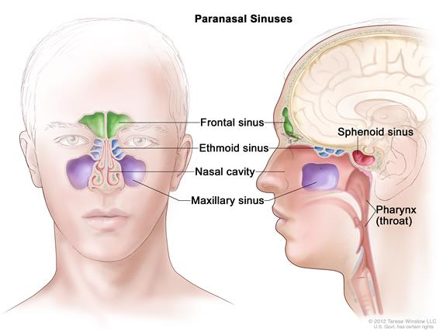
Anatomy of the paranasal sinuses (spaces between the bones around the nose

Ethmoidal sinus.
The ethmoidal sinus comprises numerous small cavities (ethmoidal cells) in the ethmoidal labyrinth. The walls of these cavities are completed by the surrounding bones. Anterior and posterior groups drain into the middle and superior meatuses, respectively

Frontal sinus
The frontal sinus may be regarded as an anterior ethmoidal cell that has invaded the frontal bone postnatally. The right and left frontal sinuses, frequently of different sizes, are separated by a bony septum that is usually deviated to one side. The frontal sinus drains into the middle meatus in a variable manner directly or by a frontonasal duct, which opens into the frontal recess or the ethmoidal infundibulum. The frontal sinus commonly extends posterorward in the roof of the orbit.

Sphenoidal sinus
The sphenoidal sinus is in the body of the sphenoid bone, and it varies greatly in size. Its superior aspect is related to the hypophysis (pituitary) and the optic nerves and chiasma and laterally to the cavernous sinus and internal carotid artery . The sphenoidal sinus drains into the spheno-ethmoidal recess superior to the superior concha. The sinus is divided into right and left parts by a bony septum.

