NAME: ODOGWU PAUL CHIDOZIE
MATRIC NO.: 15/ENG04/039
EEE 512 ASSIGNMENT
QUESTION 1 (i)
- 3G Network
3G system uses CDMA (Code Division Multiple Access) and WCDMA (Wide Band Code Division Multiple Access). CDMA is a technique in which a unique code is assigned to each user using the channel at that time. After assigning a unique code, completely available bandwidth is utilized efficiently in it. Due to this very large number, multiple users can use the channel at the same time compared to TDMA and FDMA. A unique code is assigned to each user due to which number of channels can be formed at a time. 3G uses 15 MHz to 20 MHz frequency spectrum and the frequency band for 3G is from 1800 MHz to 2500 MHz. A maximum speed of around 2 Mbps is achieved in basic 3G system. WCDMA also known as UMTS (Universal Mobile Telecommunication System) uses much larger career frequency due to which more amount of users can be accommodated at compared to CDMA. The core network used in 3G systems is combination of Circuit switching and Packet switching. To further increase the speed of data, HSPA and HSPA+ (High Speed Packet Access) was introduced. Due to HSPA+ networks can be upgraded to run at broadband speeds. The concept of MIMO (Multiple Input Multiple Output) was first introduced in HSPA+. Due to this data rates can reach to as high as 42 Mbps. HSPA and HSPA+ can be considered as 3.5G and 3.75G respectively. The modulation technique used in HSPA+ was 64-bit QAM. MIMO is a method in which the concept of Multipath propagation is used to improve the radio link. The same signal is received multiple times on receiver side. Due to this, the probability of error is decreased and overall performance is improved.
3G/UMTS Architecture
The constituent parts of 3G UMTS network are:
• Mobile Station: It could be anything like data and voice-enabled mobile phones, tabs or computers which could be used as an end user.
• RAN (Radio Access Network): It consists of base stations and radio access controller which bridges the gap between Mobile Station and Core Network. It also controls and manages the air interface for the whole network.
• CN (Core Network): It provides the main processing and management of subsystems. The 3G UMTS network Architecture is migrated from GSM with some enhancements in core network elements.
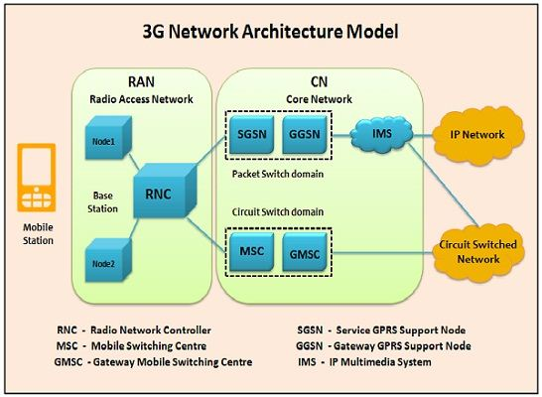
Figure 1 3G Network Architecture
The core network is classified into two parts i.e. Circuit Switched Domain and Packet-switched domain.
- Circuit Switched Domain: It uses Circuit Switched Network in which dedicated link or channel is provided for a particular time slot to set of users. The two blocks shown in Circuit Switched Domain are:
- MSC: Mobile Switching Centre manages circuit switched calls.
- GMSC: Gateway MSC acts as an intermediary between external and internal networks.
- Packet-switched domain: It uses IP Network where IP’s are responsible for transmitting and receiving data among two or more devices. The two blocks shown in Packet Switched Domain are:
- SGSN (Serving GPRS Support Node): The various functions provided by SGSN are mobility management, session management, billing, communication with other areas of the network.
- GGSN (Gateway GPRS Support Node): It can be considered as a very complex router and handles the internal operations between the external packet switched networks and UMTS packet switched network.
- IMS (IP Multimedia Subsystem): It is an Architectural framework which supplies IP multimedia services.

- 4G Network
LTE (Long Term Evolution) is a 4G mobile communication standard based on GSM/EDGE and UMTS/HSPA technologies. LTE uses Multi carrier CDMA or OFDM (Orthogonal Frequency Division Multiplexing). In OFDM, high data rate modulating stream is divided and then placed onto many slowly modulated narrowband closed-spaced subcarriers. The frequency band used in 4G is from 2000 MHz to 8000 MHz and uses a frequency spectrum of 5Mhz to 20 Mhz. A maximum downlink speed of around 100 Mbps and uplink speed of around 50 Mbps is achieved in LTE systems. Due to such a high data rate, it can support bandwidth hungry applications like online gaming, live streaming of high definition video, voice over IP.
4G LTE Architecture
The constituent parts of 4G LTE network are:
- User Equipment (UE): It could be any device capable of establishing communication functions like mobile phones, tabs, computers, etc.
- Evolved UMTS Terrestrial Radio Access Network (E-UTRAN): It controls radio communication between user equipment and EPC. LTE mobile can connect with just one cell and one base station at a time. Main operations performed by EBS (Evolved Base Station)
- Analog and digital processing functions of LTE air interface are used to transmit and receive radio transmission to all the LTE-enabled devices.
- Handles low-level operation by sending the signaling messages and commands.
- Evolved Packet Core (EPC): It communicates with internal and external packet data networks and IP multimedia subsystem. It consists of following blocks:
- HSS: Home Subscriber Server holds all the information about all the network operator’s subscribers in a central database.
- MME: Mobility Management Entity handles the high-level operation by the signalling messages and HSS.
- S-GW: Signaling Gateway performs mobility anchoring and forward data between PDN Gateway and Base Station.
- P-GW: Packet Data Network Gateway communicates with PDN’s employing interfaces. It performs operations like IP address allocation and packet filtering.
- PCRF: Policy and Charging Rule Function is accountable for controlling the flow-based charging operations in the Policy Control Enforcement Function (PCEF) and policy control decision-making.
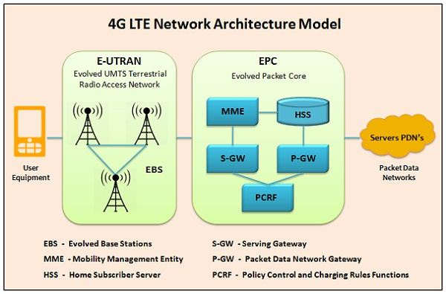
Figure 2 4G Network Architecture
- 5G Network
The 5G technology is expected to provide a new (much wider than the previous one) frequency bands along with the wider spectral bandwidth per frequency channel. As of now, the predecessors (generations) mobile technologies have evidenced substantial increase in peak bitrate. It is not only the increase in bitrate made 5G distinct from the 4G, but rather 5G is also advanced in terms of:
- High increased peak bit rate
- Larger data volume per unit area (i.e. high system spectral efficiency)
- High capacity to allow more devices connectivity concurrently and instantaneously
- Lower battery consumption
- Better connectivity irrespective of the geographic region, in which you are
- Larger number of supporting devices
- Lower cost of infrastructural development
- Higher reliability of the communications
With the wide range of bandwidth radio channels, it is able to support the speed up to 10 Gbps, the 5G WiFi technology will offer contiguous and consistent coverage. That is, wider area mobility in true sense.
A mobile network has two main components, the ‘Radio Access Network’ and the ‘Core Network’.
The Radio Access Network - consists of various types of facilities including small cells, towers, masts and dedicated in-building and home systems that connect mobile users and wireless devices to the main core network.
Small cells will be a major feature of 5G networks particularly at the new millimeter wave (mmWave) frequencies where the connection range is very short. To provide a continuous connection, small cells will be distributed in clusters depending on where users require connection which will complement the macro network that provides wide-area coverage.
5G Macro Cells will use MIMO (multiple input, multiple output) antennas that have multiple elements or connections to send and receive more data simultaneously. The benefit to users is that more people can simultaneously connect to the network and maintain high throughput. Where MIMO antennas use very large numbers of antenna elements they are often referred to as ‘massive MIMO’, however, the physical size is similar to existing 3G and 4G base station antennas.
The Core Network - is the mobile exchange and data network that manages all of the mobile voice, data and internet connections. For 5G, the ‘core network’ is being redesigned to better integrate with the internet and cloud based services and also includes distributed servers across the network improving response times (reducing latency).
Many of the advanced features of 5G including network function virtualization and network slicing for different applications and services, will be managed in the core.
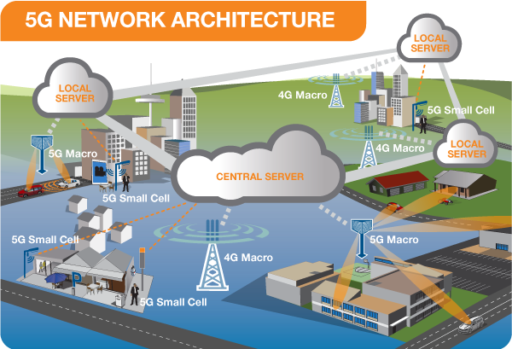
Figure 3 5G Network Architecture
QUESTION 1 (ii)
Advantages of 3G
- Wireless broadband.
- 3G is cheaper for providers.
- Extremely faster than previous networks.
Disadvantages of 3G
- Download speeds can sometimes be slower than expected with the signal strength very variable depending on your device.
- The radiation of magnetic waves.
Advantages of 4G
- Files can be quickly downloaded over a wireless network.
- Extremely high voice quality.
- Easy access Internet, IM, Social Networks, streaming media, video calling, etc.
- Higher bandwidth.
- 4G is 10 times faster than 3G.
Disadvantages of 4G
- New frequencies mean new components in cell towers.
- Higher data prices for consumers.
- The consumer is forced to buy a new device to support the 4G network.
Advantages of 5G
- Increased bandwidth for all users.
- High resolution.
- Bi-directional large bandwidth.
- More efficient and easily manageable.
- Uninterrupted uniform connectivity.
Disadvantages of 5G
- The research is still in progress.
- Old devices cannot support this.
- Required infrastructure has to be developed.

QUESTION 2
Features | 2G/2.5G | 3G | 4G | 5G
Start/Development | 1980/1999 | 1990/2002 | 2000/2010 | 2010/2015
Data Bandwidth | 14.4Kbps to 64Kbps | 2Mbps | 2000Mbps to 1Gbps | 1Gbps and higher
Standards | 2G: TDMA, CDMS, GSM  2.5G: GPRS, EDGE, 1xRTT | WCDMA, CDMA-2000 | Single unified standard | Single unified standard
Technology | Digital cellular technology | Broad bandwidth CDMA, IP technology | Unified IP and seamless combination of broadband LAN/WAN/PAN and WLAN | Unified IP and seamless combination of broadband LAN/WAN/PAN and WLAN
Service | 2G: Digital voice, Short Messaging  2.5G: Higher capacity Packetized data | Integrated higher quality audio, video and data | Dynamic Information Access, Wearable devices | Dynamic Information Access, Wearable devices with IA capabilities
Multiplexing | TDMA, CDMA | CDMA | CDMA | CDMA
Switching | 2G: Circuit  2.5G: Circuit for access network & air interface; packet for core network and data | Packet except circuit for air interface | All packet | All packet
Core Network | PSTN | Packet network | Internet | Internet
Handoff | Horizontal | Horizontal | Horizontal and Vertical | Horizontal and Vertical

QUESTION 3
- No, there is no correlation between 5G and coronavirus
- Yes, I support the state that there is no correlation between 5G and coronavirus (COVID-19).

Justification
Conspiracy theories claiming 5G technology helps transmit coronavirus have been condemned by the scientific community. None of the conspiracy theories that try to link 5G and the coronavirus even make sense. The virus is spreading in countries without access to 5G, the frequencies from 5G cannot harm the body, and COVID-19 is caused by a contagious virus that is in no way related to electromagnetic waves.
The conspiracy theories suggest that the novel coronavirus can be transmitted through 5G or that 5G suppresses the immune system. Both are untrue. To understand why 5G and the virus are not linked, it is necessary to understand why 5G radio waves are not powerful enough to damage the cells in your body alone or transmit a virus. The difference between 5G and previous generations of mobile services (4G, 3G) is that the latter use lower radio frequencies (in the 6 gigahertz range), whereas 5G uses frequencies in the 30–300 gigahertz range. In the 30-300 gigahertz range, there is not enough energy to break chemical bonds or remove electrons when in contact with human tissue. Thus, this range is referred to as "non-ionizing" electromagnetic radiation. Radiation can come into contact with the skin, for example, when we put a 5G mobile to our ear to make a call. This is when we are most exposed to non-ionizing radiation. But this exposure is well below the recommended safety level.
5G radiation cannot penetrate skin, or allow a virus to penetrate skin. There is no evidence 5G radio frequencies cause or exacerbate the spread of the coronavirus.
Also, the protein shell of the virus is incapable of hijacking 5G radio signals. This is because radiation and viruses exist in different forms that do not interact. One is a biological phenomenon and the other exists on the electromagnetic spectrum.
5G radio waves are called millimeter waves, because their wavelength is measured in millimeters. Because these waves are short, 5G cell towers need to be relatively close together - about 250 meters apart. They are organized as a collection of small cells (a cell is an area covered by radio signals).
For 5G to cover a larger geographic area, more base stations are needed in comparison to 4G. This increase in the number of base stations, and their proximity to humans, is one factor that may stir unfounded fears about 5G's potential health impacts.
Your phone may be dangerous, but its radiation is not. COVID-19 spreads through small droplets released from the nose or mouth of an infected person when they cough, spit, sneeze, talk or exhale. Transmission occurs when the droplets come into contact with the nose, eyes or mouth of a healthy person. So if an infectious person speaks through a phone held near their mouth, enough infectious droplets may land on its surface to make it capable of spreading the virus. This is why it's not advisable to share mobiles during a pandemic and why we should regularly disinfect your mobile.

REFERENCES
- Adnan Majeed (2015). Comparative Studies of 3G, 4G & 5G Mobile Network & Data Offloading Method a Survey.
- V. Lakshitha, K.V. Rohith Reddy, G. Jayanth, C. Jagadeesh Raju, Dr. Manikandan K. (2018). 3G, 4G AND 5G: A Comparative Study.
- Sagarkumar Patel, Vatsal Shah, Maharshi Kansara (2018). Comparative Study of 2G, 3G and 4G.
- E. Ezhilarasan & M.Dinakaran (2017). A Review on mobile technologies: 3G, 4G and 5G.
- B.G.Gopal, P.G.Kuppusamy (2015). A Comparative Study on 4G and 5G Technology for Wireless Applications.
- Aleksandar Tudzarov and Toni Janevski (2011). Design for 5G Mobile Network Architecture.
- Difference Between 3G and 4G Technology. https://techdifferences.com/difference-between-3g-and-4g-technology.html#Architecture
- No, 5G Radiation Doesn't Spread The Coronavirus. Here's How We Know. https://www.sciencealert.com/5g-radiation-has-nothing-to-do-with-the-spread-of-coronavirus

