Matric number: 18/mhs01/212
1)discuss ovulation- ovulation is the release of secondary oocyte from the ovaries which after released travels down the fallopian tube where fertilization of a sperm may occur, ovulation lasts one day and occurs in the middle of a womans menstrual cycle about two weeks before she expects to get her period, under the influence. Under the influence of luteinizing hormone and follicle stimulating hormone
2) differences between meiosis 1 and meiosis 11
Meiosis 1 | Meiosis 11
1) In meiosis I, homologous chromosomes separate | in meiosis II, sister chromatids separate.
2) Meiosis I produces 2 diploid daughter cells | Meiosis 11 produces 4 haploid daughter cells
3) Genetic recombination (crossing over) only occurs in meiosis I | Genetic recombination(crossing over) doesn’t occur
Meiosis is a way sex cells (gametes) divide. Since sex cells determine the genetic code of offspring, meiosis attempts to create unique combinations of chromosomes in gametes.
Meiosis I is the first stage of this cell division, where pairs of chromosomes are split up. We can see how the process occurs in the following diagram:
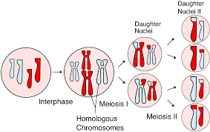

3) Discuss the stages involved in fertilization
The stages involved in fertilization include;
a) passage of the sperm through the corona radiate: for a sperm to pass through the corona radiate the sperm must be capacitated and this means the removal of the glycoprotein coat and plasma protein from the plasma membrane that overlies the acrosome region in spermatozoa and only capacitated sperm can pass through the corona radiate
b)penetration of the zona pellucida: the zona pellucida in this case is a glycoprotein shell that covers the egg thereby maintaining sperm binding and induces acrosome reaction. the acrosome binds with the zona glycoprotein on the zona pellucida. Then the sperm releases acrosin which allows the sperm to penetrate the zona pellucida thereby coming in contact with the plasma membrane of the oocyte as soon as this happens the permeability of the zona pellucida changes and lysosomal enzymes are released from cortical granules lining the pm of the oocyte
3)fusion of both the plasma membrane of the oocyte and sperm: the pm of the ooctyte and sperm breakdown at the area of fusion thereby the head and tail enters the cytoplasm of the oocyte while the sperm pm is left behind
4) completion of the second meiotic division of the oocyte and formation of female pronucleus: as soon as the sperm penetrates the oocyte, the oocyte completes its second meiotic division forming a mature oocyte and a second polar body. The nucleus of the oocyte is called the female pronucleus
5) formation of male pronucleus: as soon as the sperm enters the cytoplasm of the oocyte the nucleus enlarges to form the male pronucleus and the tail degenerates and as this is done the sperm mitochondria degenetares meaning all mitochondria within the zygote is of maternal origin, the oocyte now contains 2 pronuclei each having haploid number called ootid
6) the two pronuclei fuse into a single diploid, this ootid becomes a zygote
Note Fertilization process takes place in the ampulla of the uterine tube

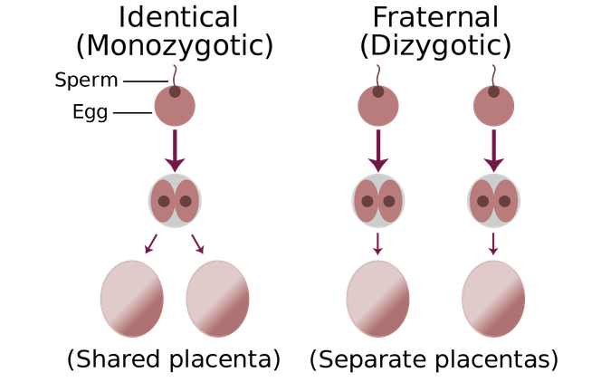
4) differentiate between monozygotic twins and dizygotic twins
Monozygotic twins | Dizygotic twins
.) resemblance is similar | Resemblance is just like any other two siblings
Are often called conjoined twins | Not seen as conjoined twins
Incidence is more common | Incidence is less common
Twins are of the same sex | Twins are of the same sex or different sex
Form from single zygote | Form from two zygotes
Genetically identical | Genetically not identical
Mostly diamniotic, monochromic, with single placenta | Mostly have two amnions two chorions and two placentas

