NAME: ADEBAYO PRECIOUS ADEDAMOLA

MATRIC NO: 18/MHS01/010

COURSE CODE/COURSE TITLE: ICBS/EMBRYOLOGY

MEDICINE AND SURGERY

200 LEVEL

ASSIGNMENT
DISCUSS OVULATION
Ovulation is the process involving the releasing of oocyte from the ovarian follicle. The secondary follicle reaches its final stages to become the Graafian follicle few days before ovulation. This is due to the influence of the follicle stimulating hormone(FSH) and luteinizing hormone(LH).
There is an abrupt increase in the luteinizing hormone causing the oocyte to complete its first meiotic division and to enter its pre-ovulatory vesicular stage. The oocyte undergoes second meiotic division but arrested at the metaphase stage.
The ovary begins to bulge locally and at the apex, an avascular spot appears called The Stigma.
Two events must occur for the oocyte to be released which is also affected by collagenase activity(digestion of collagen fibres surrounding the follicles), prostaglandin levels also increase leading to local muscular contractions.
These contractions extrude the oocyte along with its surrounding follicular cells. Some of the remaining cumulus oophorous rearrange themselves to from the corona radiata around the zona pellucida.
CLINICAL CORRELATES
During ovulation, women experience middle pain which occurs near the middle of the menstrual cycle. This leads to pain in the peritoneal cavity and sharp pains in the lower abdomen.
Some women also undergo anovulation because of low concentration of gonadotropin. This can be rectified by the administration of drugs but increases the risk of multiple pregnancies.
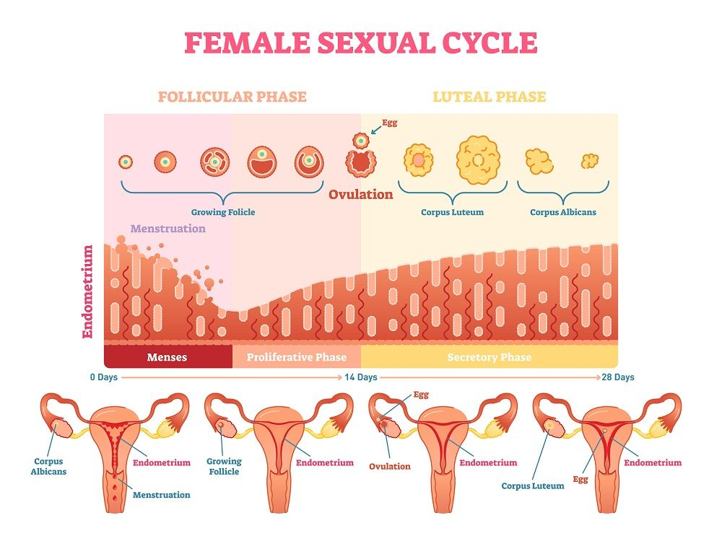

DIFFERENTIATE BETWEEN MEIOSIS I AND MEIOSIS II
- Genetic recombination (synapsis, crossing over and chiasma formation) occurs in meiosis I but doesn’t occur in meiosis II.
- Meiosis I produces two diploid daughter cells while meiosis II produces four haploid daughter cells.
- Centromeres do not split during anaphase In meiosis I but they do in Meiosis II.
- Meiosis I takes a longer duration than meiosis II.
- Prophase stage in meiosis I has five stages while meiosis II doesn’t

DISCUSS THE STAGES INVOLVED IN FERTILIZATION
Fertilization can be defined as the sequence of uncoordinated events involving the union of sperm and oocyte at the ampulla of the uterus. It takes about 24 hours to be completed.
It involves five/six stages which include;
-Passage of sperm through the corona radiata: For a sperm to be capable of passing through the corona radiata, it must undergo capacitation (the removal of glycoprotein coat and seminal plasma proteins surrounding the plasma membrane that surrounds the acrosomal region).
- Penetration of the zona pellucida: The zona pellucida is a glycoprotein shell that facilitates sperm binding and acrosome reaction. The sperm binds with a zona protein (ZP3) on the zona pellucida.
The release of acrosin (acrosomal enzymes) allows the sperm to penetrate the zona pellucida which changes its permeability. Cortical granules release lysosomal enzymes which alter the properties of the zona pellucida preventing sperm penetration and inactivation of binding sites.
-Fusion of the plasma membranes of the sperm and the oocyte:
The plasma membranes of the two gametes fuse and break down at the point of contact. The head and tail of the sperm enters the cytoplasm of the oocyte leaving the plasma membrane behind.
-Completion of the second meiotic division of oocyte and formation of female pronucleus: Penetration of the oocyte by a sperm means the oocyte has completed the second meiotic division and forms a mature oocyte and a second polar body. The nucleus of the mature oocyte is referred to as the female pronucleus.
-Formation of the male pronucleus: The tail of the sperm degenerates leaving behind only the oocyte. It enlarges and becomes the male pro nucleus.
An oocyte containing two pro nucleus is referred to as an ootid.
-The ootid fuses into a diploid aggregation of the two pro nucleus and can be referred to as a zygote.

DIFFERENTIATE BETWEEN MONOZYGOTIC AND DIZYGOTIC TWINS
MONOZYGOTIC TWINS | DIZYGOTIC TWINS
They are usually of the same sex | They may be of different sex
Forms from single zygote | Forms from two zygotes
They are genetically identical | They are not genetically identical
They share the same chorionic and amniotic sacs but same placenta. | Two amnions, two chorionic sacs and two placentas
Incidence is more common | Incidence is less common

