OKE SUCCESS OLUWASEYI
17/MHS01/243
MEDICINE AND SURGERY

ANATOMY OF THE TONGUE
The tongue is a muscular organ in the mouth. A boneless mass that one can protrude at will, fold, invert, lay flat or fill the mouth. It is a very vital organ for chewing, swallowing, and also for speech. The tongue is covered with moist, pink tissue called MUCOSA. Tiny bumps called PAPILLAE gives the tongue its rough texture. We can appreciate the presence of thousands of taste buds covering the papillae. These taste buds are collections of nerve-like cells that connect to nerves running into the brain.
The tongue is haboured to the mouth by webs of tough tissue and mucosa. The tether holding down the front of the tongue is called the FRENUM. In the back of the mouth the tongue is haboured by the HYOID BONE. The four common tastes are sweet, sour, bitter and salty. The tongue has many nerves that help detect and transmit taste signals to the brain.
INTRINSIC MUSCLES
The intrinsic muscles only attach to other structures in the tongue. There are four paired intrinsic muscles of the called which are named by the direction in which they travel; THE SUPERIOR LONGITUDINAL, THE LONGITUDINAL, INFERIOR LONGITUDINAL, TRANSVERSE AND VERTICAL MUSCLES of the tongue. These muscles affect the shape and size of the tongue. Motor innervation of the intrinsic muscles of the tongue is via the HYPOGLOSSAL NERVE (CNXII).
EXTRINSIC MUSCLES
They are as follows:
- GENIOGLOSSUS:
Attachments: Arises from the mandibular symphsis. Inserts into the body of the hyoid bone and the entire length of the tongues.
Function: Inferior fibers protrude the tongue, middle fibers depress the tongue and superior fibers draw the tip back and down.
Innervation: Motor innervation is through hypoglossal nerve(CNXII)

- HYPOGLOSSUS
Attachments: Arises from the hyoid bone and inserts into the side of the tongue.
Functions: Depresses and retracts the tongue.
Innervation: Motor innervation via the hypoglossal nerve (CNXII)

- STYLOGLOSSUS
Attachments: Originates at the styloid process of the temporal bone and inserts into the side of the tongue.
Function: Retracts and elevates the tongue.
Innervation: Motor innervation via the hypoglossal nerve (CNXII)

- PALATOGLOSSUS
Attachments: Arises from the palatine aponeurosis and inserts broadly across the tongue.
Function: Elevates the posterior aspect of the tongue.
Innervation: Motor innervation via the vagus nerve (CNX)
All of the intrinsic and extrinsic muscles are innervated by the HYPOGLOSSAL NERVE (CN XII), except palatoglossus, which has vagal innervation (CNX).

INNERVATION
Dividing the tongue into an anterior 2/3 and posterior 1/3. In the anterior 2/3, general sensation is supplied by the TRIGEMINAL NERVE (CNV). Specifically the lingual nerve, a branch of the mandibular nerve (CN V3). But taste here is supplied from the FACIAL NERVE (CNVII). In the petrous part of the temporal bone, the facial nerve gives off three branches, one of which is CHORDA TYMPANI. This travels through the middle ear, and continues on to the tongue.
The posterior 1/3 of the tongue is slightly easier. Both touch and taste are supplied by the GLOSSOPHARYNGEAL NERVE (CNIX).

VASCULATURE
The lingual artery (branch of the external carotid) does most of the supply, but there is a branch from the facial artery, called the Tonsillar artery, which can provide some collateral circulation. Drainage is by the LINGUAL VEIN.

LYMPHATIC DRAINAGE
The lymphatic drainage of the tongue is as follows:
ANTERIOR TWO THIRDS: Initially into the submental and submandibular nodes, which empty into the deep cervical lymph nodes.

POSTERIOR THIRD: Directly into the deep cervical lymph nodes.

EMBRYOLOGICAL DEVELOPMENT
One of the central points is that the first brachial arch is supplied by the trigeminal nerve, the second by the facial, the third by the glossopharyngeal, and the fourth and sixth by the vagus.
When the tongue is developing, it starts as a two longitudinal bulbous ridges, with contribution from the first four brachial arches. The ridges join, giving rise to the longitudinal line (median sulcus ) down the center of the tongues. The contribution from the second brachial arch is grown over by that of the third arch, but the nerve supply remains. This explains why majority of the tongue’s innervation is by the trigeminal nerve (CN V) and the glossopharyngeal nerve (C N IX).
Towards the back of the tongue is the presence of a transverse line near the root of the tonguewhich is called SULCUS TERMINALIS, and in the center, where it meets the MEDIAN SULCUS, there is a pit. This is the now-closed top of a deep pit, the FORAMEN CECUM (BLIND WINDOW), at the end of which lies the thyroid gland. During development, this descends from the tongue down into the neck, if, on the way down, the pit (THYROGLOSSAL DUCT) does not close behind the gland, midline THYROGLOSSAL CYSTS OR FISTULAE may remain.

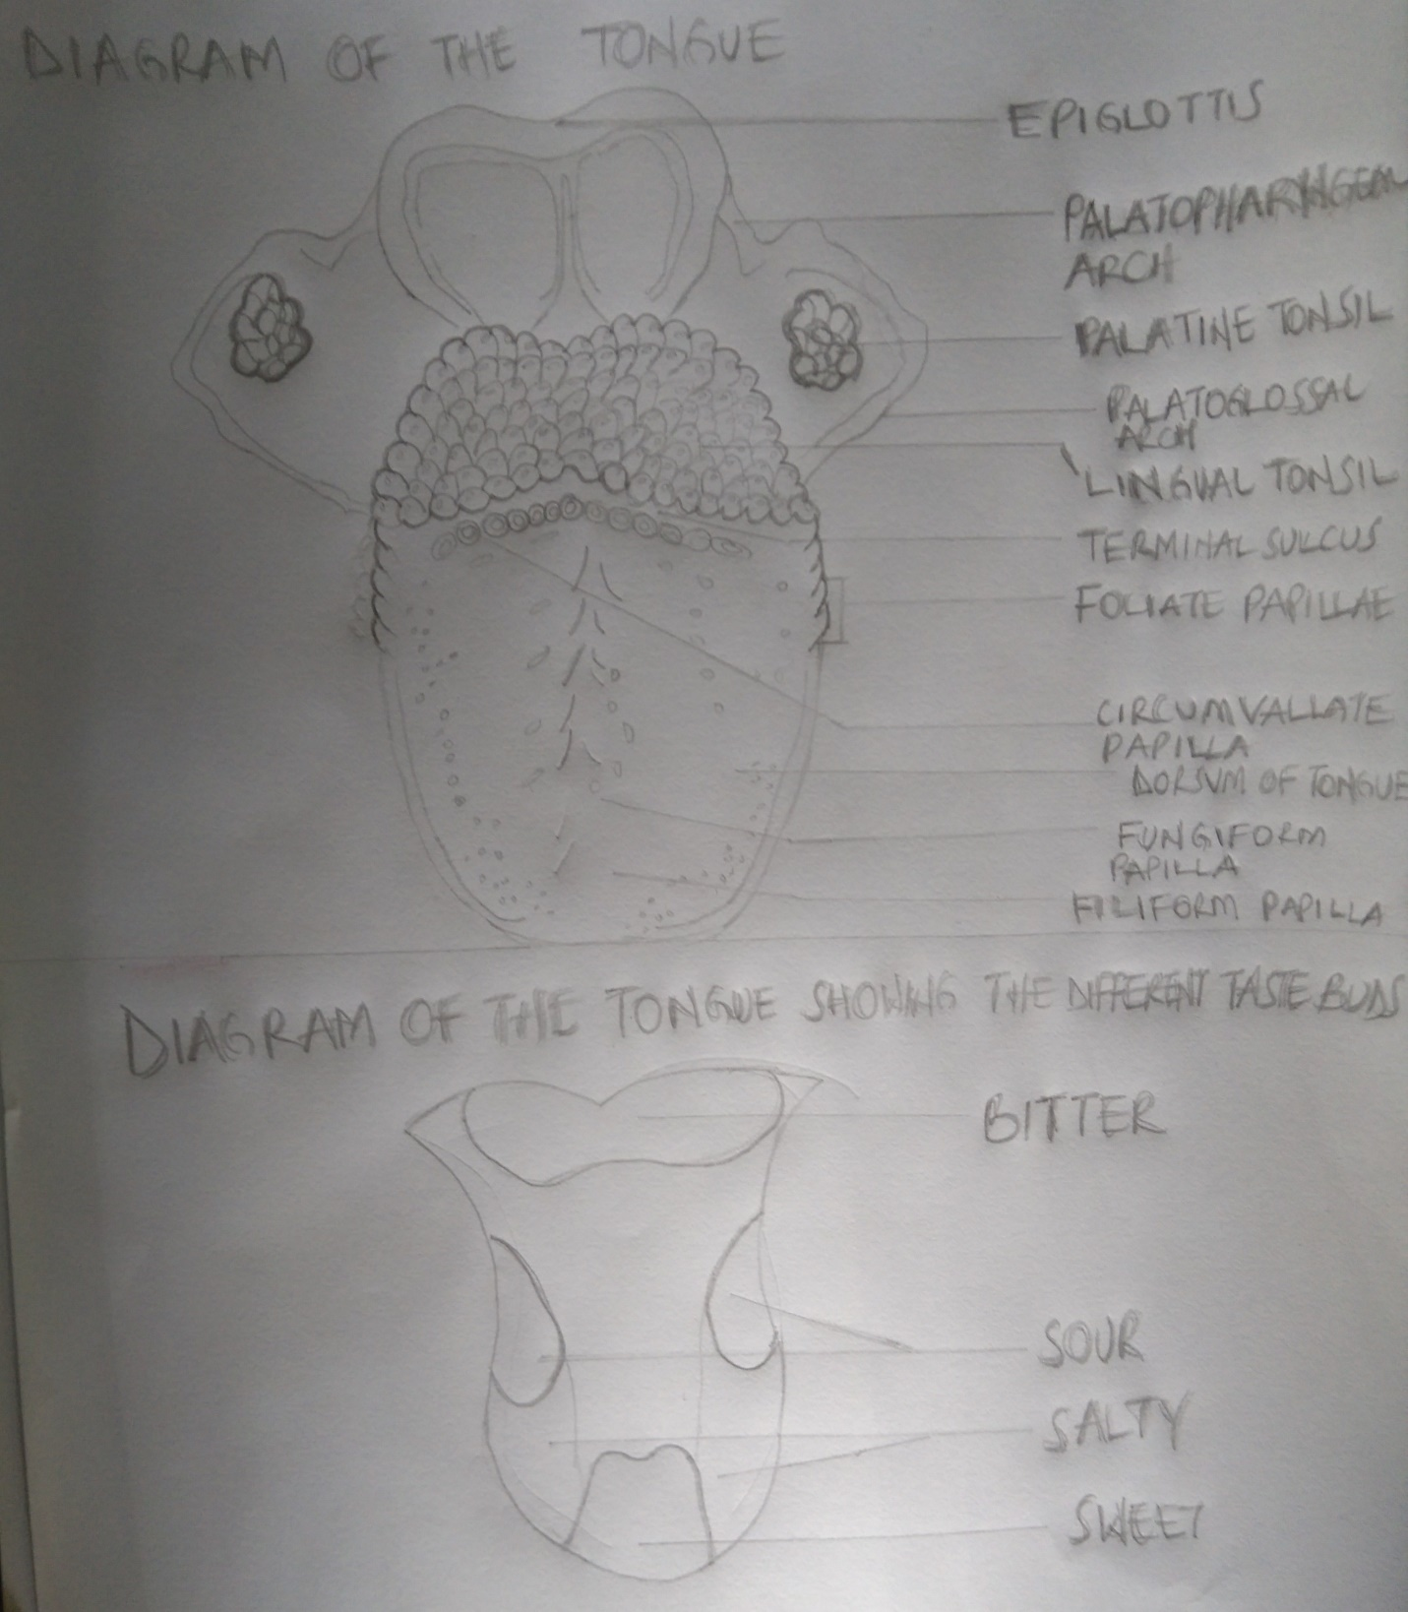S

APPLIED ANATOMY
- THRUSH (CANDIDIASIS): Candida albicans (a yeast) grows over the surface of the nouth and tongue. Thrush can occur in almost anyone, but it occurs more often in people with suppressed immune systems, the very young, and the ederly. Can be eliminated through Anti-fungal medicines.
- ORAL CANCER: A growth or ulcer appears on the tongue and grows steadily. Oral cancer is more common in people who smoke and/or drink alcohol heavily. Tongue surgery may be required.
- MACROGLOSSIA (BIG TONGUE): This can be broken down into various categories based on the cause. These include congenital, inflammatory, traumatic, cancerous, and metabolic causes. Thyroid disease, lymphangiomas, and congenital abnormalities are among some of the causes of an enlarged tongue.
- GEOGRAPHIC TONGUE: Ridges and colored spots migrate over the surface of the tongue, periodically changing its appearance. Geographic tongue is a harmless condition.
- BURNING MOUTH/BURNING TONGUE SENSATION SYNDROME: A relatively common problem. The tongue feels burned or scalded, or strange tastes or sensations develop. Apparently harmless, burning mouth syndrome may be caused by a mild nerve problem.
- ATROPHIC GLOSSITIS (BALD TONGUE): The tongue loses its bumpy texture, becoming smooth. Sometimes this is due to anemia or a B Vitamin deficiency. A vitamin B supplement can be used to correct this.
- CANKER SORES (APHTHOUS ULCERS): Small, painful ulcers appear periodically on the tongue or mouth. A relatively common condition condition, the cause of canker sores is unknown; they are unrelated to the cold sores caused by herpes viruses. Canker sores are not contagious. Applying a prescription steroid gel like LIDEX hastens the resolution of canker sores.
- ORAL LEUKOPLAKIA: White patches appear on the tongue that can’t be scraped off. Leukoplakia may be benign, or it can progress to oral cancer.
- HAIRY TONGUE: Papillae can overgrow the surface of the tongue, giving it a white or black appearance. Scraping off the papillae corrects this harmless condition.
- HERPES STOMATITIS: The herpes virus can uncommonly cause cold sores on the tongue. Herpes virus cold sores are usually on the lip.
- LICHEN PLANUS: A harmless condition that can affect the skin or the mouth. The cause is unknown; however, it is believed to be caused by the immune system attacking the skin and lining of the mouth.

AIR SINUSES
The Air sinuses otherwise known as Paranasal sinuses are air cavities that help circulate the air that is breathed in and out of the respiratory system. They are situated around the nsal cavity and they are all paired and sometimes symmetrical, while always bilateral. There are four different pairs of sinuses and they are called the:
- MAXILLARY SINUSES
- FRONTAL SINUSES
- SPHENOIDAL SINUSES
- ETHMOIDAL SINUSES

MAXILLARY SINUSES
The maxillary sinuses are the LARGEST of the all paranasal sinuses . They have thin walls which are often penetrated by the long roots of the posterior maxillary teeth.
-THE SUPERIOR BORDER of the sinus is the BONY ORBIT
-THE INFERIOR BORDER is the MAXILLIARY ALVEOLAR BONE AND CORRESPONDING TOOTH ROOTS.
-THE MEDIAL BORDER Is made up of the NASAL CAVITY.
-THE LATERAL AND ANTERIOR BORDERS are limited by the CHEEKBONES
- POSTERIOLY, Two anatomical spaces known as the PTERYGOPALATINE FOSSA and the INFRATEMPORAL FOSSA exist.
The SUBMANDIBULAR LYMPH NODES are the main destination during lymphatic drainage. The blood supply includes contribution from the:
- Anterior superior alveolar artery
- Middle superior artery
- Posterior superior alveolar artery
Innervation occurs through nerves of the same names as the arteries.

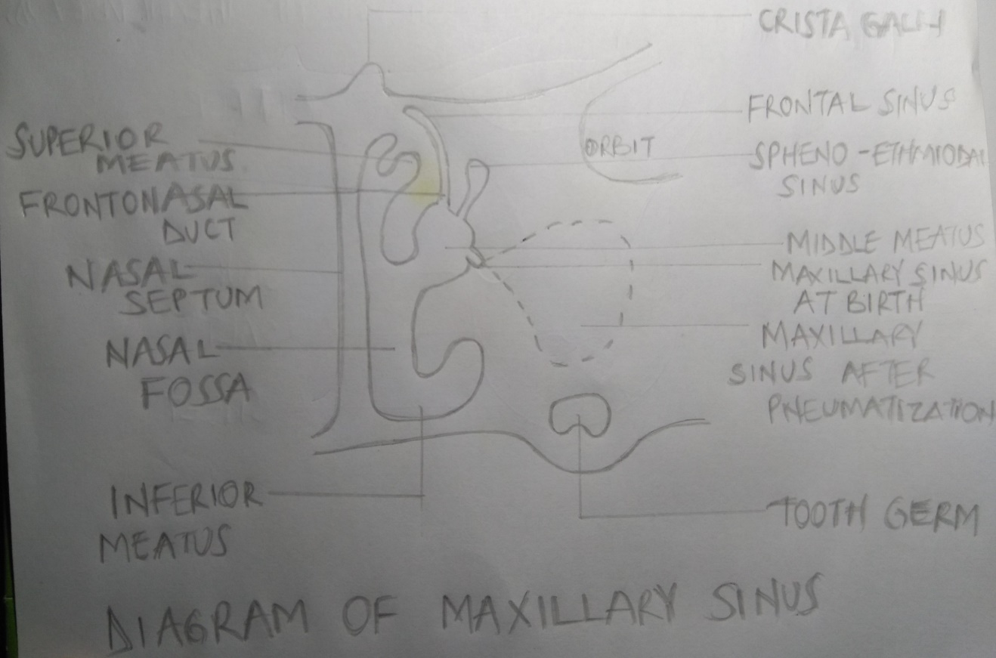

FRONTAL SINUSES
-ANTERIORLY, the frontal sinuses are contained by the FOREHEAD and the SUPERCILIARY ARCHES.
-SUPERIORLY AND POSTERIORLY, By the ANTERIOR CRANIAL FOSSA
-INFERIORLY by the BONY ORBIT, the NASAL CAVITY
-MEDIALLY the sinuses face one another, separated by the midline.
The pair of sinuses are irregular in shape when compared to one another and is underdeveloped at birth. They reach their full size and shape around seven to eight years of age.
They drain primarily into the ETHMOIDAL INFUNDIBULUM and the corresponding lymph drainage occurs via the SUBMANDIBULAR LYMPH NODES. It is innervated by the OPHTHALMIC NERVE, including the supraorbital and supratrochlear branches.
The frontal sinuses are supplied by the:
- Anterior ethmoidal artery
- Supraorbital artery
- Supratrochlear artery

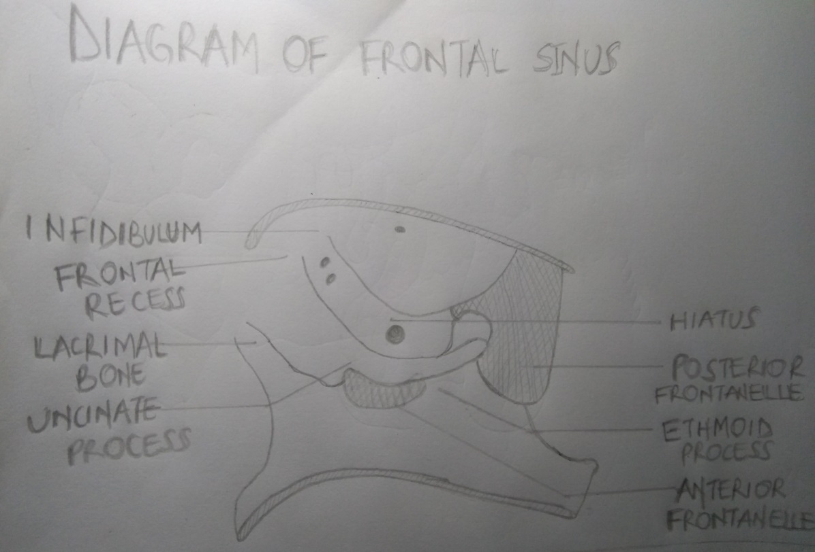

THE SPHENOIDAL SINUSES
This the MOST POSTERIOR of all the sinuses in the head, the sphenoidal sinuses are large and irregular, just like their septum, which is made by the sphenoid bone.
-LATERALLY, a cavernous sinus exists which is part of the middle cranial fossa and also the carotid artery and cranial nerves III, IV, V/I, V/II and VI can be found.
-THE ANTERIOR WALL separates this pair of sinuses from the nasal cavity, as does the hypoglossal fossa, the pituitary gland.
- SUPERIORLY the optic chiasm.
- INFERIORLY the nasopharynx and pterygoid

VASCULARIZATION, INNERVATION AND LYMPHATICS
The lymphatic drainage occurs the same way as the posterior ethmoid sinus. The POSTERIOR ETHMOIDAL ARTERY and the POSTERIOR LATERAL NASAL BRANCHES supply the sphenoidal sinuses.
The POSTERIOR ETHMOIDAL NERVE and the ORBITAL BRANCH of the PTERYGOPALATINE GANGLION innervate them.

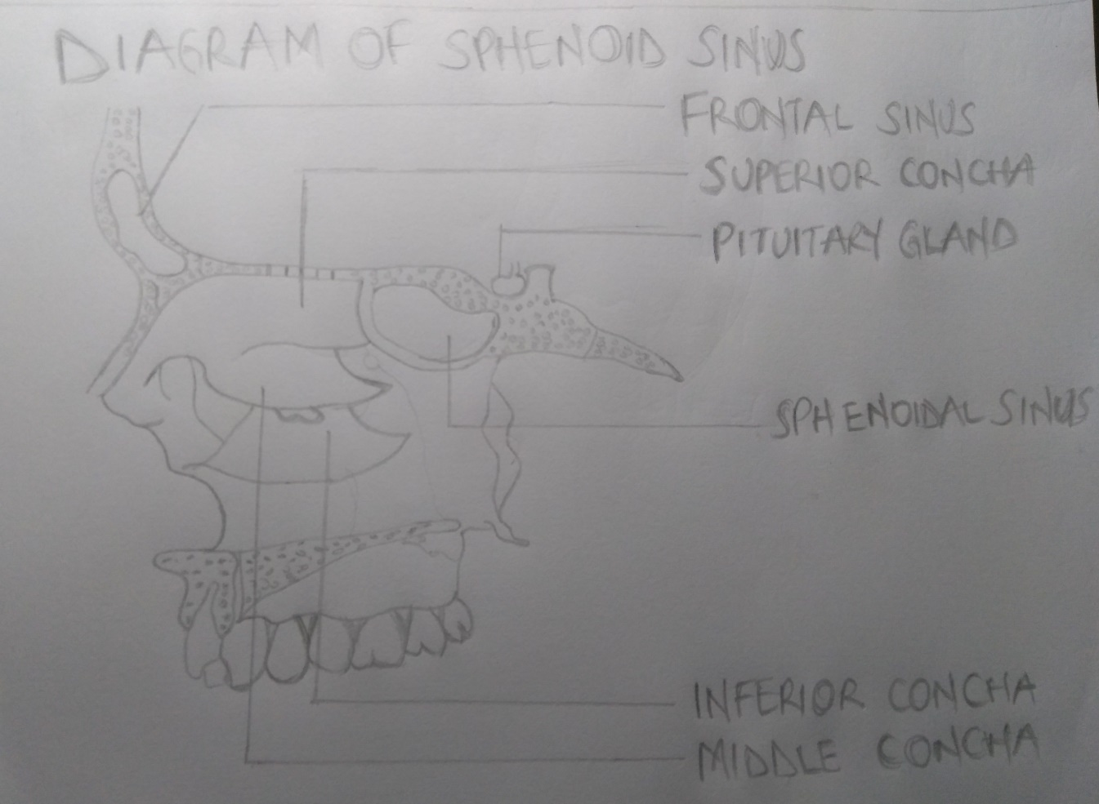

THE ETHMOIDAL SINUSES
-SUPERIOR to the ethmoidal sinus is the anterior cranial fossa and the frontal bone
-LATERALLY the ORBIT can be found.
-MEDIALLY is where the NASAL CAVITY is situated.
The ethmoid sinuses are unique because they are the only paranasal sinuses that are more complex than just a single cavity.
On each side of the midline, anywhere from three to eighteen ETHMOIDAL AIR CELLS may be grouped together to form one large one which encompass the anterior, middle and posterior nasal meatuses.

VASCULARIZATION, INNERVATION AND LYMPHATICS
The anterior and middle ethmoid sinuses send their lymphatic drainage to the SUBMANDIBULAR LYMPH NODES while the posterior ethmoid sinus sends its own to the RETROPHARYNGEAL LYMPH NODES.
The anterior and posterior ethmoidal arteries, as well as the posterior lateral nasal branches provide an ample blood supply to this region. Meanwhile the anterior and the posterior lateral superior and inferior nasal nerves help innervate it.

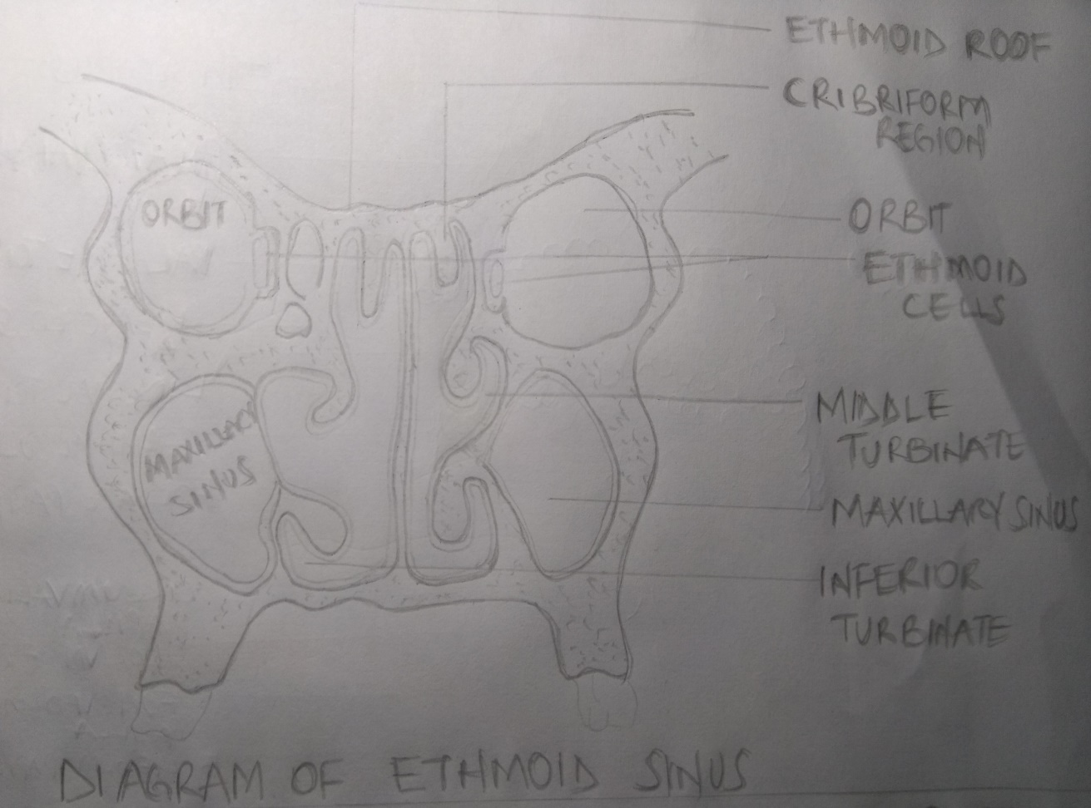

CLINICAL SIGNIFICANCE
Paranasal sinuses are prone to inflammation and infection. If the paranasal sinuses become blocked from secretions or a mass, the drainage of mucus is interrupted, and sinusitis can result
- SINUSITIS: Sinusitis is an extremely common outpatient case which presents as an inflammation of the epithelia of the sinuses. The causes can be viral or bacterial infection, or an allergic reaction. The inflammation can be acute or chronic and the maxillary sinuses are the most frequently affected. Antivirals, antibiotics and antihistamines are prescribed in persistent cases.

- MALIGNANCES OF THE PARANASAL SINUSES: Are rare. The majority of cancers occur in the maxillary sinus are more common inmen than women. Maxillary sinus malignancies occur between ages 45 to 70, and the most frequent is a sarcoma. Even though metastases are rare, these malignancies are locally invasive and destructive. Diagnosis in most cases is delayed, and the prognosis is poor.

- SYMPTOMATIC INFLAMMATION OF THE NOSE AND PARANASAL SINUSES: Acute rhinosinusitis(ARS) and Chronic rhinosinusitis(CRS) are both defined a symptomatic inflammation of the nose and paranasal sinuses. These two are distinguished based on the duration of the complaints. Acute rhinosinusitis is widely considered to be an infectious disorder. On the other hand, chronic rhinosinusitis is typically defined as an inflammatory disorder. In ARS, the underlying etiology is typically viral or bacterial, and occasionally fungal. The pathogenesis of ARS involves infection followed by tissue invasion.

