NAME: MUOKWE UGOCHUKWU
MATRIC. NO: 17/MHS01/191
DEPARTMENT: MEDICINE AND SURGERY
COURSE CODE: ANA 301
ASSIGNMENT TITLE: NOSE & ORAL CAVITY

Question 1: Discuss the anatomy of the tongue and comment on its applied anatomy.
- The word ‘tongue’ is derived from the Latin word ‘lingua’ and Greek word ‘glossa’.
- The tongue is a mobile muscular organ in the oral cavity which bulges upwards from the floor of the moth and its posterior part forms the anterior wall of the oropharynx. It is essentially a mass of skeletal muscle covered by mucous membrane.
- The tongue is separated from the teeth by the deep alveololingual sulcus.
- The tongue performs the functions of taste, speech, mastication, deglutition(process of swallowing), barrier function, jaw development, thermal regulation, secretion, defence mechanism, maintenance of oral hygiene, sucking, general sensitivity.
EXTERNAL FEATURES OF THE TONGUE
- The tip or apex of the tongue: This is the most anterior, and most mobile aspect of the organ.
- The body of the tongue: It has a rough dorsal (superior) surface that abuts the palate and is populated with taste buds and lingual papillae, and a smooth ventral (inferior) surface that is attached to the floor of the oral cavity by the lingual frenulum.
- The base of the tongue: This is the most posterior part of the organ. It is populated by numerous lymphoid aggregates known as the lingual tonsils along with foliate papillae along the posterolateral surface.

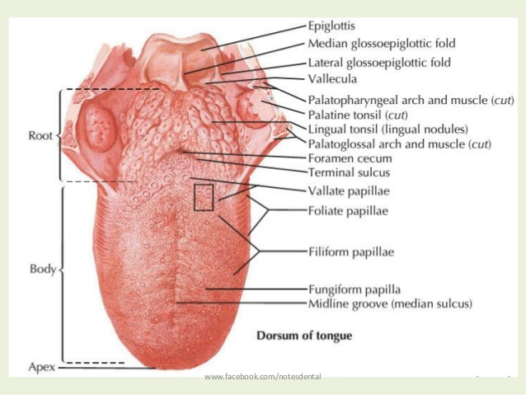

DORSAL SURFACE OF THE TONGUE
- Convex on all sides
- Divided by a V-shaped sulcus into 2 parts: anterior two-third/ oral part and posterior one-third/ pharyngeal part.
- Apex of the sulcus terminalis is marked by foramen caecum

Features of the anterior two-third/ oral part:
- A median furrow, representing bilateral origin of the tongue
- Large number of papillae
- Embryological origin – 1st and 2nd pharyngeal arches.

Features of the posterior one-third/ pharyngeal part:
- A large number of lymphoid follicles, which together constitute the lingual tonsil
- Large number of mucous and serous glands
- Embryological origin: 3rd and 4th pharyngeal arches

VENTRAL SURFACE OF THE TONGUE
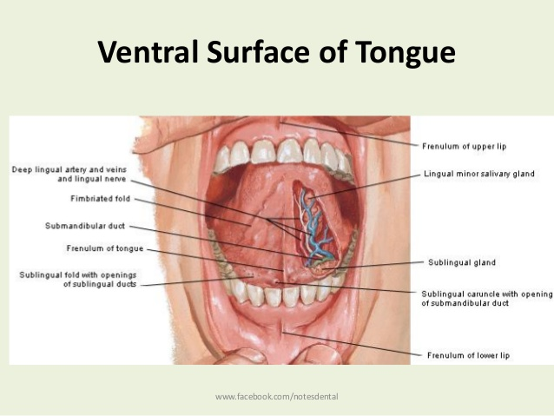

VENTRAL (INFERIOR) SURFACE:
- The mucous membrane lining this surface is smooth, thin and purplish. It presents the following features:
- Frenulum linguae – connecting the floor of the mouth with the tongue
- Deep lingual veins – seen on either side of the lingual frenum
- Plica fimbriata – It is a fringed fold of mucous membrane lateral to the lingual vein directed forwards the tip of the tongue.
STRUCTURES OF THE TONGUE
- MUSCLES: The tongue is made up of intrinsic and extrinsic group of muscles.
- MUCOUS MEMBRANE: It is a layer of connective tissue lined by stratified squamous epithelium.
- GLANDS: Numerous serous and mucous glands lie deep to the mucous membrane.

MUSCLES OF THE TONGUE
INTRINSIC MUSCLES | EXTRINSIC MUSCLES
- Superior longitudinal | - Genioglossus
- Inferior longitudinal | - Hyoglossus
- Transverse | - Styloglossus
- Vertical | - Palatoglossus

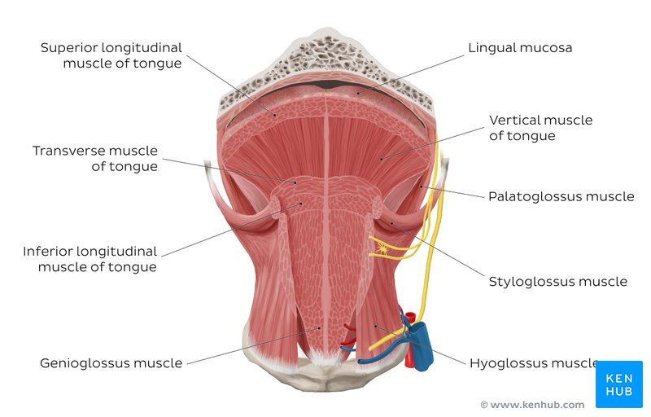

MUSCLES | ORIGIN | INSERTION | ACTIONS
- Superior longitudinal | Beneath the mucous membrane of the dorsal surface of the tongue | Into the sides of the tongue | -Shortens the tongue.  -Makes the dorsum concave
- Inferior longitudinal | Close to inferior surface between genioglossum and hyoglossum | Anterior part of median fibrous septum | -Shortens the tongue  -Makes the dorsum convex
- Transversus linguae | Arise from the median fibrous septum | Margins of the tongue | -Makes the tongue narrow and elongated.
- Verticalus linguae | At the border of the anterior part of the tongue | Sides of the tongue | -Makes the tongue broad and flattened.
- Genioglossus (fan shaped muscle) | Superior genial tubercule | -Whole of the tongue (fibeers radiate from the tip of the base)  -Hyoid bone (lowest fibers) | -Upper fibres: retract the tip  -Middle fibres: depresses the tongue  Lower fibres: Pulls the posterior part forward i.e protrusion of the tongue.
- Hyoglossus (flat quadrilaeral muscle) | Greater cornu and adjacent part of the body of hyoid | Side of the tongue (posterior half) | -Depresses the sides of the tongue  -Makes the dorsal surface convex
- Styloglossus (an elongated slip | Tip and the anterior surface of styloid process | Side of the tongue, interdigitating posteriorly with the fibres of hyoglossus | Pulls the tongue upwards and backwards during swallowing.
- Palatoglossus (a slender slip) | Oral surface of palatine aponeurosis | Side of the tongue (at the junction of its oral & pharyngeal parts) | -Pulls up the roof of the tongue  -Approximates the palatoglossal arches.

INNERVATION OF THE TONGUE
Motor nerve:
- Intrinsic and extrinsic muscles except palatoglossus muscles are supplied by hypoglossal nerve.
- Palatoglossus muscles are supplied by cranial part of accessory nerve through the pharyngeal plexus.
Sensory nerve:
- Anterior two-third - General sensation is supplied by lingual nerve.
- Taste buds are supplied by Chorda tympani nerve
- Posterior one-third – General sensation and taste buds are supplied by glossopharyngeal nerve.
- Small myelinated taste fibers of all the three nerves run into the nucleus of tractus solitarius in medulla.
- Bitter and sour taste – glossopharyngeal nerve
- Sweet and salty taste – Chorda tympani nerve

VASCULATURE OF THE TONGUE
ARTERIAL SUPPLY
- The lingual artery is a branch of external carotid artery and it supplies the major part of the tongue.
- The root of the tongue is also supplied by the tonsillar and ascending pharyngeal arteries.

VENOUS DRAINAGE
- The deep lingual vein is the largest and main vein, which supplies the tongue.
- The vein is visible in the inferior surface of the tongue. I runs bacwards and crosses the genioglossus and hyoglossus muscle.

LYMPHATIC DRAINAGE
Lymph from the tongue takes four routes:
- Lymph from the root drains bilaterally into the superior deep cervical lymph nodes.
- Lymph from the medial part of the body drains bilaterally and directly to the inferior deep cervical lymph nodes.
- Lymph from the right and left lateral parts of body drains to the submandibular lymph nodes on the ipsilateral side.
- The apex and frenulum drain to the submental lymph nodes,the medial portion draining bilaterally.
All lymph from the tongue ultimately drains to the deep cervical nodes, and passes via the jugular venous trunks into the venous system at the right and left venous angles.

APPLIED ANATOMY
- Injury to the hypoglossal nerve leads to the paralysis of the muscles of the tongue on the side of the lesion.
- If the lesion is infranuclear, there is gradual arophy of the affected half of the tongue.
- Supranuclear lesions produce paralysis without wasting.
- The tongue becomes bald in anemias due to atrophy of the filiform papillae.
- In acute glossitis (swelling of he tongue), the presence of rich network of lymphatics and loose areolar tissue is responsible for enormous swelling of the tongue.
- In unconscious patients the tongue may fall back to obstruct the air passages.
- In grandmal epilepsy, the tongue is commonly bitten by the front incisors during attack.
- Sublingual absorption of drugs: For quick absorption, pills or spray is put under the tongue where it disolves and enters the lingual vein. e.g. Nitroglycerine in angina pectoris

Question 2: Write an essay on the air sinuses
The paranasal sinuses are air cavities that help circulate the air that is breathed in and out of the respiratory system. They are situated around the nasal cavity and they are all paired and sometimes symmetrical, while always being bilateral. There are four different pairs of sinuses and they are called the:
- maxillary sinuses
- frontal sinuses
- sphenoidal sinuses
- ethmoidal sinuses
  - Maxillary sinuses: are the largest of the all the paranasal sinuses. They have thin walls which are often penetrated by the long roots of the posterior maxillary teeth. The superior border of this sinus is the bony orbit, the inferior is the maxillary alveolar bone and corresponding tooth roots, the medial border is made up of the nasal cavity and the lateral and anterior border are limited by the cheekbones.
Posteriorly, two anatomical spaces known as the pterygopalatine fossa and the infratemporal fossa exist.
Vascularization, innervation and lymphatics.
The blood supply includes a contribution from the:
- anterior superior alveolar artery
- middle superior artery
- posterior superior alveolar artery
Innervation occurs through nerves of the same names as the arteries.
The submandibular lymph nodes are the main destination during lymphatic drainage.
  - Frontal sinuses: Anteriorly, the frontal sinuses are contained by the forehead and the superciliary arches, superiorly and posteriorly by the anterior cranial fossa and inferiorly by the bony orbit, the anterior ethmoidal sinuses and the nasal cavity. Medially the sinuses face one another, separated by the midline.
This pair of sinuses are irregular in shape when compared to one another and is underdeveloped at birth. They reach their full size and shape around seven to eight years of age.
Vascularization, innervation and lymphatics
They drain primarily into the ethmoidal infundibulum and the corresponding lymph drainage occurs via the submandibular lymph nodes. It is innervated by the ophthalmic nerve, including the supraorbital and supratrochlear branches.
The frontal sinuses are supplied by the:
- anterior ethmoidal artery
- supraorbital artery
- supratrochlear artery
  - Sphenoidal sinuses: The most posterior of all the sinuses in the head, the sphenoidal sinuses are large and irregular, just like their septum, which is made by the sphenoid bone. Laterally, a cavernous sinus exists which is part of the middle cranial fossa and also the carotid artery and cranial nerves III, IV, V/I, V/II and VI can be found. The anterior wall separates this pair of sinuses from the nasal cavity, as does the hypophyseal fossa, the pituitary gland and the optic chiasm superiorly and the nasopharynx and pterygoid canal inferiorly.
Vascularization, innervation and lymphatics.
The lymphatic drainage occurs in the same way as the posterior ethmoid sinus. The posterior ethmoidal artery and the posterior lateral nasal branches supply the sphenoidal sinuses.
The posterior ethmoidal nerve and the orbital branch of the pterygopalatine ganglion innervate them.
  - Ethmoidal sinuses:
- Superior to the ethmoidal sinus is the anterior cranial fossa and the frontal bone, laterally the orbit can be found, while the nasal cavity is situated medially. The ethmoid sinuses are unique because they are the only paranasal sinuses that are more complex than just a single cavity.
- On each side of the midline, anywhere from three to eighteen ethmoidal air cells may be grouped together. These air cells are smaller individual sinuses grouped together to form one large one which encompass the anterior, middle and posterior nasal meatuses.
Vasculature, innervation and lymphatics.
The anterior and middle ethmoid sinuses send their lymphatic drainage to the submandibular lymph nodes while the posterior ethmoid sinus sends its own to the retropharyngeal lymph nodes.
The anterior and posterior ethmoidal arteries, as well as the posterior lateral nasal branches provide an ample blood supply to this region. Meanwhile the anterior and posterior ethmoidal nerves and the posterior lateral superior and inferior nasal nerves help innervate it.
Applied anatomy
Sinusitis: It is an extremely common outpatient case which presents as an inflammation of the epithelia of the sinuses. The causes can be either a viral or bacterial infection, or an allergic reaction, The inflammation can be acute or chronic and the maxillary sinuses are most frequently affected. Antivirals, antibiotics and antihistamines are prescribed in persistent cases.

