NAME: PETERSIDE TAMUNOIBILAMAM ELIJAH
MATRIC NO.: 17/MHS01/284
DEPARTMENT: MEDICINE AND SURGERY
GROSS ANATOMY OF THE HEAD AND NECK ASSSIGNMENT
GROSS ANATOMY OF THE TONGUE AND ITS APPLIED ANATOMY
The tongue is a mobile muscular organ covered with mucous membrane. It can assume a variety of shapes and positions. It is partly in the oral cavity and partly in the oropharynx. The tongue’s main function is articulation (forming words during speaking) and squeezing food into the oropharynx as part of deglutition. The tongue is also involved in mastication, taste and oral cleansing.
PARTS AND SURFACES OF THE TONGUE
The tongue has a root, body, and apex. The root of the tongue is attached to the posterior portion, extending between the mandible, hyoid, and the vertical posterior surface of the tongue. The body of the tongue is the anterior, approximately two thirds of the tongue between root and apex. The apex of the tongue is the anterior end of the body, which rest against the incisor teeth. The body and apex are extremely mobile.
The tongue features two surfaces. The more extensive, superior and posterior surface is the dorsum of the tongue, it is characterized by a V-shaped groove, the terminal sulcus of the tongue, the angle of which points posteriorly to the foramen cecum. This small pit, frequently absent, is the non-functional remnant of the proximal part of the embryonic thyroglossal duct from which the thyroid gland developed. The terminal sulcus divides the dorsum of the tongue transversely into a presulcal anterior part in the oral cavity proper and a postsulcal part in the oropharynx.
A midline groove divides the anterior part of the tongue into left and right halves. The mucosa of the anterior part of the tongue is relatively thin and closely attached to the underlying muscle it has a rough texture because of the numerous small lingual papillae:
1. Vallate papillae: large and flat topped, lie directly anterior to the terminal sulcus and arranged into a V-shped row. They are surrounded by deep circular trenches, the walls of which are studded with taste buds.
2. Foliate papillae: small lateral folds of lingual mucosa. They are poorly developed in humans.
3. Filiform papillae: long and numerous, contain afferent nerve endings that are sensitive to touch.
4. Fungiform papillae: mushroom shaped pink and red spots scattered among the filiform but numerous at the apex and margins of the tongue.
The mucosa of the posterior part of the tongue is thick and freely movable. It has no lingual papillae, but the underlying lymphoid nodules give this part of the tongue an irregular cobblestone appearance, they are known collectively as lymphoid tonsils. The pharyngeal part of the tongue constitutes the anterior wall of the oropharynx. The inferior surface is covered with a thin, transparent mucous membrane. This surface is connected to the floor of the mouth by a midline fold called frenulum of the tongue. The frenulum allows the anterior part to move freely. On each side of the frenulum, a deep lingual vein is visible through the thin mucous membrane.
Muscles
The tongue may seem like one big muscular mass. It is actually composed of many interlaced muscles, some within what would be recognized as the tongue itself and others that are nearby and control its complex movements. These various muscles are grouped as intrinsic muscles (those entirely within the tongue that affect shape) and extrinsic muscles (those that originate outside the tongue, attach to it and surrounding bones, and affect its position).
The muscles of the tongue, with main actions as noted, include intrinsic muscles and extrinsic muscles.
Intrinsic muscles:
- Superior longitudinal: Curls the tip and sides of the tongue upward and shortens the tongue.
- Inferior longitudinal: Curls the tip of the tongue downward and shortens the tongue.
- Transverse: Narrows and elongates the tongue, increasing its height and causing it to stick out (protrude).
- Vertical: Flattens and broadens the tongue within the mouth, causing it to protrude or push against the front teeth.
Extrinsic muscles:
- Genioglossus: A large fan-shaped muscle, it contributes most of the bulk to the tongue. It lowers the tongue and may pull it forward to stick out or even to wag it back and forth.
- Hyoglossus: A thin, four-sided muscle that lowers the tongue and pulls it back into the mouth.
- Styloglossus: Another small, short muscle with fibers that interdigitate with the hyoglossus muscle. It can retract the tongue and draw it up to create a trough for swallowing a bolus of food.
- Palatoglossus: In fact, more part of the soft palate than the tongue proper, it works to elevate the back portion of the tongue.
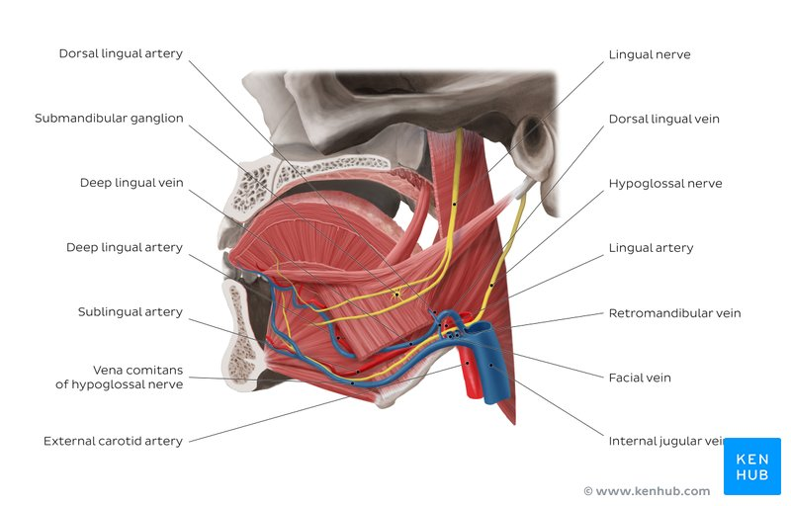
Nerves
All the muscles of the tongue are innervated by the hypoglossal nerve (also known as cranial nerve XII) with the exception of the palatoglossus muscle that is innervated by a branch of the pharyngeal plexus. Sensation, including touch and temperature, of the anterior two-thirds of the tongue’s surface, is supplied by the lingual nerve (a branch from the trigeminal nerve). Taste is a special sensation and it comes from the chorda tympani nerve, branching from the facial nerve. The back third of the tongue receives its general and special sensation innervation from a branch of the glossopharyngeal nerve. Just forward of the epiglottis is a small patch of the tongue that receives its special sensation from the internal laryngeal nerve, a branch of the vagus nerve.

Blood Supply
Without going into excessive detail, the arteries of the tongue derive from the lingual artery, which arises from the external carotid artery. The venous drainage includes the dorsal lingual vein and deep lingual veins, emptying to the internal jugular vein. The veins under the tongue may be enlarged and tortuous (varicose) in older people, but they do not bleed and this change has no clinical significance.

Clinical anatomy
There are a handful of conditions that may be associated with the tongue, often impacting the ability to swallow or speak normally. Some are present from birth, and others may develop from an infection or exposure to cancer-causing substances. Consider these associated conditions that affect the tongue:
Ankyloglossia
As noted above, the lingual frenulum (from the Latin word meaning “bridle”) is a small fold of mucous membrane that connects the middle of the lower surface of the tongue to the floor of the mouth. If it is too short, often from birth, the tongue may be abnormally retracted into the lower jaw. This lower position leads to a condition that is colloquially known as being “tongue tied.” This may be rarely checked (or simply ignored), especially if it is at the back of the tongue, and often goes untreated. It may be recognized with early infancy swallowing problems and speech impairment at school age as the short frenulum may interfere with tongue movements and function. Clipping the frenulum is a simple surgery and this frenulectomy may be necessary for infants to free the tongue for normal speech development.
Genioglossus muscle paralysis
When this muscle becomes paralyzed, the tongue falls backward, potentially obstructing the airway and increasing the risk of suffocation. Total relaxation of the tongue occurs during general anesthesia. As such, this shift of the tongue must be prevented to avoid blocking the airway. This is usually accomplished by inserting a temporary breathing tube during surgery.
Hypoglossal nerve injury
Trauma to the lower jaw (mandible) may cause a fracture that injures the hypoglossal nerve, resulting in paralysis and eventual shrinking of one side of the tongue. After the injury, the tongue deviates to the paralyzed side when protruded.
Lingual carcinoma
Cancer, or carcinoma, may affect the tongue. This is more likely due to infections from human papillomavirus (HPV) or from the use of tobacco, including chewing or smoking.³﻿ The back of the tongue has lymphatic drainage that may cause aggressive cancers to metastasize to the superior deep cervical lymph nodes on both sides of the neck. Cancers of the tongue may require surgical treatment, radiation therapy, and even chemotherapy if metastatic.
Thyroglossal duct cyst
Rarely, there can be a cystic remnant of the thyroglossal duct found within the root of the tongue. Most of these cysts lie close to the body of the hyoid bone, producing a painless swelling of the neck at the midline. It may connect with a fistula to the skin’s surface, leading to a non-healing sore (called a thyroglossal fistula) at the neck. Surgery may be required for the resolution of the problem.
Aberrant thyroid gland
The thyroid gland typically descends within the embryo along the thyroglossal duct. In some cases, remnants of the thyroid gland may remain behind. These may be found in the root of the tongue or even in the neck. In some cases, it may be treated with radioactive iodine and long-term thyroid replacement for post-surgical hypothyroidism is necessary.
Other conditions
There are a few other conditions that may be associated with the tongue, such as:
- Candidiasis: A yeast infection commonly known as thrush is caused by Candida albicans that may cause a white-colored plaque on the mucosa lining the tongue and mouth. It occurs more among the immune-suppressed, especially among the young and old.
- Hairy tongue syndrome: The tongue may appear white or black due to overgrowth of the papillae on the surface of the tongue. A thorough scraping may clear off the debris and resolve the unpleasant appearance and associated smell.
- Macroglossia: Literally a big tongue, this condition may affect the ability to swallow or breathe normally. It may occur in the setting of Down syndrome, weight gain, or hypothyroidism.
- Geographic tongue: A patchy appearance on the surface of the tongue with ridges and colored spots that migrate over time. Though harmless, it may initially seem concerning.
- Burning mouth syndrome: Like it sounds, the symptoms can be unpleasant and causes may be occasionally serious.
- Sleep apnea: The tongue size and position may increase the risk for sleep apnea due to obstruction of airflow within the throat.¹﻿
If concerned about a condition affecting the tongue, start by speaking with either a primary care provider, dentist, or relevant medical specialist. In some cases, further testing may be necessary to assess the condition.
PARANASAL SINUSES
These are a filled extensions of the respiratory parts of the nasal cavity. They are located within the bones of the skull and facial bones. There are 4 paired sinuses named according to the bone in which they are located:-
- Maxillary sinus
- Frontal sinus
- Sphenoid sinus
- Ethmoid sinus
Sinuses are formed in childhood by the nasal cavity eroding into surrounding bone. As they are outgrowths of the nasal cavity, they all drain back into it. Openings of the paranasal sinuses are found on the roof and lateral walls of the nasal cavity. The inner surface is lined by respiratory mucosa.
FUNCTIONS OF THE PARANASAL SINUSES
- Lightens the weight of the skull
- Humidifies and heats inhaled air
- Increases the resonance of speech
- Serves as a crumple zone to protect vital structures in the event of facial trauma
Maxillary Sinus
The largest of the sinuses. It is located laterally and slightly inferiorly to the nasal cavities. It drains into the nasal cavity at the hiatus semilunaris, underneath the frontal sinus opening. This is a potential pathway for spread of infection – fluid draining from the frontal sinus can enter the maxillary sinus.
Frontal Sinuses
These are the most superior in location, found under the forehead. The frontal sinuses are variable in size, but always triangular-shaped. They drain into the nasal cavity via the frontonasal duct, which opens out at the hiatus semilunaris on the lateral wall.
Sphenoid Sinuses
The sphenoid sinuses also lie relatively superiorly, at the level of the spheno-ethmodial recess. They are found more posteriorly, and are related superiorly and laterally to the cranial cavity. The sphenoid sinuses drain out onto the roof of the nasal cavity. The relationships of this sinus are of clinical importance – the pituitary gland can be surgically accessed via passing through the nasal roof, into the sphenoid sinus and through the sphenoid bone.
Ethmoidal Sinuses
There are three ethmoidal sinuses; anterior, middle and posterior. They empty into the nasal cavity at different places:

Anterior – Hiatus semilunaris
Middle – Ethmoid bulla
Posterior – Superior meatus

